ULTRA-SONIC SENSOR (HC-SR04):

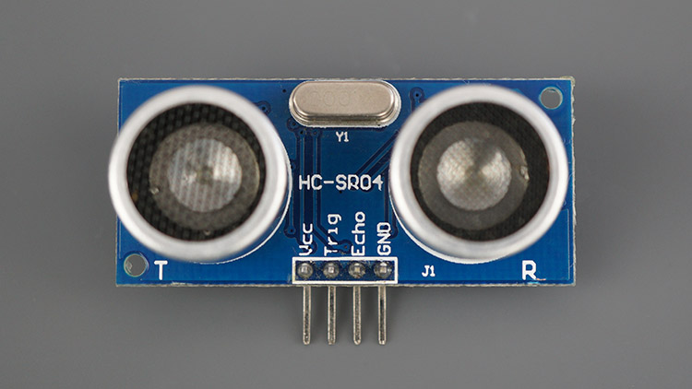

Specifications of HC-SR04:
- Power Supply: 5V DC
- Quiescent Current: < 2mA
- Working Current: 15mA
- Frequency: 40kHz
- Max Range: 4 meters
- Min Range: 2 centimeters
- Ranging Accuracy: ±3mm
- Measuring Angle: 15 degrees
- Trigger Input Pulse width: 10µs
- Dimension: 45mm x 20mm x 15mm

PIN CONFIGURATIONS :
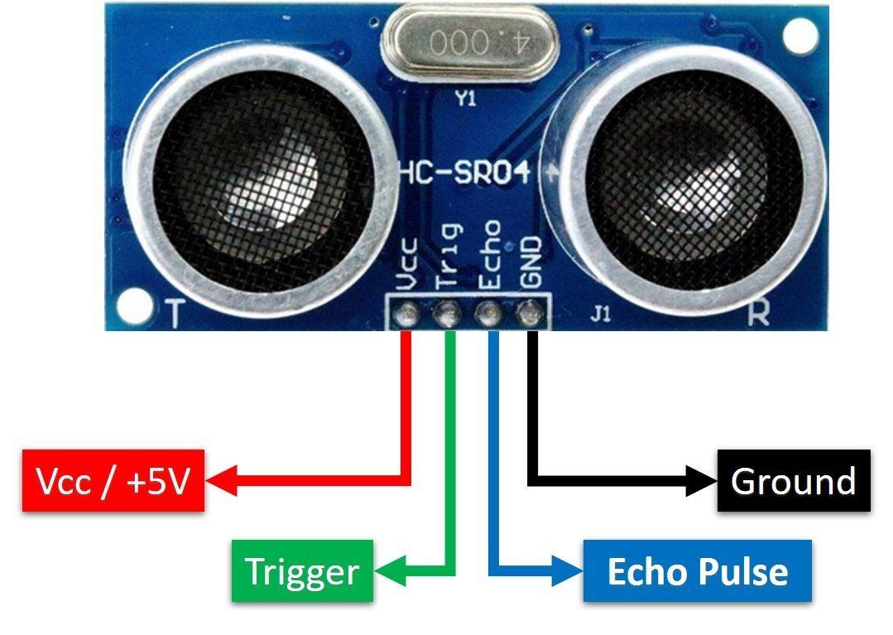
• VCC: 5V DC power supply
• Trig: Trigger input (a 10µs high pulse required to trigger the sensor)
• Echo: Echo output (pulse width proportional to the distance to the target)
• GND: Ground

WORKING PRINCIPLE:
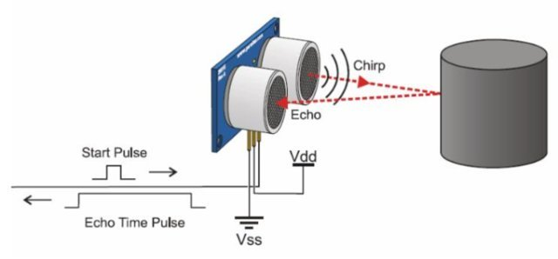
- The sensor emits a 40kHz ultrasonic pulse when the Trigger pin is set high for at least 10 microseconds.
- This pulse travels through the air and bounces back when it hits an obstacle.
- The Echo pin outputs a high pulse, the duration of which is the time taken for the pulse to travel to the object and back.
- The distance to the object can be calculated using the formula:
Distance =($\frac{TIme×Speed}{2}$)
Where the speed of sound is approximately 343 meters per second.

APPLICATIONS:
- Obstacle avoidance in robots
- Distance measurement
- Level detection
- Object detection
INTERFACING WITH VARIOUS MICROCONTROLLERS
ARDUINO :
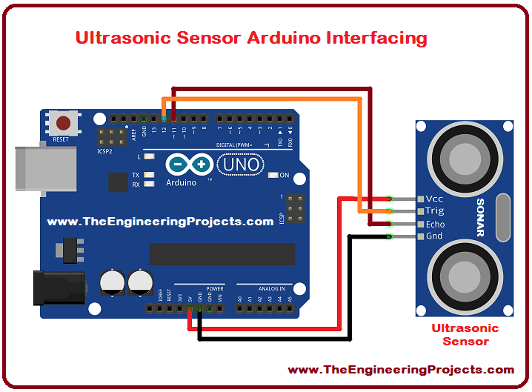

INTERFACING WITH RASPBERRY PICO:
