**Advanced Linux Assignment**

1. What is the size of MBR and what does it contains.

The size of MBR(Master Boot Record) is 512 bytes. It contains bootloader(446 bytes), 4 partition tables(16 bytes each) and a 2 bytes magic number.

1. In which file you can write commands which you want to run whenever Linux system starts/restarts?

We can write commands in rc.local file in /etc. For that, we have to provide some permissions before:

$sudo chmod +x /etc/rc.local

There are rc files present for all the runlevels(rc0.d- rc6.d).

1. Restart cron service.

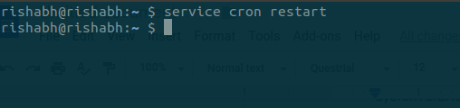

1. Create an ext4 filesystem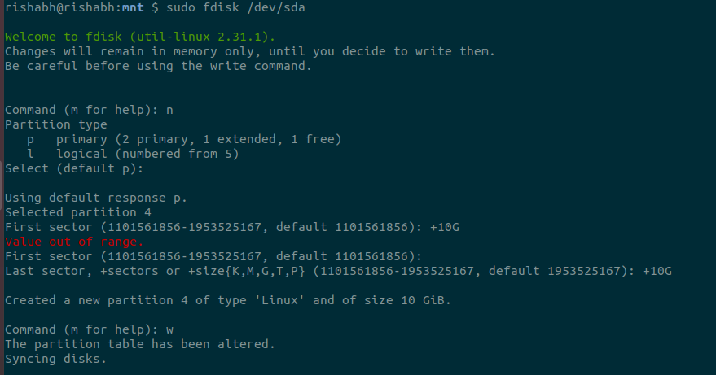

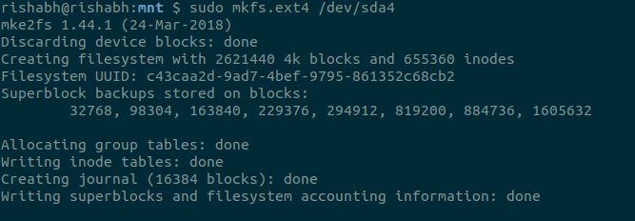

1. Mount the created filesystem on /partition directory.

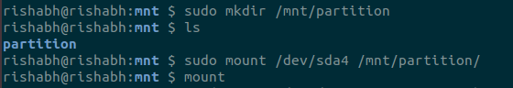



1. Create a user and add it to one secondary group.

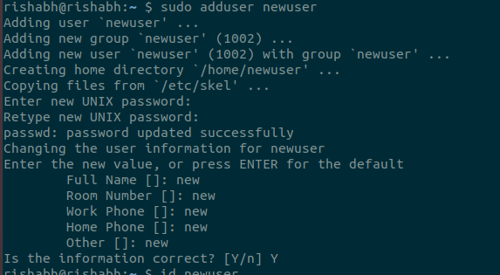

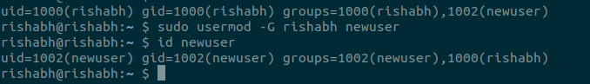

1. Lock this user.

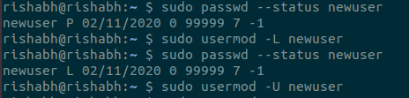

1. Give this user full access (without password).

Open visudo and add the code for that user.

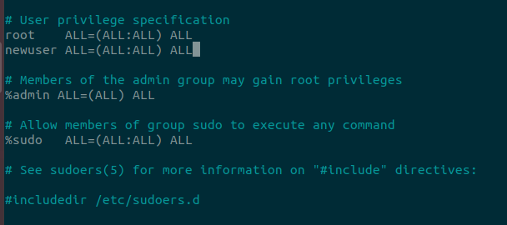

1. Delete the create user after taking backup of it home directory.

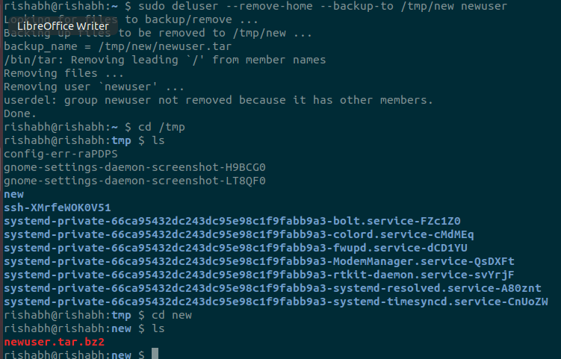

1. Create a file with some content. Change all lower case letters to upper case letters and save output to another file using redirections.

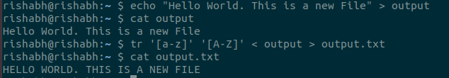

1. Set nice value of a process to -1.

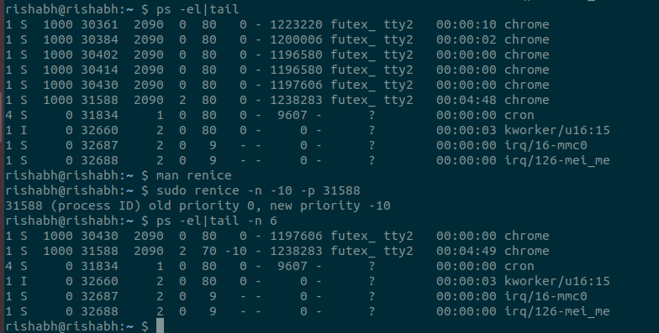

1. Get a list of all files used by “telnet”.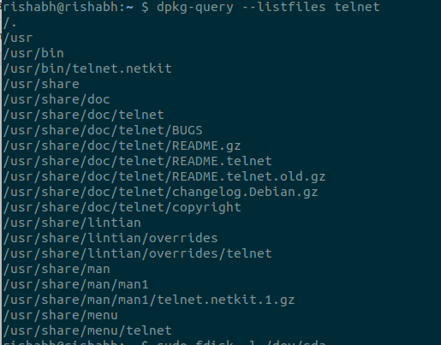
2. Check if port 22 is listening using netstat and telnet command.

Using netstat

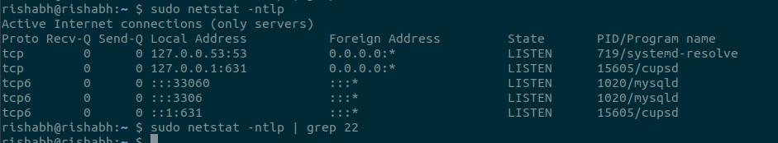

Using telnet

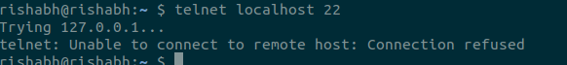

1. Create a cron job which runs once a week at 23:45.