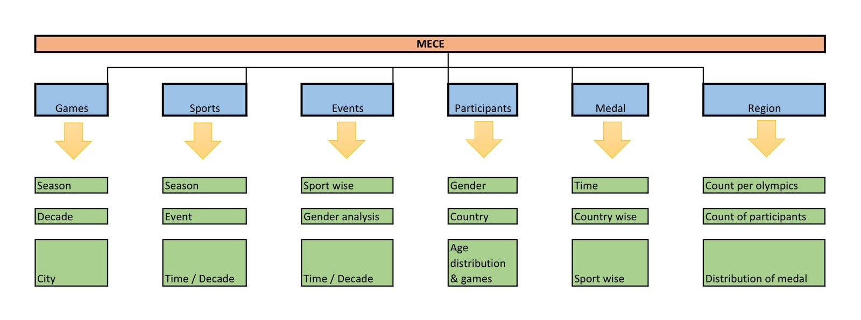

- The comprehensive analysis will be segmented into six major components, namely: Games, Sports, Events, Participants, Medals, and Regions.

Games Analysis:
In the analysis of games, the following aspects will be examined:

1. Examination of games held during different seasons and an assessment of how the seasons (summer or winter) have influenced the Olympics.
2. Identification of the highest number of games held in each decade.
3. Exploration of the cities that have consistently hosted the Olympics games the maximum number of times.

Sports Analysis:
The analysis of sports will encompass the following:

1. Investigation into the division of sports across different seasons, specifically summer and winter.
2. Identification of the sport played the most frequently in various events throughout the history of the Olympics.
3. Examination of player participation in each sport over time.

Events Analysis:
The analysis of events will focus on the following:

1. Sport-wise event analysis.
2. Examination of gender distribution in recorded events.
3. Time analysis and exploration of changes in events over the course of time.

Participants Analysis:
The analysis of participants will unveil the following:

1. Distribution of participants in each gender category.
2. Identification of the top countries with the maximum number of participants in the Olympics.
3. Examination of participants from different age groups across a variety of games.

Medal Analysis:
The analysis of medals encompasses the following:

1. The number of medals awarded in each Olympics.
2. Identification of the top countries with the maximum number of medals.
3. Categorization of different sports based on medal type (Gold, Silver, and Bronze).

Region Analysis:
The concluding region analysis will facilitate an understanding of the following:

1. The number of regions participating in the Olympics.
2. Identification of regions with the maximum number of participants.
3. Examination of regions and the medals they have won in each medal category (Gold, Silver, and Bronze).

