RISHABH JAIN

CSE 581

2/1/2019

LAB 3

/\*Q1\*/

SELECT TOP 10 VendorName, SUM(PaymentTotal) AS PaymentSum

FROM AP.dbo.Vendors AS v JOIN AP.dbo.Invoices AS i

ON v.VendorID=i.VendorID

GROUP BY VendorName

ORDER BY PaymentSum;

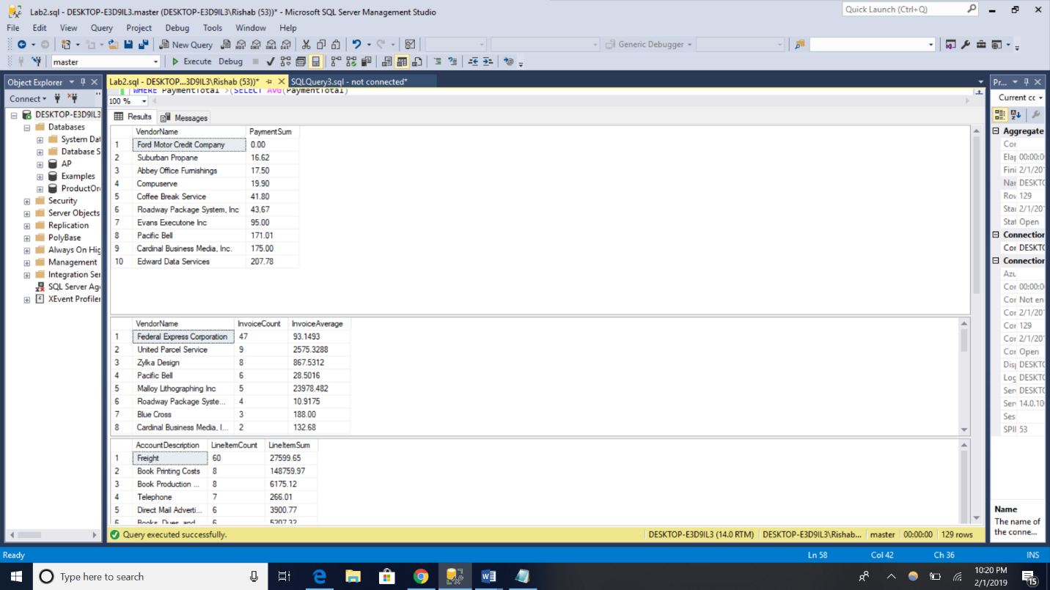

(10 rows affected)

/\*Q2\*/

SELECT VendorName, COUNT(\*) AS InvoiceCount, AVG(InvoiceTotal) AS InvoiceAverage

FROM AP.dbo.Vendors AS v JOIN AP.dbo.Invoices AS i

ON v.VendorID=i.VendorID

GROUP BY VendorName

ORDER BY InvoiceCount DESC;

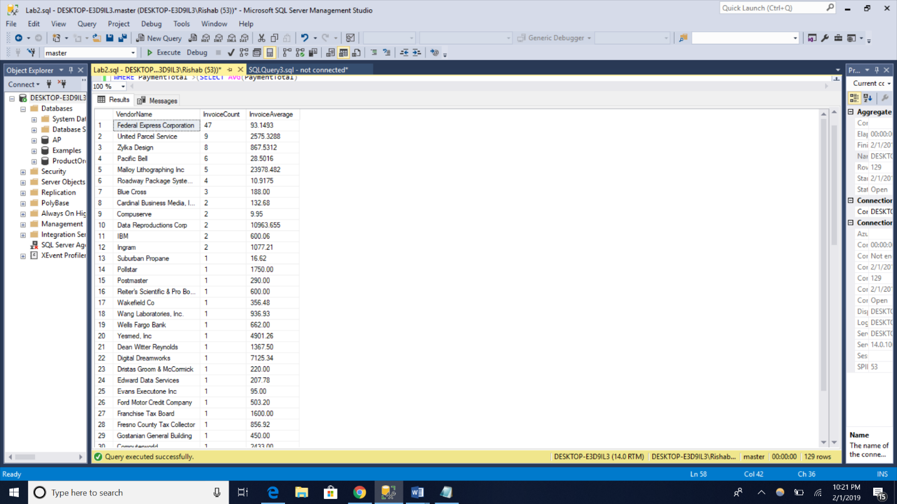

(34 rows affected)

/\*Q3\*/

SELECT g.AccountDescription, COUNT(\*) AS LineItemCount, SUM(InvoiceLineItemAmount) AS LineItemSum

FROM AP.dbo.InvoiceLineItems AS i JOIN AP.dbo.GLAccounts AS g

ON i.AccountNo=g.AccountNo

GROUP BY g.AccountDescription

HAVING COUNT(\*)>1

ORDER BY LineItemCount DESC;

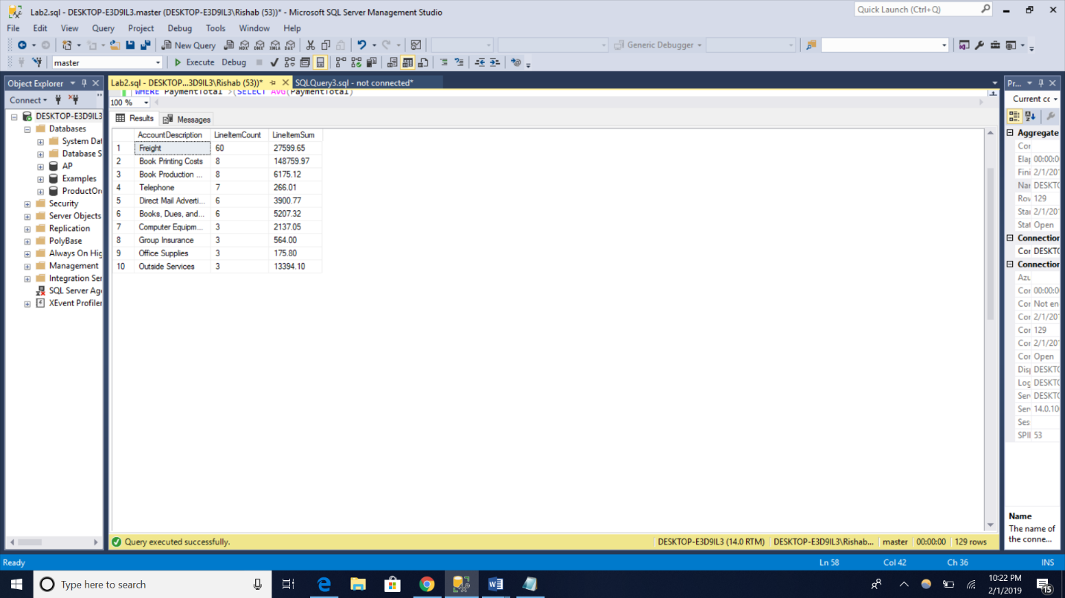

(10 rows affected)

/\*Q4\*/

SELECT AccountNo, SUM(InvoiceLineItemAmount) AS InvoiceTotal

FROM AP.dbo.InvoiceLineItems

GROUP BY AccountNo WITH ROLLUP;

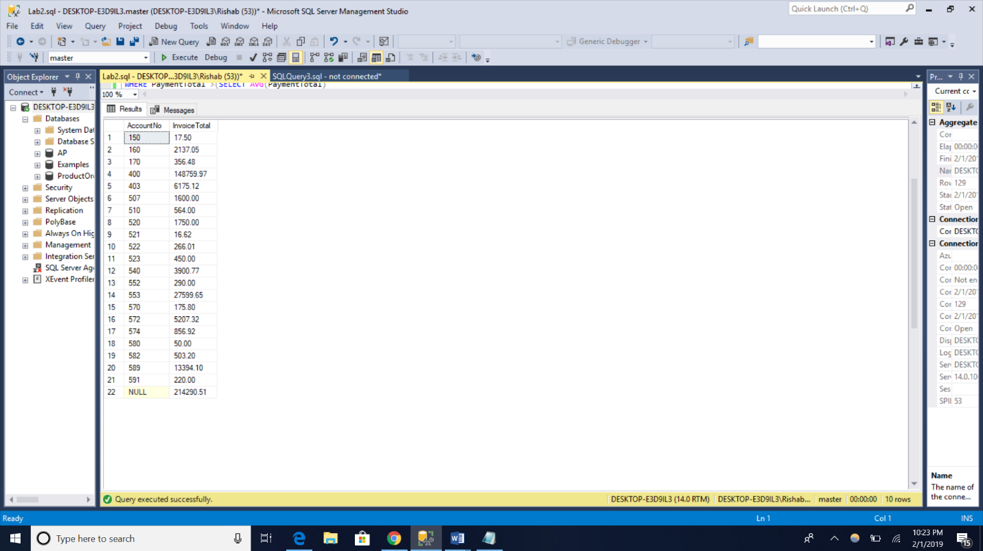

(22 rows affected)

/\*Q5\*/

SELECT VendorName, COUNT(j.AccountNo) AS NoOfAccounts

FROM AP.dbo.Vendors AS v JOIN AP.dbo.Invoices AS i

ON v.VendorID=i.VendorID

Join Ap.dbo.InvoiceLineItems AS j

ON i.InvoiceID = j.InvoiceID

GROUP BY VendorName

HAVING COUNT(j.AccountNo)>1

ORDER BY VendorName;

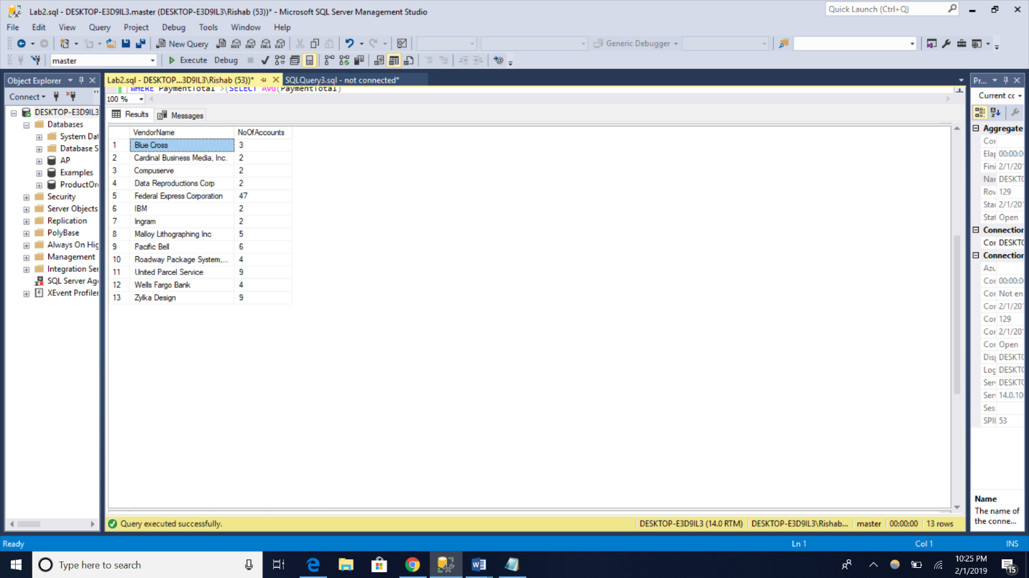

(13 rows affected)

/\*Q6\*/

SELECT VendorName, InvoiceNumber, InvoiceTotal

FROM AP.dbo.Vendors AS v JOIN AP.dbo.Invoices AS i

ON v.VendorID=i.VendorID

WHERE PaymentTotal >(SELECT AVG(PaymentTotal)

FROM AP.dbo.Invoices

WHERE PaymentTotal > 0)

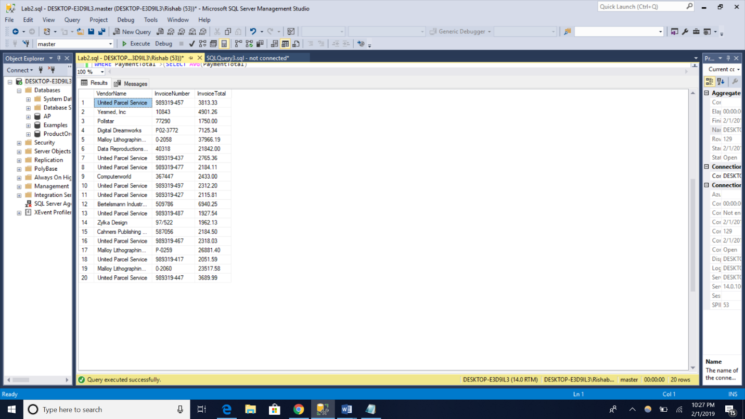

(20 rows affected)

/\*Q7\*/

SELECT SUM(MaxAmountDue) AS [Largest Unpaid Invoices]

FROM

(SELECT VendorID, MAX(InvoiceTotal) AS MaxAmountDue

FROM AP.dbo.Invoices

WHERE (InvoiceTotal - CreditTotal - PaymentTotal)>0

GROUP BY VendorID) AS Balance

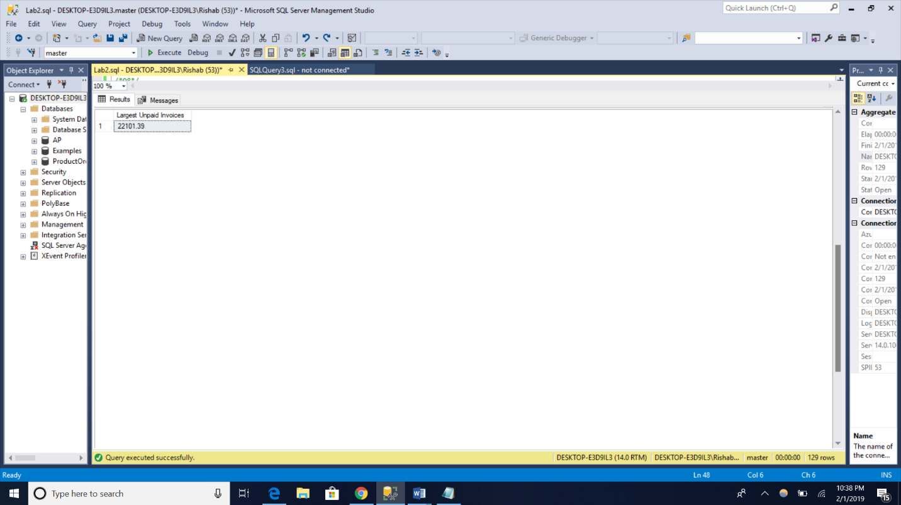

(1 row affected)

/\*Q8\*/

SELECT VendorName, VendorCity, VendorState

FROM AP.dbo.Vendors AS v

WHERE VendorState + VendorState NOT IN

(SELECT VendorState + VendorState

FROM AP.dbo.Vendors

GROUP BY VendorState, VendorCity

HAVING COUNT(\*) > 1)

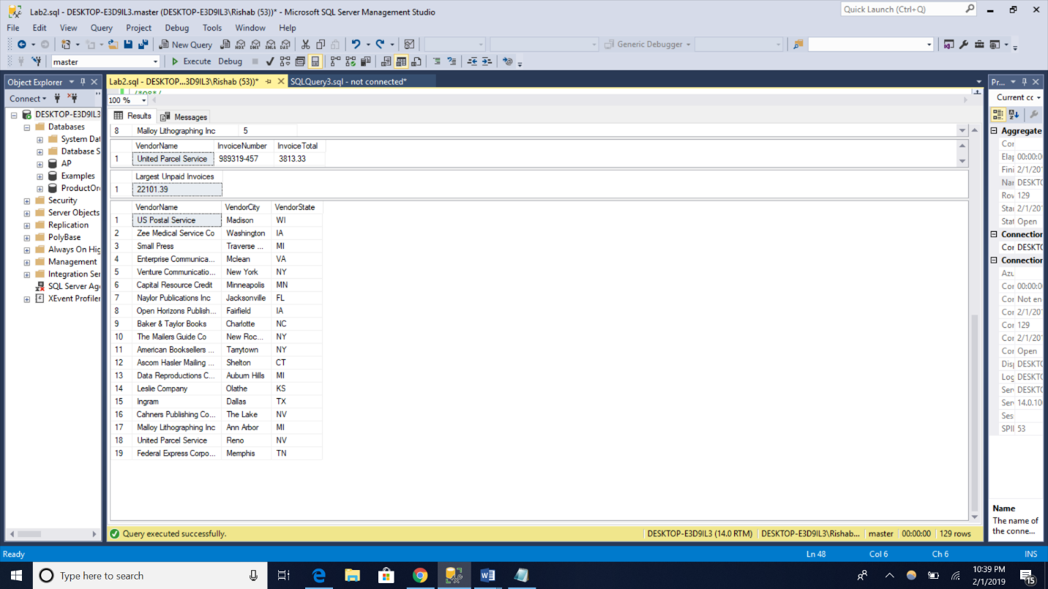

(19 rows affected)

Results:

