Rishabh Jain

Lab 4

7 February 2019

Q1

SELECT \*

INTO VendorCopy

FROM AP.dbo.Vendors;

SELECT \*

INTO InvoicesCopy

FROM AP.dbo.Invoices;

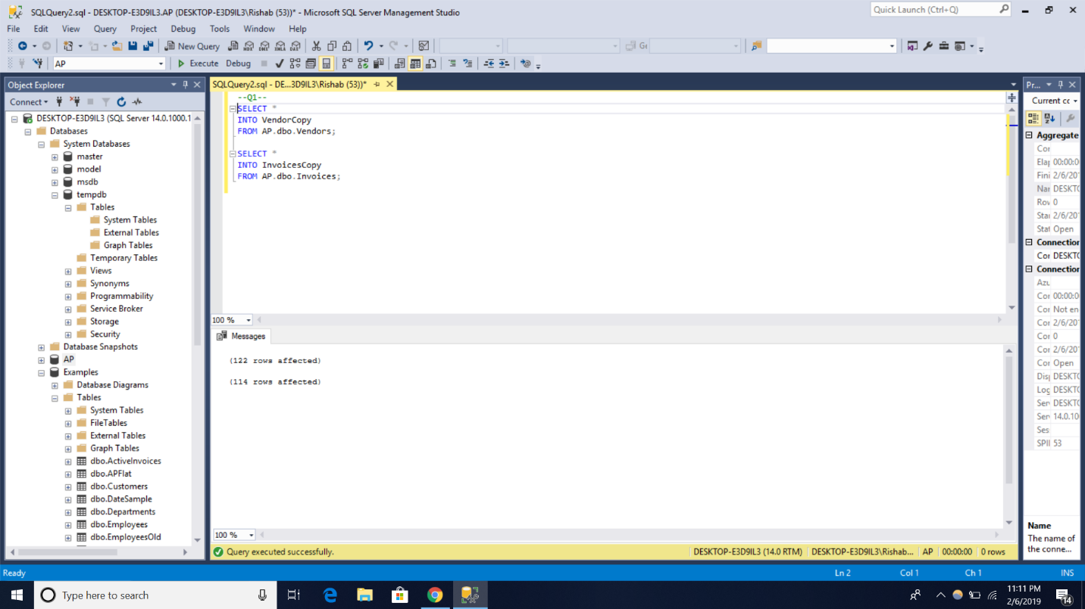

Q2

INSERT INTO InvoicesCopy

VALUES(32, ’014027’, ‘2012-06-21’, 434.58, 0, 0, 2, ‘2012-07-8’, NULL);

SELECT \*

FROM InvoicesCopy

WHERE VenorID = 32;

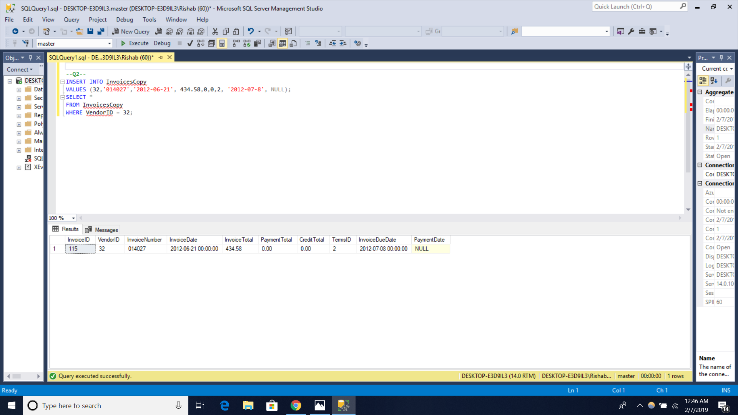

Q3

UPDATE VendorCopy

SET DefaultAccountNo = 403

WHERE DefaultAccountNo = 400;

SELECT \*  
FROM VendorCopy;

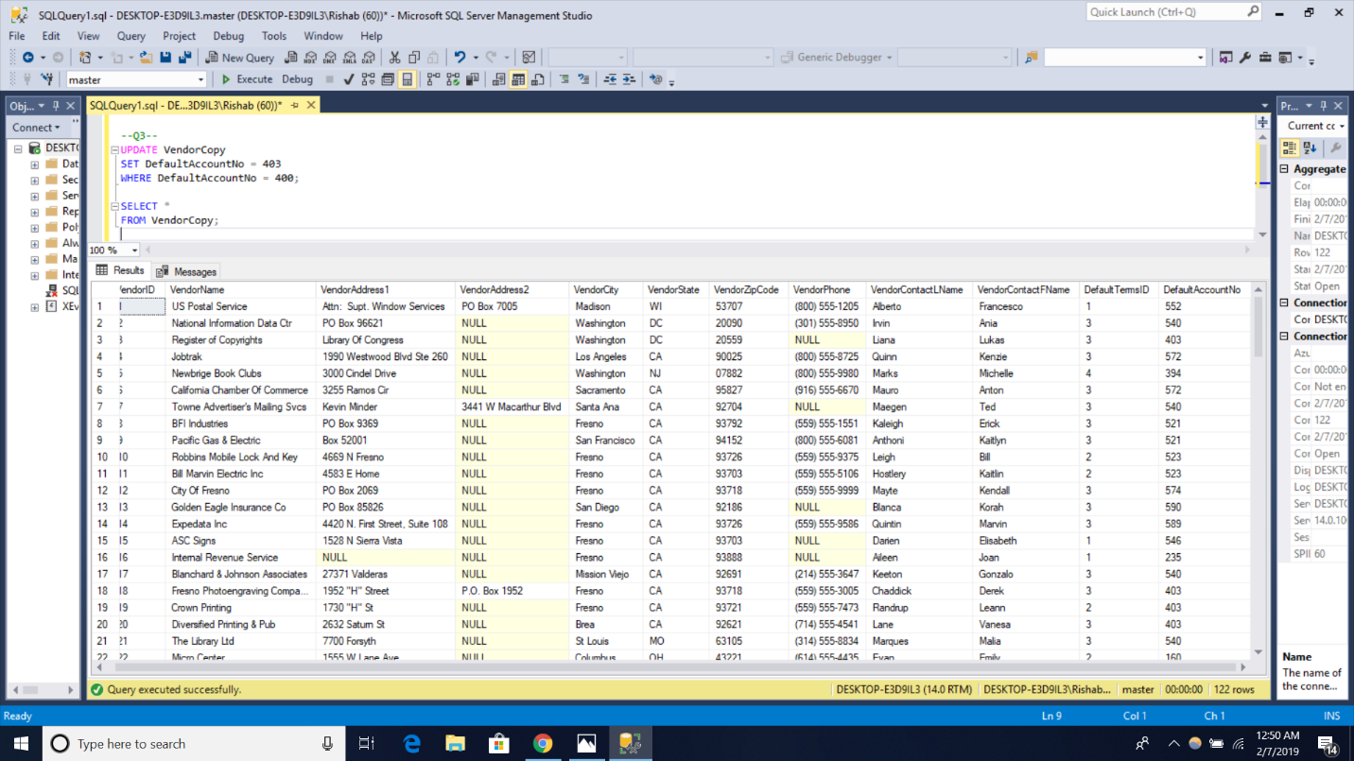

Q4

UPDATE InvoiceCopy

SET TermsID =4

FROM InvoiceCopy AS I JOIN VendorCopy AS v

ON i.VendorID = v.VendorID

WHERE DefaultTerms = 2;

SELECT \*

FROM InvoiceCopy;

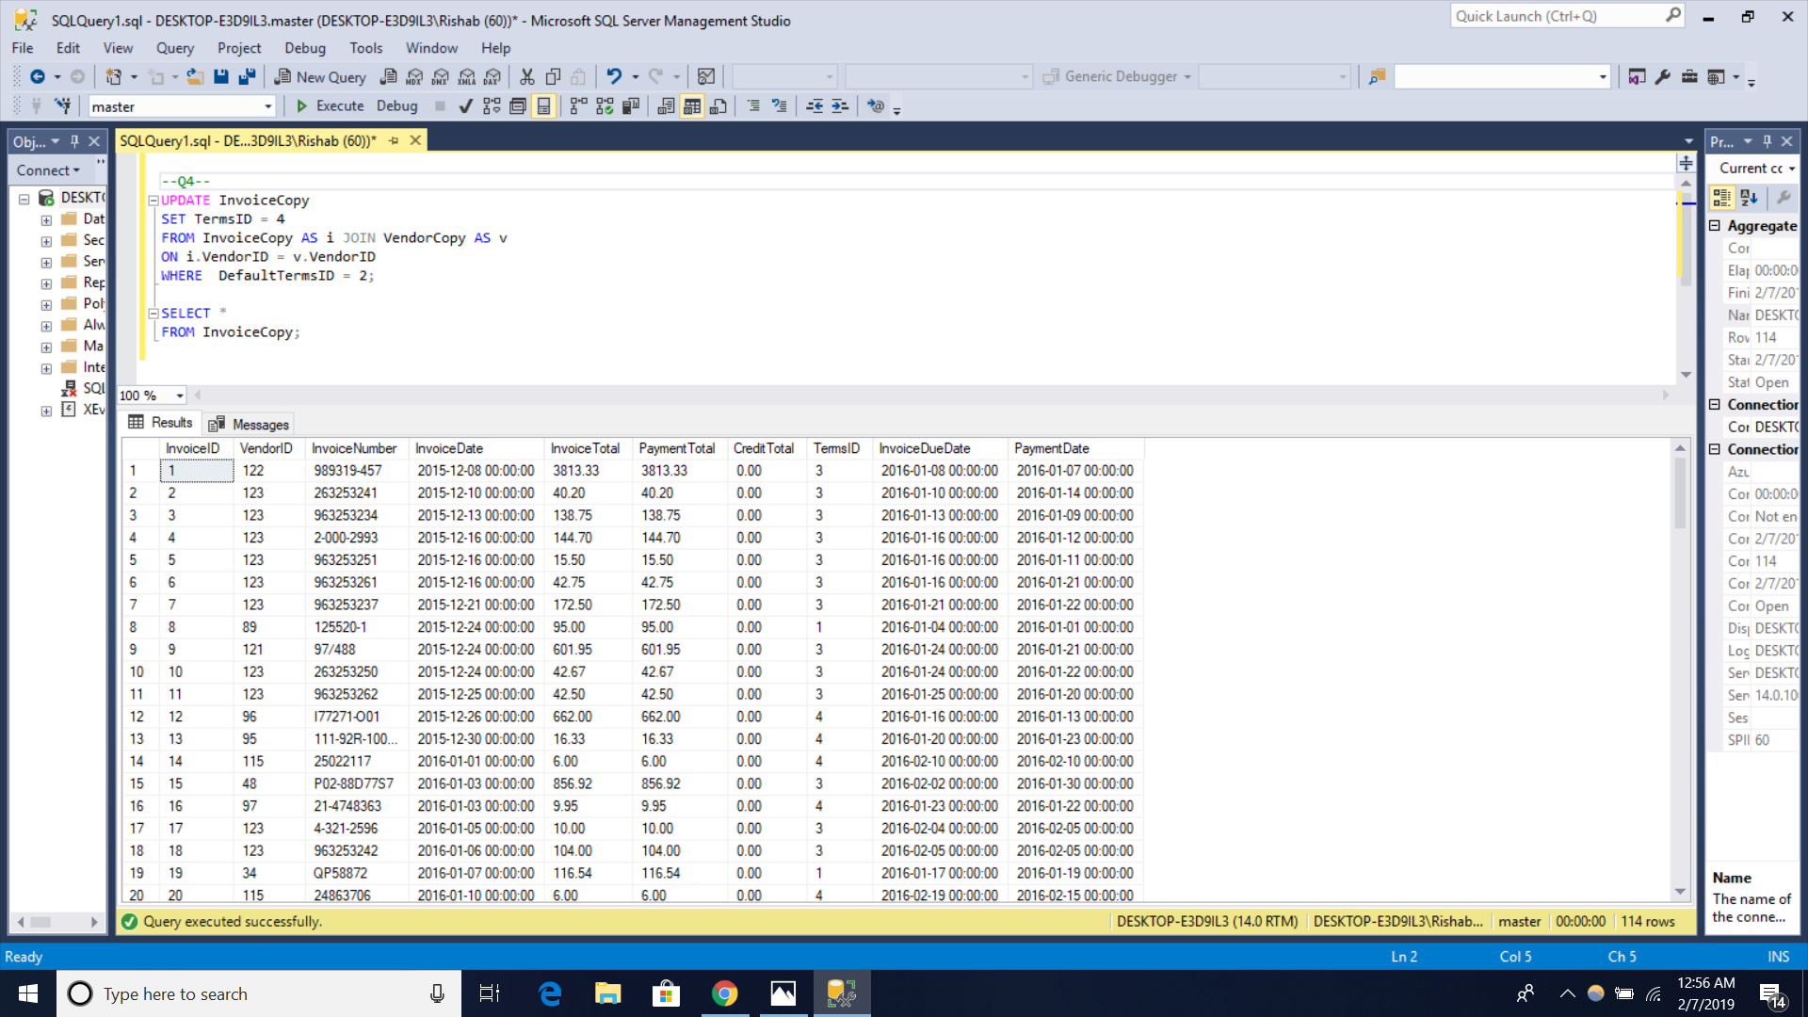

Q5

DELETE VendorCopy

WHERE VendorState = ‘CA’;

SELECT \*

FROM VendorCopy;

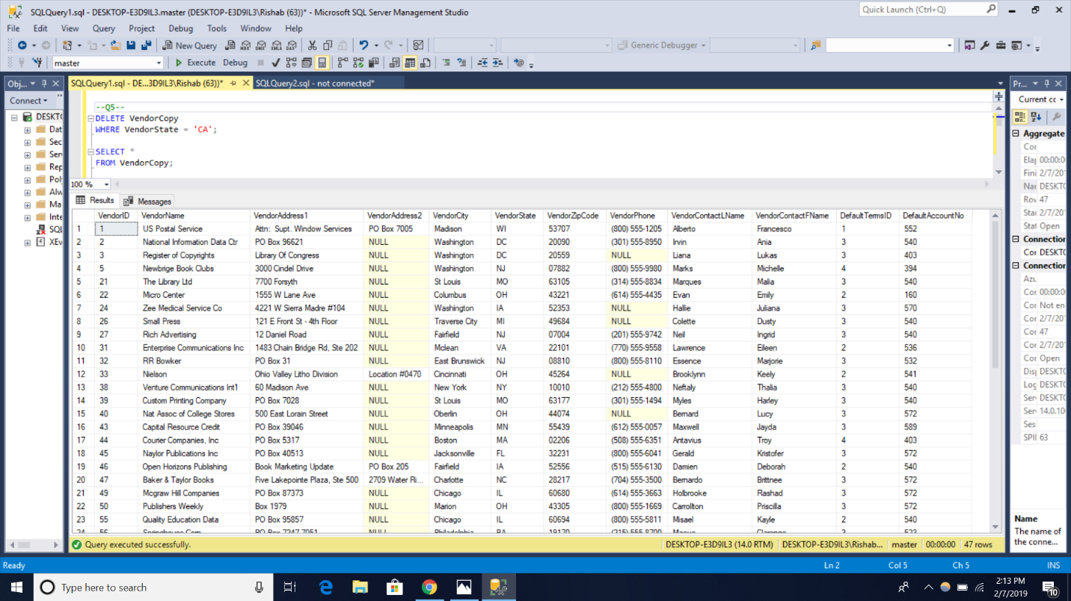

Q7

SELECT CAST(InvoiceTotal AS decimal(20,2)) AS InvoiceTotalDecimal,

CAST(InvoiceTotal AS varChar ) AS InvoiceTotalVarchar,

CONVERT(varchar, InvoiceTotal) AS InvoiceTotalConvDecimal,

CONVERT(varchar, InvoiceTotal, 1) AS InvoiceTotalConvVarChar

FROM AP.dbo.Invoices;

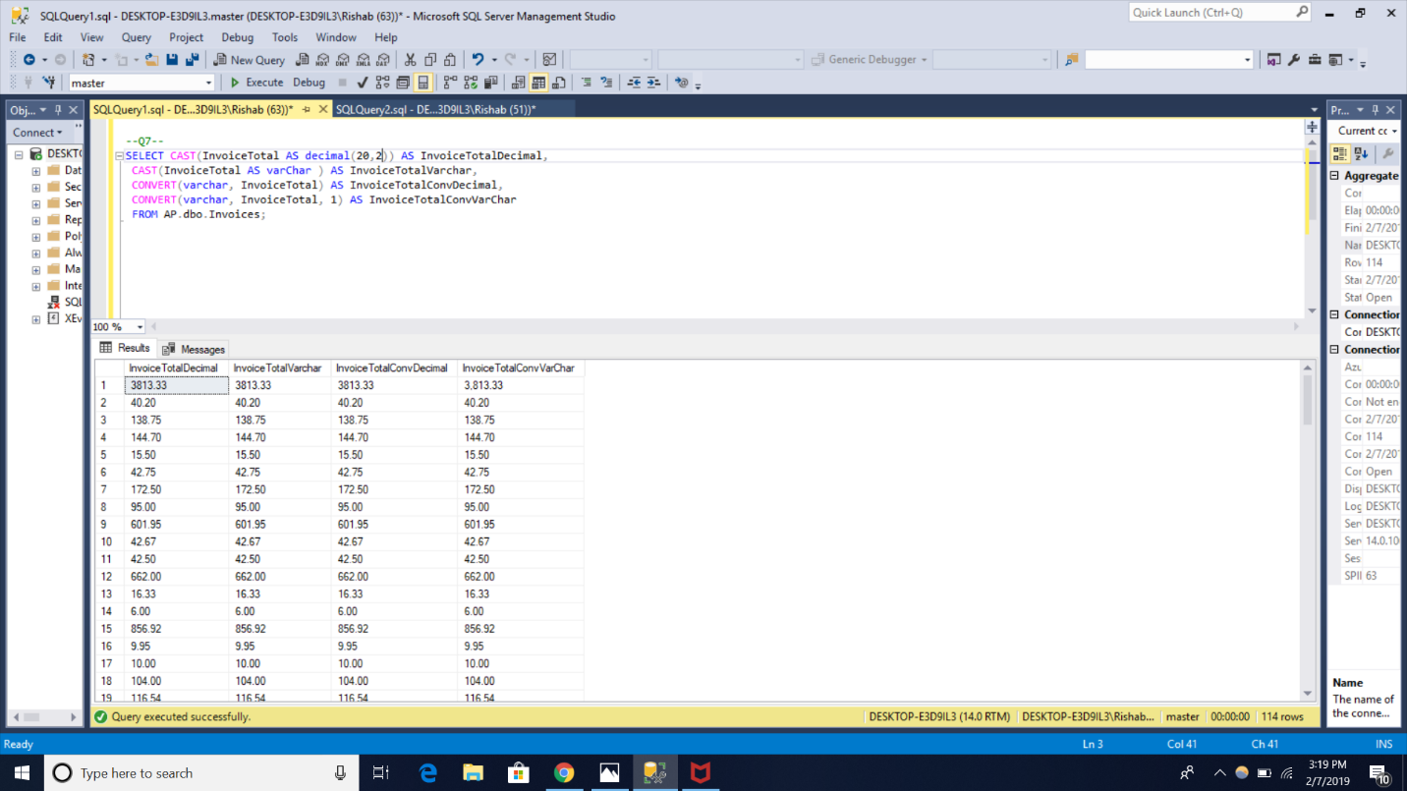

Q8

SELECT CAST(InvoiceDate AS varchar) AS DateInVarchar,

CONVERT(varchar, InvoiceDate,1) AS InvoiceDateInvarchar1,

CONVERT(varchar, InvoiceDate, 10) AS InvoicedateInVarChar10,

CAST(InvoiceDate AS real ) AS InvoiceTotalVarchar

FROM AP.dbo.Invoices;

