**Medical Handwritten Prescription Recognition and Information Retrieval using Neural Network**

**Utkarsh Shaw1, Tania2, Rishab Mamgai3 and Isha Malhotra4**

*1, 2 Computer Science and Engineering Department, Dronacharya College of Engineering, Gurugram, India*

*3 Electronics & Communication Engineering Department, Bharti Vidyapeeth’s College of Engineering, New Delhi, India*

*4Electronics and Communication Engineering Department, Dronacharya College of Engineering, Gurugram, India*

**---------------------------------------------------------------------***--------------------------------------------------------------------**

**Abstract**

The automatic interpretation of handwritten documents is one of the popular research areas over the last few decades because of the huge scope of its practical applications such as automatic reading of address, bank cheque processing, and hand written text recognition filled on forms. Moreover, information retrieval in offline doctor’s prescription images was not being focused prior the Covid -19 pandemic. However, over the last two years such prescription images are extensively being exchanged by the patients’ among offline medical consultants for useful advice. Therefore, in this paper the potential concern has been expressed on using computer technology to assess handwriting. The results support the efficiency of proposed model to identify the poor legibility of handwriting and transform it into readable correct text recognition. Further, using our system the handwritten medical prescription can be converted digitally using electronic writing pad. Such facility will enables patient to take away prescription in the form of digital media which can further be recognized by running it on our model.

**Key Words:** Handwriting Recognition, Neural Network, Medical Prescription, Segmentation.

1. **Introduction**

Handwritten digit or character recognition has included challenges in terms of pattern recognition. This happens to be a tedious job because of the high variability of handwriting and therefore, difficult to recognize the unconstrained handwriting [1]. Among the document analysis community, several systems and classification algorithms have already been exploited for the ease of identification and recognition [2]. Moreover, multiple datasets have been published such as MNIST [3], USPS [4] alongwith techniques varied from statistical methods including fisher discriminant analysis [5] to machine learning [6] or support vector machines [7] to recognize handwriting for multiple application areas.

Information retrieval in offline medical prescription is one of the unexplored application areas due to the extensive use of digitized world. However, much work related to medical prescription is still being done in offline in major parts of the country be it be in Government hospitals, dispensaries or local clinics. Recently, one report published in [8], refers the record of 300 medical professionals who have diagnosed the handwritten medical prescription. It is reported that 88% of the doctors, 82% of the nurses and

75% of the pharmacists read the prescriptions correctly. Therefore, considering the significant impact of wrong interpretation of text from handwritten medical prescription and its severe consequences, we have proposed a model based on Neural Networks supported by python programming. Further, the implementation of our system will provide a significant support in following ways:

* Development of expert diagnostic systems.
* Extraction of information from patients’ history.
* Ability to detect wrong medication.
* Analysis and comparison of prescribed medicines by doctors.

Neural Networks are widely used in development of Artificial Intelligence, field of computer vision and natural language processing. Neural network uses multilayer feedforward network and does back propagation all the way back for eliminating errors to learn optimal weights [9]. The main objective of our paper is to understand the prescription by segmenting a sequence of handwritten strokes into segments of different letters of which it is comprised. These segments will then be fed to the trained Neural Network for recognition. The rest of the paper is organized in a way: in Section II a brief discussion about related work published is presented. Section III includes detailed discussion about key features i.e. dataset, model, algorithm and libraries used in recognition. The architecture considered to implement the proposed model has been discussed in Section IV. In Section V, the training of the model is presented. Section VI the implementation of segmentation is discussed and finally in Section VII concludes our work.

**II. Related Work**

For the purpose of recognition of handwritten medical prescription high level programming language such as MATLAB has been used. In earlier works, several general methods have been proposed which includes scanning of images and are then saved locally on device which is further segmented on the basis of stroke breakpoints. Such technique has been exploited by authors in [10], wherein the published work shows that initially words are separated into letters especially where there is start of new stroke for next word. The aforementioned method is accomplished with the help of a function called “bwlabel” which computes all the connected components in the image. Then these components are extracted with the help of “regionprops” method. Figure 3 shows the recognized word using the technique mentioned in [10].

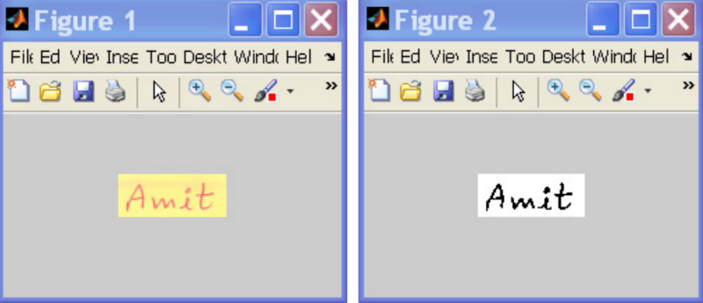

**Fig.1. Original image and the pre-processed handwritten word image [10].**

However, the limitation of their work is that they have developed an approach for segmenting the words having connected letters. In practice, the words are separated at the breakpoints as reflected in Figure 2 for reference, therefore such approach is not fully acceptable for the said application. 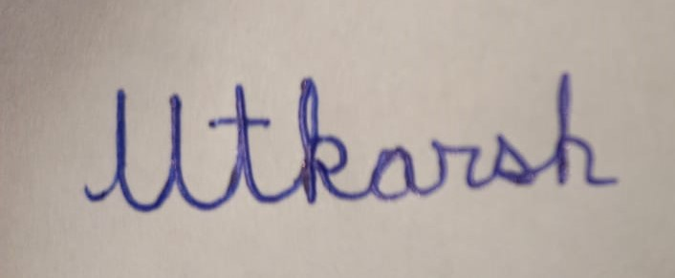 **Figure 2: Image without breakpoints**

Similarly, using Multi-column DNN (MCDNN) having MNIST digits have been explored in [11] which shows the success rate of 99.77% of recognizing the handwritten text. We have used the Extended MNIST (EMNIST) in our proposed model which is an extension of Cohen et. al. [12] work on full NIST dataset, and followed the same conversion paradigm used to create the MNIST dataset.

Dawoud et. al. [13] made use of iterative cross section sequence graph (ICSSG) for the character’s segmentation. This algorithm preserves the character’s skeletal structure by prevention of the interference of pixels that causes flooding of adjacent character’s segments. However, the experiment was performed on handwritten digits only.

In our proposed work, the potential outcomes from deploying the model in practical scenario are:

* Handwritten Prescription can be stored digitally, so as to minimize the issue of misplace.
* Enables the patient to understand the handwritten prescription for clarification and comparison.
* Eliminate the use of paper as writing pad could be suggested to be used by the practitioner.

**III. Proposed Work Approach**

The EMNIST dataset is derived from the NIST Special Database 19  which contains digits, uppercase and lowercase handwritten letters and is converted to a 28px × 28px image format i.e. dataset structure that matches the MNIST dataset. The EMNIST Letters dataset contains a set of uppercase and lowercase letters that are merged into a single set of 26 classes. It contains a training set of 88,800 examples and a test set of 14,800 examples as shown in fig 3.

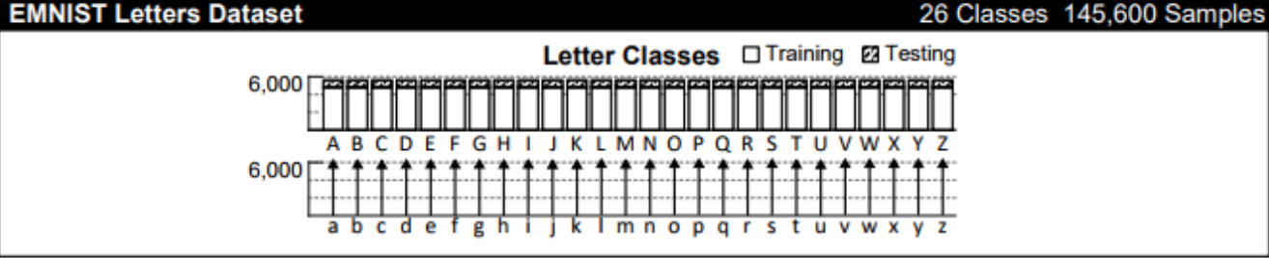**Figure 3: EMNIST Letters dataset**

The EMNIST MNIST dataset contains a handwritten set of digits. It contains a training set of 60,000 examples and a test set of 10,000 examples as shown in Figure 4.

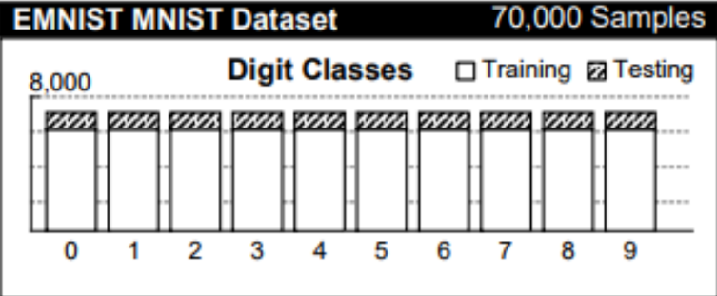

**Figure 4: EMNIST MNIST dataset**

The used and referred libraries are briefed for better understanding as;

* Pandas library, in development since 2008 is a software library which offers data structures and operations for data manipulation and statistical analysis [14]. Pandas can clean messy datasets, and make them readable and relevant. It uses data frame with integrated indexing.
* Numpy is a library in python which is used for working with multi-dimensional arrays and numerical computing. It conatins high level mathematical functions for working in domain of linear algebra and transforms.
* Python Image Processing Library(PIL) initially released in 1995 is a core library for image manipulation or processing in python programming language. It can perform many image processing tasks such as image inversion, binary conversion, pixel matrix extraction and image filtering [15].

A neural network is inspired by the way in which the brain works, where the activation unit

resembles the neurons which transmits the information over to the another one. Nowadays it is majorly used in applications for voice recognition, intelligent searching, handwriting recognition and pattern recognition. So basically it is right to say that every person has come across an application using neural network, maybe it is your fingerprint sensor or your camera of your phone.

**IV. Architecture Model**

Three layered Neural Network which contains an input layer, one hidden layer and an output layer is used. Mostly the number of hidden units per layer decreases towards the output layer as reported in [16]. In our input layer we used 785 activation units (1 biased and 784 features). In second layer of the model which is hidden layer have 25 activation units and in last layer i.e. output layer 10 activation units are considered. The proposed model is depicted in Figure 5.

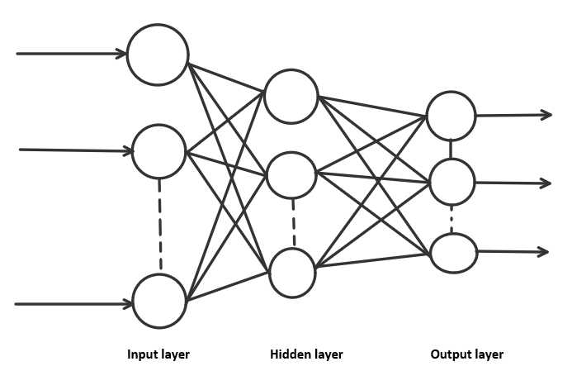

**Figure 5: Layers of Neural Network**

**V. Training of Proposed model**

Two 2D “numpy” arrays “theta1” and “theta2” are created. These arrays are the weights for our model. Then “theta1” and “theta2” are randomly initialized within a range of [-ε, +ε] , where ε is a constant having value 0.15 to break the symmetry.

Features and labels are extracted after loading the dataset with the help of “read_csv” function of pandas library. Features are scaled into a range of [0, 1] for computational ease. As without scaling these feature will grow exponentially over the layers which can cause overflow. These features are then fed into the Neural Network for learning appropriate weights and such process is generally referred as “forward propagation”.

Further, for reducing the errors over the layers and to minimize the cost function retracing of Neural Network in backward direction is explored. "Backpropagation" is the terminology given to this retracing algorithm. The architecture of backpropagation neural network is a hierarchical design which consists of fully interconnected layers [17]. Assuming a dataset with one training example (x, y)

**Forward propagation**:

1. a(1) = x
2. z(2) = Θ(1)a(1)
3. a(2) = g(z(2)) ( add a0(2) )
4. z(3) = Θ(2)a(2)
5. a(3) = g(z(3)) ( add a0(3) )
6. z(4) = Θ(3)a(3)
7. a(4) = g(z(4)) = hΘ (x)

where, a(2) , a(3) , a(4) are the activation of respective layers obtained with the help of sigmoid function (g(z(x)) where x=2,3,4,…….).

**Backward propagation:**

1. Error for last layer is computed as δ(*L*)=*a*(*L*)−*y*(*t*)
2. Errors for hidden layers δ(*L*−1), δ(*L*−2), …, δ(2) is obtained by using

δ(l)=((Θ(l))T δ(l+1)) .∗ g′(z(l))

Where, g′(z(l)) = a(l) .∗ (1− a(l))

1. For calculating error for a layer we use vectorisation as

Δ(l):=Δ(l)+δ(l+1)(a(l))T

1. Now we accumulate Δ’s with regularisation parameter for computing gradient.

For optimization,“scipy.optimize.minimize” is used to get appropriate weights in order to minimize the cost function.

**VI. Implementation of Segmentation technique**

Segmentation is the process of partitioning a digital image into multiple segments with an aim of changing the representation of the image to something more meaningful in order to make the analysis easy [18-19]. Majorly, the implementation of segmentation is in digital image processing and computer vision wherein the image is allowed to go through a number of preprocessing operations. Firstly, the image is converted from “RGB” to “Grayscale” in order to convert 3D pixel matrix to 2D pixel matrix, this will reduce the complexity associated with the calculation of larger number of values and the computation power required. Secondly, the word is scanned horizontally from left to right, row wise and the image is segmented on the basis of grids which provide an image of single characters written in a grid box.

It is important to mention here that as MNIST dataset contains pixel values of images of 28px × 28px. Therefore, there is a need of resizing the segmented images before feeding them to the Neural Network for recognition. Figure 6 represents the implementation of segmentation and the subsequent output achieved from it using our proposed implementation.

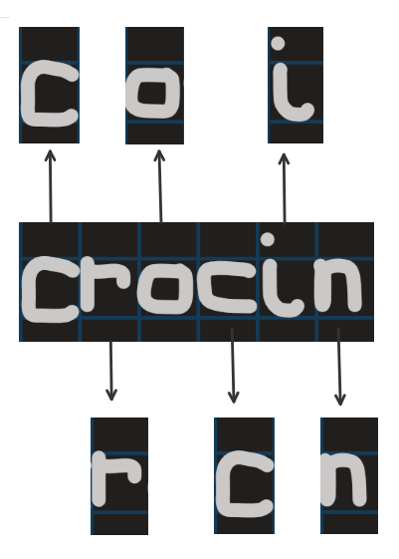

**Figure 6: Segmentation of image**

**VII. Conclusion**

Our proposed work has the capability to improve the previous methods of image recognition for handwritten medical prescriptions. However, major challenges in designing this kind of system are the unavailability of training data which resembles illegible handwriting, different and poor handwriting style of practitioner for which our future work will focus upon .

**References**

[1] F. Lauer, C.Y.Suen, and G.Bloch, “A trainable feature extractor for handwritten digit recognition”, Pattern Recognition, Elsevier, vol. 40, no. 6, pp. 1816-1824, 2007.

[2] Y.LeCun, L.Jackel, L.Bottou, A. Brunot, C. Cortes, J. Denker, H. Drucker, I. Guyon, U. Muller, E. Sackinger, P. Simard and V. Vapnik, “ Comparison of learning algorithms for handwritten digit recognition”, International Conference on Artificial Neural Networks, vol. 60, pp. 53-60, 1995, Holmdel, New Jersey, USA.

[3] J. Hull, “A database for handwritten text recognition research,” IEEE Transactions on Pattern Analysis and Machine Intelligence, vol. 16, no. 5, pp. 550–554, 1994.

[4] Y. LeCun, L. Bottou, Y. Bengio, and P. Haffner, “Gradient-based learning applied to document recognition,” Proceedings of the IEEE, vol. 86, no. 11, pp. 2278–2324, 1998.

[5] J. Yang, A.F. Frangi, J. Y. Yang, D. Zhang and Z. Jin, KPCA plus LDA: a complete kernel Fisher discriminant framework for feature extraction and recognition, “IEEE Transactions on pattern analysis and machine intelligence, vol. 27, no. 2, pp. 230-244, 2005.

[6] W. Zhang, L. Deng, L. Yang, P. Yang, D. Diao, P. Wang and Z. L. Wang, “Multilanguage-handwriting self-powered recognition based on triboelectric nanogenerator enabled machine learning,” Nano Energy, vol. 77, p. 105174, 2020.

[7] Oliveira, S. Luiz and R. Sabourin, “Support vector machines for handwritten numerical string recognition,” IEEE International Workshop on Frontiers in Handwriting Recognition, pp. 39-44, 2004.

[8] H. Brits, A. Botha, L. Niksch, R. Terblanché, K. Venter & amp; G. Joubert ”Illegible handwriting and other prescription errors on prescriptions at National District Hospital, Bloemfontein” South African Faily Practice Vol. 59, no. 1, 2017.

[9] Y.W. Teow, “A Minimal Convolutional Neural Network for Handwritten Digit Recognition”, 7th IEEE International Conference on System Engineering and Technology (ICSET 2017), pp. 171-176, 2 - 3 October 2017, Shah Alam, Malaysia.

[10] A. Choudhary, R. Rishi and S. Ahlawat, “A new approach to detect and extract characters from offline printed images and text,” Procedia Computer Science, vol. 17, pp. 434-440, 2013.

[11] D. Ciresan, U. Meier, and J. Schmidhuber, “Multi-column deep neural networks for image classification,” IEEE conference on Computer vision and Pattern recognition, pp. 3642-3649, June, 2012, New York, USA.

[12] G. Cohen, S. Afshar, J. Tapson and A. van Schaik, "EMNIST: Extending MNIST to handwritten letters," International Joint Conference on Neural Networks (IJCNN), March, 2017, pp. 2921-2926.

[13] A. Dawoud, "Iterative Cross Section Sequence Graph for Handwritten Character Segmentation," IEEE Transactions on Image Processing, vol. 16, no. 8, pp. 2150-2154, 2007.

[14] W. McKinney, “Pandas: a foundational Python library for data analysis and statistics,” Python for High Performance and Scientific Computing, vol. 14, no.9, pp.1-9, 2011.

[15] M. Harshada, Snehal, S. Shitole, M.Pranaya, K. Suchita, G. Shweta, D. Kurle, “Python based image processing,” January 2016, Conference: Avishkar 2015 At: Pune Affiliation: SNDT Women's University, Mumbai

[16] D. C. Cireşan, U. Meier, L. M. Gambardella, J. Schmidhuber; “Deep, Big, Simple Neural Nets for Handwritten Digit Recognition.” Neural Computation, vol. 22, no. 12, pp. 3207-3220, 2010.

[17] Hecht-Nielsen, "Theory of the backpropagation neural network," International Joint Conference on Neural Networks, vol. 1, pp. 593-605, 1992, Academic Press.

[18] G. L. Shapiro and G. C. Stockman, “Computer Vision”, pp 279–325, New Jersey, Prentice-Hall, ISBN 0-13-030796-3, 2001.

[19] B. Lauren, and L. W. Lee. "Perceptual information processing system." Paravue Inc. U.S. Patent Application 10/618,543, filed July 11, 2003.

Ms. Harshada Gujar

Ms. Pranaya Mhatre

Ms. Shweta Ghanate

Email Id: darshkurle@gmail.com

Ms. Snehal Chile

Ms. Suchita Kadam

Ms. Darshana Kurle

Dr. Sanjay Shitole

Ms. Harshada Gujar

Ms. Pranaya Mhatre

Ms. Shweta Ghanate

Email Id: darshkurle@gmail.com

Ms. Snehal Chile

Ms. Suchita Kadam

Ms. Darshana Kurle

Dr. Sanjay Shitole

Ms. Harshada Gujar

Ms. Pranaya Mhatre

Ms. Shweta Ghanate

Email Id: darshkurle@gmail.com

Ms. Snehal Chile

Ms. Suchita Kadam

Ms. Darshana Kurle

Dr. Sanjay Shitole

Ms. Harshada Gujar

Ms. Pranaya Mhatre

Ms. Shweta Ghanate

Email Id: darshkurle@gmail.com

Ms. Snehal Chile

Ms. Suchita Kadam

Ms. Darshana Kurle

Dr. Sanjay Shitole

Ms. Harshada Gujar

Ms. Pranaya Mhatre

Ms. Shweta Ghanate

Email Id: darshkurle@gmail.com

Ms. Snehal Chile

Ms. Suchita Kadam

Ms. Darshana Kurle

Dr. Sanjay Shitole

Ms. Harshada Gujar

Ms. Pranaya Mhatre

Ms. Shweta Ghanate

Email Id: darshkurle@gmail.com

Ms. Snehal Chile

Ms. Suchita Kadam

Ms. Darshana Kurle

Dr. Sanjay Shitole

Ms. Harshada Gujar

Ms. Pranaya Mhatre

Ms. Shweta Ghanate

Email Id: darshkurle@gmail.com

Ms. Snehal Chile

Ms. Suchita Kadam

Ms. Darshana Kurle

Dr. Sanjay Shitole

Ms. Harshada Gujar

Ms. Pranaya Mhatre

Ms. Shweta Ghanate

Email Id: darshkurle@gmail.com

Ms. Snehal Chile

Ms. Suchita Kadam

Ms. Darshana Kurle

Dr. Sanjay Shitole

Ms. Harshada Gujar

Ms. Pranaya Mhatre

Ms. Shweta Ghanate

Email Id: darshkurle@gmail.com

Ms. Snehal Chile

Ms. Suchita Kadam

Ms. Darshana Kurle

Dr. Sanjay Shitole

Ms. Harshada Gujar

Ms. Pranaya Mhatre

Ms. Shweta Ghanate

Email Id: darshkurle@gmail.com

Ms. Snehal Chile

Ms. Suchita Kadam

Ms. Darshana Kurle

Dr. Sanjay Shitole

Ms. Harshada Gujar

Ms. Pranaya Mhatre

Ms. Shweta Ghanate

Email Id: darshkurle@gmail.com

Ms. Snehal Chile

Ms. Suchita Kadam

Ms. Darshana Kurle

Dr. Sanjay Shitole

Ms. Harshada Gujar

Ms. Pranaya Mhatre

Ms. Shweta Ghanate

Email Id: darshkurle@gmail.com

Ms. Snehal Chile

Ms. Suchita Kadam

Ms. Darshana Kurle

Dr. Sanjay Shitole

Ms. Harshada Gujar

Ms. Pranaya Mhatre

Ms. Shweta Ghanate

Email Id: darshkurle@gmail.com

Ms. Snehal Chile

Ms. Suchita Kadam

Ms. Darshana Kurle

Dr. Sanjay Shitole

Ms. Harshada Gujar

Ms. Pranaya Mhatre

Ms. Shweta Ghanate

Email Id: darshkurle@gmail.com

Ms. Snehal Chile

Ms. Suchita Kadam

Ms. Darshana Kurle

Dr. Sanjay Shitole

Ms. Harshada Gujar

Ms. Pranaya Mhatre

Ms. Shweta Ghanate

Email Id: darshkurle@gmail.com

Ms. Snehal Chile

Ms. Suchita Kadam

Ms. Darshana Kurle

Dr. Sanjay Shitole

Ms. Harshada Gujar

Ms. Pranaya Mhatre

Ms. Shweta Ghanate

Email Id: darshkurle@gmail.com

Ms. Snehal Chile

Ms. Suchita Kadam

Ms. Darshana Kurle

Dr. Sanjay Shitole

Ms. Harshada Gujar

Ms. Pranaya Mhatre

Ms. Shweta Ghanate

Email Id: darshkurle@gmail.com

Ms. Snehal Chile

Ms. Suchita Kadam

Ms. Darshana Kurle

Dr. Sanjay Shitole

Ms. Harshada Gujar

Ms. Pranaya Mhatre

Ms. Shweta Ghanate

Email Id: darshkurle@gmail.com

Ms. Snehal Chile

Ms. Suchita Kadam

Ms. Darshana Kurle

Dr. Sanjay Shitole

Ms. Harshada Gujar

Ms. Pranaya Mhatre

Ms. Shweta Ghanate

Email Id: darshkurle@gmail.com

Ms. Snehal Chile

Ms. Suchita Kadam

Ms. Darshana Kurle

Dr. Sanjay Shitole

Ms. Harshada Gujar

Ms. Pranaya Mhatre

Ms. Shweta Ghanate

Email Id: darshkurle@gmail.com

Ms. Snehal Chile

Ms. Suchita Kadam

Ms. Darshana Kurle

Dr. Sanjay Shitole

Ms. Harshada Gujar

Ms. Pranaya Mhatre

Ms. Shweta Ghanate

Email Id: darshkurle@gmail.com

Ms. Snehal Chile

Ms. Suchita Kadam

Ms. Darshana Kurle

Dr. Sanjay Shitole

Ms. Harshada Gujar

Ms. Pranaya Mhatre

Ms. Shweta Ghanate

Email Id: darshkurle@gmail.com

Ms. Snehal Chile

Ms. Suchita Kadam

Ms. Darshana Kurle

Dr. Sanjay Shitole

Ms. Harshada Gujar

Ms. Pranaya Mhatre

Ms. Shweta Ghanate

Email Id: darshkurle@gmail.com

Ms. Snehal Chile

Ms. Suchita Kadam

Ms. Darshana Kurle

Dr. Sanjay Shitole

Ms. Harshada Gujar

Ms. Pranaya Mhatre

Ms. Shweta Ghanate

Email Id: darshkurle@gmail.com

Ms. Snehal Chile

Ms. Suchita Kadam

Ms. Darshana Kurle

Dr. Sanjay Shitole

Ms. Harshada Gujar

Ms. Pranaya Mhatre

Ms. Shweta Ghanate

Email Id: darshkurle@gmail.com

Ms. Snehal Chile

Ms. Suchita Kadam

Ms. Darshana Kurle

Dr. Sanjay Shitole

Ms. Harshada Gujar

Ms. Pranaya Mhatre

Ms. Shweta Ghanate

Email Id: darshkurle@gmail.com

Ms. Snehal Chile

Ms. Suchita Kadam

Ms. Darshana Kurle

Dr. Sanjay Shitole

Ms. Harshada Gujar

Ms. Pranaya Mhatre

Ms. Shweta Ghanate

Email Id: darshkurle@gmail.com

Ms. Snehal Chile

Ms. Suchita Kadam

Ms. Darshana Kurle

Dr. Sanjay Shitole

Ms. Harshada Gujar

Ms. Pranaya Mhatre

Ms. Shweta Ghanate

Email Id: darshkurle@gmail.com

Ms. Snehal Chile

Ms. Suchita Kadam

Ms. Darshana Kurle

Dr. Sanjay Shitole

Ms. Harshada Gujar

Ms. Pranaya Mhatre

Ms. Shweta Ghanate

Email Id: darshkurle@gmail.com

Ms. Snehal Chile

Ms. Suchita Kadam

Ms. Darshana Kurle

Dr. Sanjay Shitole

Ms. Harshada Gujar

Ms. Pranaya Mhatre

Ms. Shweta Ghanate

Email Id: darshkurle@gmail.com

Ms. Snehal Chile

Ms. Suchita Kadam

Ms. Darshana Kurle

Dr. Sanjay Shitol