Title: “Machine Learning-Based Detection for Cyber Attacks in Internet of Medical Things Devices”
Introduction:
The paper utilizes the CIC-IoMT 2024 dataset to perform two types of classifications: detection of DoS attacks in Bluetooth-enabled devices and detection of ARP spoofing attacks in WiFi and MQTT networks. Since both classification workflows follow the same structure, the improvement work in this study focuses specifically on enhancing the detection of DoS attacks.

Work Flow:
Paper’s Work: | Improvement work:
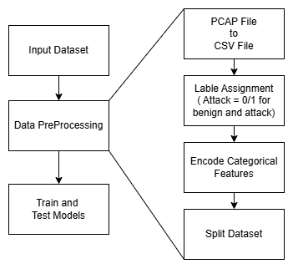 | 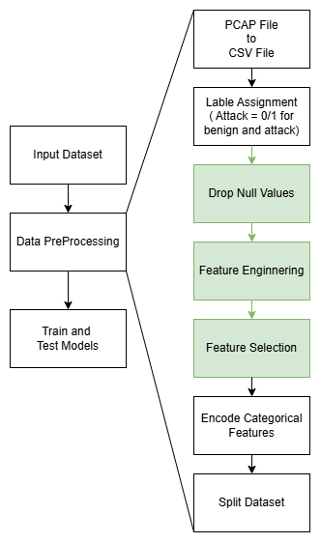

Description of the Improvement work:
Approximately, all other aspects of the experiment were kept the same. The improvement was made in the data preprocessing step, where two features containing null values were dropped. In the feature engineering phase, four new features were added since only a few features remained. The newly introduced features are:
i) IAT – Represents the Inter-Arrival Time between consecutive packets.
ii) IAT_mean – The average Inter-Arrival Time over a sequence of packets.
iii) len_mean_10 – The mean packet length calculated over the last 10 packets.
iv) len_std_10 – The standard deviation of packet lengths over the last 10 packets.
Afterward, the total set of features was evaluated, and the top five were selected based on their ranking in feature selection methods such as Fisher Score, Mutual Information Classifier, and Random Forest Classifier. The remaining parts of the workflow were kept consistent with the original paper.
Results:
Table1. comparison Table
Paper’s Work |  |  |  |  |  | Improvement
 | Accuracy | Precision | Recall | F1-Score | Accuracy |  | Precision | Recall | F1-Score
DT | 0.87 | 0.90 | 0.87 | 0.87 | 0.8474 |  | 0.8392 | 0.9992 | 0.9123
RF1(depth=8, split=10) | 0.84 | 0.86 | 0.84 | 0.79 | 0.9985 |  | 0.9999 | 0.9982 | 0.9990
RF2 (depth=10, split=5) | 0.83 | 0.86 | 0.83 | 0.78 | 0.9847 |  | 0.9826 | 0.9984 | 0.9904
GB | 0.82 | 0.84 | 0.82 | 0.76 | 0.9934 |  | 0.9934 | 0.9983 | 0.9958
XGB | 0.21 | 0.04 | 0.21 | 0.07 | 0.8598 |  | 0.8508 | 0.9985 | 0.9187
RNN | 0.21 | 0.04 | 0.21 | 0.07 | 0.9749 |  | 0.9708 | 0.9984 | 0.9844
Table2. Isolation Forest (contamination)

 | Paper’s Work (Silhouette Score) | Improvement (Silhouette Score)
Contamination = 0.1 | 0.01 | 0.2234
Contamination = 0.3 | 0.07 | 0.2918

(DT = Decision Tree, RF = Random Forest, GB = Gradient Boosting XGB = XGBoost, RNN = Recurrent Neural Network)

Discussion and Conclusion:

By applying optimized data preprocessing techniques, the improvement achieved higher accuracy and reliability across all classifiers. Among the evaluated models, the Random Forest (depth = 8, split = 10) delivered the best results, achieving 99.85% accuracy and an F1-score of 99.90%, outperforming the baseline by more than 15%. This reflects excellent generalization with minimal false detections. The RNN and XGBoost models also showed major improvements, indicating that both sequence-based and ensemble-based methods effectively capture attack behavior patterns. Additionally, the Isolation Forest model achieved a Silhouette Score improvement from 0.01 to 0.29, confirming better separation between normal and anomalous instances in the unsupervised context. Overall, the preprocessing approach significantly enhances intrusion detection performance. The Random Forest model stands out as the most robust and balanced, making it highly suitable for real-time security applications.

