**Appliances Bundle**

**with** ISLAND HOOD 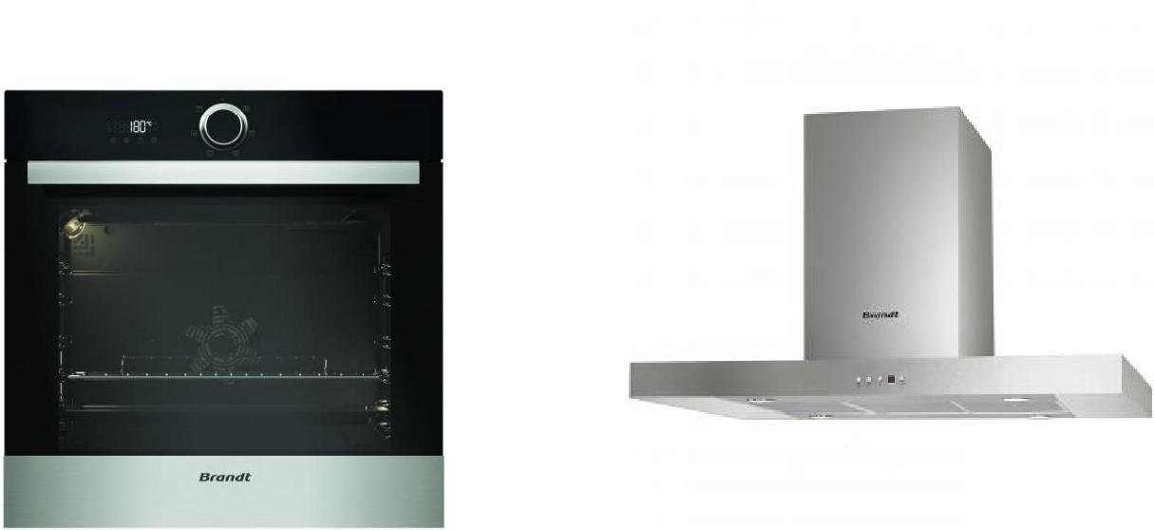

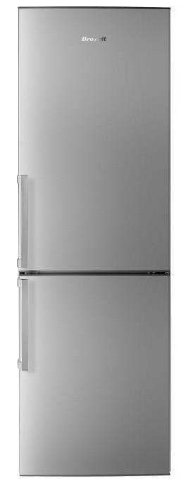

BFC582LNX – Standalone Refrigerator

* Combination refrigerator / freezer (cabinet) free-standing
* Cooling Circulation: **No** **Frost** ( ventilated air)
* Technologies: MultiFlow - No Frost
* Total net capacity: 326 L (Refrigerator: 233 L / Freezer: 93 L)

BXE 5532X – Built – In Oven

* Multifunctional built-in oven (grill, natural convection, rotating heat)
* Cooking modes: Rotating heat • Eco • Strong grill • Ventilated grill • Keep warm • Sole ventilated • Traditional
* Cleaning Method: **Manual**
* Cavity: **73 L**

AD1118X – Island Hood

* Aesthetic Decorative Glass
* Standard charcoal filters
* Halogen lighting



TG 1483B – Gas Hob Black

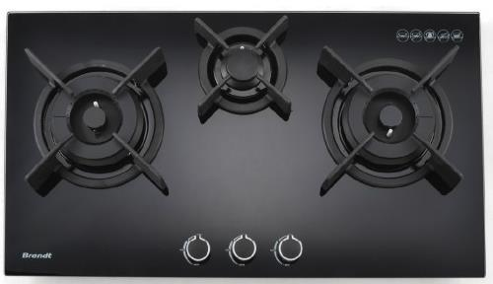

* Frontal Knobs Control
* H60 x W710 x D410mm
* Flame Rating Left : 4.5KW - Right : 4.5KW - Centre : 2.0KW
* 3 Burner

BKS6135X– Built – In Microwave

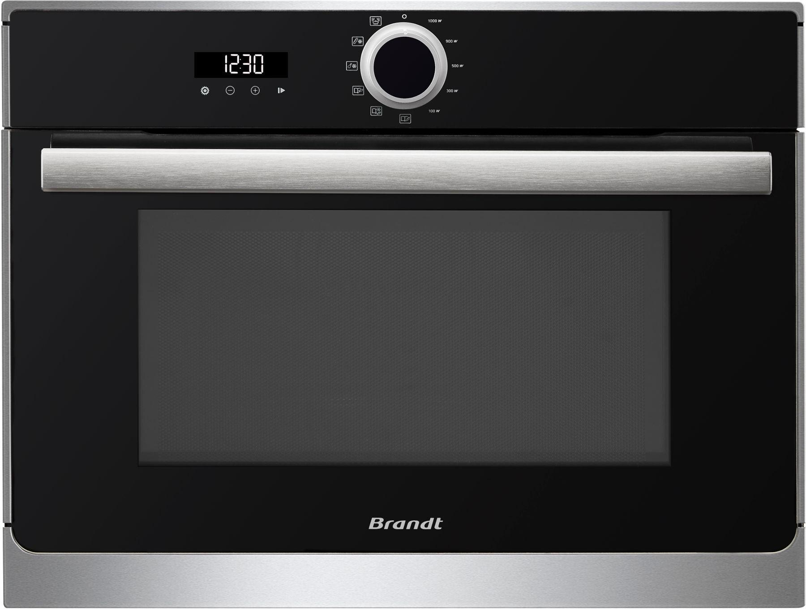

* Cavity 26L, microwave power 900W,
* Turntable 32 cm disengage able,
* 8 automatic programs according to the weight of the food



SPECIAL DEAL

BUNDLE PRICE

Rs. 806,500/-

Rs. 544,500/-

(without Refrigerator)

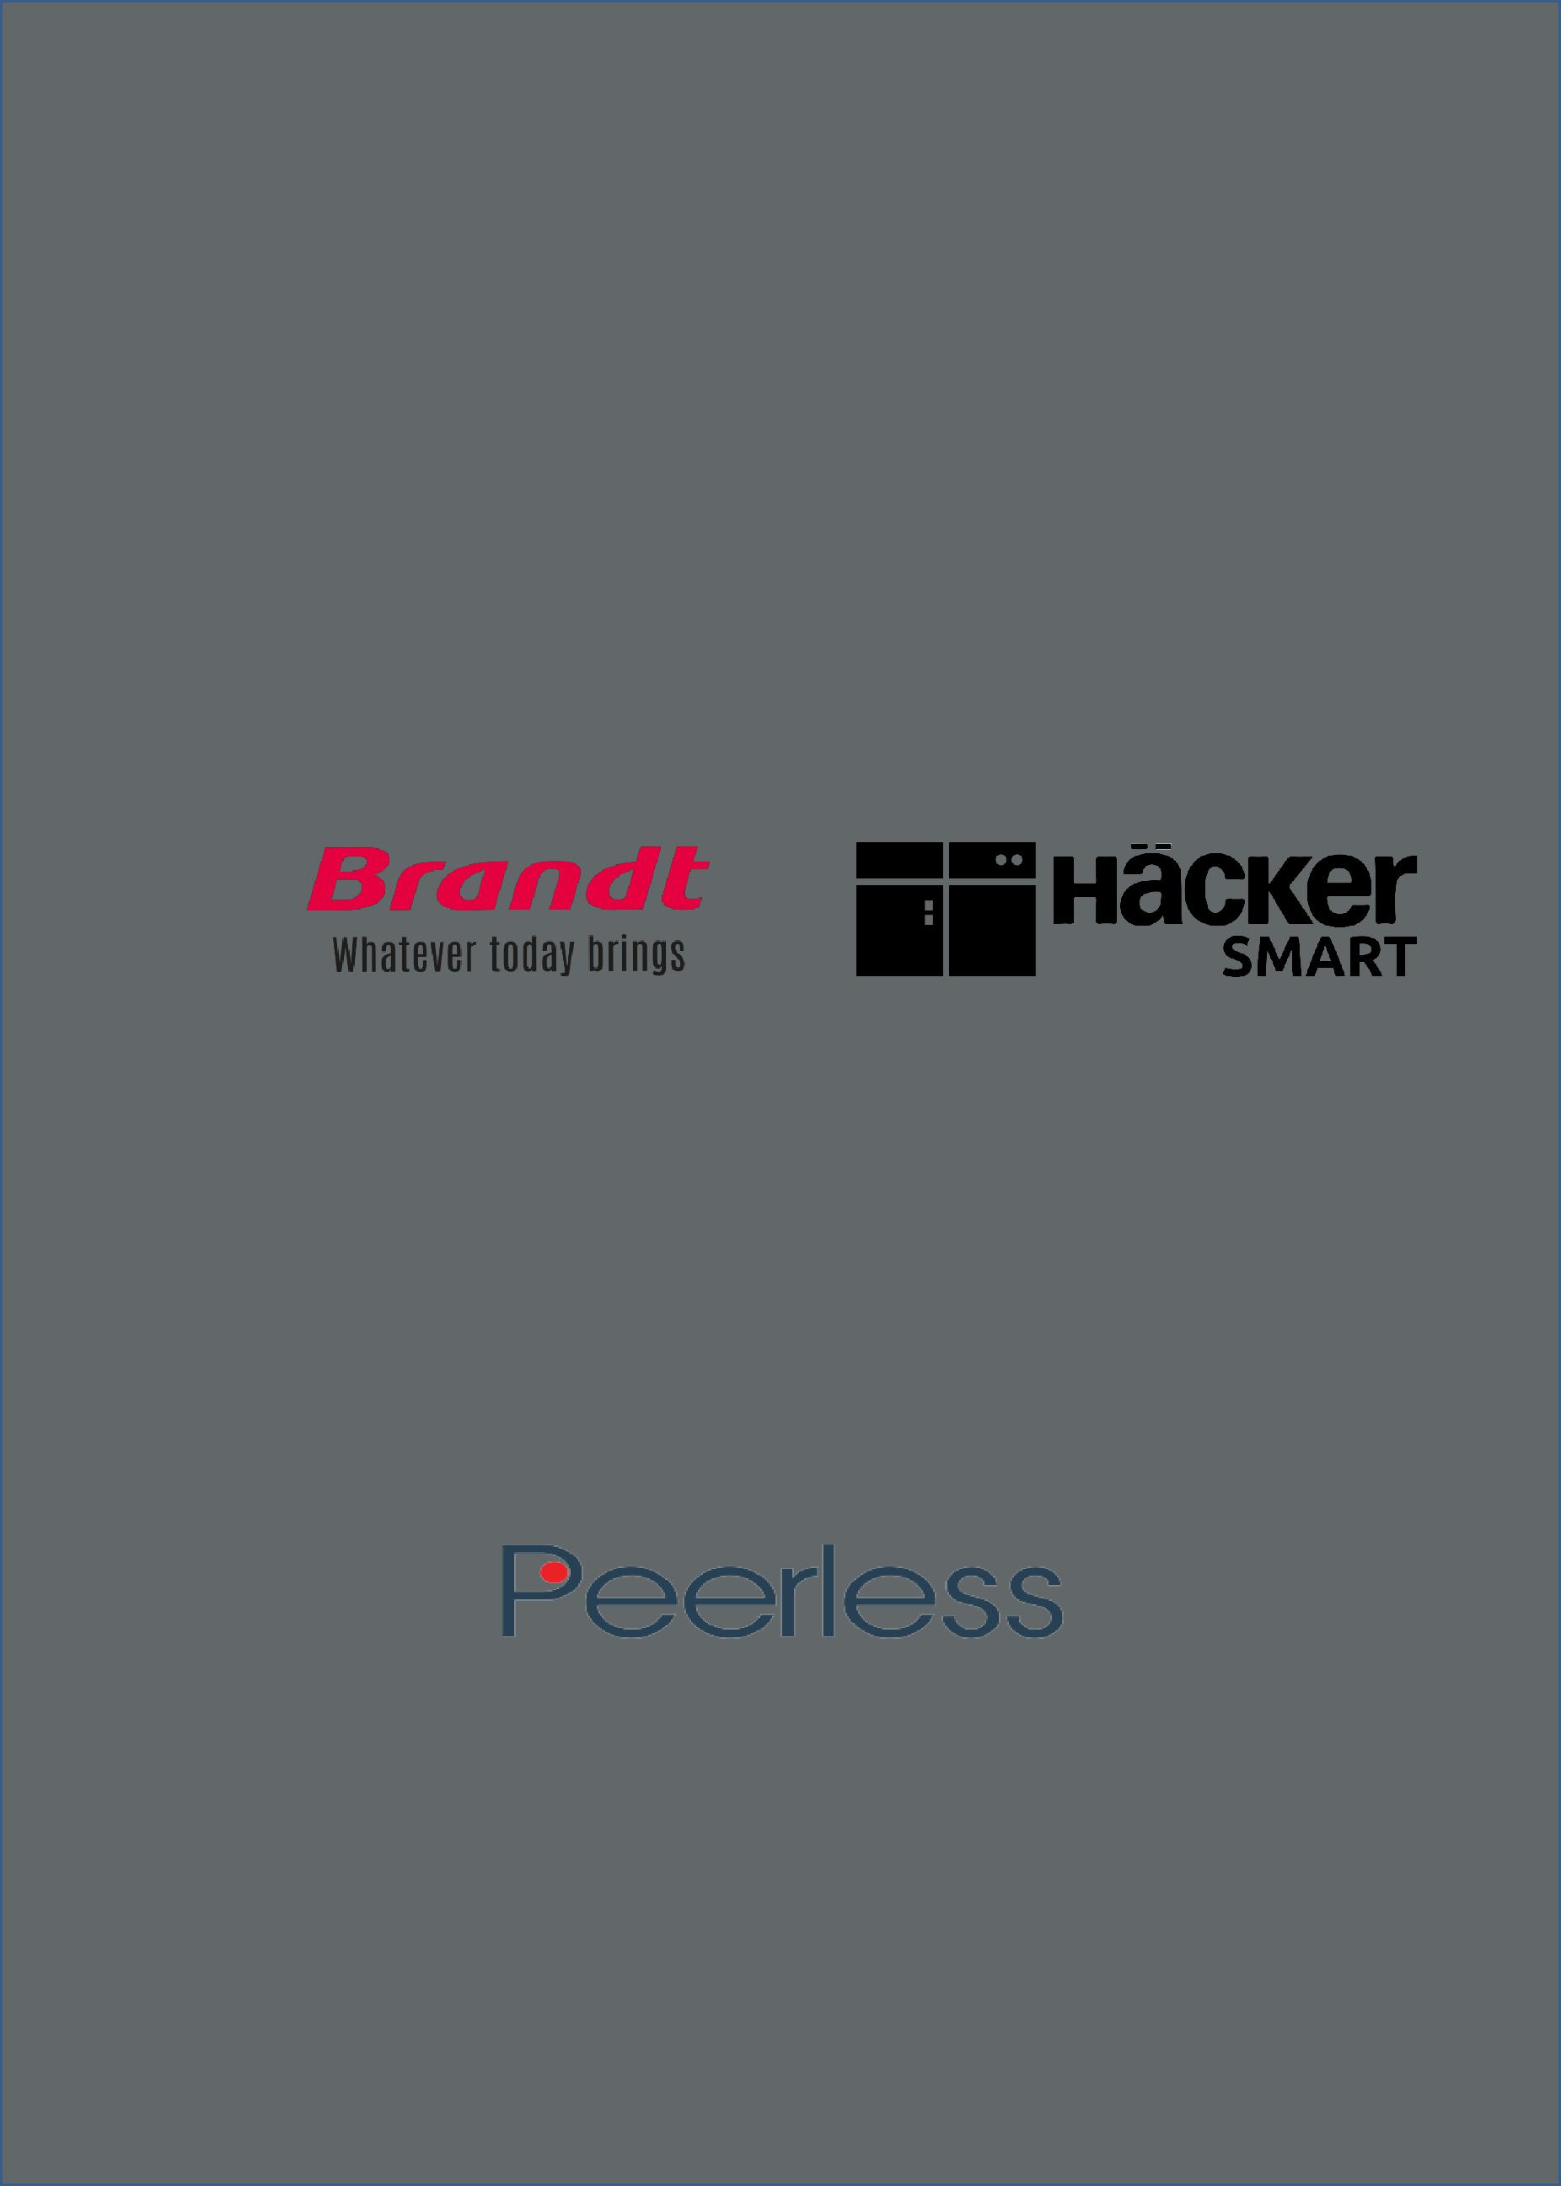

PEERLESS (PVT) LTD

Level 6, East Tower, World Trade Center,

Colombo - 01, Sri Lanka.

Hotline: +94 114 335 339 Fax: +94 112 338 235

mail: sales@peerlessventure.com Web: www.peerlessventure.com