**STYLE**

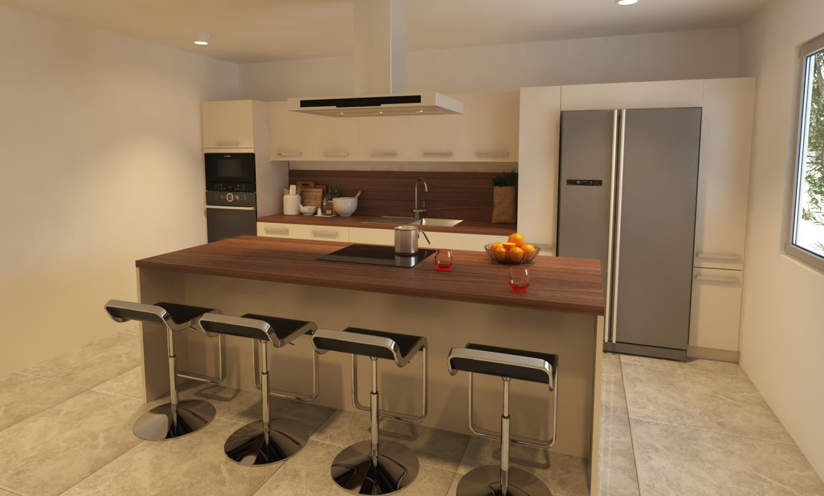

|  |  |  |
| --- | --- | --- |
| Kitchen Type : Block Kitchen with Island | Rs. 1.909 million |  |
| (Standard HPL) |  |
| *Reference image only. Final product may vary |  |
|  |  |
| FRONT FINISHES |  |  |

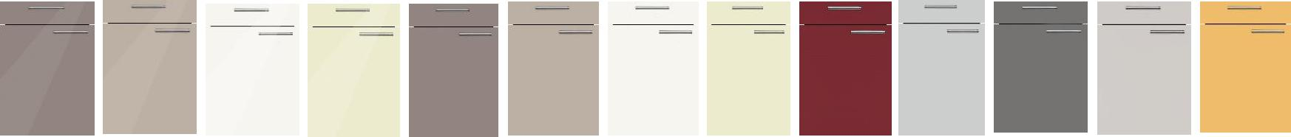

|  |  |  |  |  |  |  |  |  |  |  |  |  |
| --- | --- | --- | --- | --- | --- | --- | --- | --- | --- | --- | --- | --- |
| Basalt Grey | Cashmere | White | Magnolia | Basalt Grey | Cashmere | White | Magnolia | Orient Red | Light Grey | Pearl Grey | Taupe | Golden Yellow |
| NEO | NEO | NEO | NEO | UNO | UNO | UNO | UNO | UNO | UNO | UNO | UNO | UNO |
|  |  |  |  |  |  |  |  |  |  | 1 |  |  |

WORKTOP FINISHES

**HPL**



|  |  |  |  |  |  |  |  |  |  |  |  |  |
| --- | --- | --- | --- | --- | --- | --- | --- | --- | --- | --- | --- | --- |
| Core Oak | Dark Concrete | Dark Vesuv | Light Vesuv | Light Accacia | | Mountain | Black Marble | Natural Oak | Metallo | Silk Grey Oak | |  |
| Spruce Effect |  |
| HANDLES |  |  |  | Effect | |  | Rough Cut |  | Effect | |  |
|  |  |  |  |  |  |  |  |  |  |  |  |
|  |  |  |  |  |  |  | | |  |  |  |  |
| Code: 348 | Code: 430 | Code: 495 |  |  |  | WORKTOP FINISHES - QUARTZ | | |  |  |  |  |
|  |  |  |  |  |  |  |  |  |  |
| Height: 27 mm | Height: 30 mm | Height: 25 mm |  |  |  |  |  |  |  |  |  |  |
| RECOMMENDED SINK SIZE | | |  |  |  |  |  |  |  |  |  |  |
|  |  |  |  |  |  | QJ 102 | QJ 103 | QJ 104 |  |  |  |  |
|  |  |  |  |  |  | Rs. 000,000/- | |  |  |
|  |  |  |  |  |  |  |  |  |
|  |  |  |  |  |  |  |  |  |  |  |
|  |  |  |  |  |  |  |  |  | (By arrangement at | |  |  |
|  |  |  |  |  |  | QJ 113 | QJ 108 |  | additional charge) | |  |  |
|  |  |  |  |  |  |  |  |  |  |  |  |  |
|  |  |  |  |  |  |  |  |  |  |  |  |  |
|  |  |  |  |  |  |  |  |  |  |  |  |  |

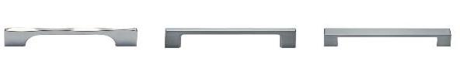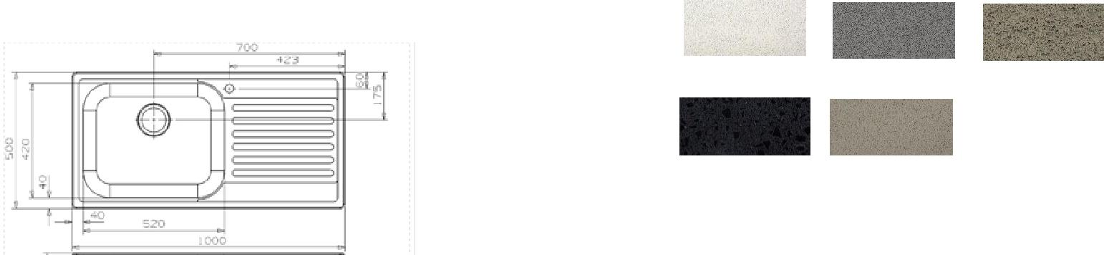

|  |  |  |  |  |  |  |  |  |  |  |  |
| --- | --- | --- | --- | --- | --- | --- | --- | --- | --- | --- | --- |
| **Style Space Requirement** | | | |  |  |  |  |  |  |  |  |
| PLAN |  |  | 4700 |  |  |  |  |  |  |  |  |
| 625 | 1000 | 1000 | 500 |  |  | 1575 |  |  |  |  |
| 25 | 600 | 1000 | 1000 | 500 | 300 | 25 | 900 | 25 | 300 | 25 |  |
| 1200 |  |  | A |  |  |  |  |  |  | 1100 |  |
|  |  |  |  |  |  |  |  |  |  |  |
|  |  |  | B 2550 |  |  |  |  |  |  |  |  |
| 1500 |  | 931 |  |  |  |  |  |  |  | 2000 |  |

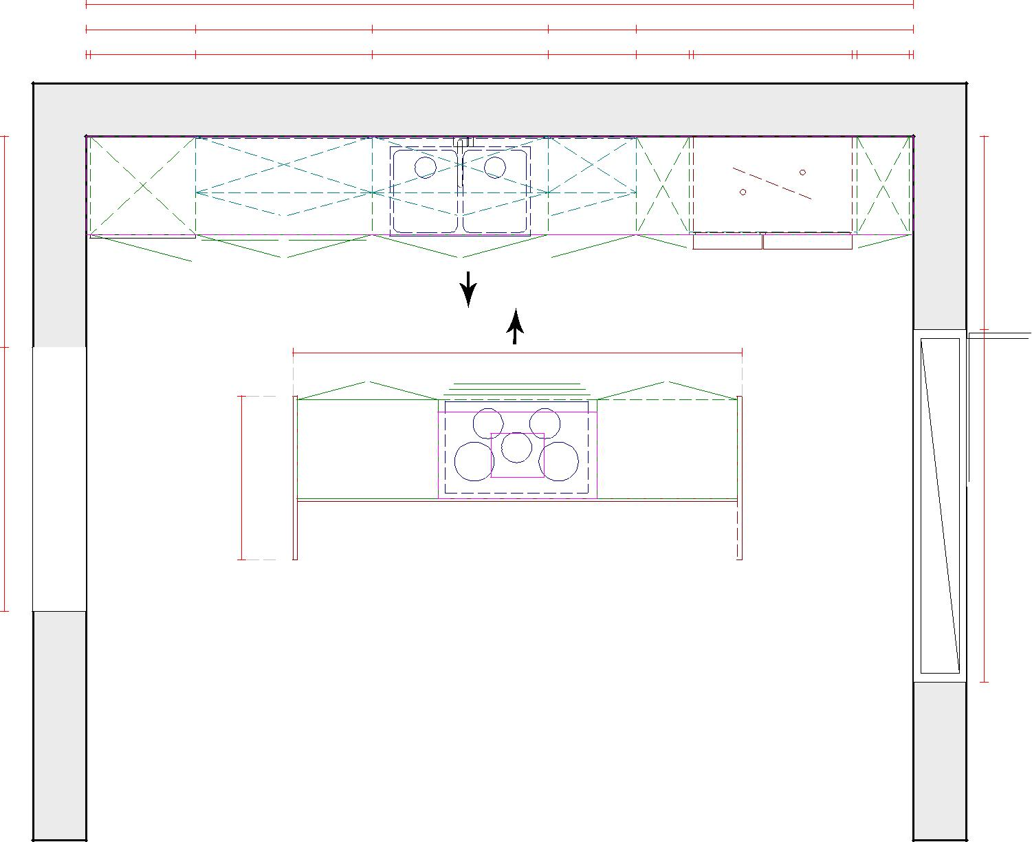

ELEVATION A ELEVATION B

