**Library Management System**

**Report- 1**

**Introduction:** A **Library Management System** is a software built to handle the primary housekeeping functions of a **library**. Libraries rely on **library management systems** to manage asset collections as well as relationships with their members **.**

**Motivation:**

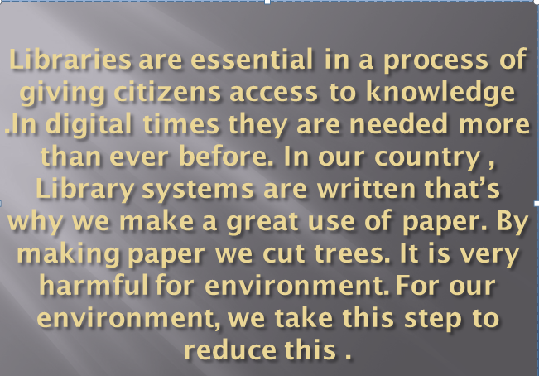

Feasibilities:

|  |
| --- |
| **Technical** |
| Economical |
| Operational |

**Feasibility:** We can strongly says that it is technically feasible since there will not be much difficulty in getting required resources for the development and maintaining the system as well. All the resources needed for the development of the system as well as the maintenance of the same is available in the organization here are utilization.

**Project Scheduling:**

1. Planning

2. Construction

3. Deployment

**Basic Gantt Chart:**

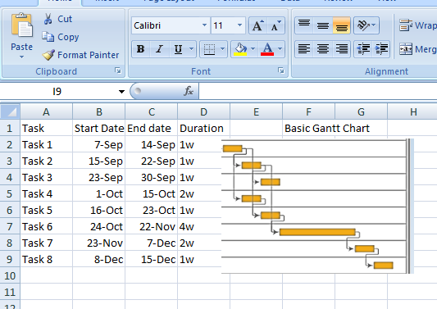

**Risk Analysis:**

Backup for Database

Secured Database & Registration Form

Timing Commitment

Hardware Backup