Uber Ride Analytics | Power BI Dashboard
By: Rishan Batra | · | Tool: Power BI Desktop · Data: Uber ride-booking dataset (150K rows)  Power BI DAX Power Query
Project Overview
Ride-hailing operations generate three kinds of pain for the teams that run them: bookings that never convert into revenue, fleets that perform unevenly across vehicle types, and demand that clusters unpredictably by time and location. Raw trip logs don’t answer which vehicle type is underperforming, where money is lost to cancellations, or when to surge drivers - someone has to model and visualize the data first.
This project turns a raw 150,000-row Uber ride log into a decision-ready Power BI report: sourcing messy transactional data, modeling it in Power Query, writing DAX measures for the metrics that matter, and designing an interactive, five-page report rather than a single static chart-dump.
Business questions the dashboard answers: How many bookings convert to completed rides vs. get lost to cancellations or nodriver-found? Which vehicle type drives the most revenue, and which is weakest? Where is demand concentrated by zone and hour? Who are the highest-value customers? Why are customers cancelling, and can it be reduced operationally?

Uber Problems and Business Requirements
The report was scoped page-by-page against a fixed set of business requirements, each mapped to a specific DAX filter or function.
- Overview Page - KPIs. Completed Bookings (dax filter = "Completed"); Lost Bookings (dax filter <> "Completed");
Revenue (sum of booking value); Total Distance (sum of distance); Avg. Distance (average DAX function). Vehicle filter applied across all downstream pages. Also: Bookings Completed per month/quarter (calendar function); Revenue per month/quarter; Revenue by Vehicle Type; Top Drop & Pickup Location by booking count (Top-N filter, N=1); Avg. customer’s and driver’s rating (average DAX function).
- VehiclePage-detailbyvehicle. Vehicle images; distinct Customers (distinct count); Revenue; Completed Bookings; Contribution % (divide, with filters removed via ALL); Total Distance per month as a sparkline.
- Revenue Page. Revenue per day (date function); Revenue by payment method; Top 5 Drop Locations by revenue (Top-N, N=5); Top 5 Customers by revenue (distinct count of customers).
- Bookings Page. Ride distance per month/quarter; Reason for cancellation by customers; Bookings by pickup location; Bookings per week by time slot (DAX switch/return function) with an added Target Bookings KPI gauge.

Key Insights & KPIs
Metric | Value
Total Bookings | 150,000
Completed Bookings | 93,000 (62%)
Lost Bookings (cancelled / no driver / incomplete) | 57,000 (38%)
Total Revenue | ₹47.26M – 51.85M∗
Total Distance Travelled | 2.51M km
Avg. Distance per Ride | 24.6 km
Avg. Customer Rating | 4.40 / 5
Avg. Driver Rating | 4.23 / 5
∗Revenue is reported at two scopes: ₹47.26M reflects completed-ride booking value only; ₹51.85M on the KPI strip includes incomplete trips with a partial fare captured. Both are intentional — an ”operations” view vs. a ”gross” view.
What the data shows:
- Auto and Bike lead the fleet mix — together 47% of completed bookings and revenue, while Uber XL is the long tail at just 3% of contribution despite the highest per-ride value.
- UPI dominates payments at 45% of revenue, more than 3× Cash — a signal for where to invest in payment-partner reliability.
- 6 PM–9 PM is the busiest slot every day of the week ( 33K bookings), the clearest signal for driver-supply incentives.
- Khandsa and Ashram are the top pickup/drop nodes, with a fairly even spread across the next five zones — demand is distributed, not concentrated.
- ”Wrong Address” and ”Change of Plans” are the top two customer-cancellation reasons, both addressable via UX rather than driver-side fixes.
- Revenue per day is volatile but range-stable (₹0.1M–0.3M), with no strong seasonal trend — growth looks volume-driven, not seasonal.
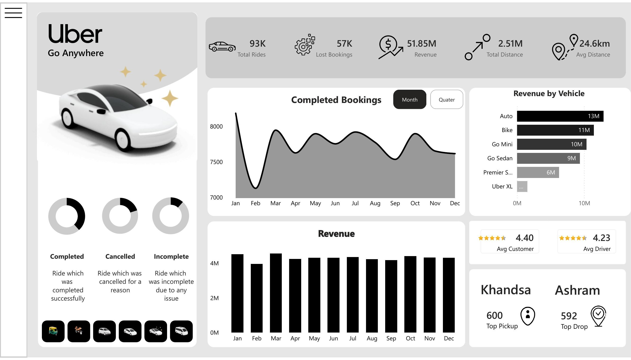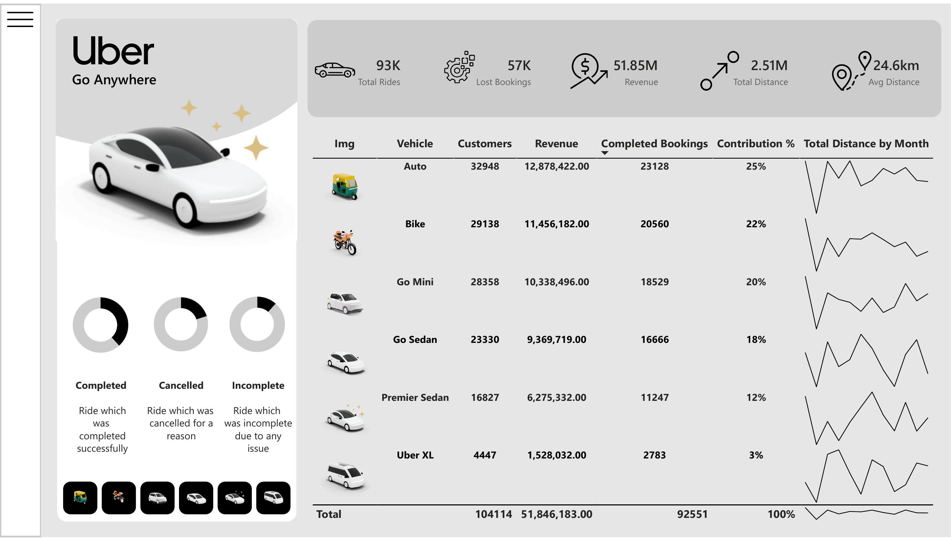
Dashboard Visualizations
1
· Overview
— top-line KPIs, trends, vehicle revenue, ratings, ride-outcome
rings.
2
· Vehicle
— per-vehicle customers, revenue, contribution %, distance
sparkline.
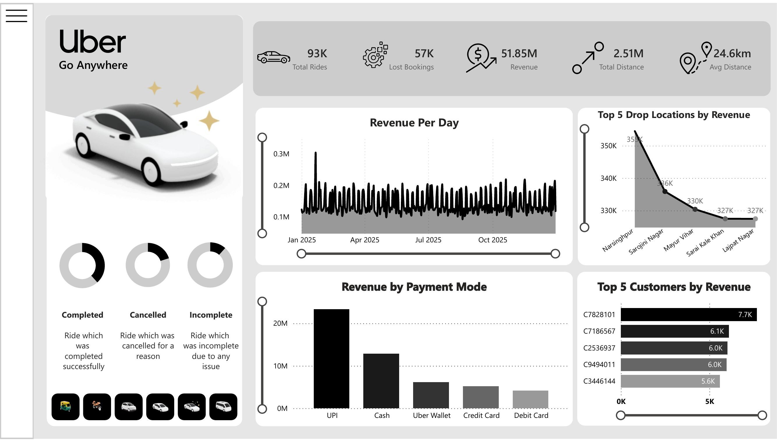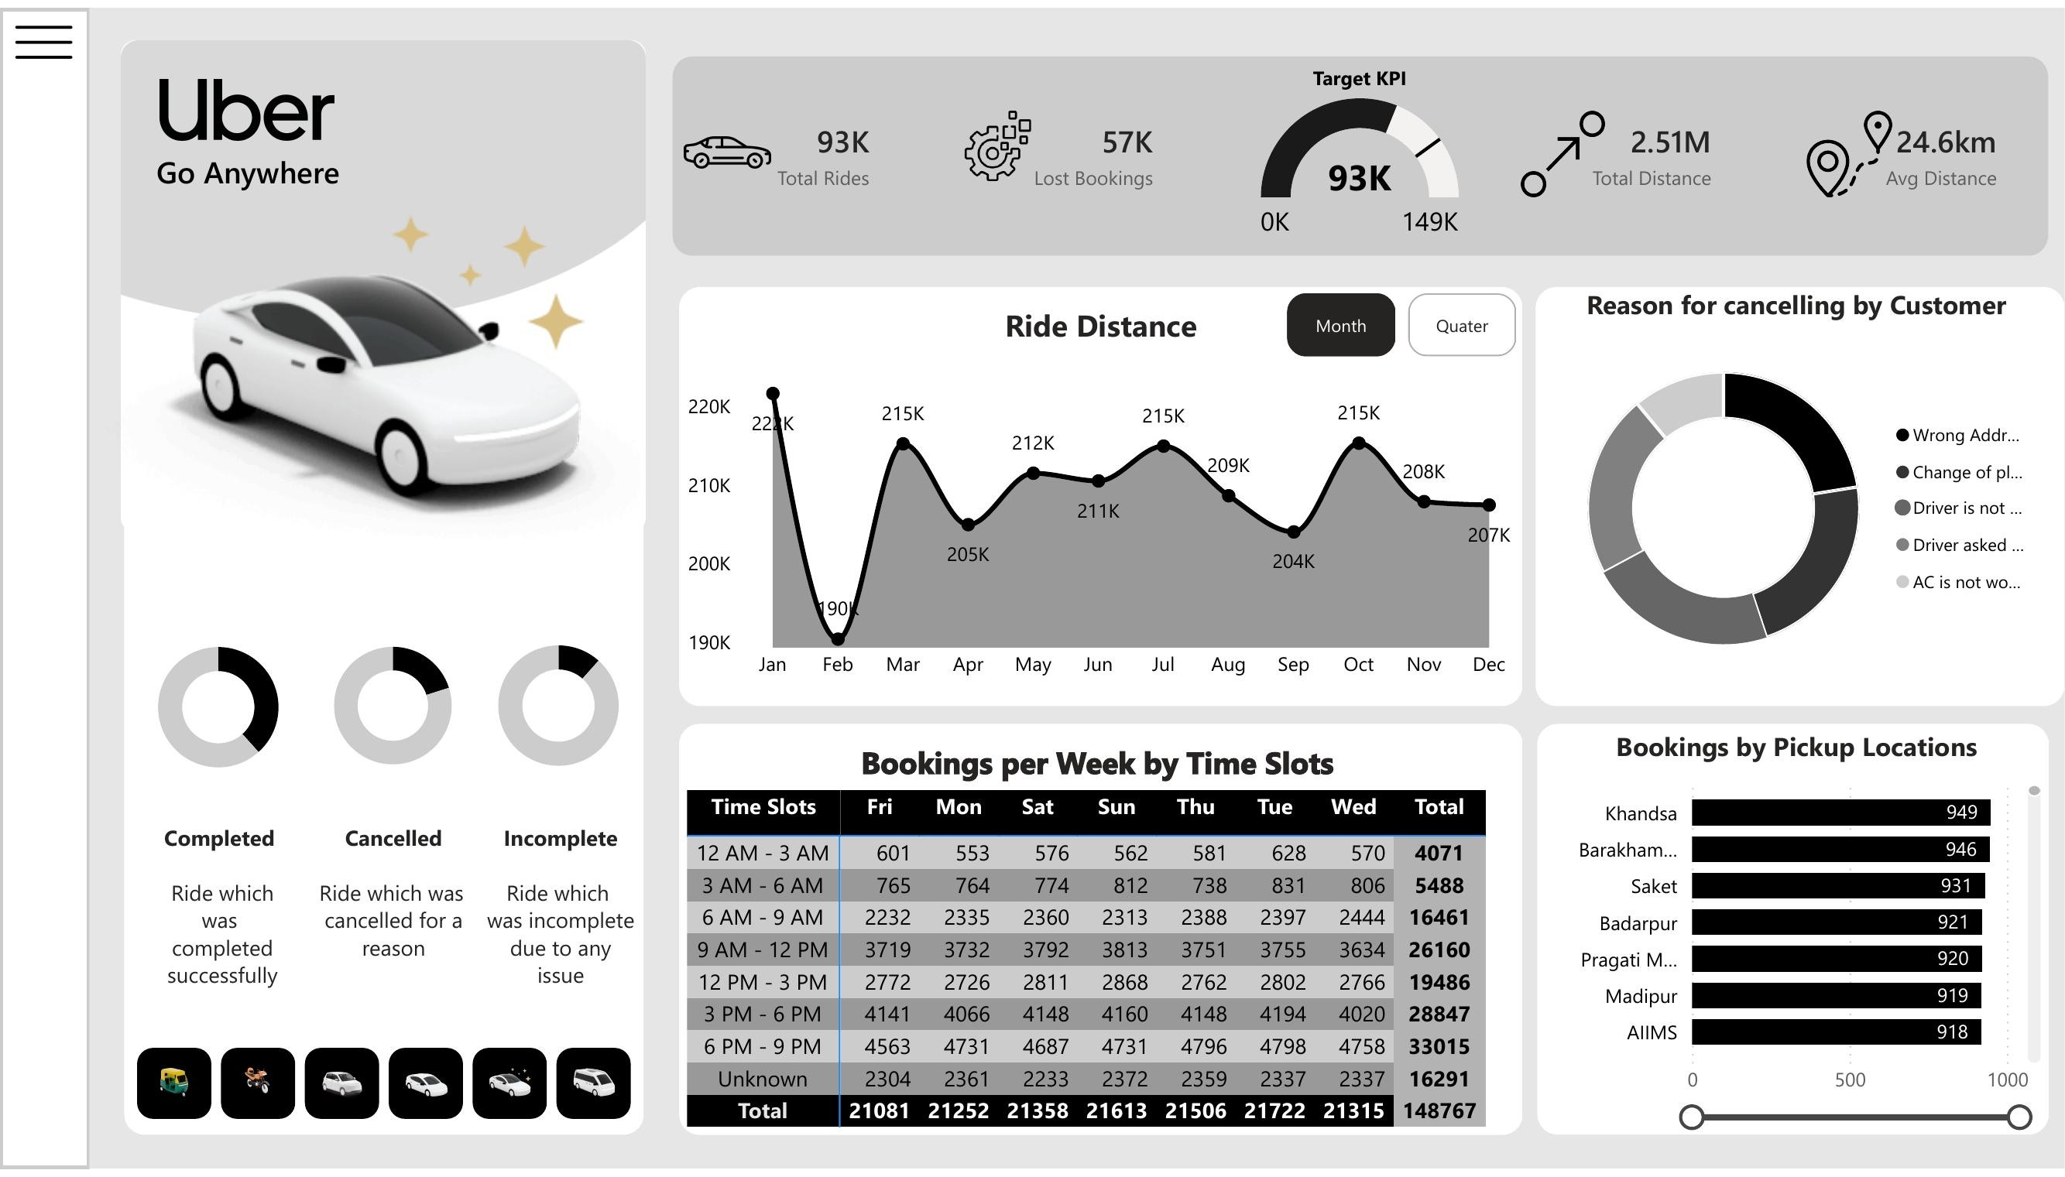
3 · Revenue — daily revenue, payment mode, top drop locations & 4 · Bookings — ride distance, cancellation reasons, pickup locations, time-slot customers. matrix, Target KPI gauge.

Tech Stack
- Power BI Desktop — report authoring, data modeling, page navigation
- Power Query (M) — data cleaning, column typing, calendar table generation, unpivoting time-slot data
- DAX — all KPIs, ratios, and time-intelligence measures
- Datasource — Uber ride-booking transactional log ( 150,000 rows: booking status, vehicle type, fare, distance, ratings, payment method, pickup/drop location, timestamps) Core DAX measures used across the report:
 | )
  Completed Bookings =
  CALCULATE(
  COUNTROWS(Bookings),
  Bookings[Booking Status]="Completed" )
Revenue =
SUM(Bookings[Booking Value])

  Lost Bookings =
  CALCULATE(
  COUNTROWS(Bookings),
  Bookings[Booking Status]<>"Completed"
  Total Distance =
  SUM(Bookings[Ride Distance])
  Avg Distance =
  AVERAGE(Bookings[Ride Distance])
  [Revenue],
  CALCULATE([Revenue],
  ALL(Bookings[Vehicle Type])) )
  Distinct Customers =
  DISTINCTCOUNT(Bookings[Customer ID])
  Target Bookings KPI =
  VAR Target = 149000
  RETURN DIVIDE(
  [Completed Bookings], Target)
Contribution % = DIVIDE(

How to Interact
- Page navigation - the pill-style nav bar (Home · Overview · Vehicle · Revenue · Bookings) on the landing page and the left sidebar icons on every report page switch between the five views.
- Vehicle filter - present on the Overview and Vehicle pages; slices every KPI, chart, and table by a single vehicle type (Auto, Bike, Go Mini, Go Sedan, Premier Sedan, Uber XL) or shows them unfiltered.
- Month / Quarter toggle - on the Overview (Completed Bookings) and Bookings (Ride Distance) pages, switches time granularity of the trend line without changing the visual.
- Date-range slider - on the Revenue page, drag either handle under ”Revenue per Day” to scope the daily revenue trend and the two Top-5 tables to a custom window.
- Drill-down tables - the Vehicle page table and the Bookings-per-Week-by-Time-Slot matrix support Power BI’s native drilldown/expand to inspect individual cells.
- Cross-filtering - clicking any bar, donut segment, or table row (e.g., a vehicle type, a payment method, a cancellation reason) cross-filters every other visual on that page, standard Power BI report interaction behavior.

