DAY 5
The Event Loop
How Node.js handles async · Why it never blocks · Call Stack & Queues

1. What is the Event Loop?
The Event Loop is the reason Node.js can handle thousands of requests at the same time — even though it runs on a single thread.

- The Event Loop is the mechanism that allows Node.js to:
handle multiple tasks
perform asynchronous operations
stay non-blocking
even though JavaScript is single-threaded.

Simple analogy
Think of a restaurant. The waiter (Node.js) takes your order and passes it to the kitchen (OS/libuv). He doesn't stand and stare at the kitchen. He goes to other tables. When the kitchen says "order ready", the waiter picks it up and delivers it. The Event Loop is this waiter — always moving, never blocking.

2. The 4 Parts You Need to Know

Part | What it is | Simple explanation
Call Stack | Where code runs | One function runs at a time, in order. When done, it leaves.
Web APIs / libuv | Background workers | Handles timers, file reads, network calls — outside the stack.
Callback Queue | Waiting room | Completed async tasks line up here, waiting to enter the stack.
Event Loop | The manager | Watches the stack. When it's empty, moves next task from queue in.
- How Node.js Works:
Node.js Architecture
1. Event Queue 📥
- Incoming client requests are stored in the Event Queue.
- The queue follows: FIFO (First In First Out)
- First request entered → first request processed.
2. Event Loop 🔁
- Event Loop is the heart of Node.js.
- It continuously monitors:
  - Event Queue
  - Call Stack
  - Callback Queue
- Responsibilities:
  - picks requests
  - checks whether task is blocking or non-blocking
  - sends tasks for execution

3. Non-Blocking Operations ⚡
- Lightweight tasks are processed immediately.
- Node.js does NOT wait for task completion.
- Server continues handling other requests simultaneously.
Examples:API calls ,timers ,async file reading ,database requests
Benefit:High scalability,Faster response ,Better performance

4. Blocking Operations ❌
- Heavy or synchronous tasks block execution.
- Main thread must wait until task finishes.
Examples:
- fs.readFileSync()
- CPU-heavy calculations
- synchronous loops
Problem:
❌ Server becomes slow
❌ New users must wait

5. Thread Pool 🧵
- Heavy async operations are offloaded to: libuv Thread Pool
- Thread pool contains worker threads.
Default Size:4 Threads
Handles:
- file system operations
- encryption
- DNS lookup
- compression

6. Why Non-Blocking Matters 🚀
- Blocking tasks occupy thread pool workers.
- If all threads become busy:
❌ New requests must wait.
- This reduces:
  - scalability
  - performance
  - concurrency

7. Synchronous vs Asynchronous
Blocking (Synchronous)
const data = fs.readFileSync("file.txt", "utf-8");
console.log(data);
console.log("Next Task");
- Execution waits until file finishes loading.

Non-Blocking (Asynchronous)
fs.readFile("file.txt", "utf-8", (err, data) => {
console.log(data);
});
console.log("Next Task");
Output:Next Task
(file loads later)
- Program continues executing other tasks.

8. Optimizing Thread Pool Size ⚙️
- Thread pool size can be increased based on CPU cores.
Check CPU cores:
const os = require("os");
console.log(os.cpus().length);

9. Complete Flow of Node.js Architecture 🌐
Incoming Requests
↓
Event Queue
↓
Event Loop
↓
Blocking or Non-Blocking?
↓
Non-Blocking → Execute Immediately
Blocking → Send to Thread Pool
↓
Task Completes
↓
Callback Queue
↓
Event Loop Executes Callback

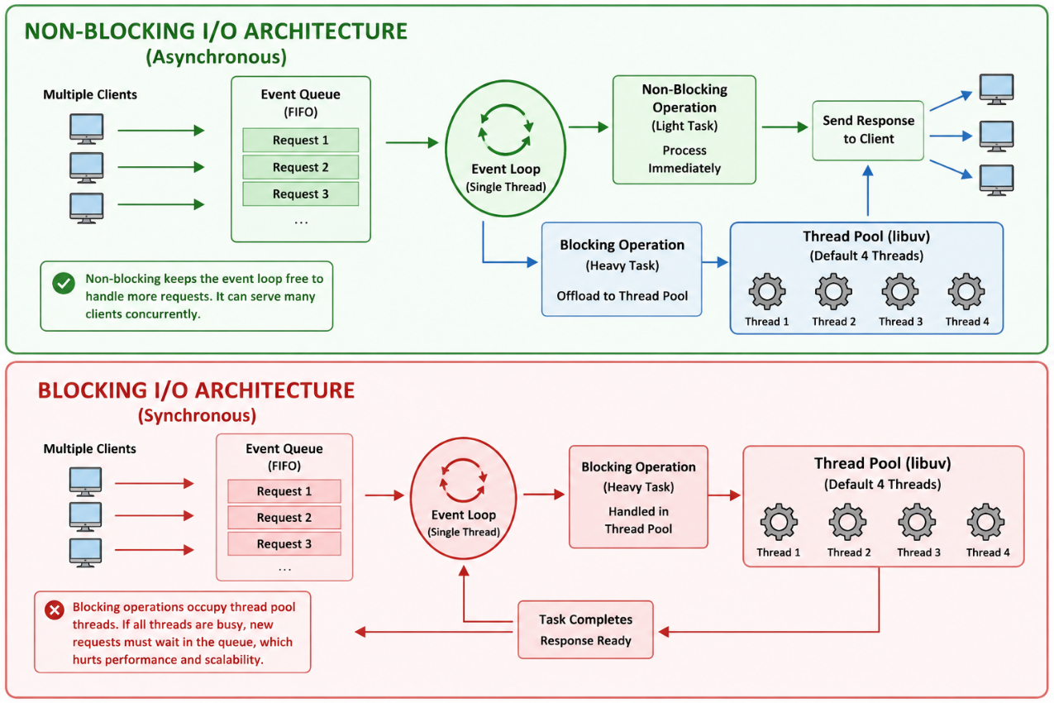

Key rule
The Event Loop only moves a callback from the queue to the stack when the stack is EMPTY. This is why async code always runs after the current synchronous code finishes.

4. Microtask Queue vs Callback Queue
Both queues are used in Node.js for handling asynchronous operations.
But: Microtask Queue has HIGHER priority than Callback Queue.
Callback Queue and Microtask Queue help Node.js manage asynchronous tasks efficiently without blocking the main thread.

Queue | What goes in it | Priority
Microtask Queue | Promise .then(), queueMicrotask(), catch , finally | HIGH — runs first, before callbacks
Callback Queue | setTimeout, setInterval, I/O | NORMAL — runs after microtasks

Proof with code
console.log('1 - Sync');

setTimeout(() => {
console.log('4 - setTimeout');
}, 0);

Promise.resolve().then(() => {
console.log('3 - Promise');
});

console.log('2 - Sync');

// Output:
// 1 - Sync ← synchronous
// 2 - Sync ← synchronous
// 3 - Promise ← microtask queue (runs before setTimeout)
// 4 - setTimeout ← callback queue (runs last)

5. Why Node.js is Single-Threaded But Still Fast
This confuses a lot of beginners. Node has one thread — but it's still incredibly fast. Here's why:

- Slow tasks (file reads, database queries, network) are handled by libuv — NOT the main thread
- The main thread never sits and waits. It only runs actual code.
- When a slow task finishes, the callback joins the queue and runs when the stack is free
- Result: one thread can handle thousands of requests because it's never blocked

The golden rule of Node.js
Never block the Event Loop. If you run heavy synchronous code (like a giant loop or complex calculation) it freezes the ENTIRE server — no other requests can be handled until it's done.

6. Things That Block vs Don't Block

Blocks the Event Loop (Avoid!) | Does NOT block (Use these!)
fs.readFileSync() — sync file read | fs.readFile() — async file read
JSON.parse() on huge data | Streams for large data
Complex for-loops with millions of steps | Break up work with setImmediate()
crypto.pbkdf2Sync() — sync hashing | crypto.pbkdf2() — async hashing

7. setTimeout, setInterval, setImmediate:
These are asynchronous functions in Node.js used for scheduling tasks.

setTimeout — run once after a delay
console.log('Before');

setTimeout(() => {
console.log('I run after 2 seconds');
}, 2000);

console.log('After');

// Output:
// Before
// After
// I run after 2 seconds

setInterval — run repeatedly
let count = 0;

const interval = setInterval(() => {
count++;
console.log('Tick:', count);

if (count === 3) {
clearInterval(interval); // stop after 3 times
console.log('Stopped!');
}
}, 1000);

// Output: Tick: 1 → Tick: 2 → Tick: 3 → Stopped!

setImmediate — run after current operation, before timers
setImmediate(() => {
console.log('setImmediate runs here');
});

setTimeout(() => {
console.log('setTimeout runs here');
}, 0);

// setImmediate usually runs before setTimeout(fn, 0)
// Both are async — exact order depends on the phase

8. Today's Practice

Goal
Understand the exact order in which async code runs. Predict the output BEFORE you run it, then verify.

Exercise 1 — Predict the output
console.log('A');

setTimeout(() => console.log('B'), 0);

Promise.resolve().then(() => console.log('C'));

console.log('D');

// Write your prediction, then run it with: node app.js
// Answer: A, D, C, B

Exercise 2 — Predict the output
setTimeout(() => console.log('timeout 1'), 0);
setTimeout(() => console.log('timeout 2'), 0);

Promise.resolve()
.then(() => console.log('promise 1'))
.then(() => console.log('promise 2'));

console.log('sync');

// Prediction: sync, promise 1, promise 2, timeout 1, timeout 2

Exercise 3 — See the blocking problem
// This simulates a BLOCKING operation
function blockFor2Seconds() {
const start = Date.now();
while (Date.now() - start < 2000) {} // busy loop
}

setTimeout(() => console.log('Timer fired!'), 100);

blockFor2Seconds(); // blocks the loop for 2 seconds

console.log('Sync done');

// Even though timer was set for 100ms, it fires at 2000ms
// Because blockFor2Seconds() froze the Event Loop

9. Summary

Concept | Remember this
Event Loop | Moves callbacks from queue into call stack when stack is empty.
Call Stack | Where your code actually runs. One thing at a time.
libuv | Handles slow async tasks (file, network) in the background.
Callback Queue | setTimeout, setInterval callbacks wait here.
Microtask Queue | Promise callbacks wait here — always runs BEFORE callback queue.
Single thread | Node is single-threaded but fast because it never blocks the thread.
Golden rule | Never block the Event Loop. Always use async versions of I/O operations.

Tomorrow — Day 6
Core Node Modules — fs, path, and os in real practical use. You'll read and write actual files on your machine.

