

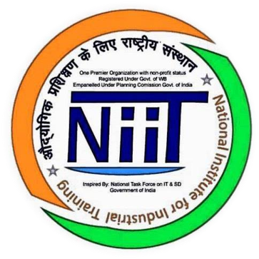



Subject: Python with A.I.

Submitted by: Rishav Chatterjee

Submitted to: Ankit Pramanik

Submitted on: 17th July 2019

Student Profile

**NAME** – Rishav Chatterjee

**COLLEGE** – Government College of Engineering and Leather Technology (GCELT)

**COURSE** – BTECH (IT)

**SEMESTER** - 3rd Sem, 2nd Year

**YEAR OF PASING** - 2022

**PHONE** **No.** - 7029088389

**EMAIL** –crishav01@gmail.com



Contents:

***1. Acknowledgement***

***2. Introduction***

***3. Objectives***

***4. Hardware and Software Requirements***

***5. Future Scope***

***6. Advantages***

***7. Coding with Snapshots***

***8. Conclusion***

***9. Bibliography***

Acknowledgement:

I have taken efforts in this project. However, it would not have been possible without the kind support and help of many individuals and organizations. I would like to extend my sincere thanks to all of them.

I am highly indebted to **National Institute for Industrial Training** for their guidance and constant supervision as well as for providing necessary information regarding the project & also for their support in completing the project.

I would like to express my gratitude towards my parents & my teachers **Mr. Ankit Pramanik** and **Mr. Sayantan Chakraborty** for their kind co-operation and encouragement which help me in completion of this project.

I would like to express my special gratitude and thanks to industry persons for giving me such attention and time.

My thanks and appreciations also go to my colleague in developing the project and people who have willingly helped me out with their abilities.

Introduction:

Python comes with a huge amount of inbuilt libraries. Many of the libraries are for Artificial Intelligence and Machine Learning. Some of the libraries are Tensorflow (which is high-level neural network library), scikit-learn (for data mining, data analysis and machine learning), pylearn2 (more flexible than scikit-learn), etc. The list keeps going and never ends.

Python has an easy implementation for OpenCV. What makes Python favourite for everyone is its powerful and easy implementation.

For other languages, students and researchers need to get to know the language before getting into ML or AI with that language. **This is not the case with python**. Even a programmer with very basic knowledge can easily handle python. Apart from that, the time someone spends on writing and debugging code in python is way less when compared to C, C++ or Java. This is exactly what the students of AI and ML want. **They don't want to spend time on debugging the code for syntax errors, they want to spend more time on their algorithms and heuristics related to AI and ML.**

**Not just the libraries but their tutorials, handling of interfaces are easily available online**. People build their own libraries and upload them on GitHub or elsewhere to be used by others.

Objectives:

• Python is a powerful open source programming language, which means that it’s free to use while having all the properties that a programming language should have.

• It is a versatile programming language that supports Object-Oriented Programming, Structured Programming, and functional programming patterns.

• Python has some 72,000 libraries in the Python Package Index that aid in scientific calculations and machine learning applications.

• Python sports an easy to understand and readable syntax that ensures that the development time is cut into half when compared with other programming languages.

• Python enables you to perform data analysis, data manipulation, and data visualization, which are very important in data science.

Hardware and Software Requirements:

**Software Requirements:**

**Operating System:** Windows 10 64-bit

**Front End:** Python 3.7

**Platform:** Anaconda

**hardware Requirements:**

**Machine:** HP Laptop 15-bs1xx

**Speed:** 1.80GHz

**Hard disk:** 1 TB

**RAM:** 4 GB

Future Scope:

➢ Python programming language is undoubtedly dominating the other languages when a future technology like Artificial Intelligence (AI) comes into the play.

➢ There are plenty of python frameworks, libraries, and tools that are specifically developed to direct Artificial Intelligence to reduce human efforts with increased accuracy and efficiency for various development purposes.

➢ It is only the Artificial Intelligence that has made it possible to develop speech recognition system, autonomous cars, interpreting data like images, videos etc.

Advantages:

1) Python can be used in the development of prototypes, and it can help speed up the concept to creation process because it is so easy to use and read.

2) Python is ideal for general purpose tasks such as data mining, and big data facilitation.

Coding with Snapshots:

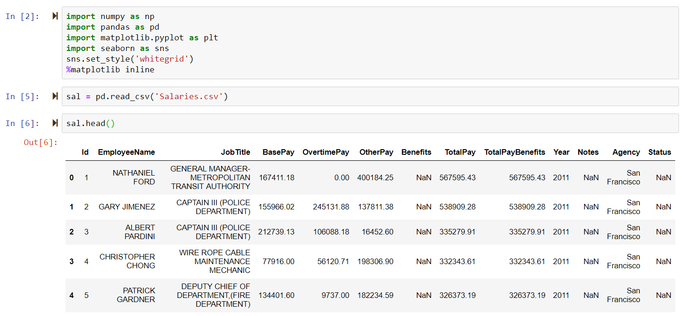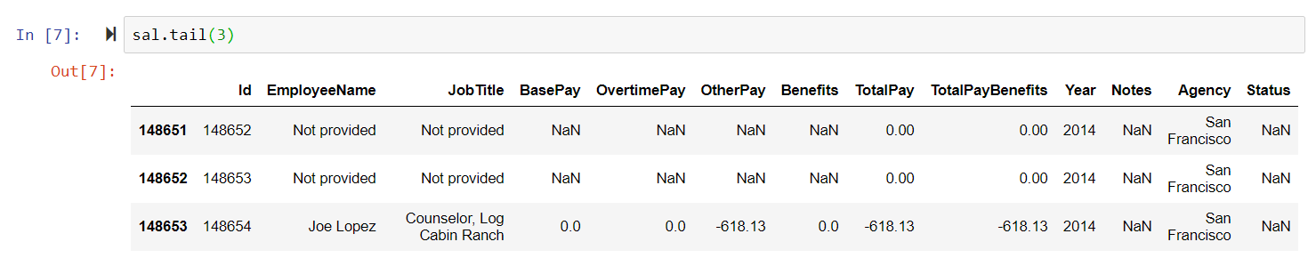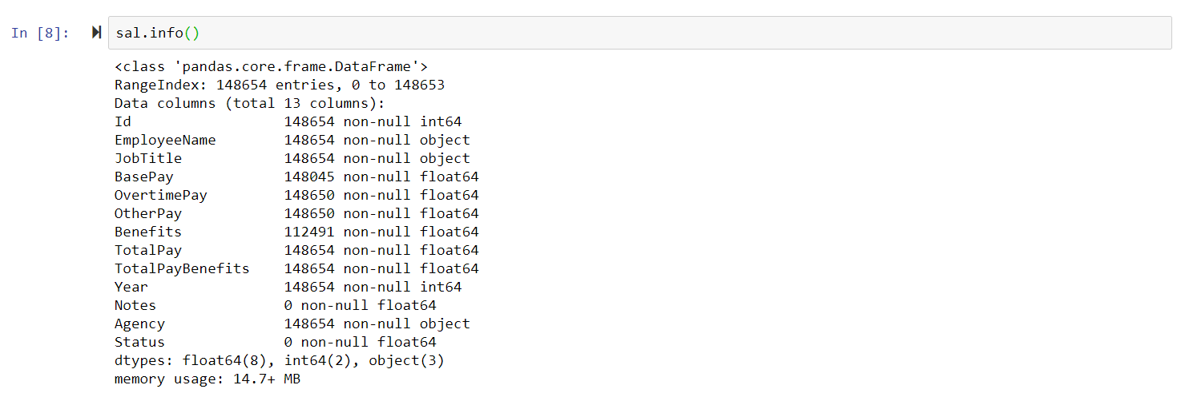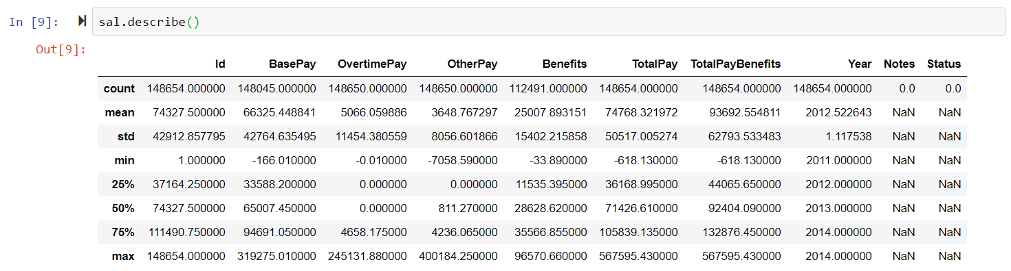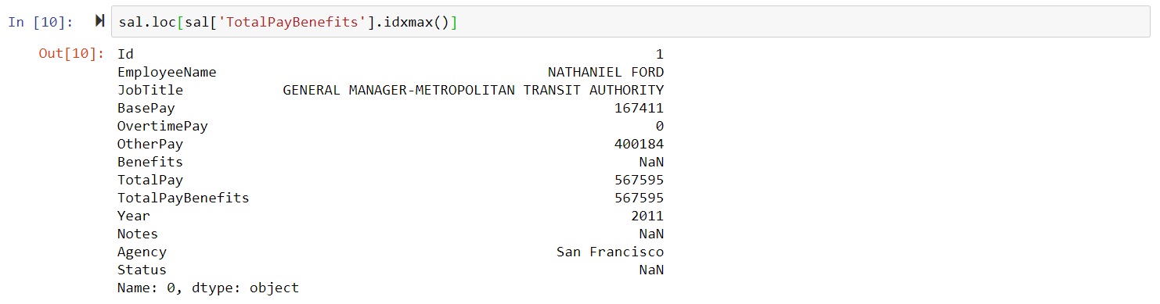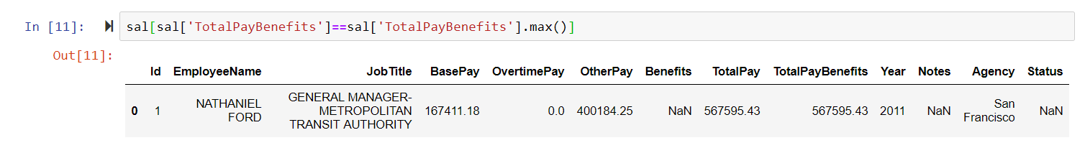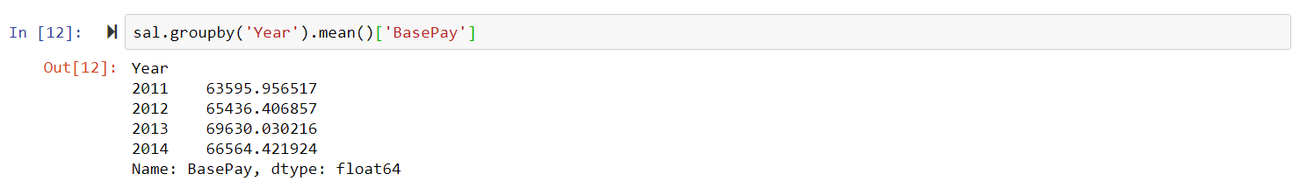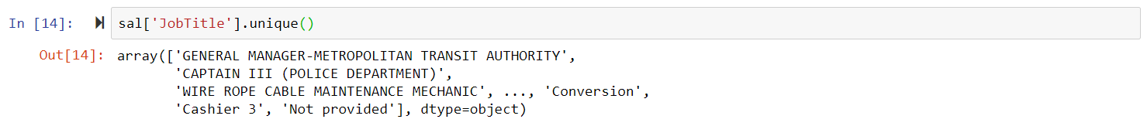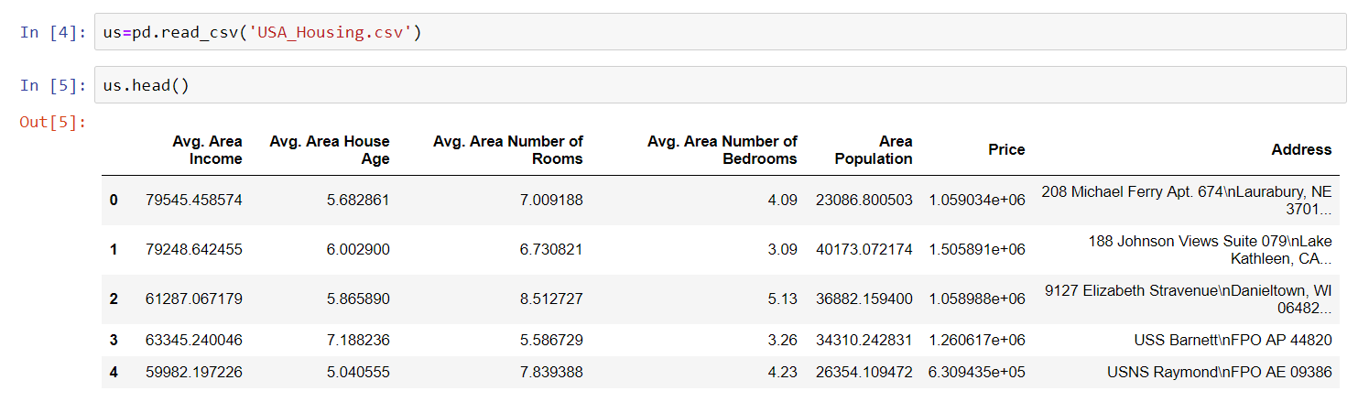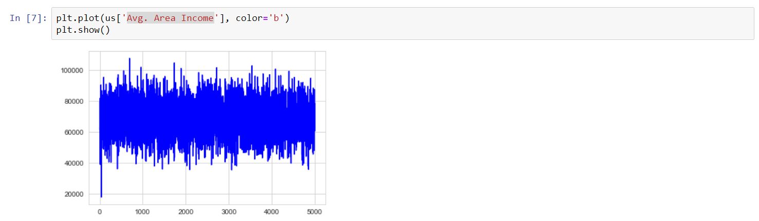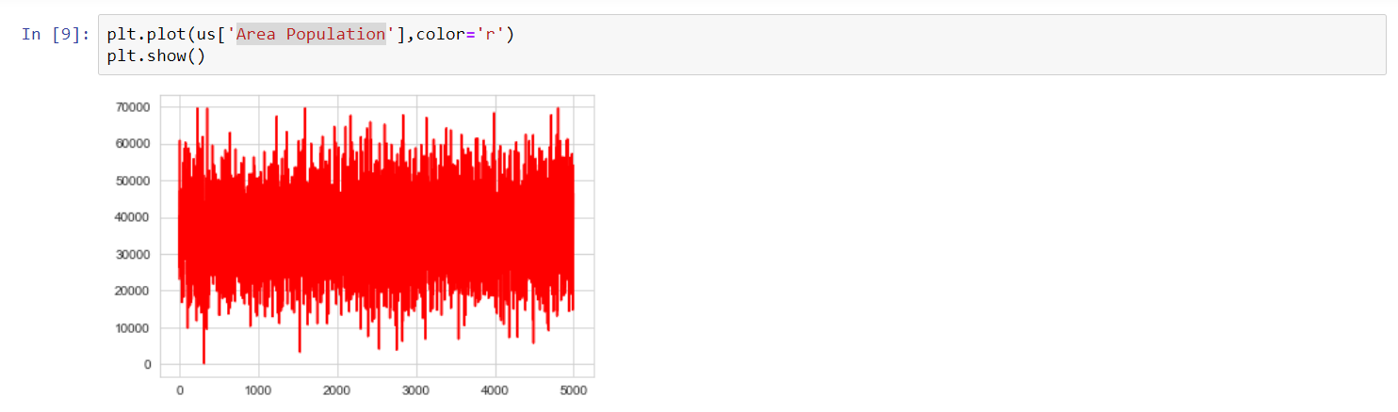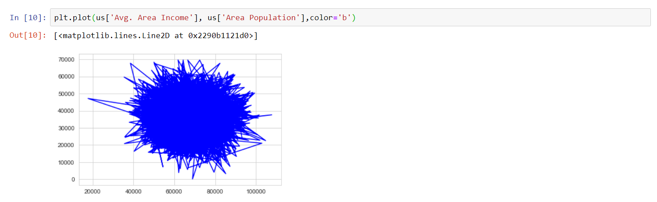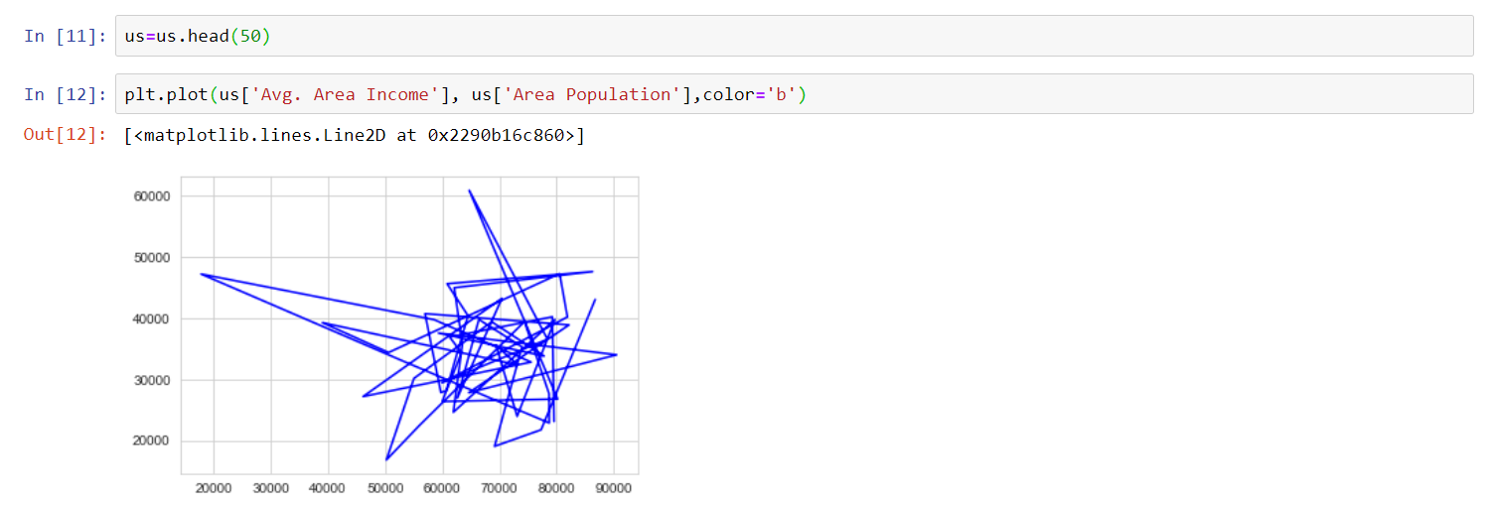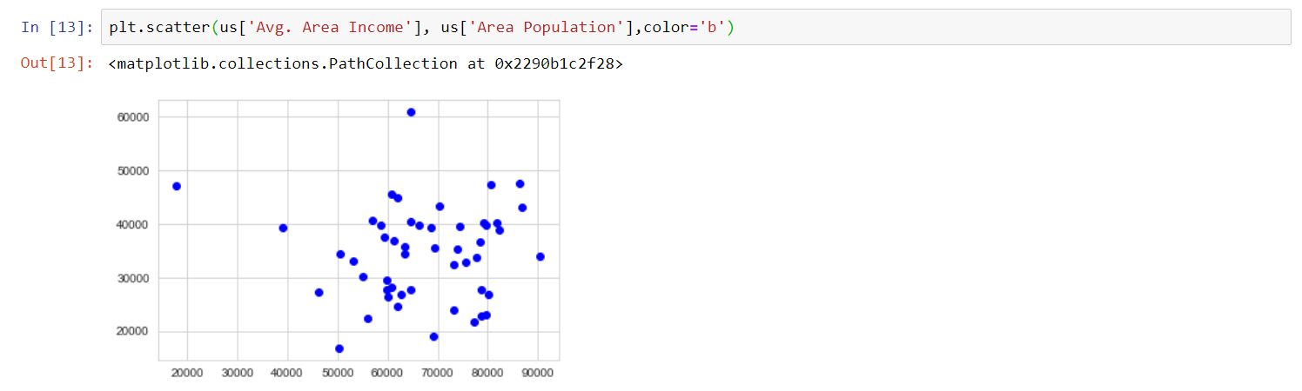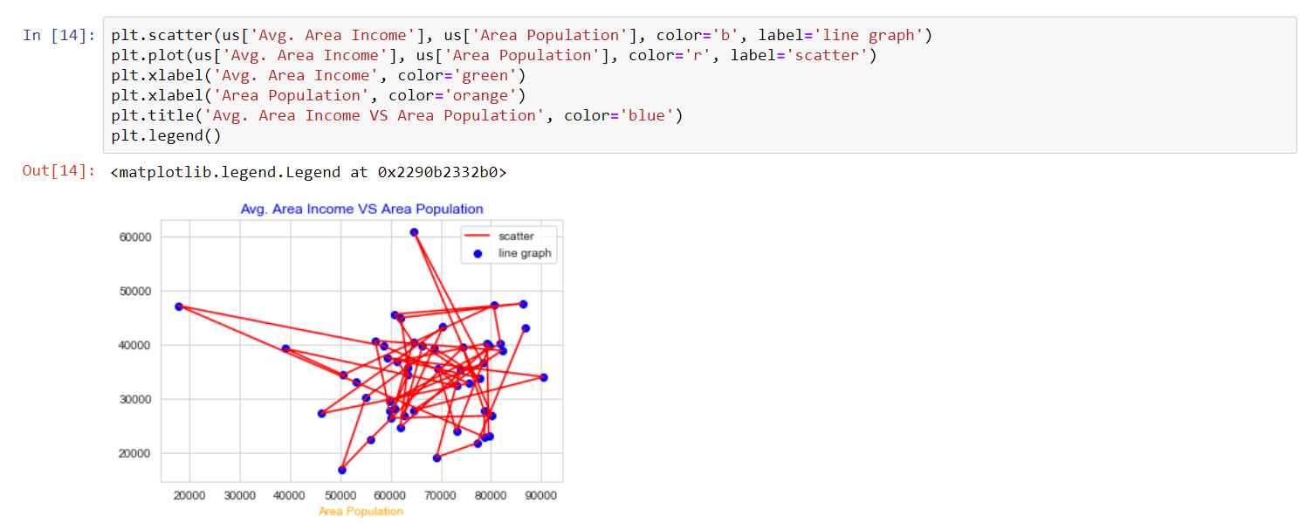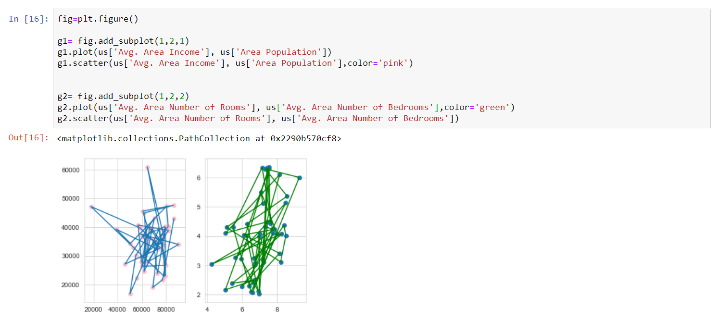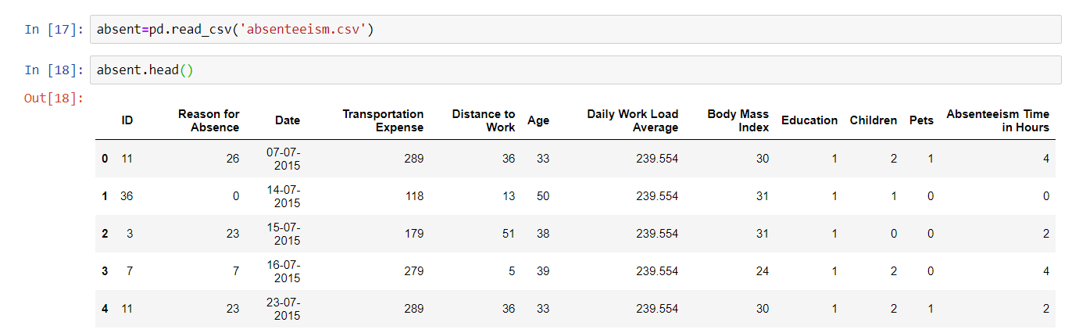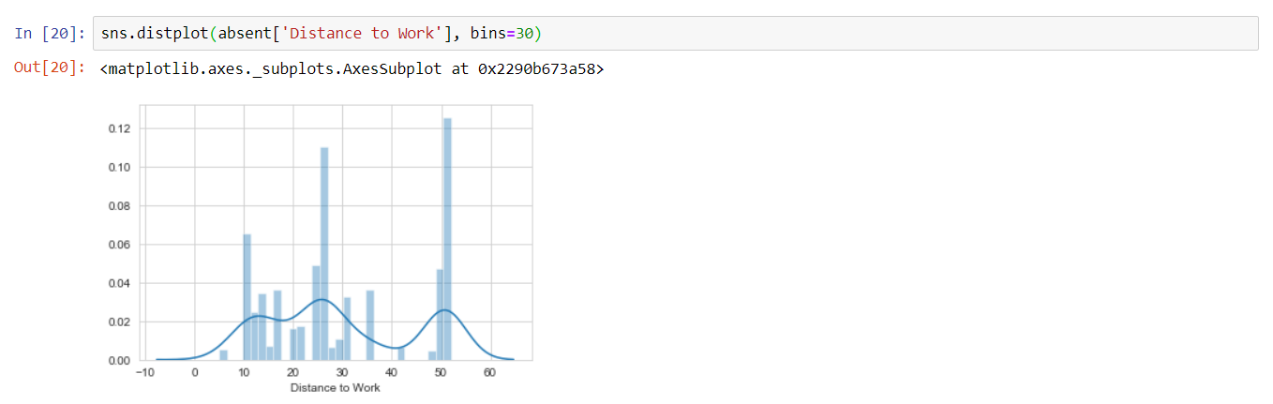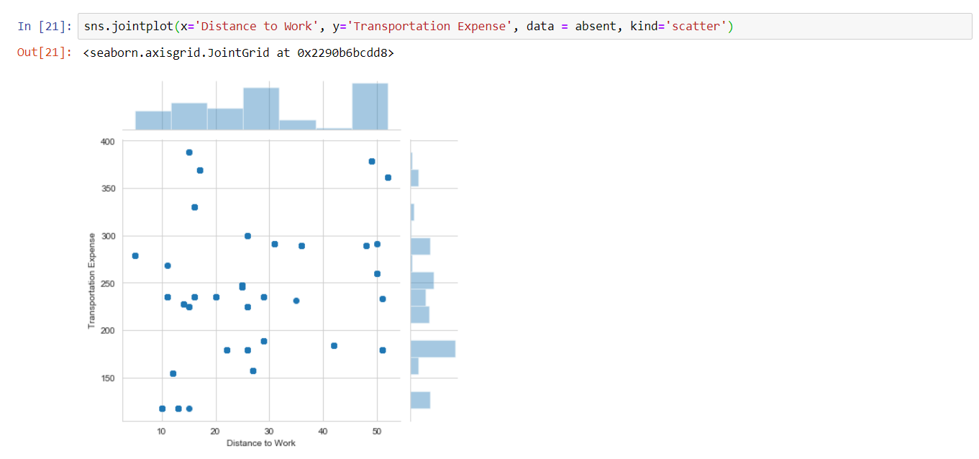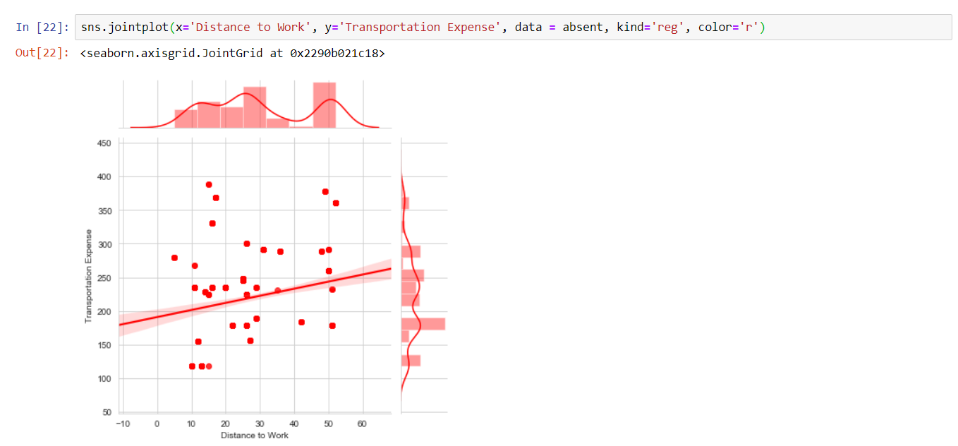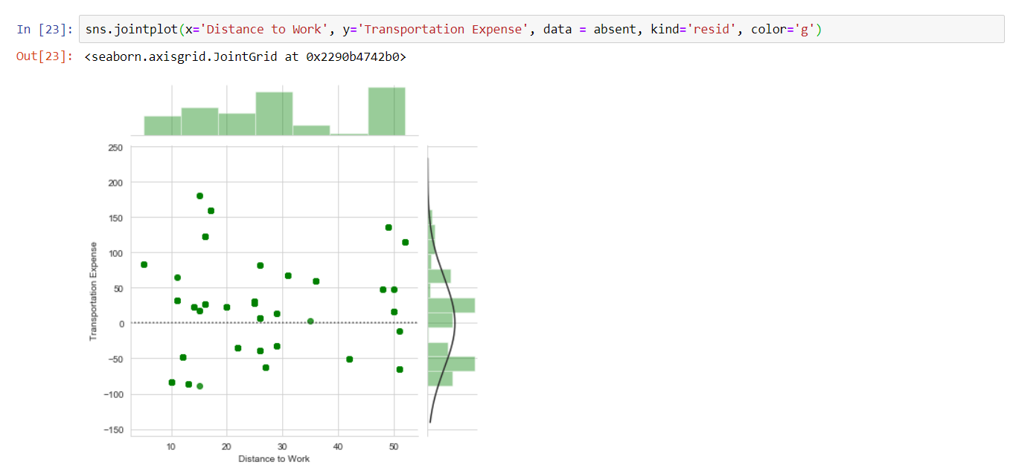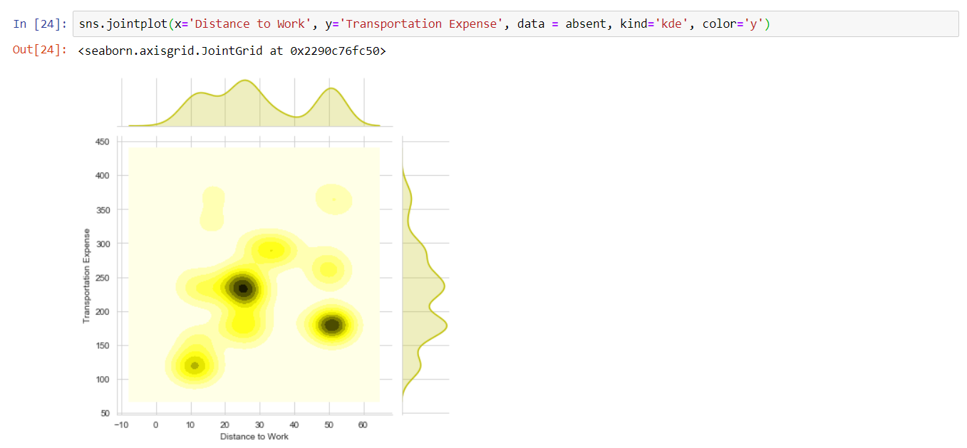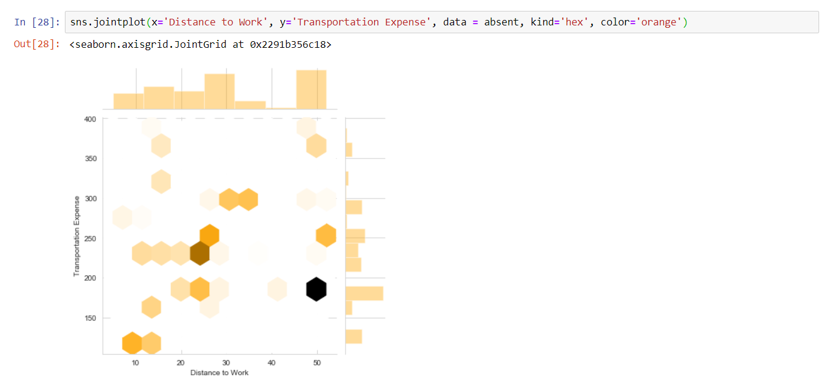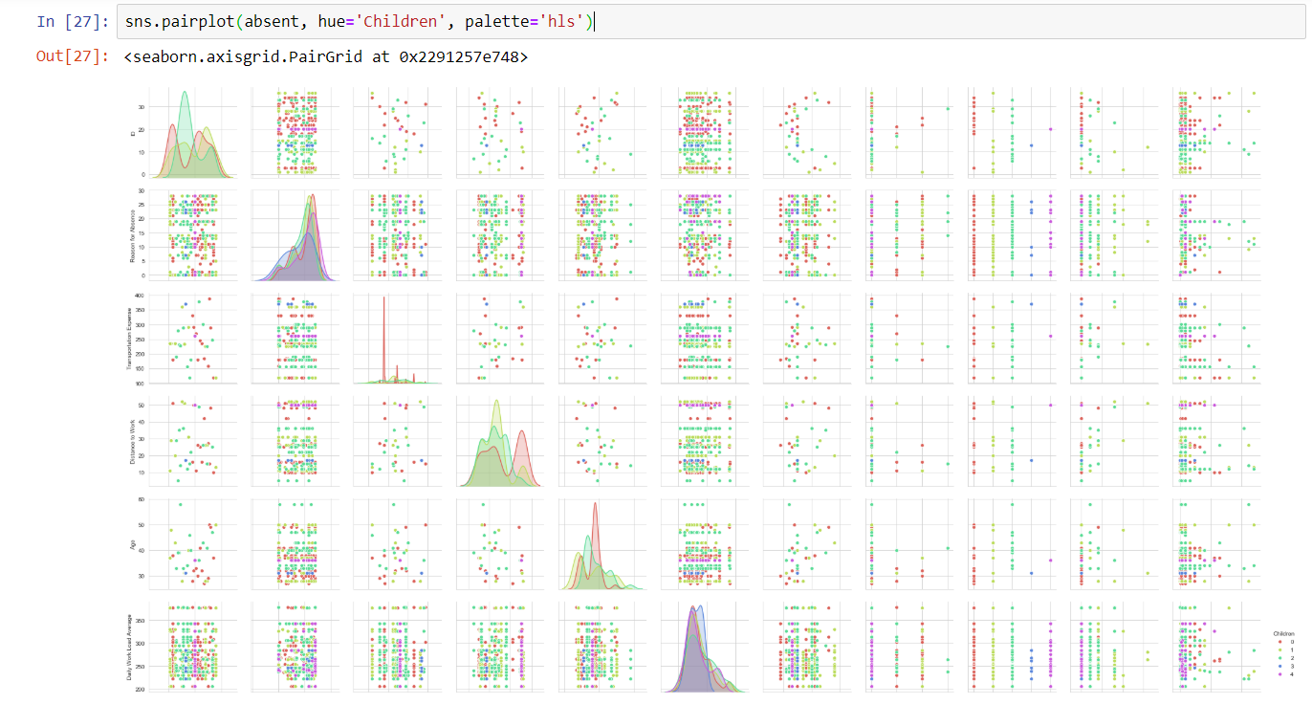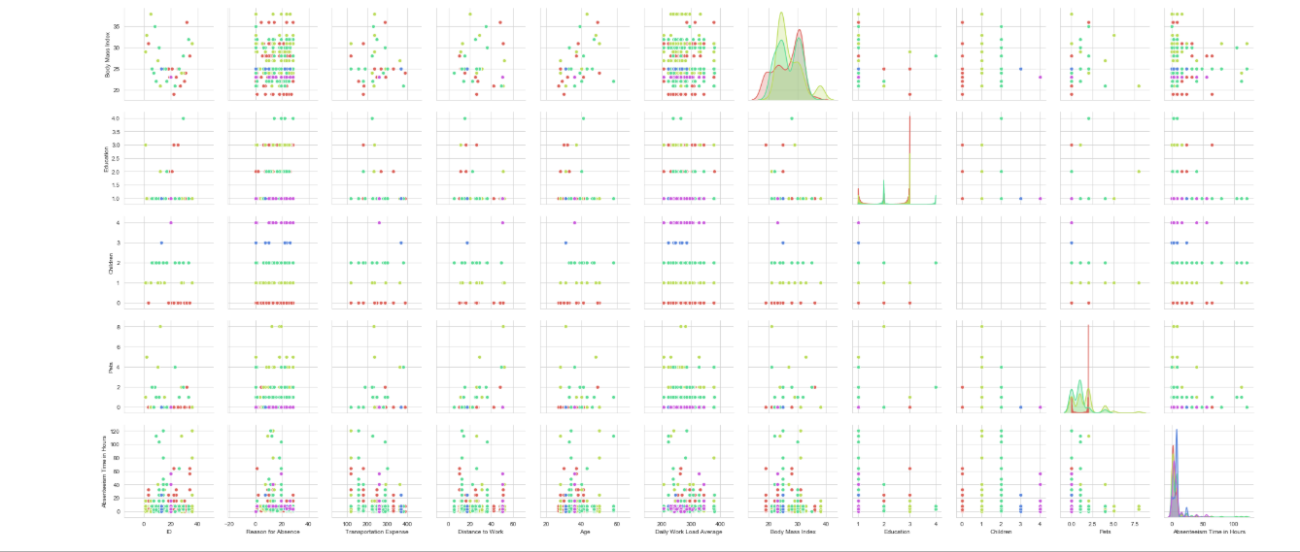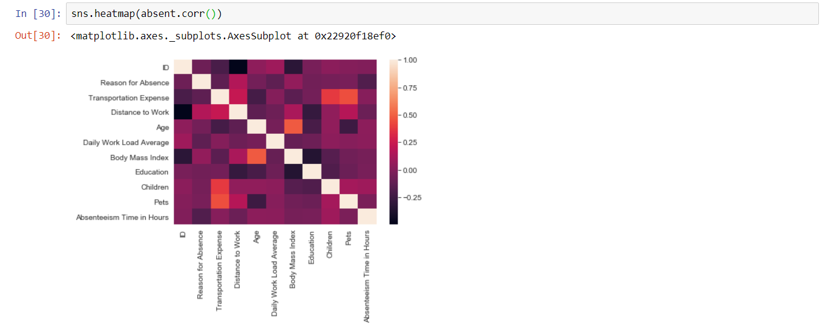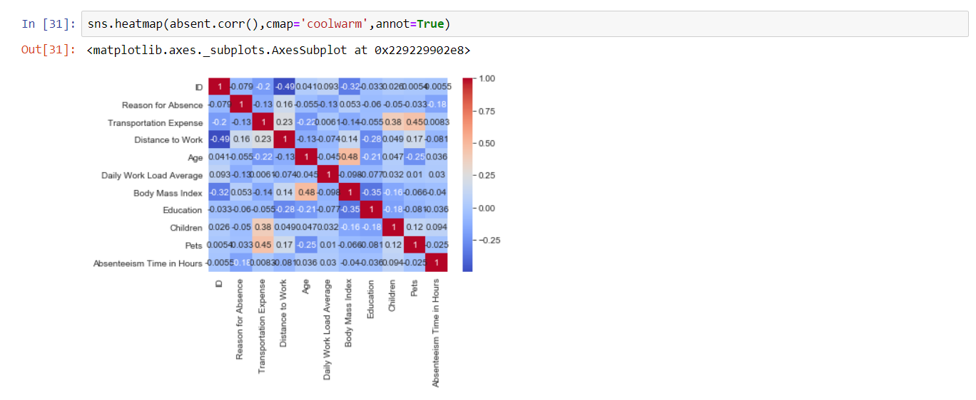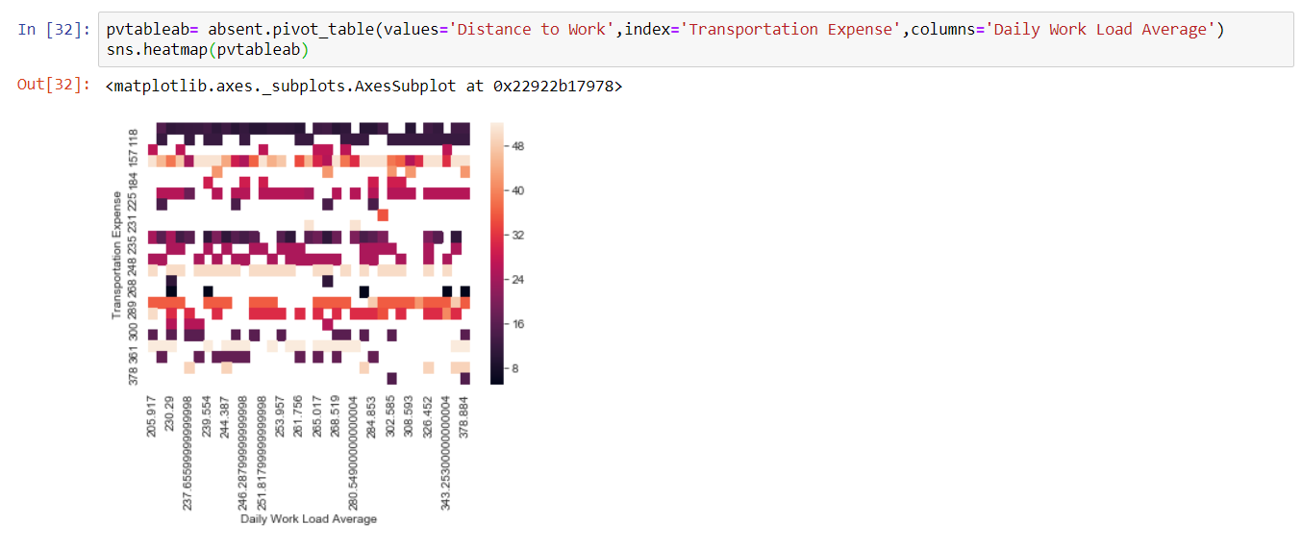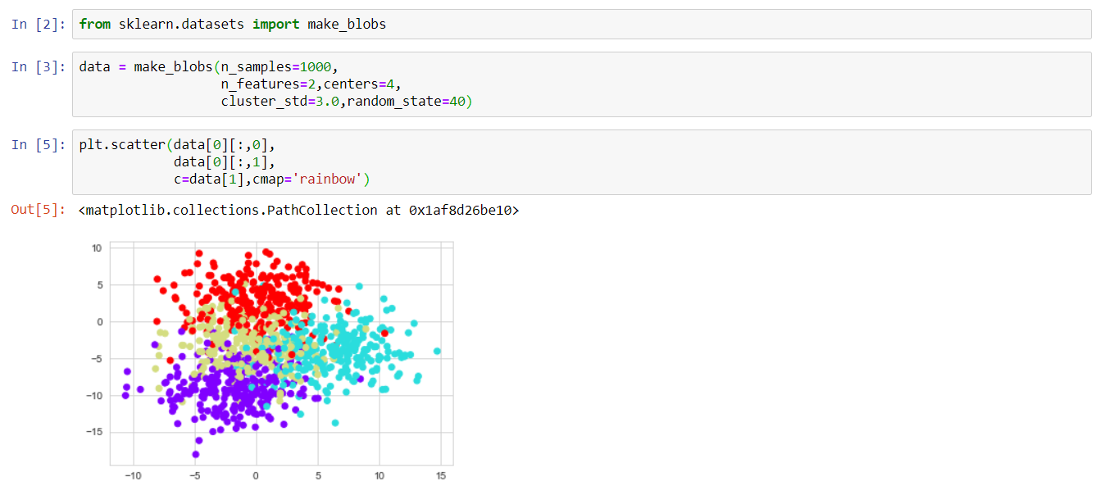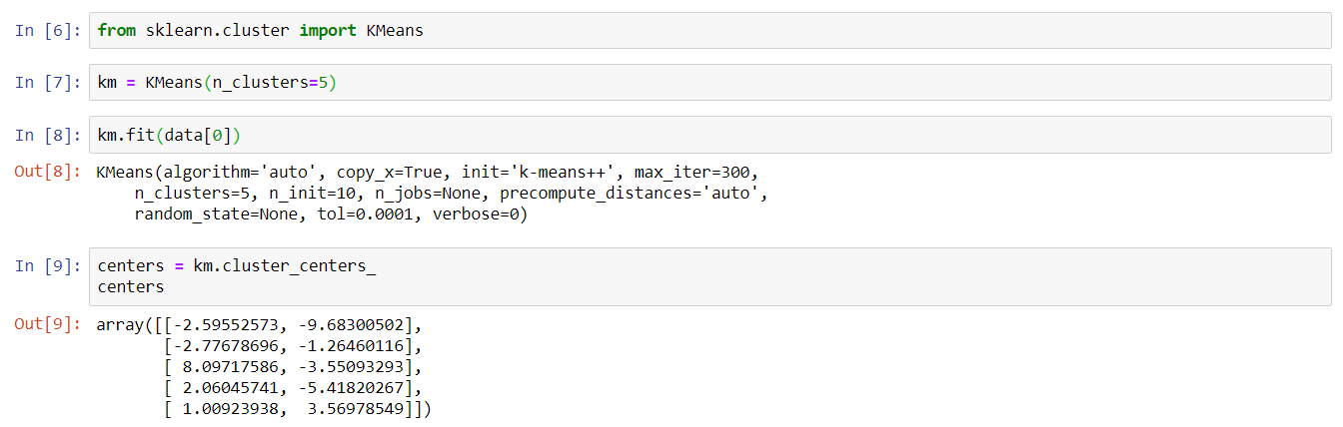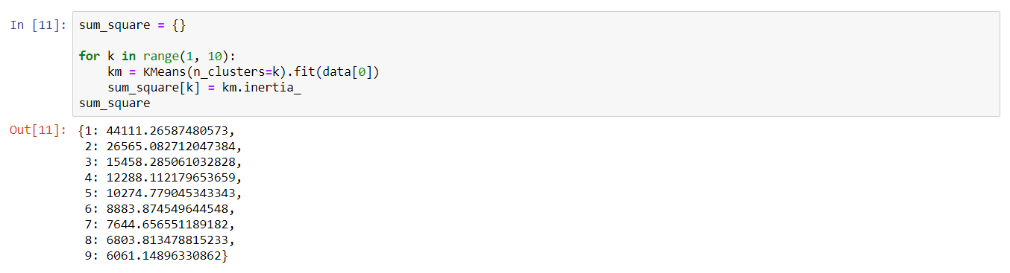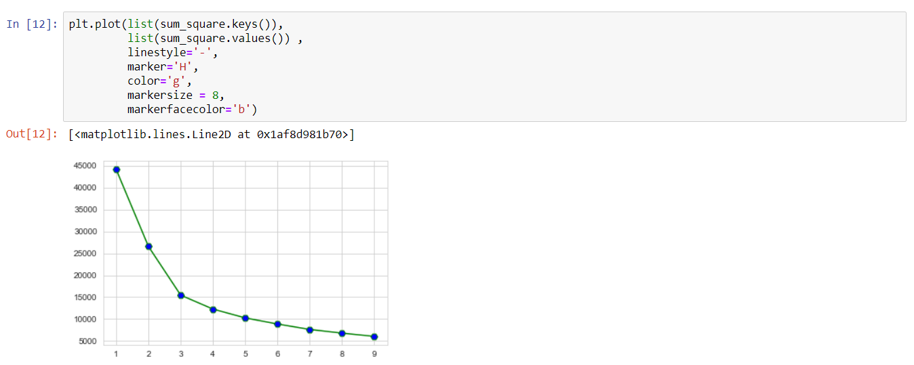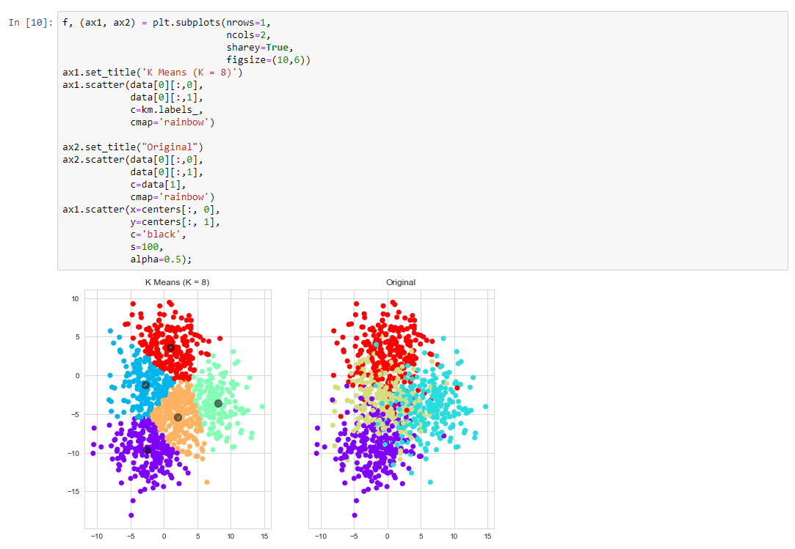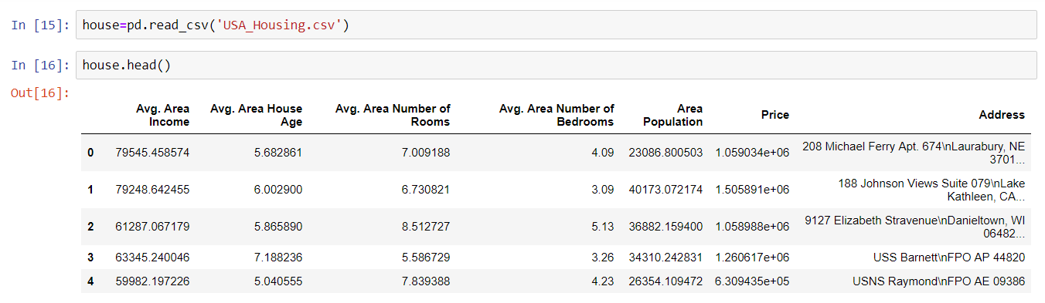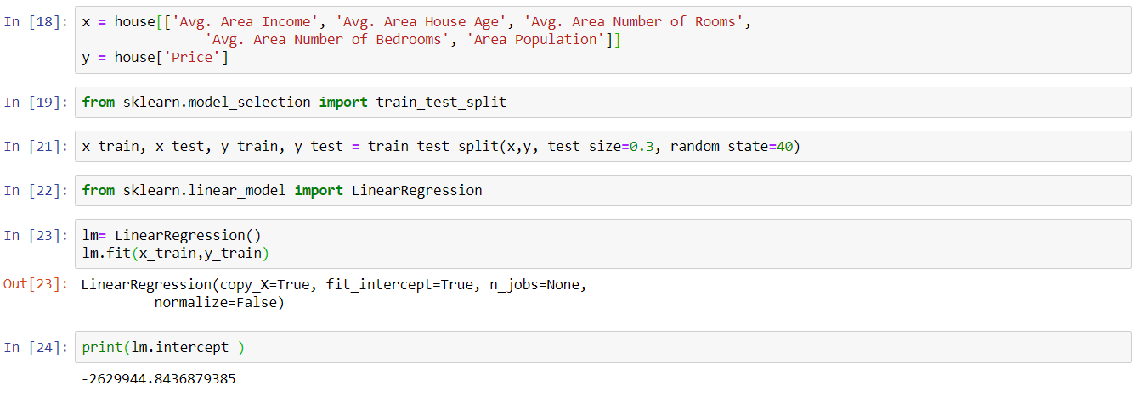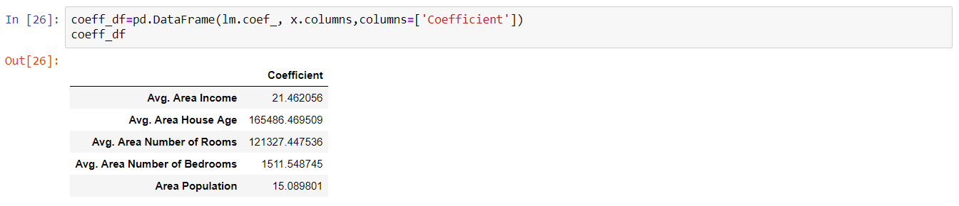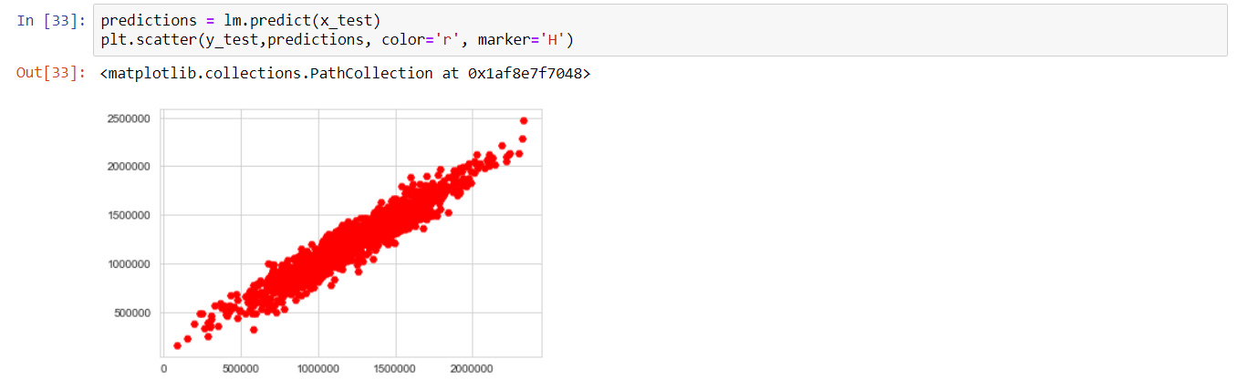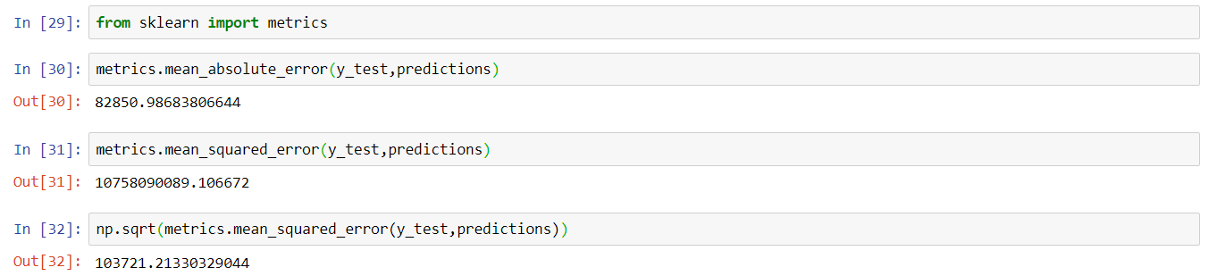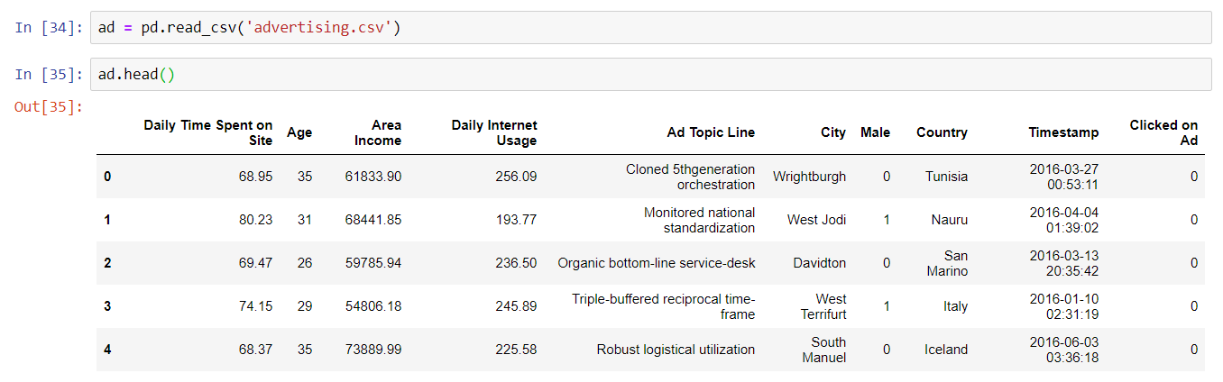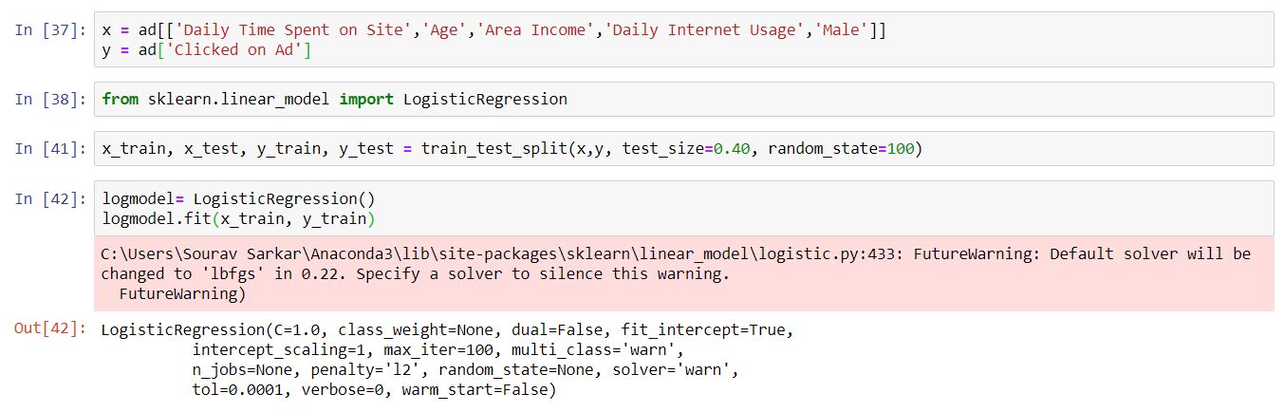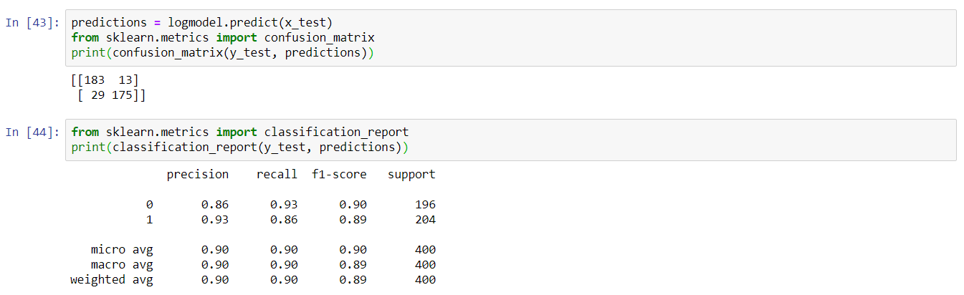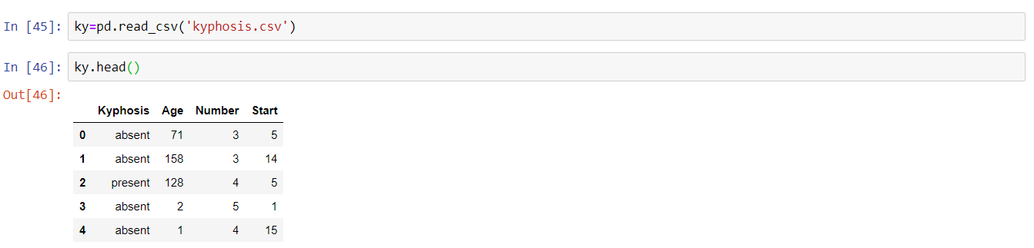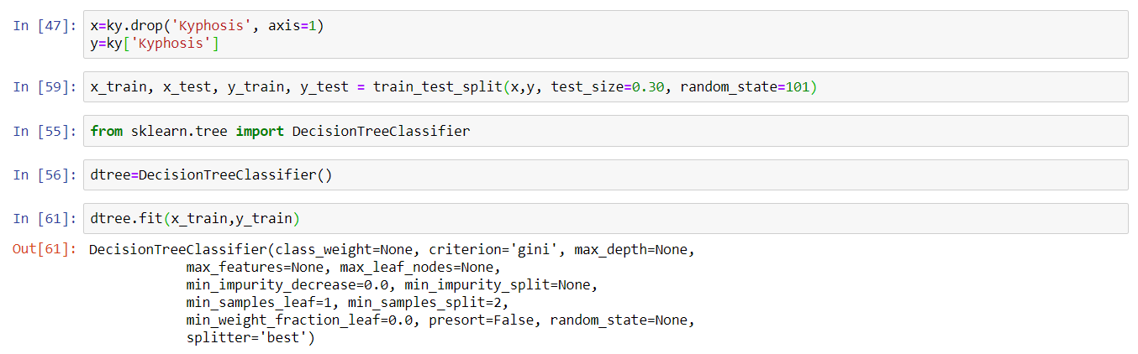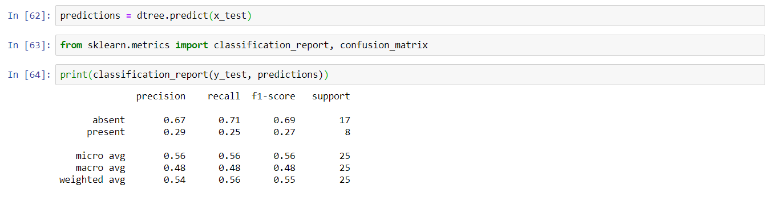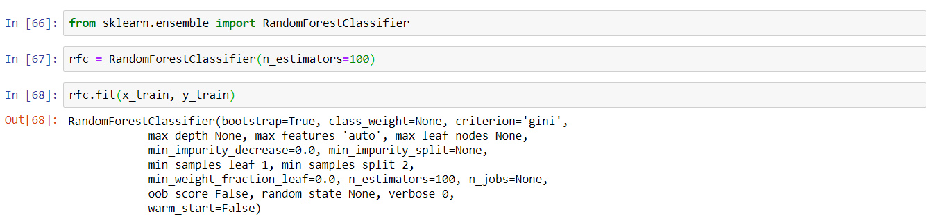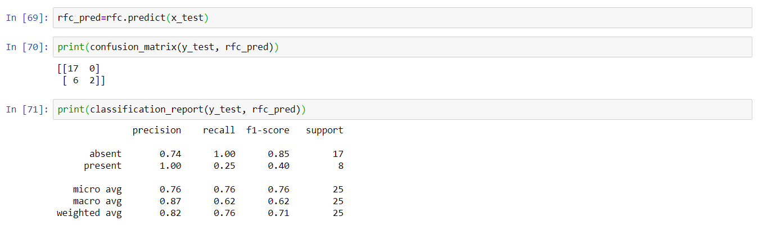

Conclusion:

There are no doubts that AI technologies are the future. Considering the increasing popularity of the trend and the number of people ready to invest in it, the global AI market is going to reach **$89.8 billion by 2025.**

The PL is what we should think about at first. The complexities of coding as well as the availability of the experienced and qualified developers are crucial moments to take into account as well. We’re to deal and process a host of data effectively when it comes to AI industry

The marketing can make use of AI by means of the tech stack of the processes that are made manually by employees can be automated, it can bring more efficiency and quickly analyze large data sets, for example. Gartner says that by 2020 AI technologies will be used in at least one of the sales processes by 30% of companies over the world. Besides that, according to Accenture reports, the profitability will rise by **38% by 2035** and AI will create **$14 trillion of additional revenue.**

The e-commerce sales are expected to be about **$4.5 trillion** by 2021. And that’s not without AI technologies used. Thanks to the AI the sites provides the customers with 24/7 service and assistance by means of the chatbots, improve consumers experience by analyzing the CRM data in moments with AI tech, IoT, and other examples of using AI in e-commerce.

High diversity of built-in libraries, simple syntax, readability, compatibility, rapid testing of sophisticated algorithms, accessibility to non-programmers, and other features make Python worthy of your attention. All that ease the process, save your budget and increase the popularity of Python. Taking to account all the advantages we get using the PL, the conclusion is obvious — Python is what we need to consider to your AI-based project.

Bibliography:

The contents have been gathered from the following:

* Information: Google
* Images: Google Images
* Coding and snapshots: Self-performed