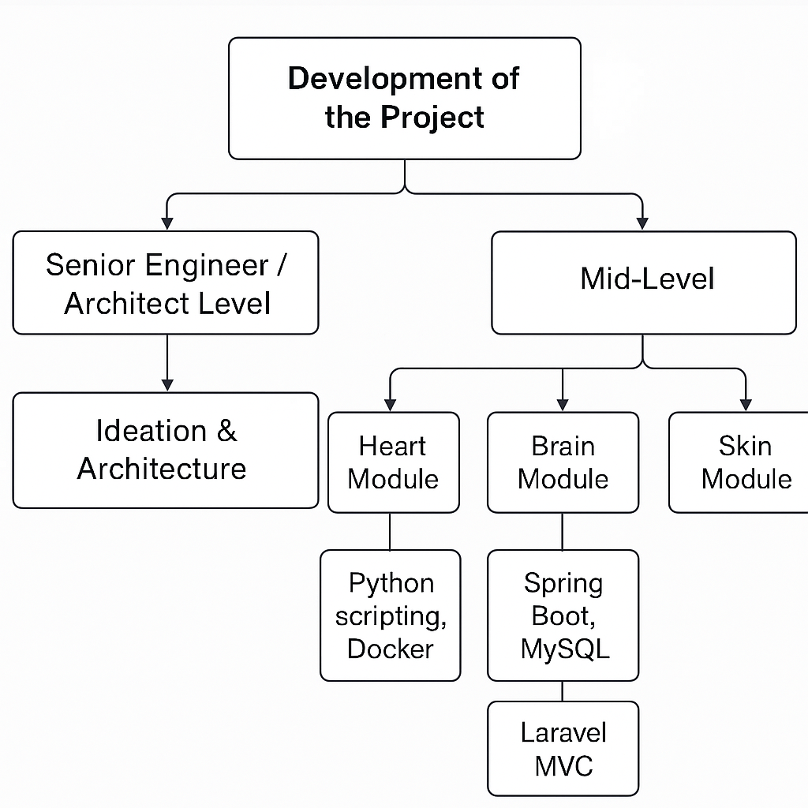

**Fig 1: A skill-map diagram showing what level of engineer would tackle which part of your project. (Generated by Chat Gpt)**