**ERP NOTES**

**UNIT – 1**

* **ERP Introduction:-**
* Enterprise Resource Planning (ERP) is a software that is built to organizations belonging to different industrial sectors, regardless of their size and strength.
* The ERP package is designed to support and integrate almost every functional area of a business process such as procurement of goods and services, sale and distribution, finance, accountings, human resource, manufacturing, production planning, logistics & warehouse management.
* 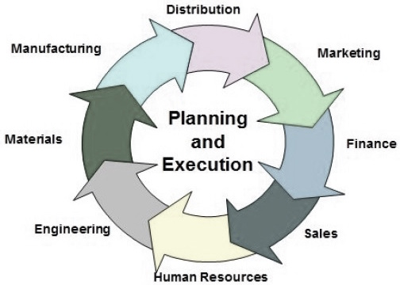

## **Functions of ERP**

An ERP system typically performs the following functions −

* Supports the integrated business process inside the organization.
* Improves capital planning and helps in executing organizational plans and strategies.
* Helps speed up the decision-making process over the analysis of accurate data.
* Helps extend the business network to wider domains, expanding the products and services to reach more customers, suppliers, and partners.
* Identifies operational risks to improve governance.
* Provides protection against organizational data breaches and security threats to leakage of information.
* Makes the organization adaptable to the rapid changes in the business process according to the needs.
* Gives long-term profit by providing means to increase the customer base.

## **Functional Areas Of ERP:-**

ERP is a business management software is usually a suite of integrated applications that a company can use to collect, store, manage, and interpret data from many functional areas including −

* **Financial Accounting** − Deals with financial transactions and data.
* **Human Resource** − Deals with information related to employee of an organization.
* **Customer Relationship Management** − Deals with capturing and managing customer’s relationship, facilitating the use of customer experience to evaluate the knowledge database.
* **Sales and Distribution** − Deals with order placement, delivery, shipment and invoicing.
* **Logistics and Warehouse Management** − Deals with storage of products and shipment.
* **Manufacturing and Material Management** − Deals with the production and production planning activities.
* **Supply Change Management** − Deals with the movement of products, storing, managing, and controlling supplies.
* **Business Intelligence** − Analyzes data and converts the same to information.

## **Advantages of ERP:-**

By integrating the business processes, the ERP offers the following advantages −

* Saves time and expenses.
* Allows faster decision-making by the management, utilizing the data and reporting tools designed in the systems.
* Single data source and sharing of data among all the units of an organization.
* Helps in tracking every transaction that takes place in an organization, from starting till end.
* Supplies real-time information whenever required.

**Data Security:-**

* Data has become a prized possession for businesses because it’s so critical to making the best possible decisions, and ERP software can help protect that asset. The fact that all this data is in one place, rather than spread across multiple systems with varying levels of security, increases the level of protection.
* Integrating and sharing of information across different departments.
* Reducing redundant data entry and processes.
* Guarantee for the security of organization data.
* Better communication across various departments.
* Improving workflow and security.

## **Disadvantages of ERP:-**

It is not always easy to incorporate ERP in an organization. ERP suffers from the following drawbacks −

* Sometimes business processes critical to an organization are to be re-engineered to align them with an ERP solution.
* Cost of complex integration can be very high.
* Switching from one ERP solution to another increases the implementation cost even further.
* End-users are to be trained for their daily operations.
* Customization is not preferred.

**Benefits of ERP:-**

1. **Information Integration :**  
   The most important benefit is promotion of integration. It is because it has the ability to update data between related business functions and components. Also the people involved in a project are interlinked to each other, thus it help in improvement of productivity.
2. **Reduction of Lead-Time :**  
   Lead-Time is the elapsed time between placing an order and receiving it. By reducing Lead-Time organization should have an efficient inventory management system, which is integrated with the purchasing, production planning and production departments.
3. **On Time Shipment :**  
   ERP system are designed to help your company to reduce data transfer time, reduce errors and increase design productivity. By using steps of ECO i.e. Engineering Change Order, ERP system automatically implements change in production database. Thus by using these, an ERP system ensures on time delivery of goods to customers.
4. **Reduction in Cycle Time :**  
   It is time between the placement of order and delivery of product. There are two types of situations; one is make-to-order and second one is make-to-stock. In both cases cycle time can be reduced but more time is saved in make-to-order case because in this ERP system save time by integrating with CAD/CAM systems.
5. **Better Customer Satisfaction :**  
   ERP system is capable of producing goods in a flexible way with consideration of time and cost management. It means will get individual attention and get services without spending more money or waiting for long period.
6. **Increased Flexibility :**  
   Product flexibility is type of ability of the operation to efficiently produce highly customized and unique products. ERP system not only improve flexibility of manufacturing operations, but is also improve flexibility of organization.

**Difference between ERP and ERP II :-**

| ERP | ERP II |
| --- | --- |
| It is developed in 1990s. | It is developed in 2000s. |
| ERP was concerned with optimizing an enterprise-Internal Optimization. | These systems are about optimizing the supply chain through collaboration with trading partners. |
| Focuses on manufacturing and distribution. | Focuses on all sectors and segments of business. |
| It’s process is internal and hidden. | It’s process is externally connected. |
| Data is internally generated and consumed. | Data is internally and externally published and subscribed. |
| It is web-aware, closed and monolithic. | It is web-based, open and componentized. |

# Business Process Re-engineering(BPR):-

**Business Process Re-engineering is the fundamental rethinking and radical design of business processes to achieve dramatic improvements in critical, contemporary measures of performance such as cost, quality, service and speed.**

**Business process re-engineering** is not just a change, but actually it is a dramatic change and dramatic improvements. This is only achieved through overhaul the organization structures, job descriptions, performance management, training and the most importantly, the use of IT i.e. Information Technology.

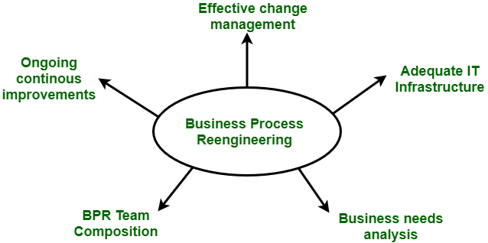

**Advantages of BPR :**  
Following are the advantages of BPR :

1. BPR offers tight integration among different modules.
2. It offers same views for the business i.e. same database, consistent reporting and analysis.
3. It offers process orientation facility i.e. streamline processes.
4. It offers rich functionality like templates and reference models.
5. It is flexible.
6. It is scalable.
7. It is expandable.

**Disadvantages of BPR :**  
Following are the Disadvantages of BPR :

1. It depends on various factors like size and availability of resources. So, it will not fit for every business.
2. It is not capable of providing an immediate resolution.

# Data Warehouse:-

# A data warehouse is a great way to store your data, so it’s easy to access and analyze. It’s perfect for businesses that want to make better decisions using their data. Data warehouse is a subject oriented, integrated, Non-volatile, time variant collectin of data in support of management decision.

# DATA MINING:-

# “**Mining**” is the process of extraction of some valuable material from the earth e.g. coal mining, diamond mining, etc. In the context of computer science, “**Data Mining”** can be referred to as **knowledge mining from data, knowledge extraction, data/pattern analysis, data archaeology, and data dredging**.  It is basically the process carried out for the extraction of useful information from a bulk of data or[data warehouses.](https://www.geeksforgeeks.org/data-warehousing/) One can see that the term itself is a little confusing. In the case of coal or diamond mining, the result of the extraction process is coal or diamond. But in the case of Data Mining, the result of the extraction process is not data!! Instead, data mining results are the patterns and knowledge that we gain at the end of the extraction process. In that sense, we can think of Data Mining as a step in the process of Knowledge Discovery or Knowledge Extraction.

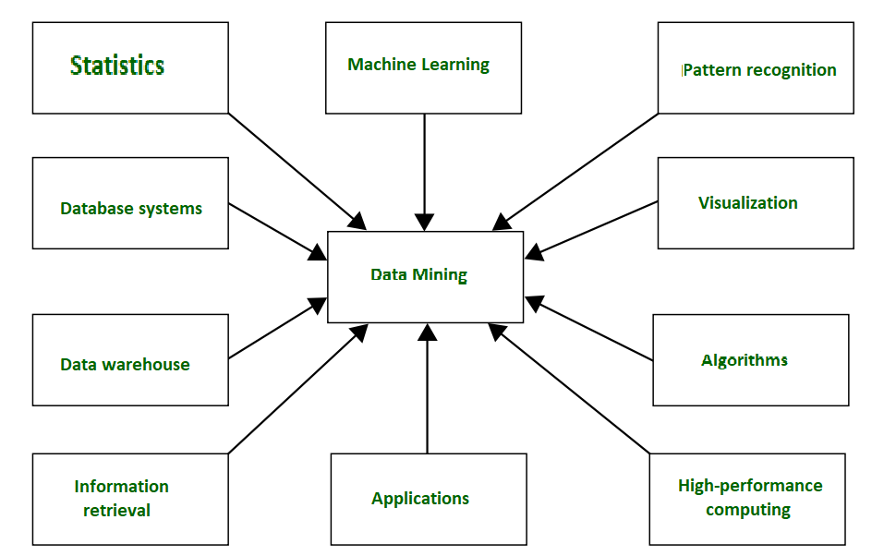

*Data Mining*

Data Mining can be applied to any type of data e.g. **Data Warehouses, Transactional Databases, Relational Databases, Multimedia Databases, Spatial Databases, Time-series Databases, World Wide Web.**  
**Data Mining as a whole process**   
The whole process of Data Mining consists of three main phases:

1. Data Pre-processing – Data cleaning, integration, selection, and transformation takes place
2. Data Extraction – Occurrence of exact data mining
3. Data Evaluation and Presentation – Analyzing and presenting results



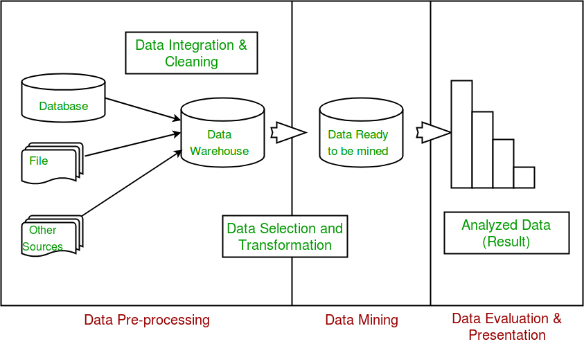

In future articles, we will cover the details of each of these phases.

**Applications of Data Mining**

1. Financial Analysis
2. Biological Analysis
3. Scientific Analysis
4. Intrusion Detection
5. Fraud Detection
6. Research Analysis

**Real-life examples of Data Mining**

**Market Basket Analysis**: It is a technique that gives the careful study of purchases done by a customer in a supermarket. The concept is basically applied to identify the items that are bought together by a customer. Say, if a person buys bread, what are the chances that he/she will also purchase butter. This analysis helps in promoting offers and deals by the companies. The same is done with the help of data mining. 

**Protein Folding:**It is a technique that carefully studies the biological cells and predicts the protein interactions and functionality within biological cells. Applications of this research include determining **causes and possible cures for Alzheimer’s, Parkinson’s,** and cancer caused by Protein misfolding.

**Fraud Detection:**Nowadays, in this land of cell phones, we can use data mining to analyze cell phone activities for comparing suspicious phone activity. This can help us to detects calls made on cloned phones. Similarly, with credit cards, comparing purchases with historical purchases can detect activity with stolen cards.

Data mining also has many successful applications, such as business intelligence, Web search, bioinformatics, health informatics, finance, digital libraries, and digital governments.

This article is contributed by **Sheena Kohli**. If you like GeeksforGeeks and would like to contribute, you can also write an article using [write.geeksforgeeks.org](https://write.geeksforgeeks.org/) or mail your article to review-team@geeksforgeeks.org. See your article appearing on the GeeksforGeeks main page and help other Geeks.

Please write comments if you find anything incorrect, or you want to share more information about the topic discussed above.

**Online analytical processing (OLAP)** :-

**Online analytical processing (OLAP)** is a type of database used for data analysis. It allows users to view data in different ways and analyze it differently. It is typically used for reporting and analysis, and companies can track trends over time.

It is also known as multidimensional databases because they allow users to view the data in multiple dimensions.

OLAP is a process used to analyze data quickly and efficiently. It allows businesses to examine their data in multiple dimensions to understand what’s happening within their company. This can help with making informed decisions about the future of the company.

It is often used in conjunction with ERP software. ERP systems contain a lot of data that can be difficult to analyze manually. It helps to make this data more manageable and accessible.

## How does it work?

For example, it provides time series and trend analysis views. To analyze data, it collects data from multiple data sources, stores data in data warehouses, and again organizes data in the form of an OLAP cube.

The chief component of online analytical processing is the OLAP server, which sits between a client and a database management system (DBMS), and which understands how data is organized in the database and has special functions for analyzing the data.

There are OLAP servers available for nearly all the major database systems.

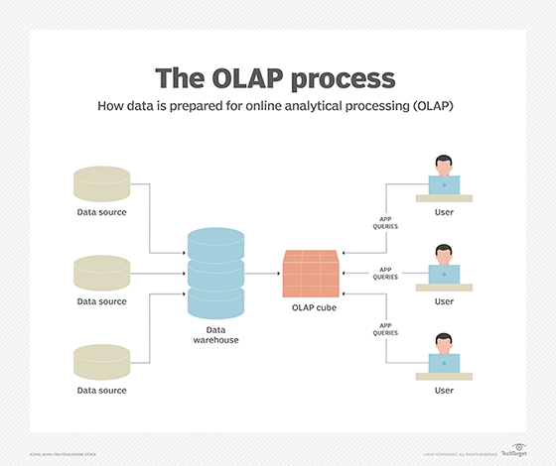

**. Supply Chain Management (SCM)**

**Supply Chain Management (SCM) :-**

SCM stands for Supply Chain Management. Supply Chain refers to a connected network of individuals, organisations, resources, activities, and technologies, all of which are involved in process of manufacturing to supply of product or service. Supply Chain Management refers to management of flow of all processes and goods and services starting from supply of raw materials to delivery of final product.

Supply Chain Management is the active management of supply chain activities which includes required integrated planning and execution of processes for optimizing flow of material, information and capital in functions. It is inter organizational system which allows companies to efficiently handle the entire production flow of a good or service.

**Difference between ERP and SCM :-**

|  |  |  |
| --- | --- | --- |
| S.No. | ERP | SCM |
| 01. | Enterprise Resource Planning covers a wide range of functionalities. | Supply Chain Management covers limited supply chain functionalities |
| 02. | Enterprise Resource Planning is highly complex. | Supply Chain Management is relatively less complex. |
| 03. | ERP focuses on business’s internal work processes. | SCM focuses on supply chain activities of involved external parties. |
| 04. | It integrates and optimizes business processes limited to boundary of single organization. | It integrates and optimizes business processes of single organization as well as interacts with other business partners involved in supply chain. |
| 05. | Enterprise Resource Planning is relatively static in terms of sourcing. | Supply Chain Management is relatively dynamic in terms of sourcing. |

**UNIT -2:-**

# ERP Implementation Life-Cycle:-

[Enterprise Resource Planning (ERP)](https://www.geeksforgeeks.org/evolution-of-erp-system/) is made to automate any task. With ERP, it is easy to manage every department under one single database.

Erp implementation is use to build our business and it is use for make profit in our business.

**Different phases of ERP Implementation :**

1. **Pre-evaluation screening :**  
   This phase starts when company decides to go for ERP system. For this, search for package starts. It is time-consuming process because every package has to analyze first before reaching to any decision. As all packages are not same and each has its own strengths and weakness. This process should eliminate those packages that are not suitable for company’s business processes.
2. **Package Evaluation :**  
   It is the most important phase in implementation. This phase depends on success and failure of entire project with package selection. Most important factor while selecting any package is that not every package can be totally perfect for project but at-least it should be good fit for project.
3. [Project Planning Phase](https://www.geeksforgeeks.org/software-engineering-project-planning/)**:**  
   This phase plans and designs implementation process.
4. **Gap Analysis :**  
   It is the most crucial phase in this implementation. Here, gaps are analyzed between company’s practices and that practices which are supported by ERP package. It has been estimated that even best ERP package only meets 80-85% of company’s functional requirements.
5. [Re-engineering](https://www.geeksforgeeks.org/software-engineering-re-engineering/)**:**  
   It is the fundamental rethinking and radical redesign of business processes to achieve improvements.
6. **Customization :**  
   It is the main functional area of ERP Implementation. Arrived solution must match with overall goals of company. Prototype should allow for thorough testing and attempts to solve logistical problem.
7. **Implementation Team Training :**  
   Now after above processes, implementation team knows how to implement system. This is phase where company trains its employees to implement and later run system.
8. **Testing :**  
   This is the phase where team break system. Sometimes, system overloads or multiple users trying to login at same time etc. Test cases are designed specifically to find weak links in system. Different types of testing are: Unit testing, integration testing, acceptance testing, security testing, performance and stress testing.
9. **Going Live :**  
   Once technical and functional side is properly working and testing is done. There comes next phase i.e, “Going Live”. Once system is ‘live’, old system is removed & new system is used for doing business.
10. **End-User Training :**  
    This is the phase where user of system is given training on how to use system. Employees and their skills are identified and training is given to them in groups based on their current skills. Every employee is provided with training of job which he is going to perform.
11. **Post-Implementation :**  
    It is the most important and critical factor. Post Implementation is based on two words- Operation and Maintenance of system. Duration of this phase depends on training efficiency. Necessary enhancements & upgrades are made in this phase.

* **ERP IMPLEMENTATION STETIGY:-**

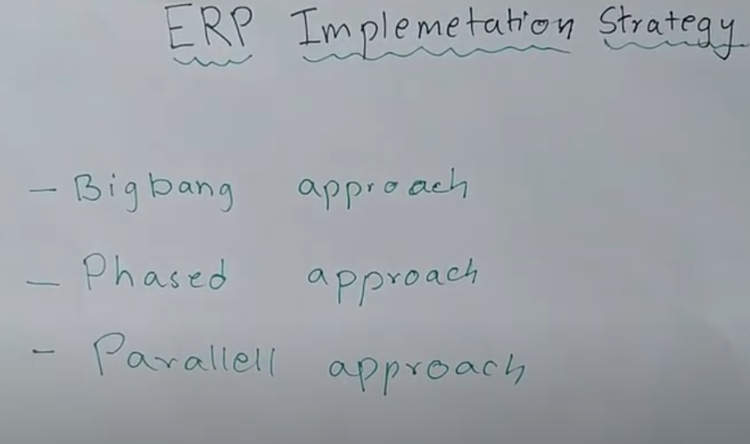

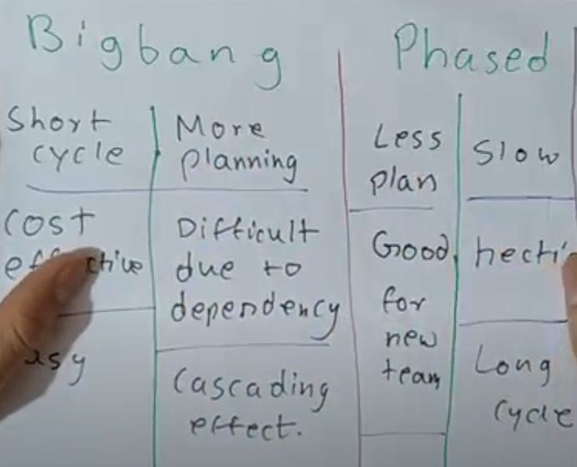

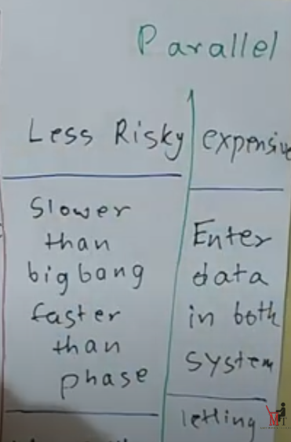

# Hidden Cost :-

Hidden Cost behind ERP Implementation. Hidden cost is a common point in Companies when implementing an ERP System.

ERP creating , analyzing flaws , Implementing , Removing Flaws and finalizing ERP System are the important steps for Creating ERP System .  in this process there are some cost hidden which are not included in the Creating ERP System.

**Some common Hidden Cost in ERP Implementation :**

1.labor costs

2.Training cost

3.testing , re- testing and testing again

4.costomer dissatisfaction

5.Re-Engineering process

6.data conversion, Retesting and Testing Again

**4.** Customization

1. **Labor Costs –** Labor is the major part of ERP implementation. These are the person’s who are major part of designing of the ERP. For example : In a company if some organization order to create ERP for them then it is created by ERP Implementation Company. But Employee’s salary doesn’t depend upon the only this project. Their Salary is fixed and is independent on how much they contributed on how many projects of developing ERP.

**2.Training Cost –when company decide to build your business in ERP system then company have give the training of employee to use of ERP system then some cost will utilize in training that cost is called training cost.**

**3.Testing, Retesting and testing again: When tester will test ERP system after created then that will be take some cost for testing . that cost is called Testing cost.**

**4.Customer Dissatisfaction –** When an ERP is handed on to the Customer that is organization so at that time sometime happens that the provided ERP System doesn’t matched with the requirement of customers. So at that time the Vendor’s has to make some changes to the ERP System which meets the requirements of the Customer which is an extra cost to them.

**5.Re-engineered Processes –** Re-engineered process means a company recreate it’s business process or ERP with the goal of improvement by removing flaws faced in previous process. So also consist of hidden cost like when a company created an ERP system so firstly it goes for testing after that final product(ERP) is provided to the other company. So when that company really implemented the system at that time some flaws are also caused so for removing this the ERP system is goes for updating.

**5.when**  Customer Dissatisfaction

**6.Data Conversion –** When an organization buy an ERP system so, at that time data is not import itself to new System. An organization have to pay for it so that without any difficulty the data is imported from previous system to new system**6.** Re-engineered Processes

## **ERP Implementation:-**

An ERP system integrates many functions across the business, such as financial management, human resources, sales and manufacturing, to deliver benefits such as increased productivity and efficiency. ERP implementation describes the process of [planning, configuring and deploying an ERP](https://www.netsuite.com/portal/resource/articles/erp/erp-implementation-project-plan.shtml).

* **There is 6 stages to implementation:-**

### 1.Discovery & Planning

### 2. Design

### 3. Development

### 4. Testing

### 5. realise in market

### 6. Support & Updates

* **Vendor:-**

**1. VENDORS :**  
Vendors are the people who develop ERP packages, they spent a huge amount of time and effort in research and development to create the package solution which flexible, easy to use, and efficient. ERP vendors spent a large amount of money so that they become experts to develop flexible ERP Package.

**Roles of Vendors:**

* The vendors should supply product and its documentation as soon as the contract is signed.
* Vendor is responsible to fix bugs that are found during implementation process.
* Vendor also provides training to the company’s users and also to the people who are involved in implementation process.
* Vendors take care of quality control factors while developing ERP.
* Vendors participate in all phases of an implementation in which he gives advice, answers to all technical questions about product and technology.

**2. CONSULTANTS :**  
Consultants are professional people who develop the different methods and techniques to deal with the implementation process and with the various problems that will help during implementation. They are experts in the field of Administration, management, and control activities.

They have experience that ensures successful implementation. The only limitation to Consultants is that they are expensive.

**Roles of Consultants:**

* They have to make a plan to carry activities in the right direction during the implementation process.
* They provide best optimum result such as reduction in cycle time, increased response time, improved productivity to satisfaction of customers.
* They have to make ERP implementation for an organization as their own business.

**3. END USERS :**  
End users are the people who use the ERP system once it has been developed. End-users are given training as to how to use various functions that are automated in the software.

**Roles Of End Users:**

* End users are the people who are doing functions that are automated by ERP System.
* They analyze and provide suggestions where customization needs to take place.
* They should be able to balance their loyalty to the client and project.
* Consultant should create a knowledge base and train people so that knowledge stays in the organization when consultants leave the project.

# Contracts with Vendors:-

# Contracts with vendors are important in business.

# Suppose you want to create a ERP software than you will contact with vender then vender tell you futures of that our company and try to convence you to make the ERP software he will be tell you much benefits of our company .

# And suppose you have convence to create software by that company. But you have not any contract file than venders can cheat (froud) you so contract is important between costomer and vendor at dealing time.

# ERP Contract | Points to be covered in ERP Implementation Agreement |

* **Consultants and Empolyee:-**

# ERP project management and monitoring:-

* 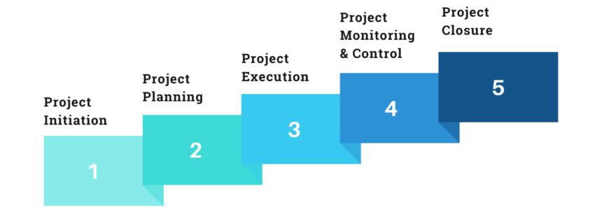

# UNIT-3

# ERP Business Modules:

ERP is used to create a common database in an industry so right information can be reached by right person at right time. There are different section of ERP for various departments in an industry, these are called ERP business modules. Various business modules in ERP are:-

# Different types of Business moduels in ERP are:-

(1.)Finance and Accounting module

(2.) Sales and Distribution module

(3.) HR and Payroll

(4.) Production module

(5.) Material Management module (MM module)

(6.) Plant maintenance

(7.) Project Management.

## **What is ERP Finance Module:-**

An ERP finance module also known as ERP core finance contains accounting records such as balance sheets, general ledger (GL), financial records, expense reporting, and other related transactions. It is also known as ERP core finance and even supports functions like profitability analysis and revenue management.

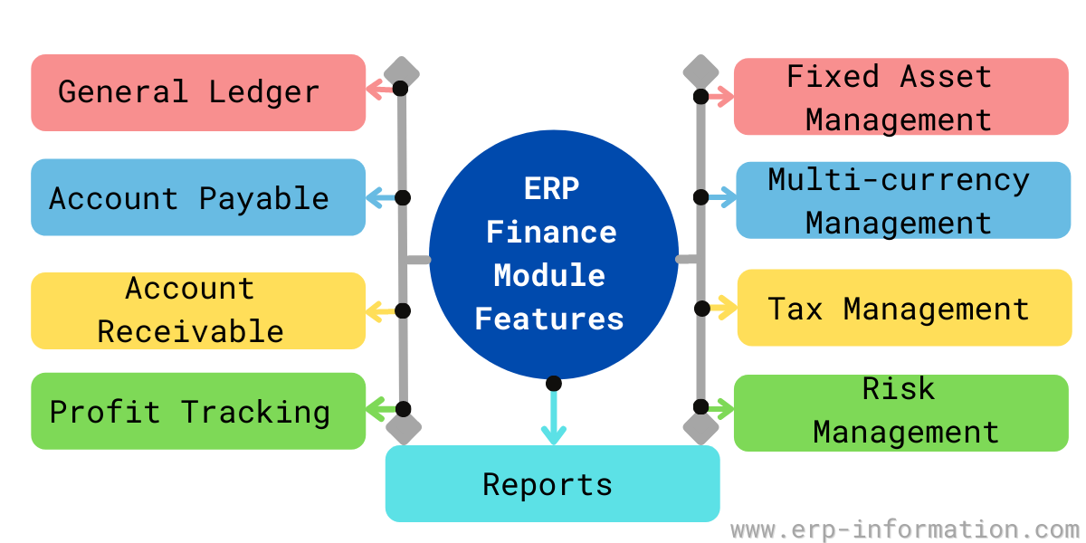

**Human Resource Module(HR):-**

HR module **helps to manage employee information, track employee records like performance reviews, designations, job descriptions, skill matrix, time & attendance tracking**.

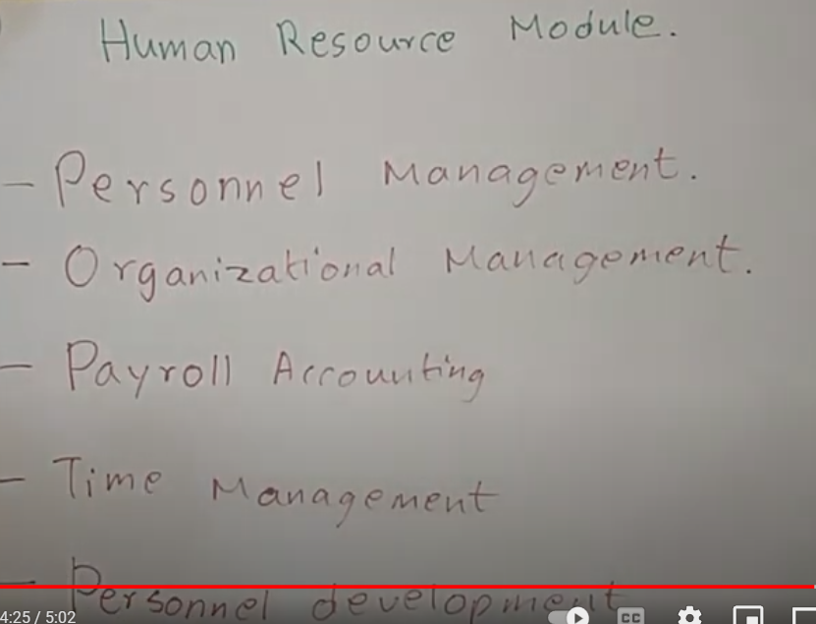

* **Manufacturing in ERP:-**

Which product is use to create or developed of software that product is call manufacturing like:- to create software we need of planning , analizing , coding , testing , finance etc. that is called manufacturing.

Suppose one company want to start your business then that company need to finance , sales management , HR management , project management, production management etc. that is called manufacturing.

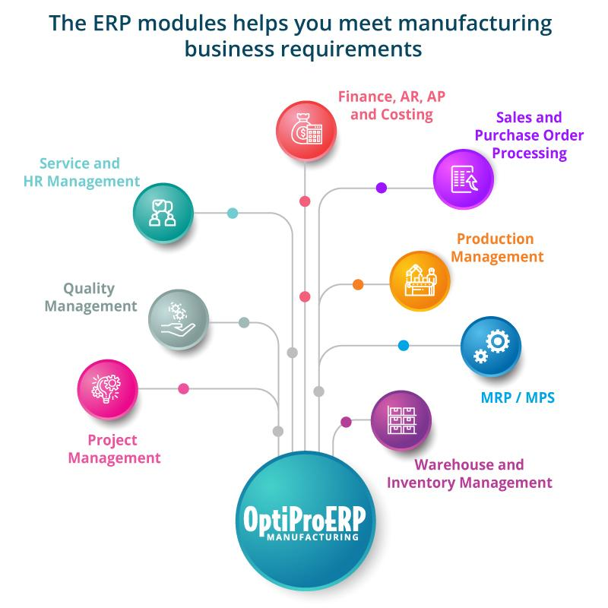

**Material Management Module:-** in [ERP System](https://www.geeksforgeeks.org/introduction-to-erp/) Determines needs, identifies a potential source of supply, compare alternative quotations, create a purchase order, track the status of the purchase order, receive goods, and verify invoices upon receipt of goods. Material management is also important with regard to the warehouse management because companies will know how many raw material, finished products, and spare parts, etc. are available in Warehouse at all the time.

* **material management module:-**
* Collecting material
* Shipping planning
* Container Management
* Inventory Management
* **Quality management:-**

The quality management module is one of the important modules in the ERP system. Quality management helps the industry to inspect and maintain the quality of manufactured items that match the standards for certification. 

**Sales and Distribution:-**

[SAP SD](http://tekslate.com/sap-sd-training/)(Sales and Distribution) is one of the worth noting modules of [SAP ERP](http://www.sap.com/india/product/enterprise-management/erp.html). It encloses all the information regarding customer and services. In an organization, it deals with shipping, selling and transportation of goods and services.

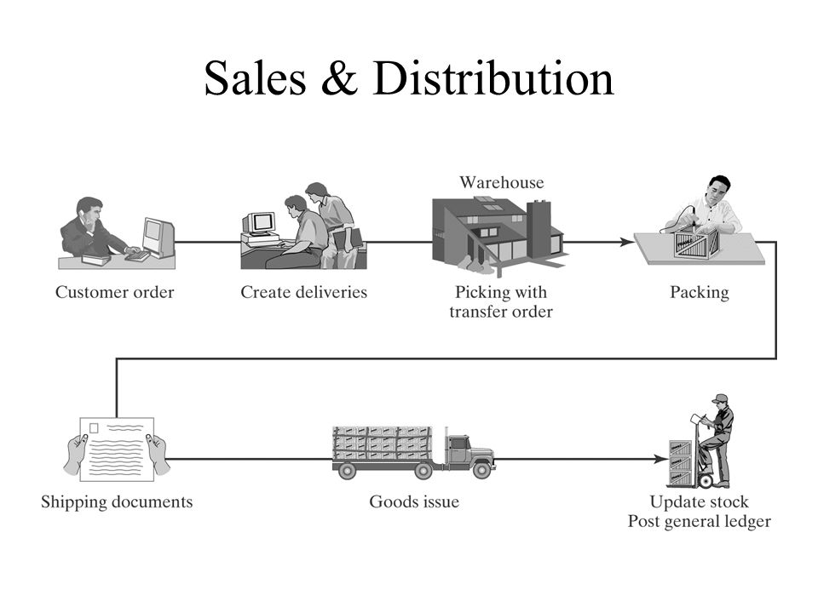

* **Plant Maintenance:-**

**Plant maintenance** is a type of module that provides an **integrated solution** which supports the operational needs of an enterprise-wide system. Plant maintenance is a technic to mainten the machine and software which is available in plant. Plant means It is a place there is maintenance of software or machine.

**UNIT-4**

* **ERP Marketing:-**

ERP Marketing is a globle marketing . It is a online marketing . with ERP marketing company can communicate with other-other country . With ERP marketing Company can build you branches in other-other country and sell your product in that country.

Suppose Amazon is a Company of US . Main Branch of Amazon company Amazon is in US but branches of Amazon company is available in Many country .

So it can be possible by ERP Marketing.

In ERP Marketing company use Many software like :- SAP(system Application Product) , ORACLE , Microsoft etc. These software runs on Windows and lunix.

* **Peoplesoft:-**

It is a ERP software .it is an integral software which is use to grow business on online . It is an oracle software .all manatenence of peoplesoft are depend upon oracle software.

In Peoplesoft day by day features are add when new features come in markets.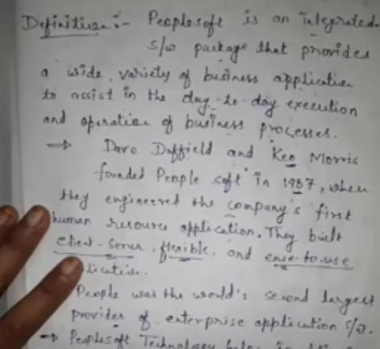

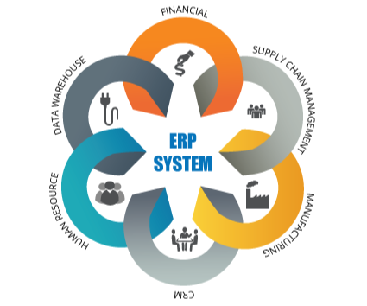

* **Baan ERP :-**

This ERP system runs on Windows, AS/400, and Unix systems and has various modules. The modules are designed for management, distribution, finances, manufacturing, and project estimation. At the core, the system was designed to offer administrative services as well as record keeping. Baan also has the modular software suite, which has multiple small programs to meet the individual needs of the companies, as we have already mentioned.

## **JD Edwards:-**

JD Edwards EnterpriseOne offers a powerful, fully integrated ERP software suite that provides more choice of databases and deployment options, including on-premise, private cloud, public cloud or hybrid cloud for maximized flexibility and low TCO

## **Oracle :-**

ORACLE is company which is create software for multiple company to store data and retrive data from software oracle use SQL(structure Query language ).

Oracle database is a relational database management system. It is also called **OracleDB**, or simply **Oracle**. It is produced and marketed by **Oracle Corporation**. It was created in **1977** by **Lawrence Ellison** and other engineers. It is one of the most popular relational database engines in the IT market for storing, organizing, and retrieving data.

Oracle database was the first DB that designed for **enterprise grid computing** and data warehousing. Enterprise grid computing provides the most flexible and cost-effective way to manage information and applications. It uses SQL queries as a language for interacting with the database.

* **QAD:-**

**QAD**is a company that provides **enterprise resource planning** (**ERP**) software to manufacturing companies. QAD was formed in 1979 by**Pamela Lopker.** **ERP** is business process management software that allows an organization to use a system of integrated applications to manage the business and many back office functions related to technology. **ERP** is to manage and connect information from all core areas of the organization with the aim of improving effective decision making.

* **SSA:-**

SSA Enterprise Resource Planning (ERP) helps automate, plan, collaborate, and execute according to specific business requirements. It is designed for a wide range of manufacturing industries and used by more companies to actually manufacture products than any other ERP system. Its modern, flexible architecture and web-based user interfaces deliver competitive advantage.

* **UNIT:-5**

[**https://youtu.be/xfn6zr7nhWI**](https://youtu.be/xfn6zr7nhWI)

* **EIA :-**

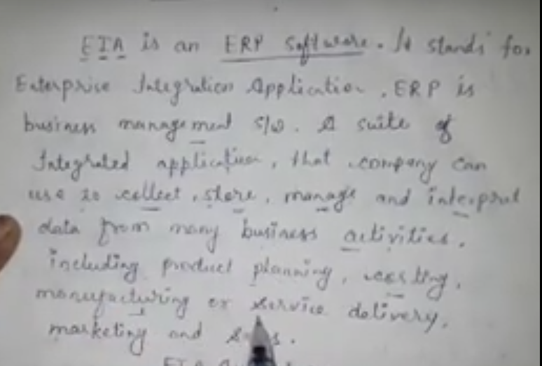

**EIA link for youtube :-** [**https://youtu.be/xfn6zr7nhWI**](https://youtu.be/xfn6zr7nhWI)

**ERP and Internet ERP and Internet**

**ERP and Internet:-**

**Integration of ERP and Internet :**  
Integration of ERP and Internet provide the best benefit to the organizations. It makes it easier to share information and communicate across the entire organization and to the other organization.

**Benefits of ERP Integration :**

* With the help of Internet , Paper based system is replaced with shared resource’s computer system.
* Data is Captured only at Once.
* A Single Copy of Data is stored in such a way that all authorized user’s can be accessed it easily.
* Allow Selection and Manipulation of Data in a variety of Ways to suit the need of different groups in an organization.
* **E-Commerce:-** is a business model that allows to buy and sell goods and services over the internet. It is also known as Electronic Commerce and Internet Commerce. Also, the Transaction of money, funds are also considered as part of E-Commerce.
* **Some E-Commerce Software:**Amazon, Flipkart, Quikr, Paytm, etc.
* 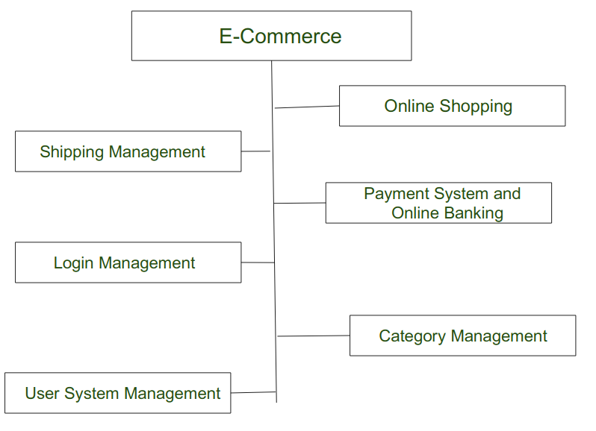

### **Future of ERP:-**

**1. Increased Demand of ERP as Now:**

* As the time fleet, the new generation wants to focus more on starting the startup as compared to working as an Employee due to this the demand for ERP systems will rise.
* At the same point, the pressure of ERP vendors will increases because they have to meet the requirements of users and provide a user-friendly ERP system.
* As more user-friendly ERP is manufactured by vendor’s it results in using new and advantage technology which will satisfy both users and vendors**.**