**Background of the problem statement:**

As a developer, you are assigned to a project. You need to develop a website where program managers of a specific team will add details of professional deals they want to have with vendors. The finance team will check expenses of those teams and will decide their annual budget.

Building a Budget Planner using HTML, CSS & JavaScript. This is done using JavaScript Classes and the Import/Export syntax.

Folder structure:

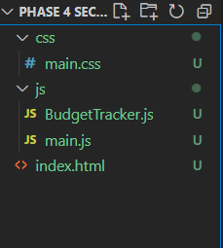

BudgetTracker.js basically is going to be a class which is going to handle everything related to the budget tracker which means this main.js file needs to import this file here .