### A project report for partial fulfilment of the degree of Bachelor of Technology

A project report for partial fulfilment of the

degree of Bachelors of Technology

In Electronics and Communication Engineering on

“Heart Disease Prediction using Machine Learning”

In Electronics and Communication Engineering on

**“HEART BEAT SENSOR”**

Submitted by: -

|  |  |  |
| --- | --- | --- |
| **AYUSH KUMAR** | - | **18700320003** |
| **MD AYAZ ALAM** | - | **18700320026** |
| **RAHUL PANDEY** | - | **18700321126** |
| **RISHAV KUMAR** | - | **18700320030** |

**RISHAV RAJ** - **18700320020**

Under the supervision of

**Prof.** **Dr.Pradip Kumar Ghosh**



Techno International New Town

1/1, Service Rd, DG Block (Newtown), Action Area I,

Newtown, Rajarhat, West Bengal 700156



**CERTIFICATE**

This is to certify that “**AYUSH KUMAR, MD AYAZ ALAM, RAHUL PANDEY, RISHAV KUMAR,RISHAV RAJ**” of the Department of Electronics and Communication Engineering have successfully completed a project on “**HEART BEAT SENSOR**”, session 2020-24 (under Maulana Abul Kalam Azad University of Technology) under my supervision.

Prof.Dr.Pradip Kumar Ghosh Prof. (Dr) Manabendra Maiti

**Project Guide Head of the Dept.**

Department of Electronics and

Communication Engineering

**ABSTRACT**

Heartbeat Sensor is an electronic device that is used to measure the heart rate, i.e. speed of the heartbeat. Monitoring body temperature, heart rate and blood pressure are the basic things that we do in order to keep us healthy. In order to measure the body temperature; we use thermometers and a sphygmomanometer to monitor the Arterial Pressure or Blood Pressure. Heart Rate can be monitored in two ways: one way is to manually check the pulse either at wrists or neck and the other way is to use a Heartbeat Sensor. In this project, we have designed a Heart Rate Monitor System using Arduino and Heartbeat Sensor. You can find the Principle of Heartbeat Sensor; working of the Heartbeat Sensor and Arduino based Heart Rate Monitoring System using a practical heartbeat Sensor.

**CONTENTS**

**CHAPTER**-1

* Introduction
  1. Defining Arduino Uno
  2. History
  3. Hardware
  4. Different Types of Arduino Boards
  5. Feature of Arduino Boards
  6. Arduino Uno
  7. Lily Pad Arduino Board
  8. Arduino Mega (R3) Board
  9. Arduino Leonardo Board
  10. LM358 IC
  11. Pin Configuration of LM358 IC
  12. Features of LM358 IC

CHAPTER-2

* 1. Principle of Heartbeat Sensor
  2. Architecture of Project

CHAPTER-3

* Components Required
* Cost Table
  1. Arduino UNO x 1
  2. 16 x 2 LCD Display x 1
  3. 10KΩ Potentiometer
  4. Heartbeat Sensor Module with Probe (finger Based)
  5. Mini Breadboard
  6. Connecting Wires

CHAPTER-4

* Working of Heartbeat Sensor
  1. Circuit Design of Interfacing Heartbeat Sensor with Arduino
  2. Finger Measuring Heartbeat Module
  3. Working of the circuit

CHAPTER-5

* Code

CHAPTER-6

* Applications of Heart Rate Monitor using Arduino

CHAPTER-7

* Conclusion

CHAPTER-8

* References

**CHAPTER-1**

**Introduction to Heartbeat Sensor**

* 1. **Defining Arduino Uno:**

An Arduino is actually a microcontroller based kit which can be either used directly by purchasing from the vendor or can be made at home using the components, owing to its open source hardware feature. It is basically used in communications and in controlling or operating many devices.

* + - Digital pins: 14 (These pins have only 2 states i.e. high or low or in simple words either 5 V or 0 V no in between values. These pins are mostly used to sense the voltage presence when switch is open or close)
    - Analog pins: 6 (A0 to A5 and they come up with a resolution of 10 bits and they provide flexibility of connecting any external device via these pins. These pins are configured from 0 V to 5 V but they can be configured to high range by using AREF pin or analog Reference () function. ADC (analog to digital convertor) is used to sample these pins. These pins take analog signal and by using ADC convertor they convert this analog signal to number between 0 – 1023)
    - 16 MHz crystal oscillator
    - Out of 14 digital pins, 6 can be used for PWM (pulse width modulation)
    - USB port
    - TX and RX pins (for serial communication)
    - Arduino is an open-source hardware and software company, project and user community that designs and manufactures single-board microcontrollers and microcontroller kits for building digital devices. Its products are licensed under the GNU Lesser General Public License (LGPL) or the GNU General Public License (GPL), permitting the manufacture of Arduino boards and software distribution by anyone.
    - Arduino board designs use a variety of [microprocessors](https://en.wikipedia.org/wiki/Microprocessor) and controllers. The boards are equipped with sets of digital and analog [input/output](https://en.wikipedia.org/wiki/Input/output) (I/O) pins that may be interfaced to various expansion boards ('shields') or [breadboards](https://en.wikipedia.org/wiki/Breadboards) (For prototyping) and other circuits. The boards feature serial communications interfaces, including [Universal](https://en.wikipedia.org/wiki/Universal_Serial_Bus) [Serial Bus](https://en.wikipedia.org/wiki/Universal_Serial_Bus) (USB) on some models, which are also used for loading programs from personal computers. The microcontrollers can be programmed using [C](https://en.wikipedia.org/wiki/C_(programming_language)) and [C++](https://en.wikipedia.org/wiki/C%2B%2B) [programming languages.](https://en.wikipedia.org/wiki/Programming_language) In addition to using traditional [compiler toolchains,](https://en.wikipedia.org/wiki/Compiler) the Arduino project provides an [integrated development environment](https://en.wikipedia.org/wiki/Integrated_development_environment) (IDE) based on the [Processing](https://en.wikipedia.org/wiki/Processing_(programming_language)) language project.
    - The Arduino project started in 2005 as a program for students at the [Interaction](https://en.wikipedia.org/wiki/Interaction_Design_Institute_Ivrea) [Design Institute Ivrea](https://en.wikipedia.org/wiki/Interaction_Design_Institute_Ivrea) in [Ivrea,](https://en.wikipedia.org/wiki/Ivrea) Italy, aiming to provide a low-cost and easy way for novices and professionals to create devices that interact with their environment using [sensors](https://en.wikipedia.org/wiki/Sensor) and [actuators.](https://en.wikipedia.org/wiki/Actuator) Common examples of such devices intended for beginner hobbyists include simple [robots, thermostats](https://en.wikipedia.org/wiki/Robot) and [motion detectors.](https://en.wikipedia.org/wiki/Motion_detector)
    - The name Arduino comes from a bar in Ivrea, Italy, where some of the founders of the project used to meet. The bar was named after Arduino of Ivrea, who was the margrave of the March of Ivrea and King of Italy from 1002 to 1014.
  1. **History**:

The Arduino project was started at the [Interaction Design Institute Ivrea](https://en.wikipedia.org/wiki/Interaction_Design_Institute_Ivrea) (IDII) in [Ivrea,](https://en.wikipedia.org/wiki/Ivrea) Italy. At that time, the students used a [BASIC Stamp](https://en.wikipedia.org/wiki/BASIC_Stamp) [microcontroller](https://en.wikipedia.org/wiki/BASIC_Stamp) at a cost of $50, a considerable expense for many students. In 2003 Hernando Barragán created the development platform [wiring](https://en.wikipedia.org/wiki/Wiring_(development_platform)) as a Master's thesis project at IDII, under the supervision of Massimo Banzi and [Casey](https://en.wikipedia.org/wiki/Casey_Reas) [Reas.](https://en.wikipedia.org/wiki/Casey_Reas) Casey Reas is known for co-creating, with Ben Fry, the [Processing](https://en.wikipedia.org/wiki/Processing_(programming_language)) development platform. The project goal was to create simple, low cost tools for creating digital projects by non- engineers. The Wiring platform consisted of a [printed circuit](https://en.wikipedia.org/wiki/Printed_circuit_board) [board](https://en.wikipedia.org/wiki/Printed_circuit_board) (PCB) with an [ATmega](https://en.wikipedia.org/wiki/ATmega)168 microcontroller, an IDE based on Processing and library functions to easily program the microcontroller

In 2005, Massimo Banzi, with David Mellis, another IDII student, and David Cuartielles,

addedsupport for the cheaper ATmega8 microcontroller to Wiring. But instead of continuing the work on Wiring, they [forked](https://en.wikipedia.org/wiki/Fork_(software_development)) the project and renamed it *Arduino*

The initial Arduino core team consisted of Massimo Banzi, David Cuartielles, Tom Igoe, Gianluca Martino, and David Mellis, but Barragán was not invited to participate

Following the completion of the Wiring platform, lighter and less expensive versions were distributed in the open-source community

It was estimated in mid-2011 that over 300,000 official Arduinos had been commercially produced, and in 2013 that 700,000 official boards were in users' hands.

In October 2016, Federico Musto, Arduino's former CEO, secured a 50% ownership of the company. In April 2017, [Wired](https://en.wikipedia.org/wiki/Wired_(magazine)) reported that Musto had "fabricated his academic record. On his company's website, personal LinkedIn accounts, and even on Italian business documents, Musto was until recently listed as holding a PhD from the Massachusetts Institute of Technology. In some cases, his biography also claimed an MBA from New York University." Wired reported that neither university had any record of Musto's attendance, and Musto later admitted in an interview with Wired that he had never earned those degrees.

Around that same time, Massimo Banzi announced that the Arduino Foundation would be "a new beginning for Arduino. But a year later, the Foundation still hasn't been established, and the state of the project remains unclear.

The controversy surrounding Musto continued when, in July 2017, he reportedly pulled many [Open source](https://en.wikipedia.org/wiki/Open_source_model) licenses, schematics, and code from the Arduino website, prompting scrutiny and outcry.

In October 2017, Arduino announced its partnership with [ARM Holdings](https://en.wikipedia.org/wiki/ARM_Holdings) (ARM). The announcement said, in part, "ARM recognized independence as a core value of Arduino without any lock-in with the [ARM architecture.](https://en.wikipedia.org/wiki/ARM_architecture)” Arduino intends to continue to work with all technology vendors and architectures.

* 1. **Hardware:**

Arduino is open-source hardware. The hardware reference designs are distributed under a Creative Commons Attribution Share-Alike 2.5 license and are available on the Arduino website. Layout and production files for some versions of the hardware are also available.

Although the hardware and software designs are freely available under copyleft licenses, the developers have requested the name Arduino to be exclusive to the official product and not be used for derived works without permission. The official policy document on use of the Arduino name emphasizes that the project is open to incorporating work by others into the official product. Several Arduino-compatible products commercially released have avoided the project name by using various names ending in – duino

Most Arduino boards consist of an Atmel 8-bit AVR microcontroller (ATmega8, ATmega168, ATmega328, ATmega1280, or ATmega2560) with varying amounts of flash memory, pins, and features. The 32-bit Arduino Due, based on the Atmel SAM3X8E was introduced in 2012. The boards use single or double-row pins or female headers that facilitate connections for programming and incorporation into other circuits. These may connect with add-on modules termed shields. Multiple and possibly stacked shields may be individually addressable via an I²C serial bus. Most boards include a 5 V linear regulator and a 16 MHz crystal oscillator or ceramic resonator. Some designs, such as the Lily Pad, run at 8 MHz and dispense with the onboard voltage regulator due to specific form-factor restrictions.

Arduino microcontrollers are pre-programmed with a boot loader that simplifies uploading of programs to the on-chip flash memory. The default bootloader of the Arduino Uno is the Optiboot bootloader. Boards are loaded with program code via a serial connection to another computer. Some serial Arduino boards contain a level shifter circuit to convert between RS232 logic levels and transistor–transistor logic (TTL) level signals. Current Arduino boards are programmed via Universal Serial Bus (USB), implemented using USB-to-serial adapter chips such as the FTDI FT232.

Some boards, such as later-model Uno boards, substitute the FTDI chip with a separate AVR chip containing USB-to-serial firmware, which is reprogrammable via its own ICSP header. Other variants, such as the Arduino Mini and the unofficial Boarduino, use a detachable USBto-serial adapter board or cable, Bluetooth or other methods.

When used with traditional microcontroller tools, instead of the Arduino IDE, standard AVR in-system programming (ISP) programming is used.

The Arduino board exposes most of the microcontroller's I/O pins for use by other circuits. The Diecimila, Duemilanove, and current Uno[ provide 14 digital I/O pins, six of which can produce pulse-width modulated signals, and six analog inputs, which can also be used as six digital I/O pins. These pins are on the top of the board, via female 0.1-inch (2.54 mm) headers. Several plug-in application shields are also commercially available. The Arduino Nano, and Arduino-compatible Bare Bones Board and Boarduino boards may provide male header pins on the underside of the board that can plug into solderless breadboards.

Many Arduino-compatible and Arduino-derived boards exist. Some are functionally equivalent to an Arduino and can be used interchangeably. Many enhance the basic Arduino by adding output drivers, often for use in school-level education, to simplify making buggies and small robots. Others are electrically equivalent, but change the form factor, sometimes retaining compatibility with shields, sometimes not. Some variants use different processors, of varying compatibility.

* 1. **Different Types of Arduino Boards**
     + Arduino Uno
     + Arduino due
     + Arduino Mega (R3)
     + Arduino Leonardo
  2. **Features of Arduino Boards**

|  |  |  |  |  |
| --- | --- | --- | --- | --- |
| **Arduino Board** | **Processor** | **Memory** | **Digital I/O** | **Analogue I/O** |
| Arduino Uno | 16Mhz ATmega328 | 2KB SRAM,  32KB flash | 14 | 6 input, 0 output |
| Arduino Due | 84MHz AT91SAM3X8E | 96KB SRAM,  512KB flash | 54 | 12 input, 2 output |
| Arduino Mega | 16MHz ATmega2560 | 8KB SRAM,  256KB flash | 54 | 16 input, 0 output |
| Arduino Leonardo | 16MHz ATmega32u4 | 2.5KB SRAM,  32KB flash | 20 | 12 input, 0 output |
|  |  |  |  |  |

* 1. **Arduino Uno**

The Uno is a huge option for your initial Arduino. It consists of 14-digital I/O pins, where 6- pins can be used as PWM (pulse width modulation outputs), 6-analog inputs, a reset button, a power jack, a USB connection and more. It includes everything required to hold up the microcontroller; simply attach it to a PC with the help of a USB cable and give the supply to get started with a AC-to-DC adapter or battery.

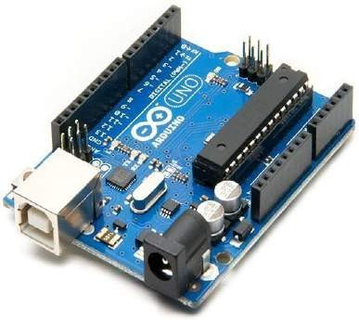

* 1. **Lily Pad Arduino Board**

The Lily Pad Arduino board is a wearable e-textile technology expanded by Leah “Buechley” and considerately designed by “Leah and SparkFun”. Each board was imaginatively designed with huge connecting pads & a smooth back to let them to be sewn into clothing using conductive thread. This Arduino also comprises of I/O, power, and also sensor boards which are built especially for e-textiles. These are even washable.

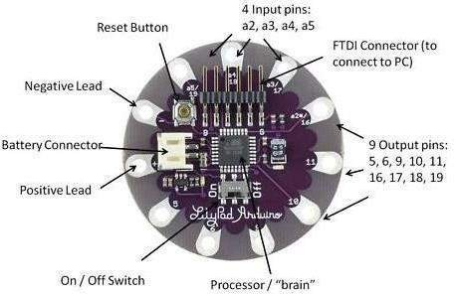

* 1. **Arduino Mega (R3) Board**

The Arduino Mega is similar to the UNO’s big brother. It includes lots of digital I/O pins (fromthat, 14-pins can be used as PWM o/ps), 6-analog inputs, a reset button, a power jack, a USB connection and a reset button. It includes everything required to hold up the microcontroller; simply attach it to a PC with the help of a USB cable and give the supply to get started with a AC-to-DC adapter or battery. The huge number of pins makes this Arduino board very helpful for designing the projects that need a bunch of digital i/ps or o/ps like lots buttons.

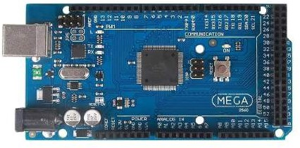

* 1. **Arduino Leonardo Board**

The first development board of an Arduino is the Leonardo board. This board uses one microcontroller along with the USB. That means, it can be very simple and cheap also. Because this board handles USB directly, program libraries are obtainable which let the Arduino board to follow a keyboard of the computer, mouse, etc.

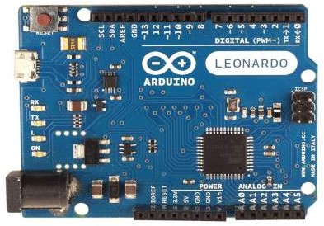

* 1. 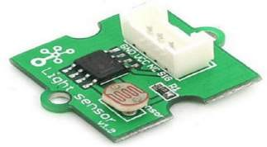**LM358 IC :**

The LM358 IC is a great, low power and easy to use dual channel op-amp IC. It is designed and introduced by national semiconductor. It consists of two internally frequency compensated, high gain, independent op-amps. This IC is designed for specially to operate from a single power supply over a wide range of voltages. The LM358 IC is available in a chip sized package and [applications of this op amp include](https://www.elprocus.com/op-amp-applications-in-electronics/) conventional op-amp circuits, DC gain blocks and transducer amplifiers. LM358 IC is a good, standard [operational amplifier](https://www.elprocus.com/operational-amplifiers/) and it is suitable for your needs. It can handle 3-32V DC supply & source up to 20mA per channel. This op-amp isapt, if you want to operate two separate op-amps for a single power supply. It’s available in an8-pin DIP package

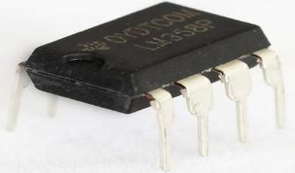

* 1. **Pin Configuration of LM358 IC**

The pin diagram of LM358 IC comprises of 8 pins, where Pin-1 and Pin-8 are o/p of the comparator

Pin-2 and Pin-6 are inverting i/ps

Pin-3 and Pin-5 are non inverting i/ps Pin-4 is GND terminal

Pin-8 is VCC+

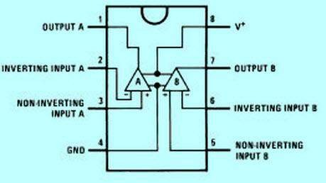

* 1. **Features of LM358 IC**
     + The features of the LM358 IC are
     + It consists of two op-amps internally and frequency compensated for unity gain
     + The large voltage gain is 100 dB
     + Wide bandwidth is 1MHz
     + Range of wide power supplies includes single and dual power supplies
     + Range of Single [power supply](https://www.elprocus.com/switch-mode-power-supply-working/) is from 3V to 32V
     + Range of dual power supplies is from + or -1.5V to + or -16V
     + The supply current drain is very low, i.e., 500 μA
     + 2mV low i/p offset voltage
     + Common mode i/p voltage range comprises ground
     + The power supply voltage and differential i/p voltages are similaro/p voltage swing is large.

**Monitoring heart rate is very important** for athletes, patients as it determines the condition of the heart (just heart rate). There are many ways to measure heart rate and the most precise one is using an Electrocardiography

But the more easy way to monitor the heart rate is to use a Heartbeat Sensor. It comes in different shapes and sizes and allows an instant way to measure the heartbeat.

Heartbeat Sensors are available in Wrist Watches (Smart Watches), Smart Phones, chest straps, etc. The heartbeat is measured in beats per minute or bpm, which indicates the number of times the heart is contracting or expanding in a minute.

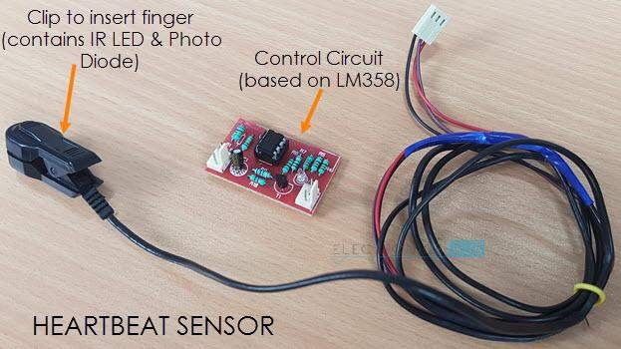

**CHAPTER-2**

* 1. **Principle of Heartbeat Sensor**

The principle behind the working of the Heartbeat Sensor is Photoplethysmograph.According to this principle, the change in the volume of blood in an organ is measured by thechanges in the intensity of the light passing through that organ.

Usually, the source of light in a heartbeat sensor would be an IR LED and the detector would be any Photo Detector like a Photo Diode, an LDR (Light Dependent Resistor) or a Photo Transistor.

With these two i.e. a light source and a detector, we can arrange them in two ways: A Transmissive Sensor and a Reflective Sensor.

In a Transmissive Sensor, the light source and the detector are place facing each other and the finger of the person must be placed in between the transmitter and receiver.

Reflective Sensor, on the other hand, has the light source and the detector adjacent to each other and the finger of the person must be placed in front of the sensor.

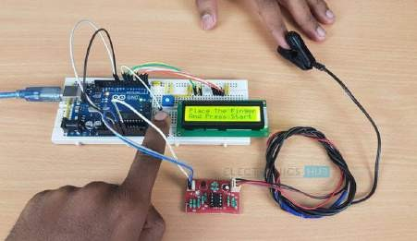

* 1. **Architecture of Project**

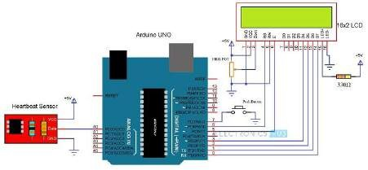

The following image shows the circuit diagram of the Arduino based Heart Rate Monitor using Heartbeat Sensor. The sensor has a clip to insert the finger and has three pins coming out of it for connecting VCC, GND and the Data.

Heart beat sensor module’s output pin is directly connected to pin 8 of arduino. Vcc andGND are connected to Vcc and GND. A 16x2 LCD is connected with arduino in [4-bit mode.](http://circuitdigest.com/microcontroller-projects/arduino-lcd-interfacing-tutorial) Control pin RS, RW and En are directly connected to arduino pin 12, GND and 11. And data pin D4-D7 is connected to pins 5, 4, 3 and 2 of arduino. And one push button is added for resetting reading and another is used to start the system for reading pulses. When we need to count heart rate, we press start button then arduino start counting pulses and also start counter for five seconds. This start push button is connected to pin 7 and reset push button is connectedto pin 6 of arduino with respect to ground.

**CHAPTER-3**

**Components Required**

* + - Arduino UNO x 1
    - 16 x 2 LCD Display x 1
    - 10KΩ Potentiometer
    - 330Ω Resistor (Optional – for LCD backlight)
    - Push Button
    - Heartbeat Sensor Module with Probe (finger based)
    - Mini Breadboard
    - Connecting Wires

**Cost Table:-**

|  |  |
| --- | --- |
| Arduino Uno (1) | Rs - 1,440 |
| 16 x 2 LCD Display (1) | Rs - 270 |
| 10KΩ Potentiometer (1) | Rs - 10 |
| 330Ω Resistor  (Optional – for LCD backlight) | Rs – 5 (Approx) |
| Push Button (1) | Rs – 50 |
| Heartbeat Sensor Module with Probe (finger  based) (1) | Rs - 880 |
| Mini Breadboard (1) | Rs - 70 |
| Connecting Wires | Rs - 120 |
| **TOTAL** | **Rs – 2,845 (approx)** |



* 1. 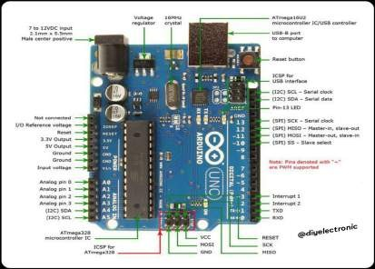**Arduino UNO x 1**

**Defining Arduino:** An Arduino is actually a microcontroller-based kit which can be either used directly by purchasing from the vendor or can be made at home using the components, owing to its open source hardware feature. It is basically used in communications and in controlling or operating many devices.

**How to use Arduino Board?**

The 14 digital input/output pins can be used as input or output pins by using pin Mode, digital Read and digital Write functions in Arduino programming. Each pin operates at 5V and can provide or receive a maximum of 40mA current and has an internal pull-up resistor of 20- 50 K Ohms which are disconnected by default. Out of these 14 pins, some pins have specific functions as listed below:

**Serial Pins 0 (Rx) and 1 (Tx):** Rx and Tx pins are used to receive and transmit TTL serial data. They are connected with the corresponding ATmega328P USB to TTL serial chip.

**External Interrupt Pins 2 and 3:** These pins can be configured to trigger an interrupt on a low value, a rising or falling edge, or a change in value.

**PWM Pins 3, 5, 6, 9 and 11:** These pins provide an 8-bit PWM output by using analog write function.

**SPI Pins 10 (SS), 11 (MOSI), 12 (MISO) and 13 (SCK):** These pins are used for SPI communication.

**In-built LED Pin 13:** This pin is connected with a built-in LED, when pin 13 is HIGH – LED is on and when pin 13 is LOW, it’s off.

Along with 14 Digital pins, there are 6 analog input pins, each of which provides 10 bits of resolution, i.e. 1024 different values. They measure from 0 to 5 volts, but this limit can be increased by using AREF pin with analog Reference () function.

Analog pin 4 (SDA) and pin 5 (SCA) also used for TWI communication using Wire library. Arduino Uno has a couple of other pins as explained below:

**AREF:** Used to provide reference voltage for analog inputs with analog Reference function.

**Reset Pin:** Making this pin LOW, resets the microcontroller.

**How to program on arduino**:

The Arduino tool window consists of the toolbar with the buttons like verify, upload, new, open, save, serial monitor. It also consists of a text editor to write the code, a message area which displays the feedback like showing the errors, the text console which displays the output and a series of menus like the File, Edit, Tools menu. Thus, the code is uploaded by the bootloader onto the microcontroller.

* 1. **16 x 2 LCD Display x 1**

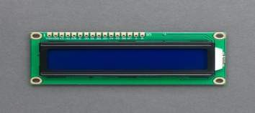

A liquid-crystal display (LCD) is a [flat-panel display](https://en.wikipedia.org/wiki/Flat_panel_display) or other [electronically modulated](https://en.wikipedia.org/wiki/Electro-optic_modulator) [optical device t](https://en.wikipedia.org/wiki/Electro-optic_modulator)hat uses the light-modulating properties of [liquid crystals](https://en.wikipedia.org/wiki/Liquid_crystal) combined with [polarizers.](https://en.wikipedia.org/wiki/Polarizer) Liquid crystals do not emit light directly, instead using a [backlight](https://en.wikipedia.org/wiki/Backlight) or [reflector](https://en.wikipedia.org/wiki/Reflector_(photography)) to produce images in color or [monochrome.](https://en.wikipedia.org/wiki/Monochrome) LCDs are available to display arbitrary images (as in a general-purpose computer display) or fixed images with low information content, which can be displayed or hidden, such as preset words, digits, and [seven- segment displays,](https://en.wikipedia.org/wiki/Seven-segment_display) as in a [digital clock.](https://en.wikipedia.org/wiki/Digital_clock) They use the same basic technology, except that arbitrary images are made from a matrix of small [pixels,](https://en.wikipedia.org/wiki/Pixel) while other displays have larger elements. LCDs can either be normally on (positive) or off (negative), depending on the polarizer arrangement. For example, a character positive LCD with a backlight will have black lettering on a background that is the color of the backlight, and a character negative LCD will have a black background with the letters being of the same color as the backlight. Optical filters are added to white on blue LCDs to give them their characteristic appearance.

* 1. **10KΩ Potentiometer**

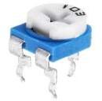

A potentiometer is a three-[terminal resistor](https://en.wikipedia.org/wiki/Terminal_(electronics)) with a sliding or rotating contact that forms an adjustable voltage divider. If only two terminals are used, one end and the wiper, it acts as a [variable resistor](https://en.wikipedia.org/wiki/Potentiometer#Rheostat) or [rheostat](https://en.wikipedia.org/wiki/Potentiometer#Rheostat).

The measuring instrument called a [potentiometer](https://en.wikipedia.org/wiki/Potentiometer_(measuring_instrument)) is essentially a [voltage divider](https://en.wikipedia.org/wiki/Voltage_divider) used for measuring [electric potential](https://en.wikipedia.org/wiki/Electric_potential) (voltage); the component is an implementation of the same principle, hence its name.

Potentiometers are commonly used to control electrical devices such as volume controls on audio equipment. Potentiometers operated by a mechanism can be used as position [transducers,](https://en.wikipedia.org/wiki/Transducer) for example, in a [joystick.](https://en.wikipedia.org/wiki/Joystick) Potentiometers are rarely used to directly control significant power (more than a [watt](https://en.wikipedia.org/wiki/Watt)), since the power dissipated in the potentiometer would be comparable to thepower in the controlled load.

* 1. **Heartbeat Sensor Module with Probe (finger based)**

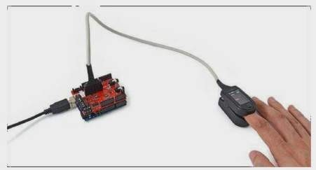

A heart rate monitor (HRM) is a personal monitoring device that allows one to measure/display [heart rate](https://en.wikipedia.org/wiki/Heart_rate) in real time or record the heart rate for later study. It is largely used to gather heart rate data while performing various types of [physical exercise.](https://en.wikipedia.org/wiki/Physical_exercise) Measuring electrical heart information is referred to as [Electrocardiography (ECG or EKG).](https://en.wikipedia.org/wiki/Electrocardiography)

Medical heart rate monitoring used in hospitals is usually wired and usually multiple sensors are used. Portable medical units are referred to as a [Holter monitor.](https://en.wikipedia.org/wiki/Holter_monitor) Consumer heart rate monitors are designed for everyday use and do not use wires to connect.

* 1. **Mini Breadboard**

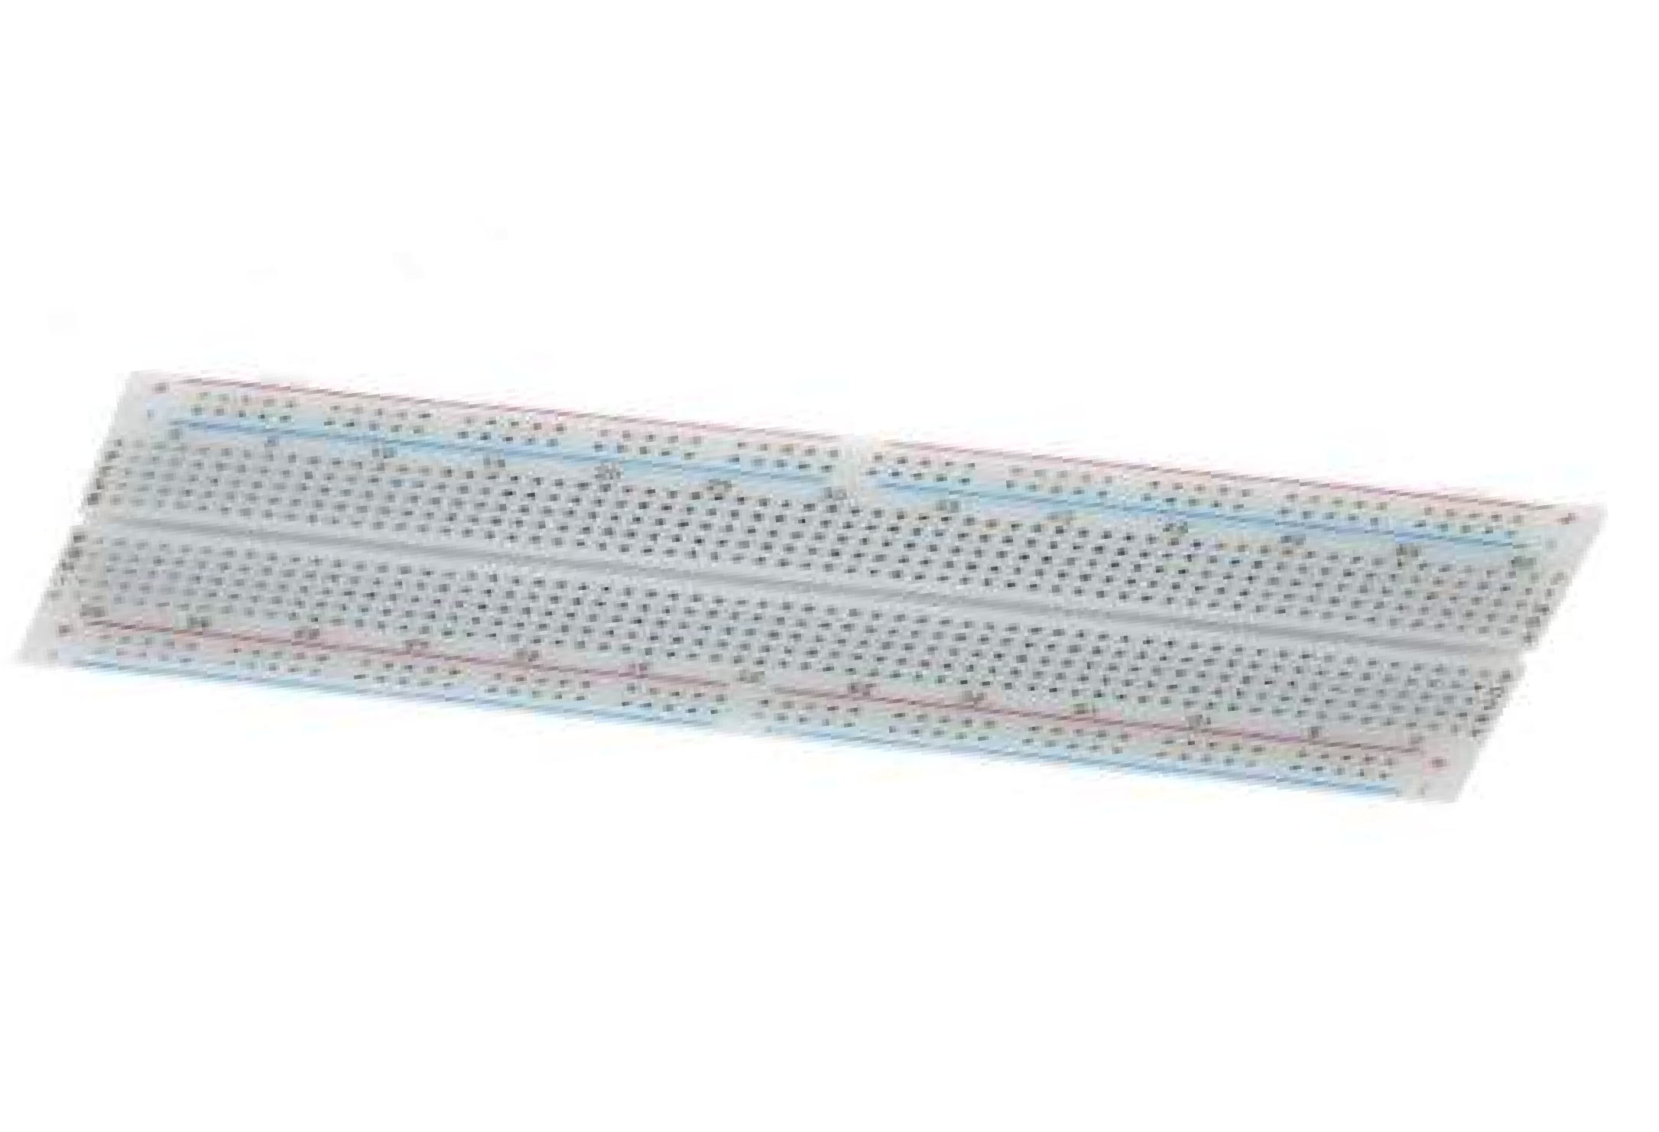

* 1. **Connecting Wires**

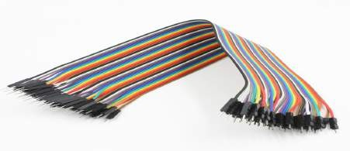

Jumper wires are simply wires that have connector pins at each end, allowing them tobe used to connect two points to each other without soldering. Jumper wires are typically used with breadboards and other prototyping tools in order to make it easy to change a circuitas needed.

**CHAPTER-4**

**Working of Heartbeat Sensor**

A simple Heartbeat Sensor consists of a sensor and a control circuit. The sensorpart of the Heartbeat Sensor consists of an IR LED and a Photo Diode placed in a clip.

The Control Circuit consists of an Op-Amp IC and few other components that help in connecting the signal to a Microcontroller. The working of the Heartbeat Sensor can be understood better if we take a look at its circuit diagram.

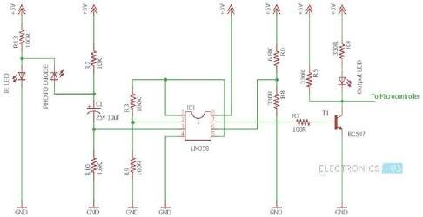

The above circuit shows the finger type heartbeat sensor, which works by detecting thepulses. Every heartbeat will alter the amount of blood in the finger and the light from the IR LED passing through the finger and thus detected by the Photo Diode will also vary.

The output of the photo diode is given to the non – inverting input of the first op – amp through a capacitor, which blocks the DC Components of the signal. The first op – amp cats as a non– inverting amplifier with an amplification factor of 1001.

The output of the first op – amp is given as one of the inputs to the second op – amp, which acts as a comparator. The output of the second op – amp triggers a transistor, from which, the signal is given to a Microcontroller like Arduino.

The Op – amp used in this circuit is LM358. It has two op – amps on the same chip. Also, the transistor used is a BC547. An LED, which is connected to transistor, will blink when the pulse is detected.

Working of this project is quite easy but a little calculation for calculating heart rate is required. There are several methods for calculating heart rate, but here we have read only five pulses. Then we have calculated total heart beat in a minute by applying the below formula:

Five pulse time=time2-time1;

Single pulse time= Five pulse time /5; rate=60000/ Single pulse time;

where time1 is first pulse counter value time2 is list pulse counter value

rate is final heart rate.

When first pulse comes, we start counter by using timer counter function in arduino that is millis; And take first pulse counter value form millis;. Then we wait for five pulses. After getting five pulses we again take counter value in time2 and then we subtract time1 from time2 to take original time taken by five pulses. And then divide this time by 5 times for getting single pulse time. Now we have time for single pulse and we can easily find the pulse in one minute, dividing 600000 ms by single pulse time.

Rate= 600000/single pulse time.

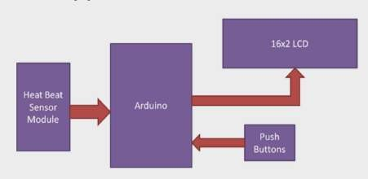

In this project we have used **Heart beat sensor module** to detect Heart Beat. This sensor module contains an IR pair which actually detect heart beat from blood. Heart pumps the blood in body which is called heart beat, when it happens the blood concentration in body changes. And we use this change to make a voltage or pulse electrically.

* 1. **Circuit Design of Interfacing Heartbeat Sensor with Arduino**

The circuit design of Arduino based Heart rate monitor system using Heart beat Sensor is very simple. First, in order to display the heartbeat readings in bpm, we have to connect a 16×2 LCD Display to the Arduino UNO.

The 4 data pins of the LCD Module (D4, D5, D6 and D7) are connected to Pins 1, 1, 1 and 1 of the Arduino UNO. Also, a 10KΩ Potentiometer is connected to Pin 3 of LCD (contrast adjust pin). The RS and E (Pins 3 and 5) of the LCD are connected to Pins 1 and 1 of the Arduino UNO.

Next, connect the output of the Heartbeat Sensor Module to the Analog Input Pin (Pin 1) of Arduino.

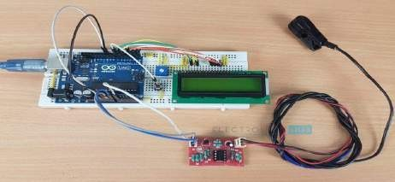

* 1. **Finger measuring heartbeat module**

This project uses bright infrared (IR) LED and a phototransistor to detect the pulse ofthe finger, a red LED flashes with each pulse. Pulse monitor works as follows: The LED is the light side of the finger, and phototransistor on the other side of the finger, phototransistor usedto obtain the flux emitted, when the blood pressure pulse by the finger when the resistance of the photo transistor will be slightly changed. The project's schematic circuit as shown, we chose a very high resistance resistor R1, because most of the light through the finger is absorbed,it is desirable that the phototransistor is sensitive enough. Resistance can be selected by experiment to get the best results. The most important is to keep the shield stray light into the phototransistor. For home lighting that is particularly important because the lights at home mostly based 50HZ or 60HZ fluctuate, so faint heartbeat will add considerable noise.

When running the program the measured values are printed. To get a real heartbeat from this could be challenging.

* 1. **Working of the Circuit**

Upload the code to Arduino UNO and Power on the system. The Arduino asks us to place our finger in the sensor and press the switch

Place any finger (except the Thumb) in the sensor clip and push the switch (button). Based on the data from the sensor, Arduino calculates the heart rate and displays the heartbeat in bpm.

While the sensor is collecting the data, sit down and relax and do not shake the wire as it might result in a faulty value.

After the result is displayed on the LCD, if you want to perform another test, just push the rest button on the Arduino and start the procedure once again

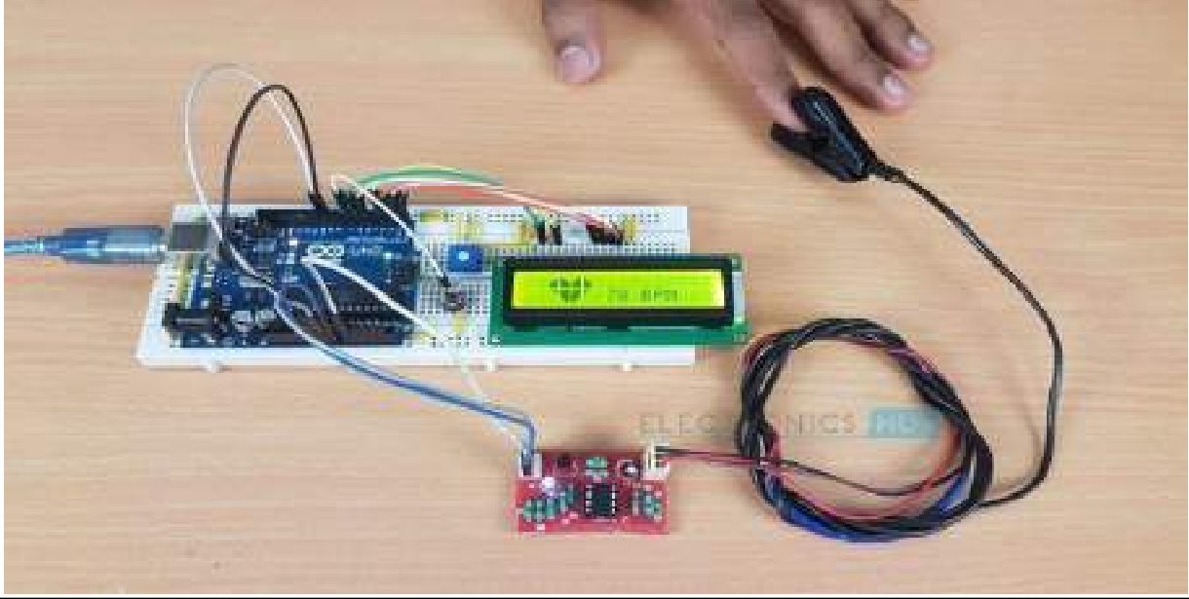

**CHAPTER-5**

**Code:-**

#include <LiquidCrystal.h> LiquidCrystal lcd(6, 5, 3, 2, 1, 0); int data=A0;

int start=7; int count=0; unsigned long temp=0;

byte customChar1[8] = {0b00000,0b00000,0b00011,0b00111,0b01111,0b01111,0b01111,0b01111}; byte customChar2[8] = {0b00000,0b11000,0b11100,0b11110,0b11111,0b11111,0b11111,0b11111}; byte customChar3[8] = {0b00000,0b00011,0b00111,0b01111,0b11111,0b11111,0b11111,0b11111}; byte customChar4[8] = {0b00000,0b10000,0b11000,0b11100,0b11110,0b11110,0b11110,0b11110}; byte customChar5[8] = {0b00111,0b00011,0b00001,0b00000,0b00000,0b00000,0b00000,0b00000}; byte customChar6[8] = {0b11111,0b11111,0b11111,0b11111,0b01111,0b00111,0b00011,0b00001}; byte customChar7[8] = {0b11111,0b11111,0b11111,0b11111,0b11110,0b11100,0b11000,0b10000}; byte customChar8[8] = {0b11100,0b11000,0b10000,0b00000,0b00000,0b00000,0b00000,0b00000};

void setup()

{

lcd.begin(16, 2); lcd.createChar(1, customChar1); lcd.createChar(2, customChar2); lcd.createChar(3, customChar3); lcd.createChar(4, customChar4); lcd.createChar(5, customChar5); lcd.createChar(6, customChar6); lcd.createChar(7, customChar7); lcd.createChar(8, customChar8);

pinMode(data,INPUT); pinMode(start,INPUT_PULLUP);

}

void loop()

{

lcd.setCursor(0, 0); lcd.print("Place The Finger"); lcd.setCursor(0, 1); lcd.print("And Press Start");

while(digitalRead(start)>0);

lcd.clear(); temp=millis();

while(millis()<(temp+10000))

{

if(analogRead(data)<100)

{

count=count+1;

lcd.setCursor(6, 0); lcd.write(byte(1)); lcd.setCursor(7, 0); lcd.write(byte(2)); lcd.setCursor(8, 0); lcd.write(byte(3)); lcd.setCursor(9, 0); lcd.write(byte(4));

lcd.setCursor(6, 1); lcd.write(byte(5)); lcd.setCursor(7, 1); lcd.write(byte(6)); lcd.setCursor(8, 1); lcd.write(byte(7)); lcd.setCursor(9, 1); lcd.write(byte(8));

while(analogRead(data)<100);

lcd.clear();

}

}

lcd.clear(); lcd.setCursor(0, 0); count=count*6; lcd.setCursor(2, 0); lcd.write(byte(1)); lcd.setCursor(3, 0); lcd.write(byte(2)); lcd.setCursor(4, 0); lcd.write(byte(3)); lcd.setCursor(5, 0); lcd.write(byte(4));

lcd.setCursor(2, 1); lcd.write(byte(5)); lcd.setCursor(3, 1); lcd.write(byte(6)); lcd.setCursor(4, 1); lcd.write(byte(7)); lcd.setCursor(5, 1); lcd.write(byte(8)); lcd.setCursor(7, 1);

lcd.print(count); lcd.print(" BPM"); temp=0;

while(1);

}

**CHAPTER-6**

**Applications of Heart Rate Monitor using Arduino**

* A simple project involving Arduino UNO, 16×2 LCD and Heartbeat Sensor Module is designed here which can calculate the heart rate of a person.
* This project can be used as an inexpensive alternative to Smart Watches and other expensive Heart Rate Monitors.

**CHAPTER-7**

**CONCLUSION**

Upload the code to Arduino UNO and Power on the system. The Arduino asks us to place our finger in the sensor and press the switch. Place any finger (except the Thumb) in the sensor clip and push the switch (button). Based on the data from the sensor, arduino calculates the heart rate and displays the heartbeat in bpm.

**CHAPTER-8**

**References:-**

* + [https://www.electronicshub.org/heartbeat-sensor-using-arduino-heart-rate-](https://www.electronicshub.org/heartbeat-sensor-using-arduino-heart-rate-monitor/#Applications_of_Heart_Rate_Monitor_using_Arduino) [monitor/#Applications_of_Heart_Rate_Monitor_using_Arduino](https://www.electronicshub.org/heartbeat-sensor-using-arduino-heart-rate-monitor/#Applications_of_Heart_Rate_Monitor_using_Arduino)
  + <https://www.youtube.com/watch?v=_J7pyL_3-AI>