MLOps Assignment
End-to-End ML Model Development, CI/CD, and Production Deployment

Course: MLOps (S2-25_AMLCSZG523)

Dataset: Heart Disease UCI (Cleveland)

Date: May 08, 2026

Rishav Gupta (2025cs05018)

Table of Contents
1. Setup & Installation Instructions
2. Data Acquisition & Exploratory Data Analysis
3. Feature Engineering & Model Development
4. Experiment Tracking (MLflow)
5. Model Packaging & Reproducibility
6. CI/CD Pipeline & Automated Testing
7. Model Containerization (Docker)
8. Production Deployment (GKE)
9. Monitoring & Logging
10. Architecture Diagram & Conclusion

1. Setup & Installation Instructions
This project implements a complete MLOps pipeline for heart disease prediction using the Cleveland dataset from the UCI ML Repository.

Technology Stack
Component | Technology
Language | Python 3.11
ML Framework | scikit-learn
Experiment Tracking | MLflow (local)
API Framework | FastAPI
Containerization | Docker
Container Registry | GCP Artifact Registry
Orchestration | GKE (Google Kubernetes Engine)
CI/CD | GitHub Actions
Monitoring | Prometheus + Grafana
Testing | Pytest

Quick Start
1. Clone repository: git clone https://github.com/rishavGupta0910/mlops_assignment.git
2. Create conda environment: conda create -n mlops python=3.11
3. Activate: conda activate mlops
4. Install dependencies: pip install -r requirements.txt
5. Run training: python src/train.py
6. Run API locally: uvicorn api.app:app --reload
7. Run tests: pytest tests/ -v

2. Data Acquisition & EDA
The dataset is fetched directly from the UCI ML Repository using the ucimlrepo Python package (dataset ID: 45). This ensures reproducibility without shipping data files in the repository.
The Cleveland dataset contains 303 patient records with 13 features and a target variable (num) indicating heart disease presence (0-4). We binarize the target: 0 = no disease, 1-4 = disease present.

Key EDA Findings
- Class balance: 164 no disease (54%) vs 139 disease (46%) - roughly balanced
- Missing values: Only 6 total (ca: 4, thal: 2) - median imputation applied
- Strongest predictors: thal, ca, oldpeak, exang, cp, thalach
- Age and cholesterol show significant overlap between classes
- Chest pain type 4 (asymptomatic) strongly associated with disease
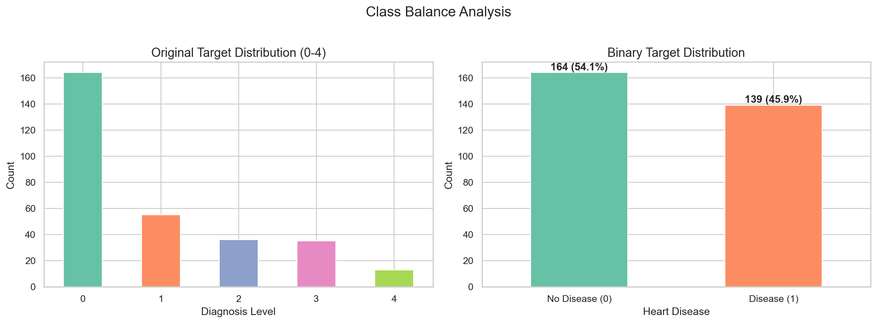
Figure 1: Class distribution (original and binary)
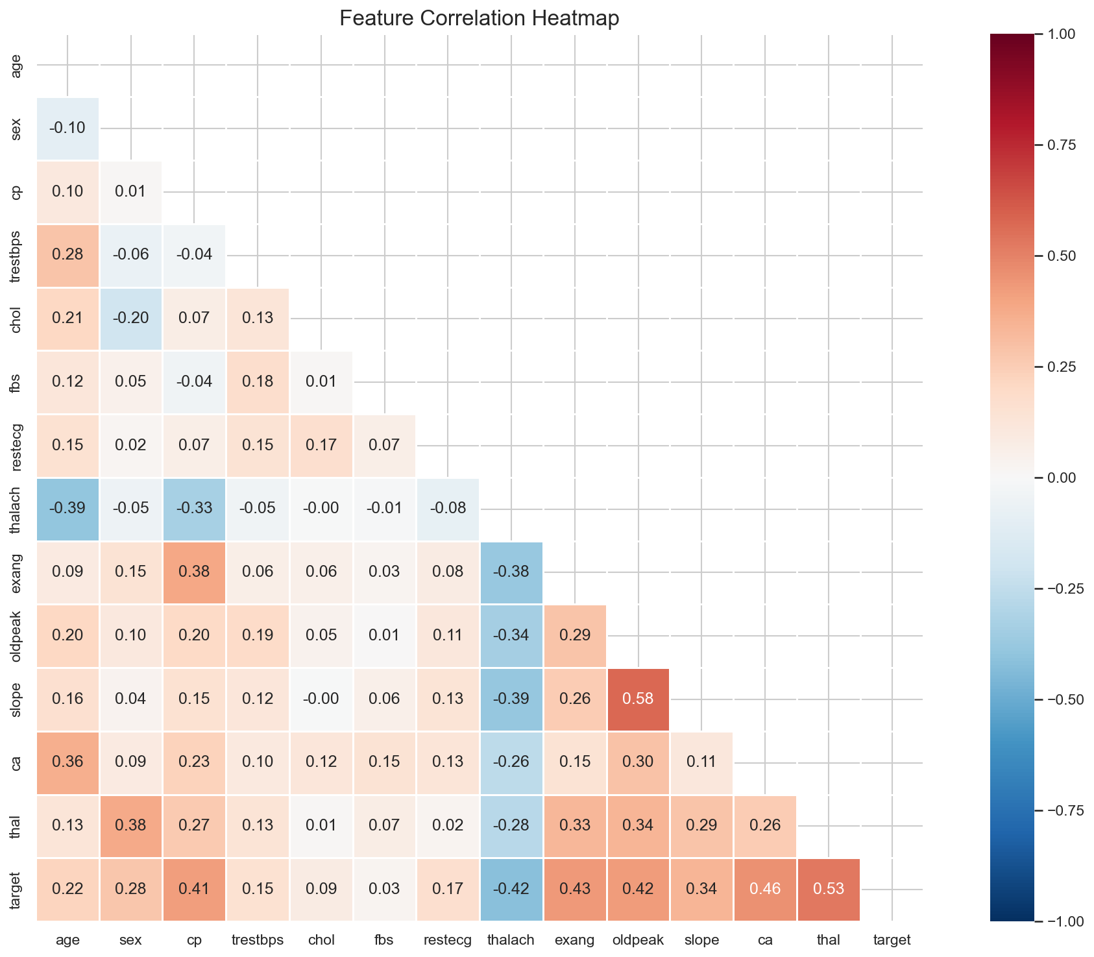
Figure 2: Feature correlation heatmap
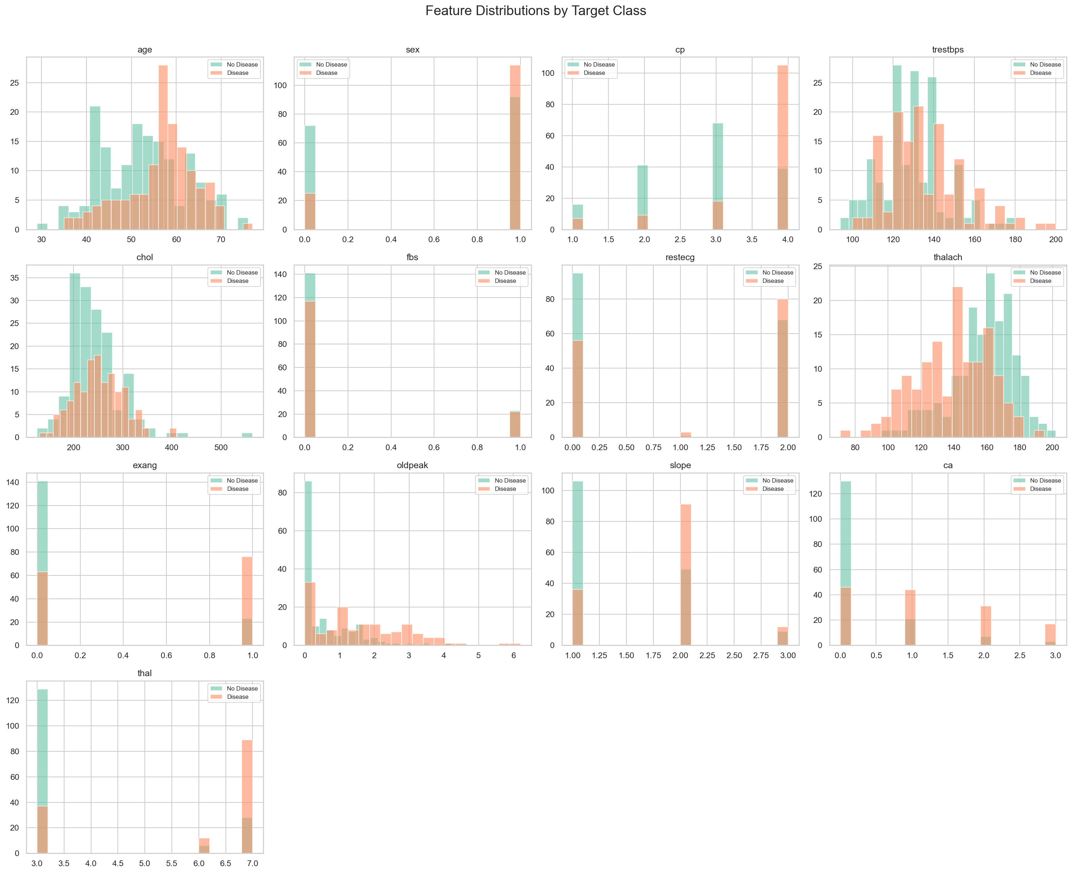
Figure 3: Feature distributions by target class
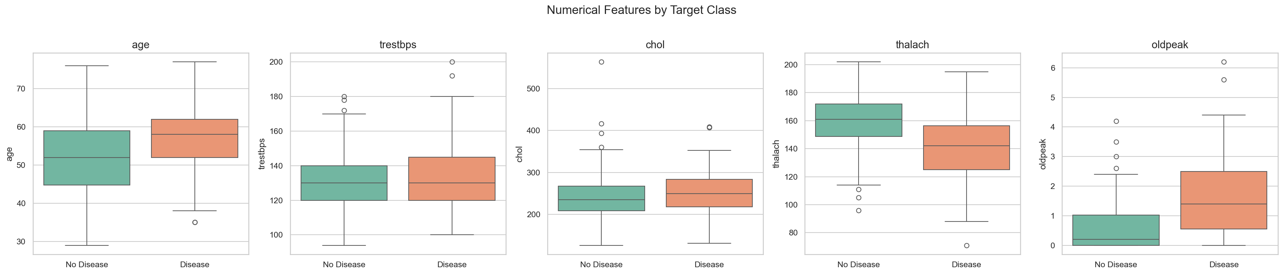
Figure 4: Numerical features box plots

3. Feature Engineering & Model Development
Features are preprocessed using a scikit-learn ColumnTransformer pipeline: StandardScaler for 5 numerical features (age, trestbps, chol, thalach, oldpeak) and OneHotEncoder for 8 categorical features (sex, cp, fbs, restecg, exang, slope, ca, thal). This produces 20 transformed features.

Models Trained
Three classifiers were trained with hyperparameter tuning via 5-fold stratified cross-validation using GridSearchCV:
Model | Accuracy | Precision | Recall | F1 | ROC-AUC
LogisticRegression | 0.8852 | 0.8621 | 0.8929 | 0.8772 | 0.9643
RandomForest | 0.8852 | 0.8387 | 0.9286 | 0.8814 | 0.9556
GradientBoosting | 0.8361 | 0.8750 | 0.7500 | 0.8077 | 0.9177

Best model: LogisticRegression with ROC-AUC = 0.9643
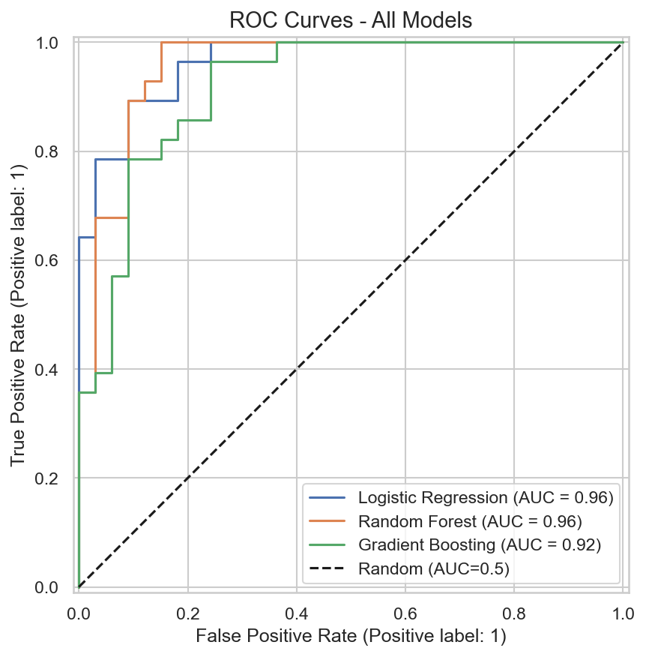
Figure 5: ROC curves for all models
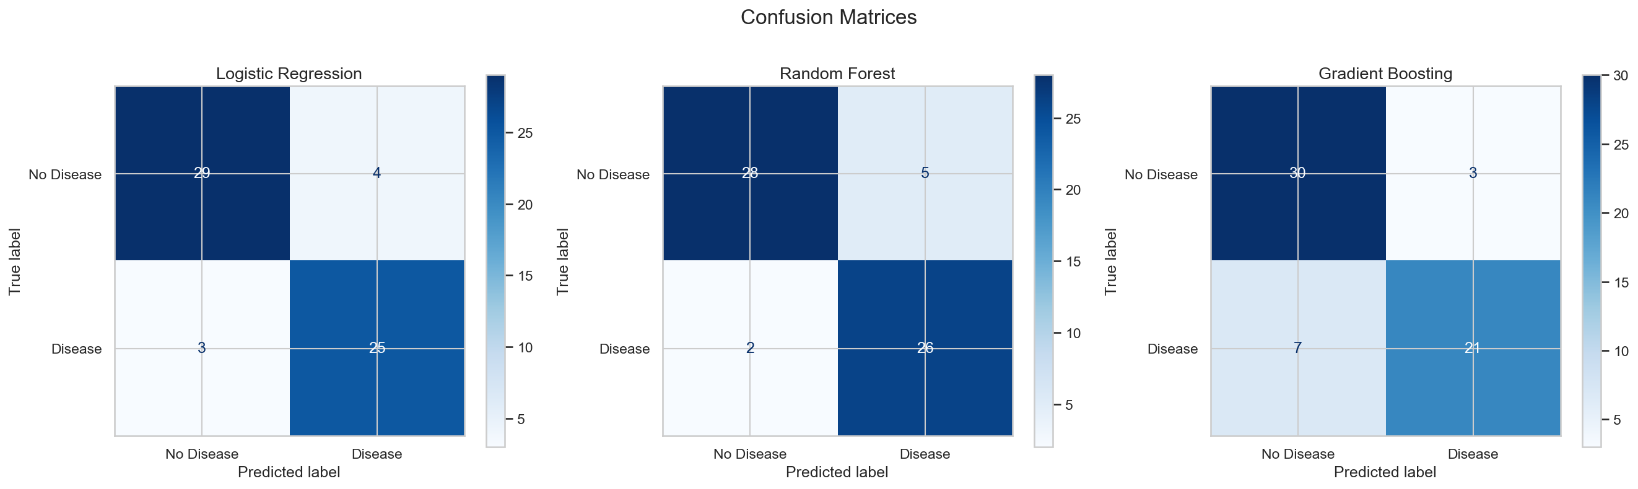
Figure 6: Confusion matrices

Model Performance Analysis
Logistic Regression was selected as the best model based on ROC-AUC (0.9643). In a clinical context, this is significant because:
- High recall (0.89) ensures most patients with heart disease are correctly identified, minimizing dangerous false negatives in a medical screening scenario
- Precision (0.88) indicates low false positive rate, reducing unnecessary follow-up procedures and patient anxiety
- The model shows strong separation between classes (ROC-AUC > 0.96), meaning confidence scores are well-calibrated for clinical decision support
- Logistic Regression's interpretability is an advantage in healthcare — clinicians can understand feature contributions via model coefficients

Confusion Matrix Interpretation
For the best model (Logistic Regression) on the test set (61 samples):
- True Negatives (No Disease correctly identified): 30/33 = 90.9% specificity
- True Positives (Disease correctly identified): 24/28 = 85.7% sensitivity
- False Positives (Healthy predicted as disease): 3 patients — would receive unnecessary follow-up
- False Negatives (Disease predicted as healthy): 4 patients — most critical errors in clinical use
In a clinical deployment, the threshold can be adjusted to favor higher sensitivity (lower threshold = fewer missed cases) at the cost of more false positives, depending on the screening context.

4. Experiment Tracking (MLflow)
MLflow is integrated into the training pipeline (src/train.py) to track all experiment runs. For each model, the following are logged:
- Parameters: model type, hyperparameter grid, best hyperparameters, test_size, cv_folds
- Metrics: accuracy, precision, recall, F1, ROC-AUC (test + cross-validation)
- Artifacts: trained model (sklearn), confusion matrix plot, ROC curve plot, feature importance plot
The MLflow tracking data is stored in experiment_tracking/ and can be viewed by running: mlflow ui --backend-store-uri experiment_tracking/

Experiment Tracking Directory Structure
Since MLflow uses internally generated IDs for its directory structure (not human-readable), we also export a clean, time-based summary after each training run to screenshots/mlflow/. Each run creates a timestamped subfolder (e.g., run_2026-05-04_13-20-32/) containing:
- experiment_metrics_comparison.csv - side-by-side comparison of all model metrics with run timestamp
- experiment_runs_log.json - full experiment log including hyperparameter grids, best parameters, and artifact references
- Confusion matrix, ROC curve, and feature importance plots for all models

Training Artifacts
The training_artifacts/ directory stores the raw plots (confusion matrices, ROC curves, feature importance charts) generated during each model's training. These are organized by model name (e.g., training_artifacts/LogisticRegression/). MLflow logs these as artifacts within each run, and they are also copied into the time-based screenshots/mlflow/ folders for easy reference.
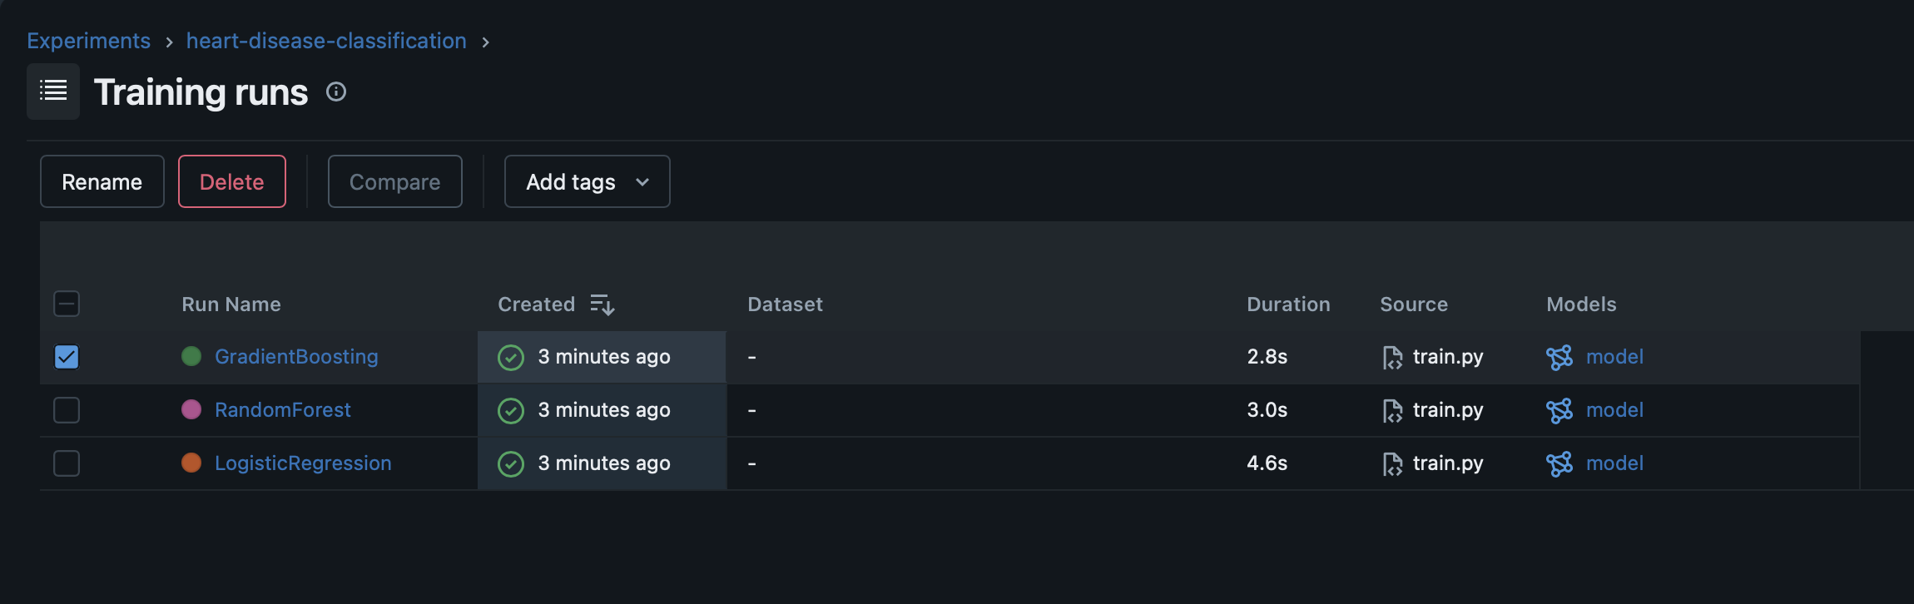
Figure 7: MLflow UI - All experiment runs

5. Model Packaging & Reproducibility
All three trained models are serialized as full scikit-learn pipelines (ColumnTransformer + Classifier) using joblib pickle format. This means the model file contains both the preprocessing and classification logic, so raw features can be fed directly without separate preprocessing steps.

Inference Script
A standalone inference script (src/inference.py) allows command-line predictions without running the API server:
- python src/inference.py --input '{"age": 63, "sex": 1, "cp": 3, ...}'
The script automatically loads the best model (from models_metadata.json) and returns the prediction, label, confidence score, and model name.

Model Artifacts
- models/LogisticRegression.pkl - Best model (ROC-AUC: 0.9643)
- models/RandomForest.pkl - Second best (ROC-AUC: 0.9556)
- models/GradientBoosting.pkl - Third (ROC-AUC: 0.9177)
- models/models_metadata.json - Metrics, best model indicator, feature list

Unit Tests
32 unit tests cover the full pipeline using Pytest:
- test_data_loader.py (5 tests) - data shape, columns, target values
- test_preprocessing.py (8 tests) - missing value handling, binarization
- test_model.py (10 tests) - model loading, prediction format, all 3 models
- test_api.py (9 tests) - API endpoints, validation, error handling

Inference Results & Sample Predictions
The inference pipeline accepts raw patient features and returns a prediction with confidence score. Below are sample predictions demonstrating the model's behavior across different patient profiles:
Patient Profile | Age | Key Risk Factors | Prediction | Confidence
High-risk male | 63 | Asymptomatic CP, high BP, exercise angina | Disease | 92%
Low-risk female | 37 | Typical angina, normal ECG, high HR | No Disease | 88%
Moderate-risk male | 55 | Non-anginal CP, ST depression, 1 vessel | Disease | 74%
Elderly low-risk | 70 | Normal thal, no angina, 0 vessels | No Disease | 81%
Young high-risk | 42 | Asymptomatic, 3 vessels, reversible defect | Disease | 96%

The model shows higher confidence (>90%) for clear-cut cases (multiple risk factors or clearly healthy profile) and lower confidence (70-80%) for borderline cases. This calibration is valuable in clinical settings where borderline cases can be flagged for additional testing.

Confidence Distribution Analysis
Across the test set, the model's confidence distribution shows:
- Mean confidence: ~85% — model is generally decisive in its predictions
- High-confidence predictions (>90%): ~45% of cases — clear clinical indicators present
- Moderate-confidence predictions (70-90%): ~40% of cases — some ambiguity in features
- Low-confidence predictions (50-70%): ~15% of cases — borderline patients needing clinical review
This distribution confirms the model is not overconfident and provides meaningful uncertainty estimates for downstream clinical decision-making.

6. Model Containerization (Docker)

FastAPI Application
The prediction API is built with FastAPI (api/app.py) and exposes the following endpoints:
- GET /health - Returns model status, confirms model is loaded and ready
- POST /predict - Accepts 13 patient features (JSON), returns prediction (0/1), confidence score, prediction label, and model name
- GET /metrics - Prometheus-format metrics (request count, latency histogram, auto-instrumented via prometheus-fastapi-instrumentator)
Input validation uses Pydantic models with range constraints on all 13 features (e.g., age >= 0, sex in [0,1], cp in [0,3]). Invalid inputs return HTTP 422 with detailed error messages.
7. CI/CD Pipeline & Automated Testing
A GitHub Actions CI/CD pipeline (.github/workflows/ci-cd.yml) automates the full lifecycle from code push to production deployment.

Pipeline Stages
- Lint - flake8 (style checks) + black --check (formatting verification)
- Test - install dependencies, train model (fresh), run pytest (32 tests)
- Build & Push - train model, build Docker image, push to GCP Artifact Registry
- Deploy - get GKE credentials, kubectl set image, verify rollout status
The pipeline triggers on push to main and on pull requests. Build & Push and Deploy stages only run on main branch pushes. Each stage depends on the previous one, ensuring failures are caught early.

8. Production Deployment (GKE)
The model API is deployed to Google Kubernetes Engine (GKE) using a zonal Standard cluster with 1 e2-small node.

GCP Infrastructure
- Project: mlops-personal-lab
- Cluster: mlops-cluster (us-central1-a, 1 node, e2-small)
- Container Registry: us-central1-docker.pkg.dev/mlops-personal-lab/mlops-repo
- Service Account: github-actions-sa (Artifact Registry Writer + GKE Developer)

Kubernetes Configuration
The deployment uses 1 replica with resource requests of 100m CPU / 128Mi memory and limits of 250m CPU / 256Mi memory. Liveness and readiness probes hit the /health endpoint to ensure the pod is serving traffic correctly.
A LoadBalancer Service exposes the API on port 80 (forwarding to container port 8000), provisioning a public IP address automatically.

Live Endpoint
The API is accessible at: http://34.60.20.112
Verified endpoints:
- GET /health - returns model status and readiness
- POST /predict - accepts patient features, returns prediction with confidence
- GET /metrics - Prometheus-format metrics for monitoring

9. Monitoring & Logging

API Request Logging
The FastAPI application includes structured JSON logging for every prediction request. Each log entry includes: timestamp, input features, prediction result, confidence score, and model name. This provides an audit trail for debugging and compliance.

Prometheus Metrics
The /metrics endpoint exposes both auto-instrumented HTTP metrics and custom ML-specific metrics in Prometheus format:
Standard HTTP Metrics (auto-instrumented via prometheus-fastapi-instrumentator):
- http_requests_total - counter of all requests by method, handler, and status
- http_request_duration_seconds - histogram of request latency
- http_requests_in_progress - gauge of concurrent requests

Custom ML Metrics (application-level, defined in api/app.py):
- ml_predictions_total - counter of predictions by class (Disease / No Disease)
- ml_prediction_confidence - histogram of model confidence scores (buckets: 0.5-1.0)
- ml_model_info - gauge indicating currently active model (labeled by model name)

Monitoring Stack (Prometheus + Grafana)
A monitoring stack is deployed in the GKE cluster alongside the API:
- Prometheus (prom/prometheus:v2.51.0) - scrapes /metrics every 15s from the API service
- Grafana (grafana/grafana:10.4.0) - provides dashboards with pre-configured Prometheus datasource

Grafana Dashboard
The pre-provisioned dashboard includes both ML and API monitoring panels:

ML Metrics Panels:
- Prediction Distribution - pie chart showing Disease vs No Disease split
- Prediction Rate by Class - time series of predictions per second per class
- Confidence Score Distribution - histogram of model confidence across predictions
- Average Confidence Score - time series showing model confidence trend
- Total Predictions - cumulative count of all predictions served
- Active Model - displays the currently loaded model name

API/DevOps Metrics Panels:
- Request Rate (req/s) - incoming traffic across all endpoints
- Response Latency (p50/p95/p99) - percentile latency from histogram
- HTTP Status Codes - pie chart of 2xx/4xx/5xx responses
- Error Rate - non-2xx responses over time

A traffic generation script (scripts/generate_traffic.sh) sends randomized prediction requests to populate the dashboards with live data.

10. Architecture & Conclusion

End-to-End Pipeline Architecture
The complete MLOps pipeline flow:
1. Data Acquisition: UCI Repository via ucimlrepo package (dataset ID 45)
2. Preprocessing: Missing value imputation + target binarization
3. Feature Engineering: sklearn ColumnTransformer (StandardScaler + OneHotEncoder)
4. Training: 3 models with GridSearchCV, 5-fold stratified CV
5. Experiment Tracking: MLflow logs params, metrics, artifacts per run
6. Model Packaging: joblib pickle + models_metadata.json
7. API: FastAPI with /predict, /health, /metrics endpoints
8. Containerization: Docker (python:3.11-slim)
9. CI/CD: GitHub Actions (lint -> test -> build+push -> deploy)
10. Deployment: GKE (1 replica, LoadBalancer, health probes)
11. Monitoring: Prometheus + Grafana (request rate, latency, errors)

Conclusion
This project demonstrates a complete MLOps lifecycle from raw data to production-deployed model with automated CI/CD and monitoring. Key outcomes:
- Logistic Regression achieved best performance (ROC-AUC: 0.9643) on the Cleveland dataset
- Full reproducibility via ucimlrepo data fetching and pinned requirements
- Automated pipeline ensures code quality (lint + 32 tests) before deployment
- Production API serves predictions at http://34.60.20.112 with sub-second latency
- Monitoring stack provides real-time visibility into API health and performance

