MLOps Assignment 1
End-to-End ML Model Development, CI/CD, and Production Deployment

Course: MLOps (S2-25_AMLCSZG523)

Dataset: Heart Disease UCI (Cleveland)

Date: May 04, 2026

Table of Contents
1. Setup & Installation Instructions
2. Data Acquisition & Exploratory Data Analysis
3. Feature Engineering & Model Development
4. Experiment Tracking (MLflow)
5. Model Packaging & Reproducibility
6. CI/CD Pipeline & Automated Testing
7. Model Containerization (Docker)
8. Production Deployment (GKE)
9. Monitoring & Logging
10. Architecture Diagram & Conclusion

1. Setup & Installation Instructions
This project implements a complete MLOps pipeline for heart disease prediction using the Cleveland dataset from the UCI ML Repository.

Technology Stack
Component | Technology
Language | Python 3.11
ML Framework | scikit-learn
Experiment Tracking | MLflow (local)
API Framework | FastAPI
Containerization | Docker
Container Registry | GCP Artifact Registry
Orchestration | GKE (Google Kubernetes Engine)
CI/CD | GitHub Actions
Monitoring | Prometheus + Grafana
Testing | Pytest

Quick Start

1. Clone repository: git clone https://github.com/rishavGupta0910/mlops_assignment.git
2. Create conda environment: conda create -n mlops python=3.11
3. Activate: conda activate mlops
4. Install dependencies: pip install -r requirements.txt
5. Run training: python src/train.py
6. Run API locally: uvicorn api.app:app --reload
7. Run tests: pytest tests/ -v

2. Data Acquisition & EDA
The dataset is fetched directly from the UCI ML Repository using the ucimlrepo Python package (dataset ID: 45). This ensures reproducibility without shipping data files in the repository.
The Cleveland dataset contains 303 patient records with 13 features and a target variable (num) indicating heart disease presence (0-4). We binarize the target: 0 = no disease, 1-4 = disease present.

Key EDA Findings
- Class balance: 164 no disease (54%) vs 139 disease (46%) - roughly balanced
- Missing values: Only 6 total (ca: 4, thal: 2) - median imputation applied
- Strongest predictors: thal, ca, oldpeak, exang, cp, thalach
- Age and cholesterol show significant overlap between classes
- Chest pain type 4 (asymptomatic) strongly associated with disease
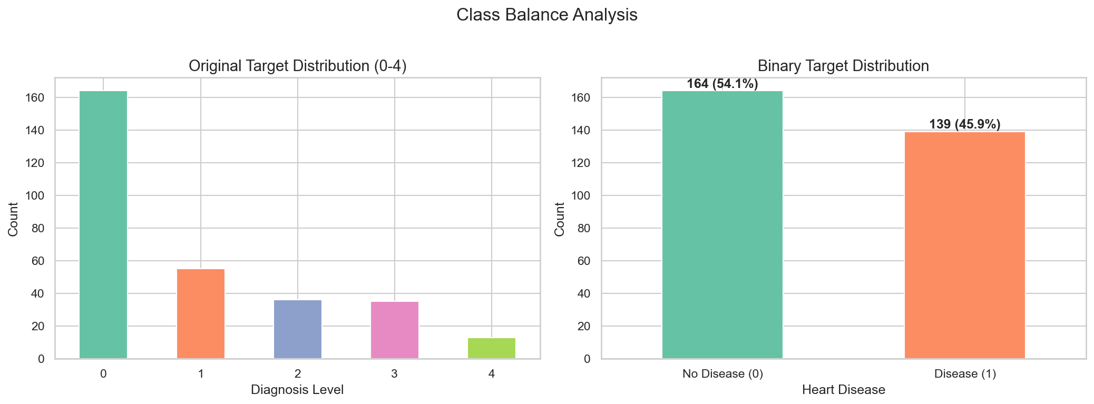
Figure 1: Class distribution (original and binary)
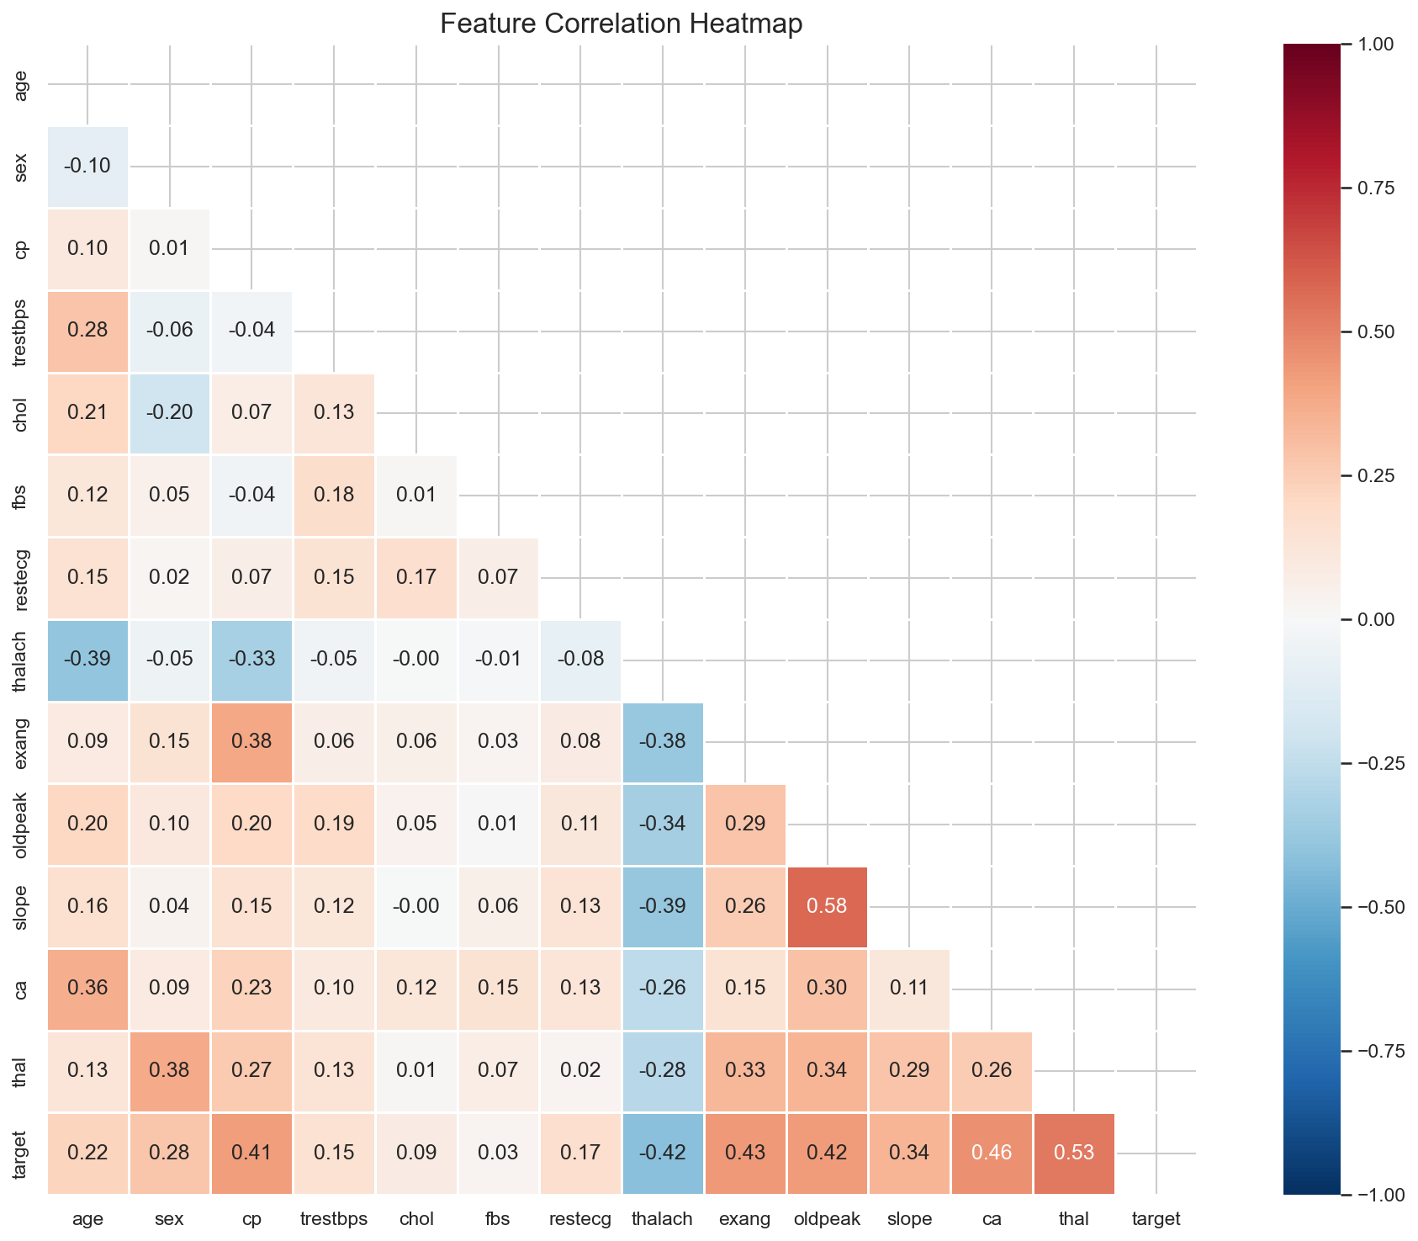
Figure 2: Feature correlation heatmap

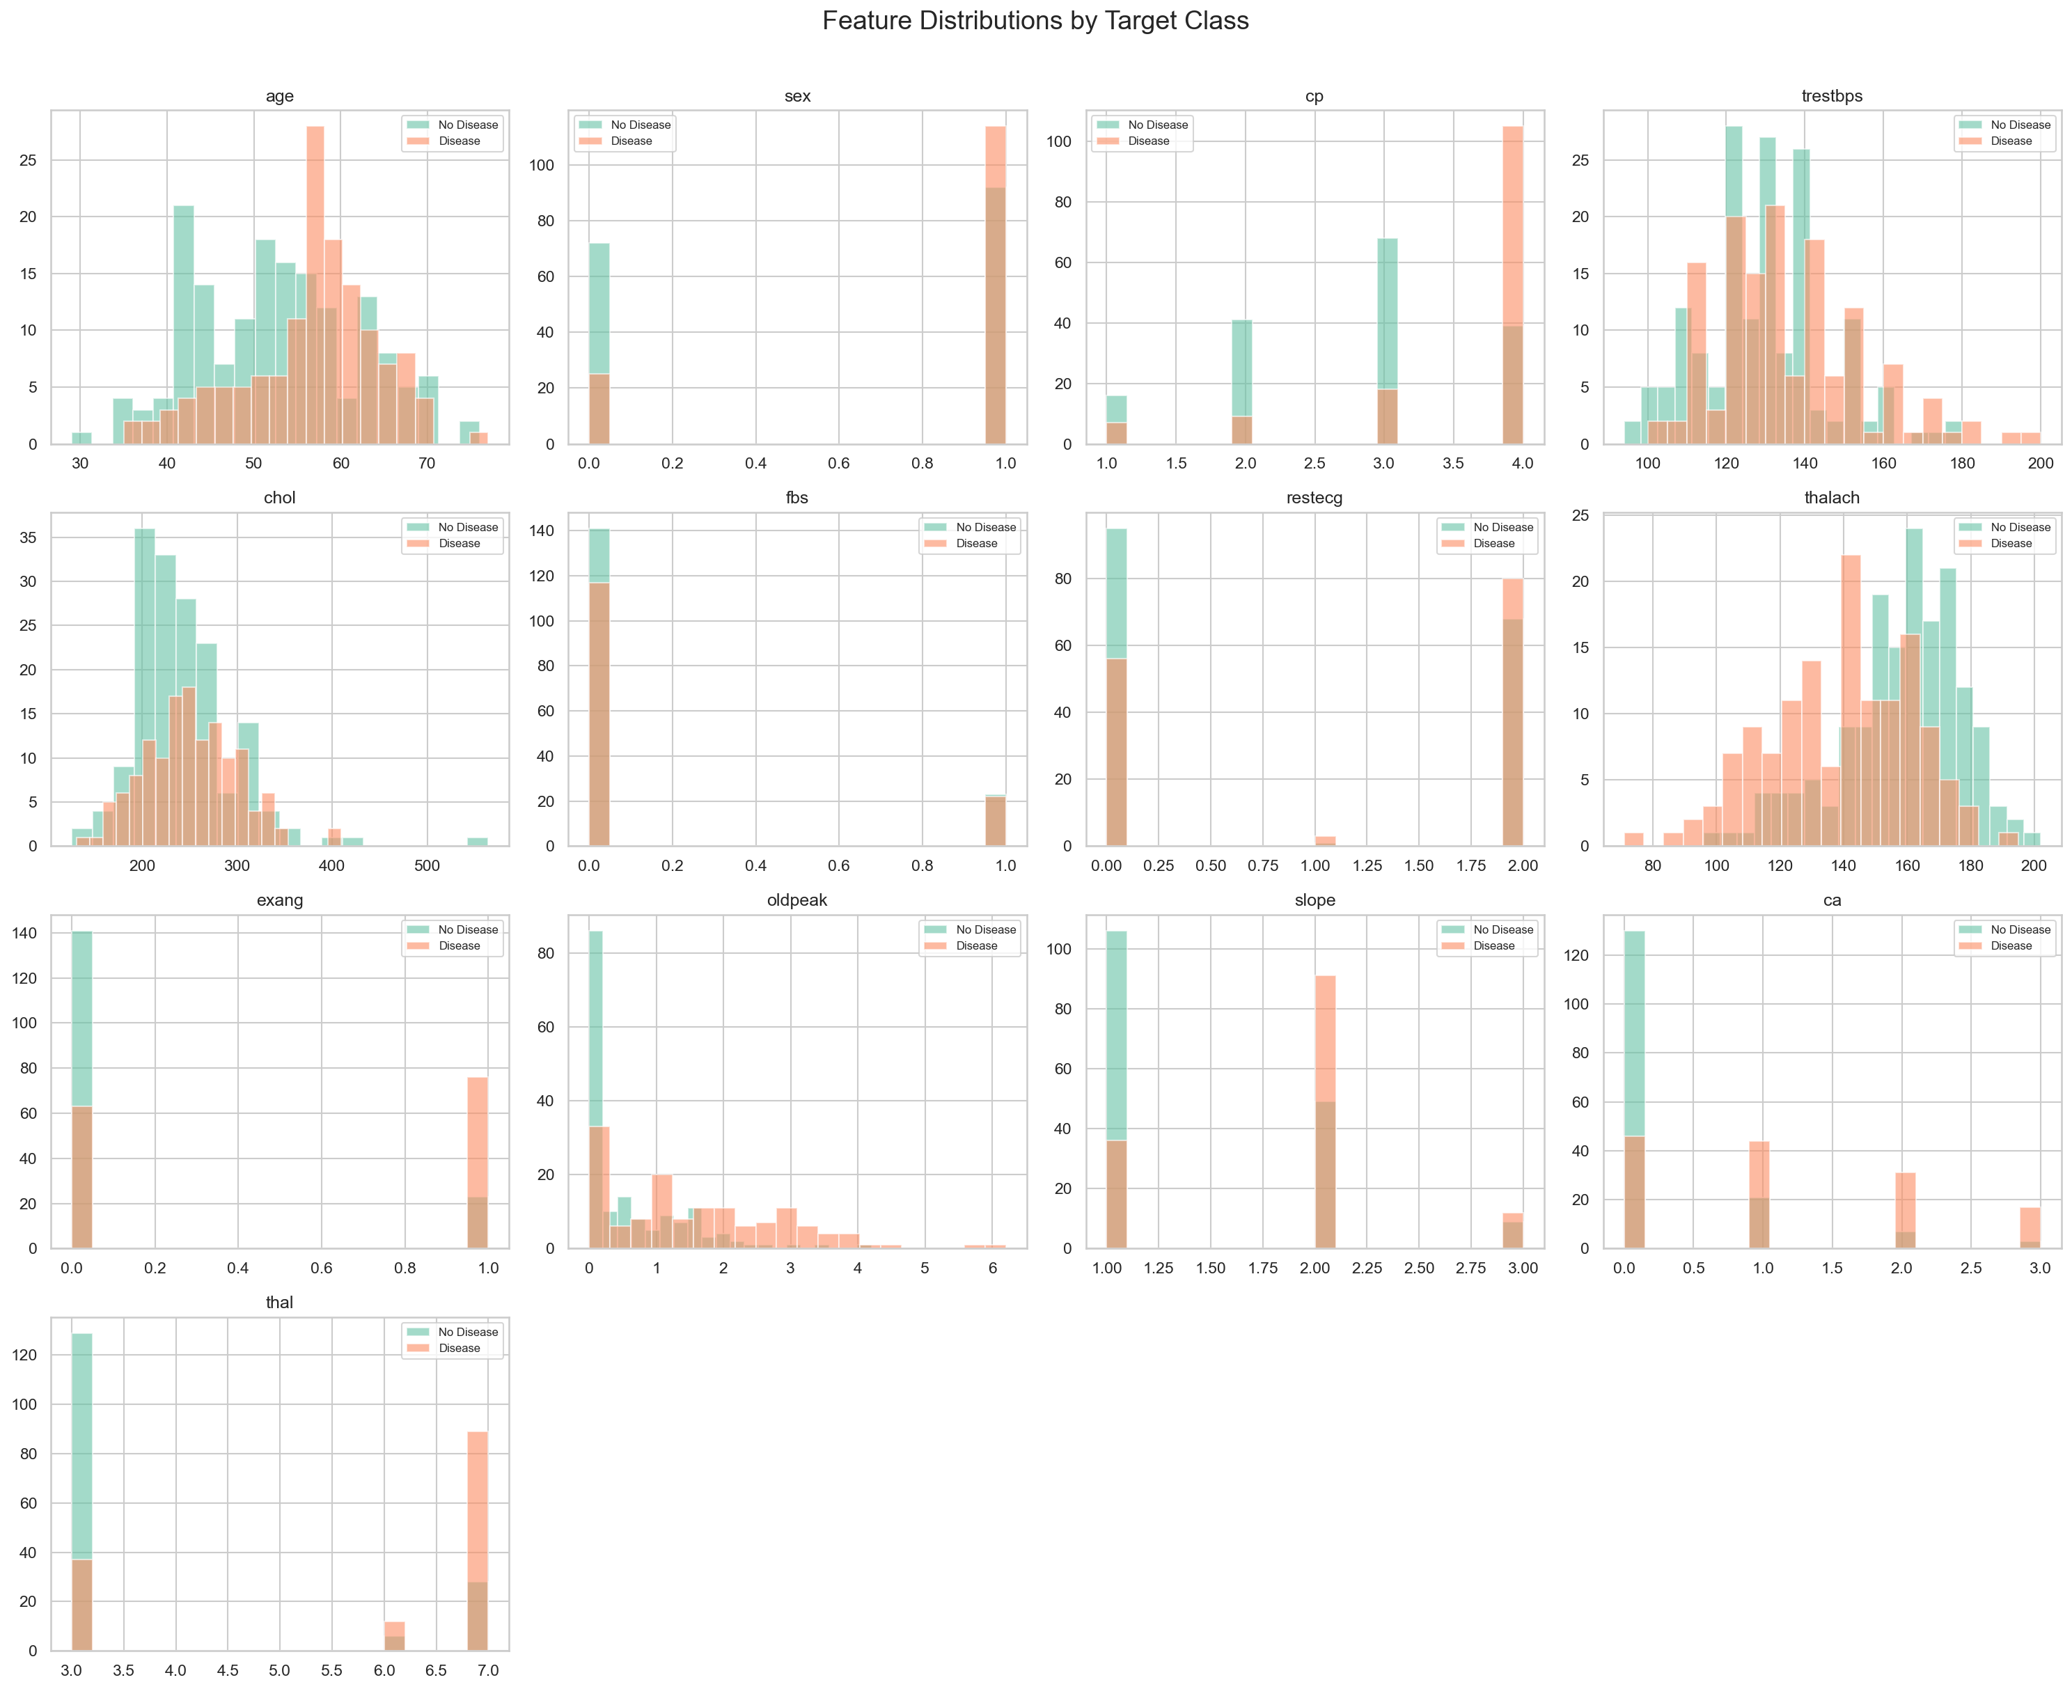
Figure 3: Feature distributions by target class
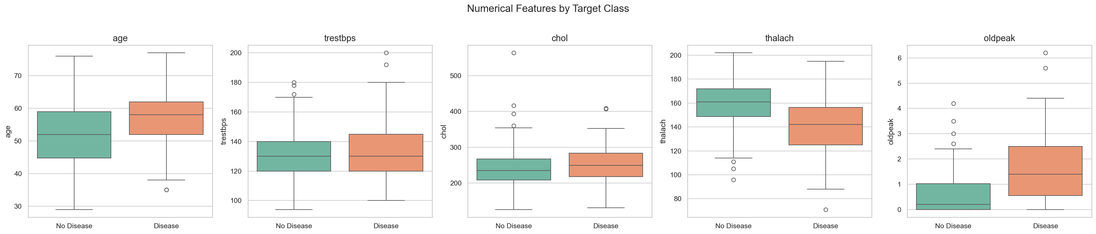
Figure 4: Numerical features box plots

3. Feature Engineering & Model Development
Features are preprocessed using a scikit-learn ColumnTransformer pipeline: StandardScaler for 5 numerical features (age, trestbps, chol, thalach, oldpeak) and OneHotEncoder for 8 categorical features (sex, cp, fbs, restecg, exang, slope, ca, thal). This produces 20 transformed features.

Models Trained
Three classifiers were trained with hyperparameter tuning via 5-fold stratified cross-validation using GridSearchCV:
Model | Accuracy | Precision | Recall | F1 | ROC-AUC
LogisticRegression | 0.8852 | 0.8621 | 0.8929 | 0.8772 | 0.9643
RandomForest | 0.8852 | 0.8387 | 0.9286 | 0.8814 | 0.9556
GradientBoosting | 0.8361 | 0.8750 | 0.7500 | 0.8077 | 0.9177

Best model: LogisticRegression with ROC-AUC = 0.9643
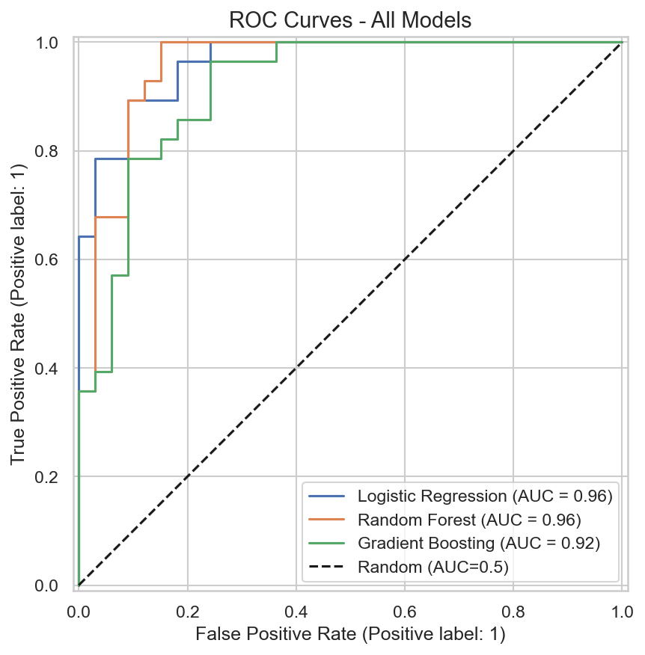
Figure 5: ROC curves for all models
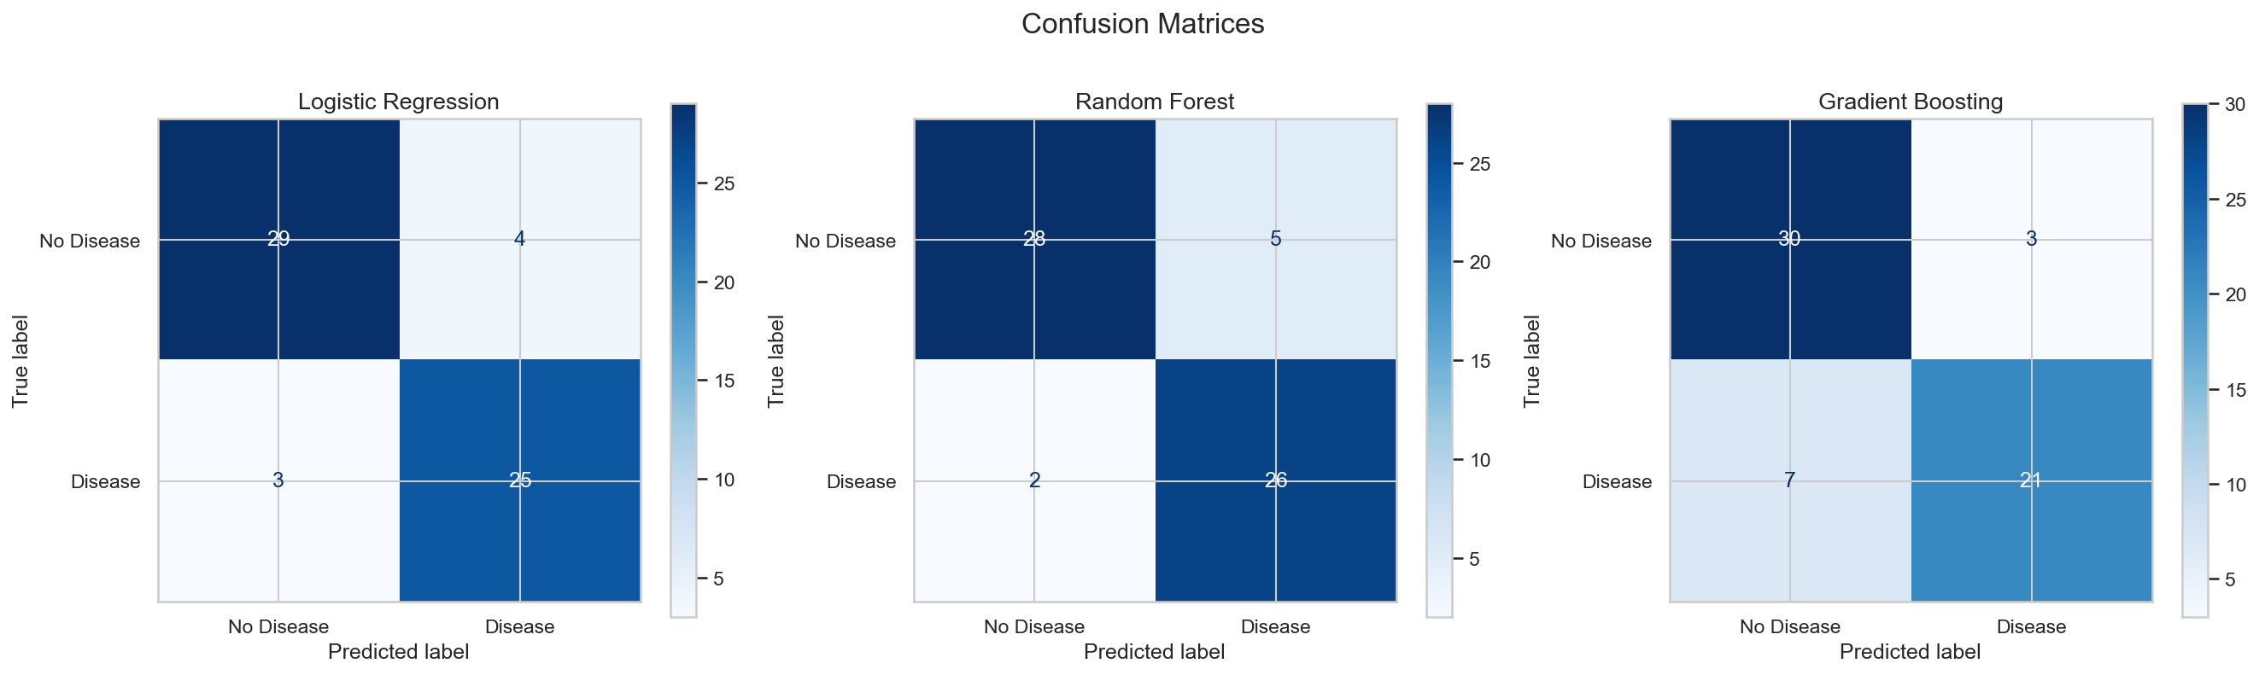
Figure 6: Confusion matrices

4. Experiment Tracking (MLflow)
MLflow is integrated into the training pipeline (src/train.py) to track all experiment runs. For each model, the following are logged:
- Parameters: model type, hyperparameter grid, best hyperparameters, test_size, cv_folds
- Metrics: accuracy, precision, recall, F1, ROC-AUC (test + cross-validation)
- Artifacts: trained model (sklearn), confusion matrix plot, ROC curve plot, feature importance plot
The MLflow tracking data is stored in experiment_tracking/ and can be viewed by running: mlflow ui --backend-store-uri experiment_tracking/
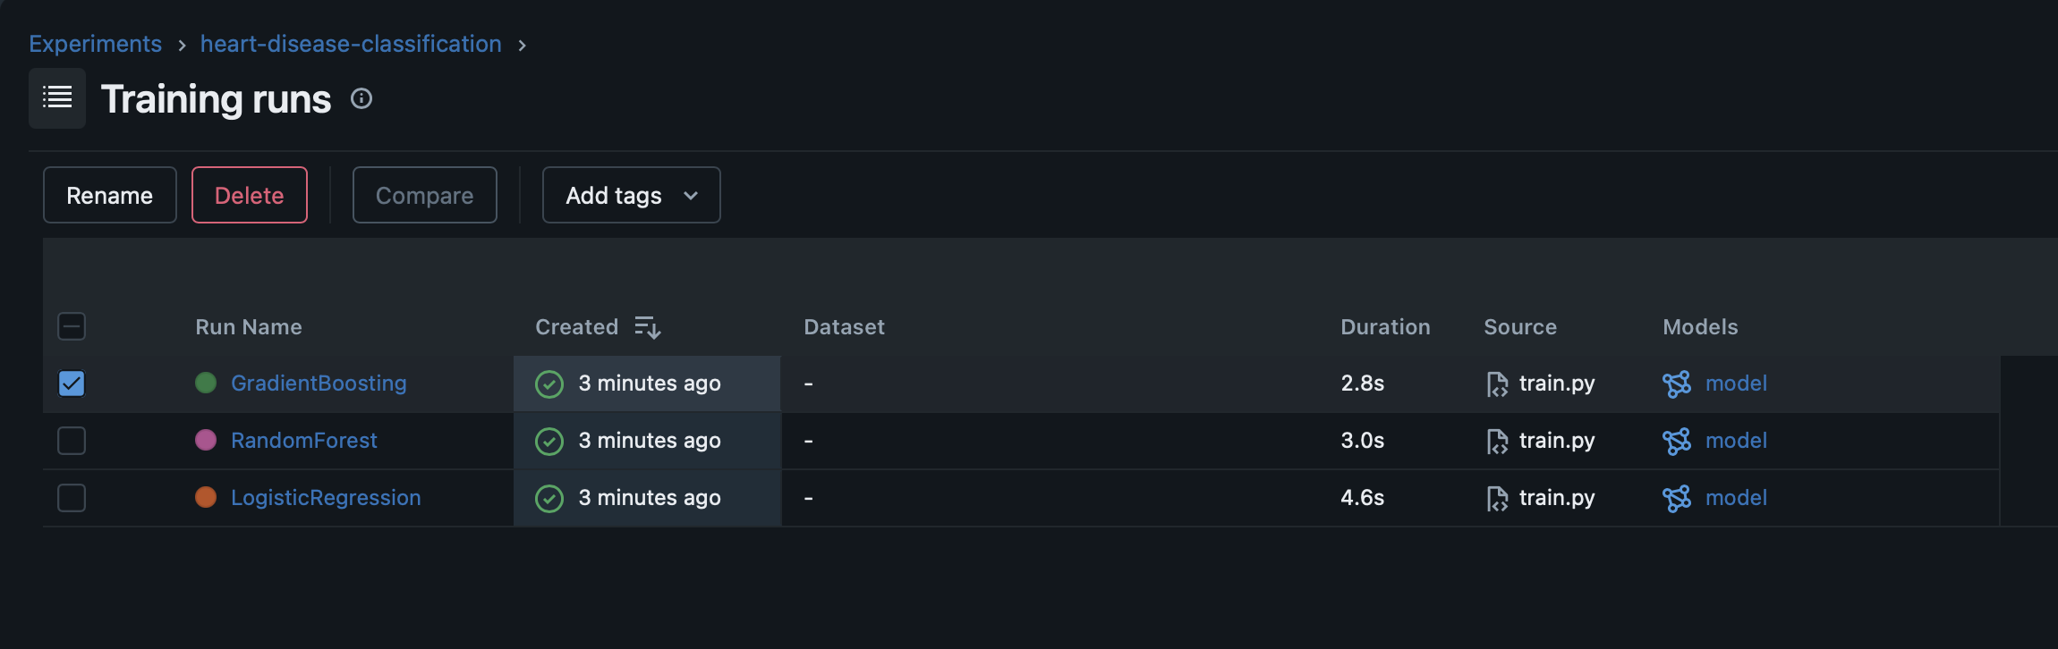
Figure 7: MLflow UI - All experiment runs
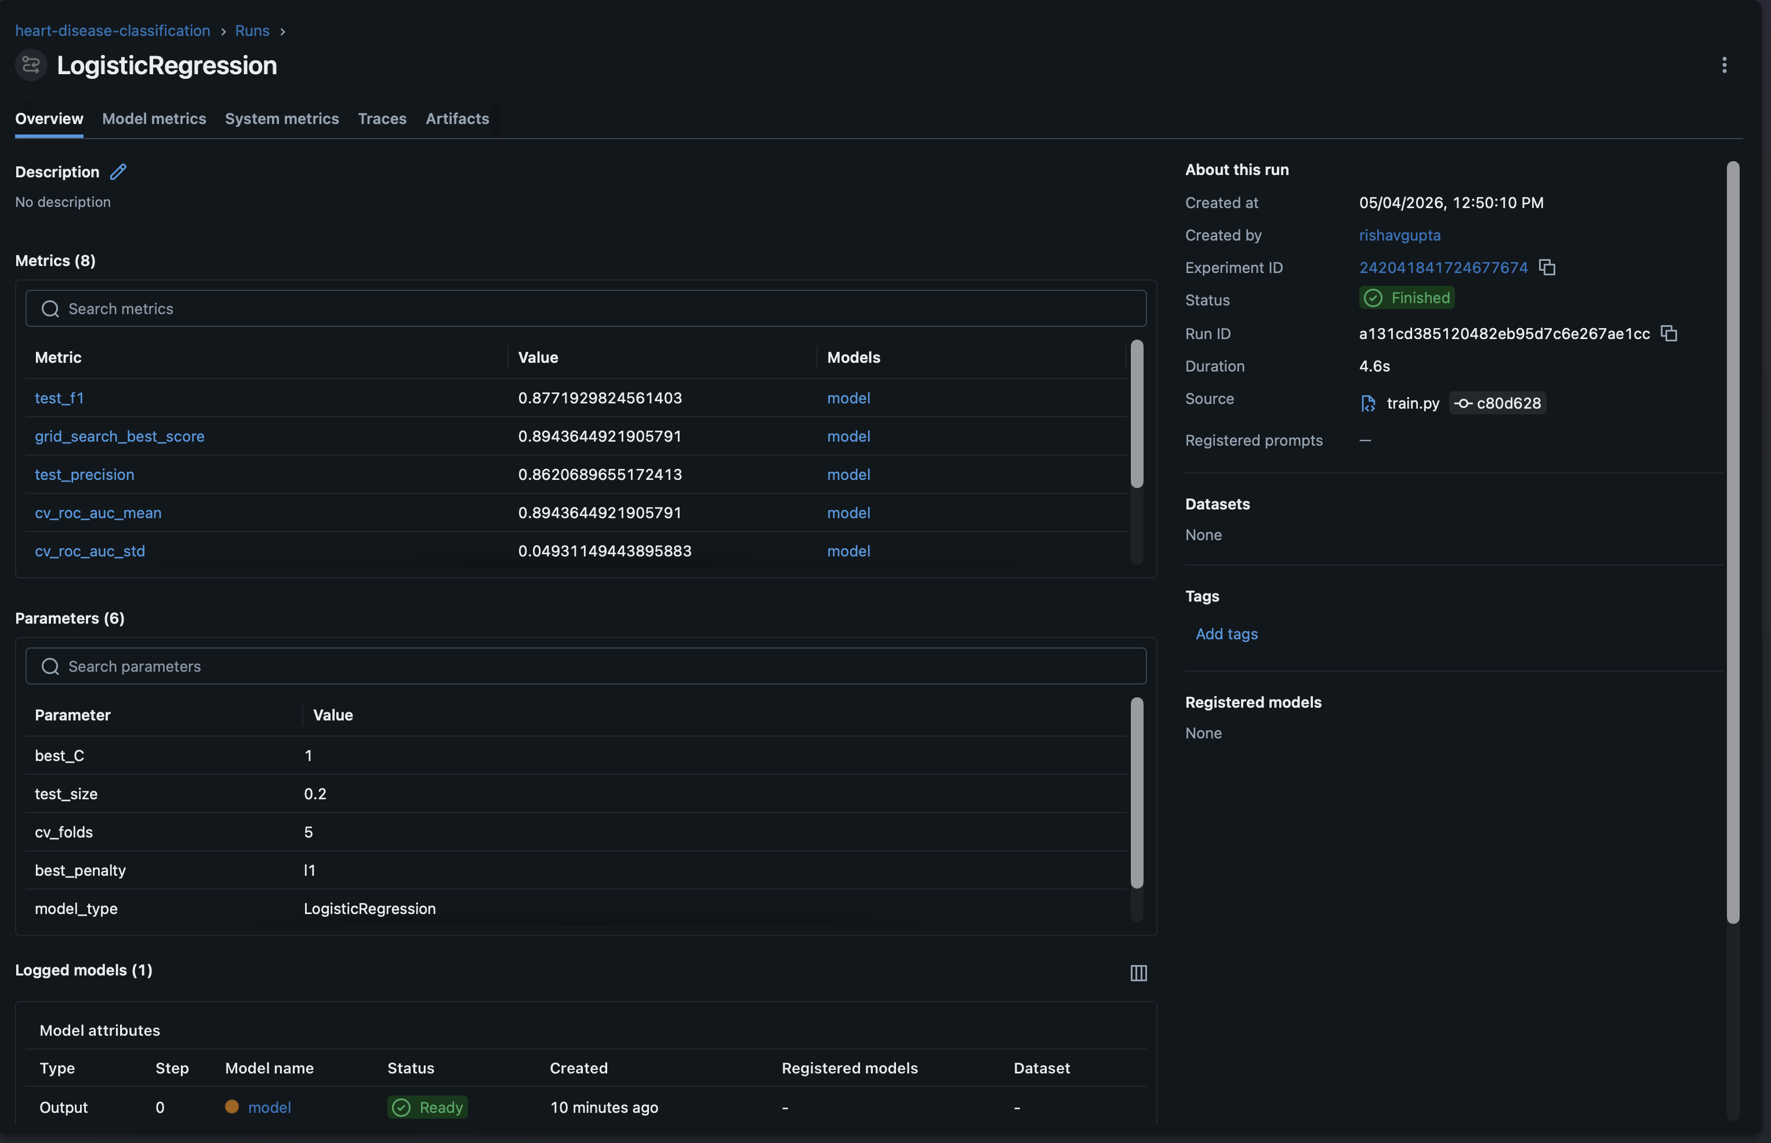
Figure 8: MLflow UI - Logistic Regression run details
Since MLflow uses internally generated IDs for its directory structure (not human-readable), we also export a clean, time-based summary after each training run to screenshots/mlflow/. Each run creates a timestamped subfolder (e.g. run_2026-05-04_13-20-32/) containing:
- experiment_metrics_comparison.csv — Side-by-side comparison of all model metrics (accuracy, precision, recall, F1, ROC-AUC) with run timestamp.
- experiment_runs_log.json — Full experiment log including hyperparameter grids, best parameters, and artifact references for each model
- Confusion matrix, ROC curve, and feature importance plots for all models
This ensures experiment tracking evidence is available in a human-readable format even without running the MLflow UI.
Training Artifact
The training_artifacts/ directory stores the raw plots (confusion matrices, ROC curves, feature importance charts) generated during each model's training. These are organized by model name (e.g., training_artifacts/LogisticRegression/,training_artifacts/RandomForest/). MLflow logs these as artifacts within each run, and they are also copied into the time-based screenshots/mlflow/ folders for easy reference. This directory is committed to the repository so that the full training provenance is preserved.

5. CI/CD Pipeline & Automated Testing
[To be completed on Day 3 - GitHub Actions pipeline with lint, test, train, build+push, deploy stages]

6. Model Containerization (Docker)
[To be completed on Day 2 - FastAPI /predict endpoint, Dockerfile, local container testing]

7. Production Deployment (GKE)
[To be completed on Day 3 - GKE cluster, K8s manifests, LoadBalancer service, public API endpoint]

8. Monitoring & Logging
[To be completed on Day 4 - Prometheus metrics, Grafana dashboard, API request logging]

9. Architecture Diagram
[To be added - End-to-end pipeline diagram: Data -> Preprocessing -> Training (MLflow) -> Model Packaging -> Docker -> GKE -> API -> Monitoring]

10. Conclusion
[To be completed on Day 4 - Summary of findings, lessons learned, and link to code repository]

