**LAB 8 BOOK DATABASE:**

create table student8( regno varchar(30), name varchar(30), major varchar(30), bdate date,

primary key(regno));

create table course( course_no int, cname varchar(10), dept varchar(30),

primary key(course_no));

create table enroll( regno varchar(30), course_no int, sem int,

marks int,

primary key(regno,course_no),

foreign key(regno) references student8(regno) on delete cascade,

foreign key(course_no) references course(course_no) on delete cascade);

create table text( book_isbn int, book_title varchar(50), publisher varchar(50), author varchar(50),

primary key(book_isbn));

create table book_adoption( course_no int,

sem int, book_isbn int,

primary key(course_no,book_isbn),

foreign key(course_no) references course(course_no) on delete cascade, foreign key(book_isbn) references text(book_isbn) on delete cascade);

INSERT INTO student8 VALUES ('1bm18cs001','a','sr','09-DEC-17'); INSERT INTO student8 VALUES ('1bm18cs002','b','sr','01-JUN-17'); INSERT INTO student8 VALUES ('1bm18cs003','c','sr','27-NOV-93');

INSERT INTO student8 VALUES ('1bm18cs004','d','sr','13-APR-93'); INSERT INTO student8 VALUES ('1bm18cs005','e','jr','24-AUG-94');

INSERT INTO course VALUES (111,'OS','CSE'); INSERT INTO course VALUES (112,'EC','CSE'); INSERT INTO course VALUES (113,'SS','ISE'); INSERT INTO course VALUES (114,'DBMS','CSE'); INSERT INTO course VALUES (115,'SIGNALS','ECE');

INSERT INTO text VALUES (10,'DATABASE SYSTEMS','PEARSON','SCHIELD'); INSERT INTO text VALUES (900,'OPERATING SYS','PEARSON','LELAND'); INSERT INTO text VALUES (901,'CIRCUITS','HALL INDIA','BOB');

INSERT INTO text VALUES (902,'SYSTEM SOFTWARE','PETERSON','JACOB'); INSERT INTO text VALUES (903,'SCHEDULING','PEARSON','PATIL');

INSERT INTO text VALUES (904,'DATABASE SYSTEMS','PEARSON','JACOB'); INSERT INTO text VALUES (905,'DATABASE MANAGER','PEARSON','BOB'); INSERT INTO text VALUES (906,'SIGNALS','HALL INDIA','SUMIT');

INSERT INTO enroll VALUES ('1bm18cs001',115,3,100); INSERT INTO enroll VALUES('1bm18cs002',114,5,100); INSERT INTO enroll VALUES('1bm18cs003',113,5,100); INSERT INTO enroll VALUES('1bm18cs004',111,5,100); INSERT INTO enroll VALUES('1bm18cs005',112,3,100);

INSERT INTO book_adoption VALUES (111,5,900); INSERT INTO book_adoption VALUES (111,5,903); INSERT INTO book_adoption VALUES (111,5,904); INSERT INTO book_adoption VALUES (112,3,901); INSERT INTO book_adoption VALUES (113,3,10); INSERT INTO book_adoption VALUES (114,5,905); INSERT INTO book_adoption VALUES (113,5,902); INSERT INTO book_adoption VALUES (115,3,906);

INSERT INTO book_adoption VALUES (112,5,906); select * from student8;

select * from course; select * from text; select * from enroll;

select * from book_adoption;

SELECT c.course_no,t.book_isbn,t.book_title FROM course c,book_adoption ba,text t WHERE c.course_no=ba.course_no

AND ba.book_isbn=t.book_isbn AND c.dept='CSE'

AND 2<( SELECT COUNT(book_isbn) FROM book_adoption b

WHERE c.course_no=b.course_no)

ORDER BY t.book_title;

SELECT DISTINCT c.dept

FROM course c WHERE c.dept IN ( SELECT c.dept

FROM course c,book_adoption b,text t WHERE c.course_no=b.course_no AND t.book_isbn=b.book_isbn

AND t.publisher='PEARSON')

AND c.dept IN (SELECT c.dept

FROM course c,book_adoption b,text t WHERE c.course_no=b.course_no AND t.book_isbn=b.book_isbn

AND t.publisher != 'PEARSON');

# OUTPUT:

## TABLES:

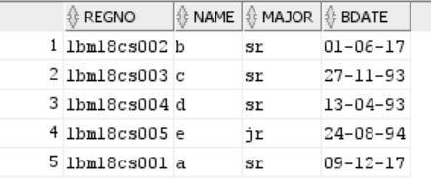 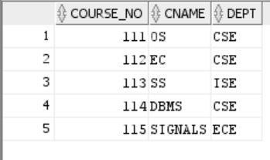

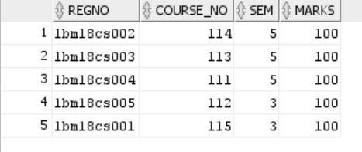 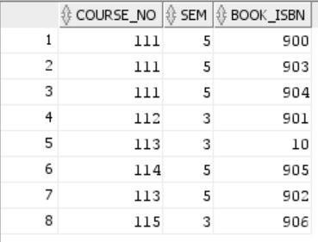

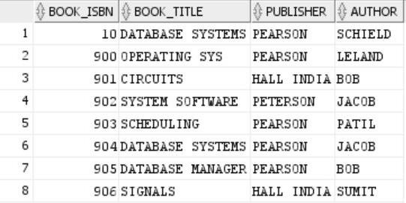

## QUERY:

