MOVIE DATABASE

# QUERY:

create table actor(act_id int, act_name varchar(20), act_gender varchar(1), primary key(act_id));

create table director( dir_id int,

dir_name varchar(20), dir_phone varchar(10), primary key(dir_id));

create table movies( mov_id int,

mov_title varchar(20), mov_year varchar(5), mov_lang varchar(20), dir_id int,

primary key(mov_id),

foreign key(dir_id) references director(dir_id));

create table movie_cast( act_id int,

mov_id int,

role varchar(20),

foreign key(act_id) references actor(act_id), foreign key(mov_id) references movies(mov_id));

create table rating( mov_id int, rev_stars int,

foreign key(mov_id) references movies(mov_id));

insert into actor values('&act_id','&act_name','&act_gender'); select * from actor;

insert into director values('&dir_id','&dir_name','&dir_phone'); select * from director;

insert into movies values('&mov_id','&mov_title','&mov_year','&mov_lang','&dir_id'); select * from movies;

insert into movie_cast values('&act_id','&mov_id','&role'); select * from movie_cast;

insert into rating values('&mov_id','&rev_stars'); select * from rating;

select mov_title from movies

where dir_id in (select dir_id from director where dir_name='Hitchcock');

select mov_title from movies m, movie_cast mv

where m.mov_id=mv.mov_id and act_id in( select act_id from movie_cast group by act_id

having count( act_id)>1)

group by mov_title having count(*)>1;

select act_name from actor a join movie_cast c on a.act_id=c.act_id

join movies m on c.mov_id=m.mov_id

where m.mov_year not between 2000 and 2015;

select mov_title ,max(rev_stars) from movies

inner join rating using(mov_id)

group by mov_title having max(rev_stars)>0 order by mov_title;

update rating

set rev_stars=5 where mov_id

in(select mov_id from movies where dir_id

in(select dir_id from director where dir_name='Steven Spielberg'));

select * from rating;

# OUTPUT:

TABLE1: TABLE 2:

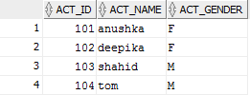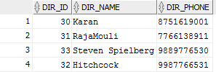

TABLE 3:

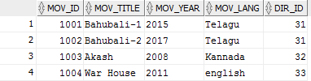

TABLE 4: TABLE 5;

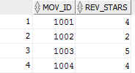

QUERY1:



QUERY 2:



QUERY 3:



QUERY 4:



QUERY 5:

