create table branch(

branchname varchar2(20),

branchcity varchar(20),

assets real,

primary key(branchname));

create table bankaccount(

accno integer,

branchname varchar(30),

balance real,

primary key(accno),

foreign key(branchname) references branch(branchname));

create table bankcustomer(

customername varchar(30),

customerstreet varchar(30),

customercity varchar(30),

primary key(customername));

create table depositer(

customername varchar(30),

accno integer,

primary key(customername,accno),

foreign key(customername) references bankcustomer(customername),

foreign key(accno) references bankaccount(accno));

create table loan(

loannumber int,

branchname varchar(30),

amount real,

primary key(loannumber),

foreign key(branchname) references branch(branchname));

insert into branch values('&branchname','&branchcity', '&assets');

commit;

select \* from branch;



insert into loan values('&loannumber','&branchname', '&amount');

commit;

select \* from loan;



insert into bankaccount values('&accno','&branchname', '&balance');

commit;

select \* from bankaccount;

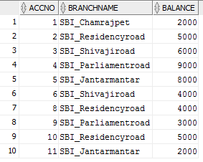

insert into bankcustomer values('&customername','&customerstreet', '&customercity');

commit;

select \* from bankcustomer;

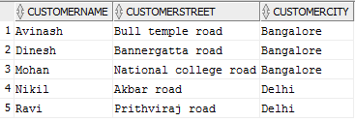

insert into depositer values('&customername','&accno');

commit;

select \* from depositer;

