**PROGRAM 3: SUPPLIER DATABASE**

**Schema Diagram**

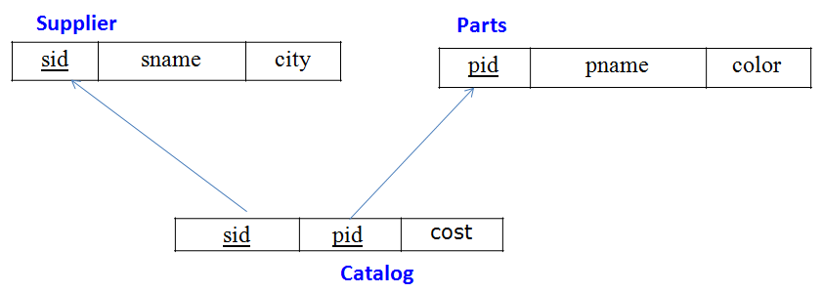

**Table Data**

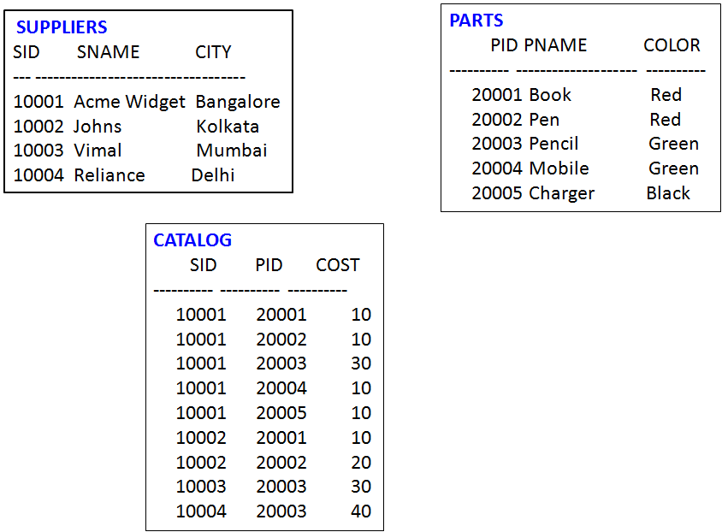

**CREATION of Tables:**

**SQL> create table SUPPLIERS(sid number(5) primary key, sname varchar(20), city varchar(20));**

Table created.

**SQL> desc SUPPLIERS;**

Name Null? Type

----------------------------------------- -------- ----------------------------

SID NOT NULL NUMBER(5)

SNAME VARCHAR2(20)

CITY VARCHAR2(20)

**SQL> create table PARTS(pid number(5) primary key, pname varchar(20), color varchar(10));**

Table created.

**SQL> desc PARTS;**

Name Null? Type

----------------------------------------- -------- ----------------------------

PID NOT NULL NUMBER(5)

PNAME VARCHAR2(20)

COLOR VARCHAR2(10)

**SQL> create table CATALOG(sid number(5), pid number(5), foreign key(sid) references SUPPLIERS(sid), foreign key(pid) references PARTS(pid), cost float(6), primary key(sid, pid));**

Table created.

**SQL> desc CATALOG;**

Name Null? Type

----------------------------------------- -------- ----------------------------

SID NOT NULL NUMBER(5)

PID NOT NULL NUMBER(5)

COST FLOAT(6)

**INSERTION OF DATA:**

**SQL> insert into suppliers values(&sid, '&sname','&city');**

Enter value for sid: 10001

Enter value for sname: Acme Widget

Enter value for address: Bangalore

old 1: insert into suppliers values(&sid, '&sname','&city')

new 1: insert into suppliers values(10001, 'Acme Widget','Bangalore')

1 row created.

SQL> /

Enter value for sid: 10002

Enter value for sname: Johns

Enter value for address: Kolkata

old 1: insert into suppliers values(&sid, '&sname','&city')

new 1: insert into suppliers values(10002, 'Johns','Kolkata')

1 row created.

SQL> /

Enter value for sid: 10003

Enter value for sname: Vimal

Enter value for address: Mumbai

old 1: insert into suppliers values(&sid, '&sname','&city')

new 1: insert into suppliers values(10003, 'Vimal','Mumbai')

1 row created.

SQL> /

Enter value for sid: 10004

Enter value for sname: Reliance

Enter value for address: Delhi

old 1: insert into suppliers values(&sid, '&sname','&city')

new 1: insert into suppliers values(10004, 'Reliance','Delhi')

1 row created.

SQL> /

Enter value for sid: 10005

Enter value for sname: Mahindra

Enter value for address: Mumbai

old 1: insert into suppliers values(&sid, '&sname','&city')

new 1: insert into suppliers values(10005, 'Mahindra','Mumbai')

1 row created.

**SQL> select * from SUPPLIERS;**

SID SNAME CITY

---------- -------------------- --------------------

10001 Acme Widget Bangalore

10002 Johns Kolkata

10003 Vimal Mumbai

10004 Reliance Delhi

**SQL> commit;**

Commit complete.

**SQL> insert into PARTS values(&pid, '&pname','&color');**

Enter value for pid: 20001

Enter value for pname: Book

Enter value for color: Red

old 1: insert into PARTS values(&pid, '&pname','&color')

new 1: insert into PARTS values(20001, 'Book','Red')

1 row created.

SQL> /

Enter value for pid: 20002

Enter value for pname: Pen

Enter value for color: Red

old 1: insert into PARTS values(&pid, '&pname','&color')

new 1: insert into PARTS values(20002, 'Pen','Red')

1 row created.

SQL> /

Enter value for pid: 20003

Enter value for pname: Pencil

Enter value for color: Green

old 1: insert into PARTS values(&pid, '&pname','&color')

new 1: insert into PARTS values(20003, 'Pencil','Green')

1 row created.

SQL> /

Enter value for pid: 20004

Enter value for pname: Mobile

Enter value for color: Green

old 1: insert into PARTS values(&pid, '&pname','&color')

new 1: insert into PARTS values(20004, 'Mobile','Green')

1 row created.

SQL> /

Enter value for pid: 20005

Enter value for pname: Charger

Enter value for color: Black

old 1: insert into PARTS values(&pid, '&pname','&color')

new 1: insert into PARTS values(20005, 'Charger','Black')

1 row created.

**SQL> select * from PARTS;**

PID PNAME COLOR

---------- -------------------- ----------

20001 Book Red

20002 Pen Red

20003 Pencil Green

20004 Mobile Green

20005 Charger Black

**SQL> commit;**

Commit complete.

**SQL> insert into CATALOG values(&sid, '&pid','&cost');**

Enter value for sid: 10001

Enter value for pid: 20001

Enter value for cost: 10

old 1: insert into CATALOG values(&sid, '&pid','&cost')

new 1: insert into CATALOG values(10001, '20001','10')

1 row created.

SQL> /

Enter value for sid: 10001

Enter value for pid: 20002

Enter value for cost: 10

old 1: insert into CATALOG values(&sid, '&pid','&cost')

new 1: insert into CATALOG values(10001, '20002','10')

1 row created.

SQL> /

Enter value for sid: 10001

Enter value for pid: 20003

Enter value for cost: 30

old 1: insert into CATALOG values(&sid, '&pid','&cost')

new 1: insert into CATALOG values(10001, '20003','30')

1 row created.

SQL> /

Enter value for sid: 10001

Enter value for pid: 20004

Enter value for cost: 10

old 1: insert into CATALOG values(&sid, '&pid','&cost')

new 1: insert into CATALOG values(10001, '20004','10')

1 row created.

SQL> /

Enter value for sid: 10001

Enter value for pid: 20005

Enter value for cost: 10

old 1: insert into CATALOG values(&sid, '&pid','&cost')

new 1: insert into CATALOG values(10001, '20005','10')

1 row created.

SQL> /

Enter value for sid: 10002

Enter value for pid: 20001

Enter value for cost: 10

old 1: insert into CATALOG values(&sid, '&pid','&cost')

new 1: insert into CATALOG values(10002, '20001','10')

1 row created.

SQL> /

Enter value for sid: 10002

Enter value for pid: 20002

Enter value for cost: 20

old 1: insert into CATALOG values(&sid, '&pid','&cost')

new 1: insert into CATALOG values(10002, '20002','20')

1 row created.

SQL> /

Enter value for sid: 10003

Enter value for pid: 20003

Enter value for cost: 30

old 1: insert into CATALOG values(&sid, '&pid','&cost')

new 1: insert into CATALOG values(10003, '20003','30')

1 row created.

SQL> /

Enter value for sid: 10004

Enter value for pid: 20003

Enter value for cost: 40

old 1: insert into CATALOG values(&sid, '&pid','&cost')

new 1: insert into CATALOG values(10004, '20003','40')

1 row created.

**SQL> select * from CATALOG;**

SID PID COST

---------- ---------- ----------

10001 20001 10

10001 20002 10

10001 20003 30

10001 20004 10

10001 20005 10

10002 20001 10

10002 20002 20

10003 20003 30

10004 20003 40

9 rows selected.

1. **Find the pnames of parts for which there is some supplier.**

**SQL> SELECT DISTINCT P.pname**

**2 FROM Parts P, Catalog C**

**3 WHERE P.pid = C.pid;**

PNAME

--------------------

Book

Charger

Mobile

Pen

Pencil

1. **Find the snames of suppliers who supply every part.**

**SQL> SELECT S.sname**

**2 FROM Suppliers S**

**3 WHERE NOT EXISTS ((SELECT P.pid FROM Parts P)**

**4 MINUS (SELECT C.pid FROM Catalog C**

**5 WHERE C.sid = S.sid));**

SNAME

--------------------

Acme Widget

1. **Find the snames of suppliers who supply every red part.**

**SQL>SELECT S.sname**

**FROM Suppliers S**

**WHERE NOT EXISTS (( SELECT P.pid**

**FROM Parts P**

**WHERE P.color = ‘Red’ )**

**MINUS**

**( SELECT C.pid**

**FROM Catalog C, Parts P**

**WHERE C.sid = S.sid AND**

**C.pid = P.pid AND P.color = ‘Red’ ));**

SNAME

--------------------

Acme Widget

Johns

1. **Find the pnames of parts supplied by Acme Widget Suppliers and by no one else.**

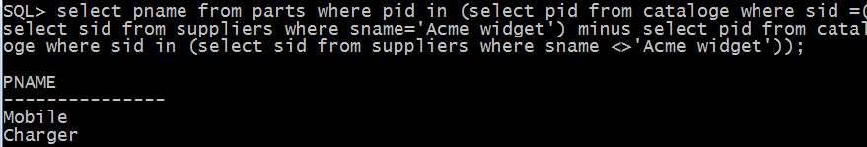

PNAME

--------------------

Mobile

Charger

1. **Find the sids of suppliers who charge more for some part than the average cost of that part (averaged over all the suppliers who supply that part).**

**SQL> SELECT DISTINCT C.sid FROM Catalog C**

**2 WHERE C.cost > ( SELECT AVG (C1.cost)**

**3 FROM Catalog C1**

**4 WHERE C1.pid = C.pid );**

SID

----------

10002

10004

1. **For each part, find the sname of the supplier who charges the most for that part.**

**SQL>SELECT P.pid, S.sname**

**FROM Parts P, Suppliers S, Catalog C**

**WHERE C.pid = P.pid**

**AND C.sid = S.sid**

**AND C.cost = (SELECT MAX (C1.cost)**

**FROM Catalog C1**

**WHERE C1.pid = P.pid);**

PID SNAME

---------- --------------------

20001 Acme Widget

20004 Acme Widget

20005 Acme Widget

20001 Johns

20002 Johns

20003 Reliance

6 rows selected.