3b. Summary Statistics
We follow the sample design of Autor, Dorn, and Hanson (2013). The unit of analysis is the 1990 commuting zone (CZ) of Tolbert and Sizer (1996), covering 722 CZs over 1990–2000 and 2000–2007 stacked in first differences (1,444 observations). Table 1 reports population-weighted means from ADH's replication package. Two findings stand out. Chinese imports per worker (10-year equivalent) more than doubled, from $1.14k in 1990–2000 to $2.63k in 2000–2007, tracking China's WTO accession in 2001. Manufacturing share fell from 12.69% in 1990 to 8.51% in 2007.
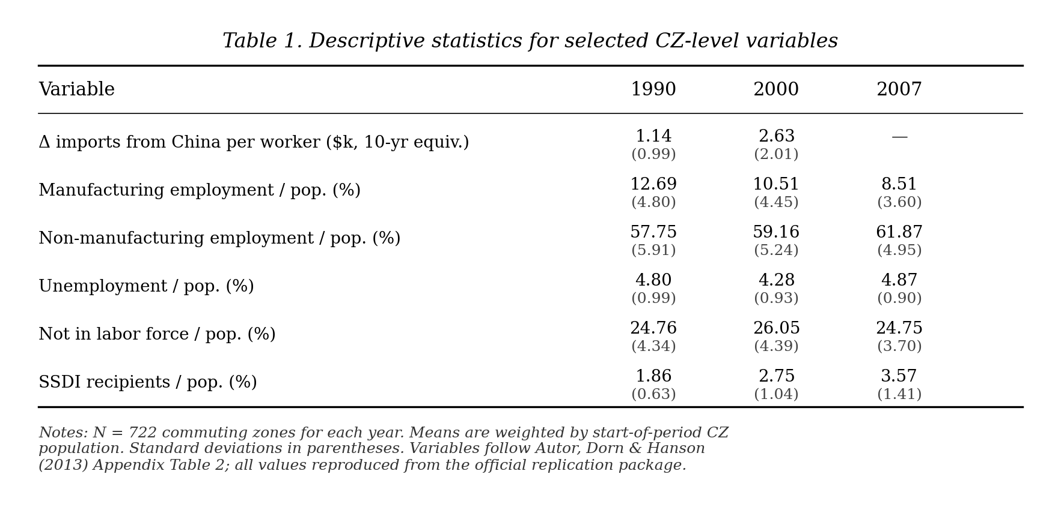
Table 1. Descriptive statistics for selected CZ-level variables (reproduced from ADH 2013, Appendix Table 2).

4a. Identification Strategy and its Plausibility
OLS estimation of the labor-market effect of Chinese import exposure faces an endogeneity problem. Observed U.S. imports reflect both Chinese supply-side and U.S. demand shocks, biasing OLS toward zero. ADH (2013) report an OLS estimate of −0.171 versus an IV estimate of −0.596.
They address this with a Bartik-style instrument, replacing ΔIPW_{uit} with ΔIPW_{oit}, built from same-period Chinese exports to eight other high-income countries (Australia, Denmark, Finland, Germany, Japan, New Zealand, Spain, and Switzerland). The identifying assumption is that within-industry import growth shared by these countries reflects China's supply-side improvements, not correlated demand:
ΔIPW_{uit} = Σ_{j} (L_{ijt} / L_{ujt}) · (ΔM_{ucjt} / L_{it}), (1)
ΔIPW_{oit} = Σ_{j} (L_{ij,t-1} / L_{uj,t-1}) · (ΔM_{ocjt} / L_{i,t-1}). (2)
The second-stage equation is estimated as stacked first differences:
ΔL_{it}^{m} = γ_{t} + β₁ ΔIPW_{uit} + X_{it}′ β₂ + e_{it}, (3)
where X_{it} contains start-of-period manufacturing share, demographic controls, the routine and offshorability indices of Autor and Dorn (2013), and Census division dummies.
Three pieces of evidence support the strategy. First, the first stage is strong: the instrument predicts the endogenous regressor with coefficient 0.631 (t = 6.90), well above the weak-IV threshold. Second, a falsification test shows that 1970s–1980s manufacturing changes do not predict future Chinese exposure, ruling out a pre-existing decline. Third, dropping suspect industries leaves the coefficient near −0.596.
The main residual concern is correlated demand shocks across high-income economies. A gravity-based check yields similar estimates; Chinese manufacturing TFP grew about 8% per year over 1998–2007, against 3.9% in the U.S., supporting the supply-driven interpretation.
4b. Reproduction of Published Results
We verify that the official replication package functions correctly. Our target is Table 3 of ADH (2013), the 2SLS regression of CZ-level change in manufacturing employment share on ΔIPW_{uit}, instrumented by the eight-country measure. We focus on column (6) with full controls.
Running the official Stata code on the published workfile, we obtain coefficients matching the published values exactly to three decimal places across all six columns. In column (6), the coefficient on ΔIPW is −0.596 (SE 0.099); the first-stage coefficient is 0.631 (t = 6.90); N = 1,444 with R² = 0.343. Table 2 reports the full comparison.

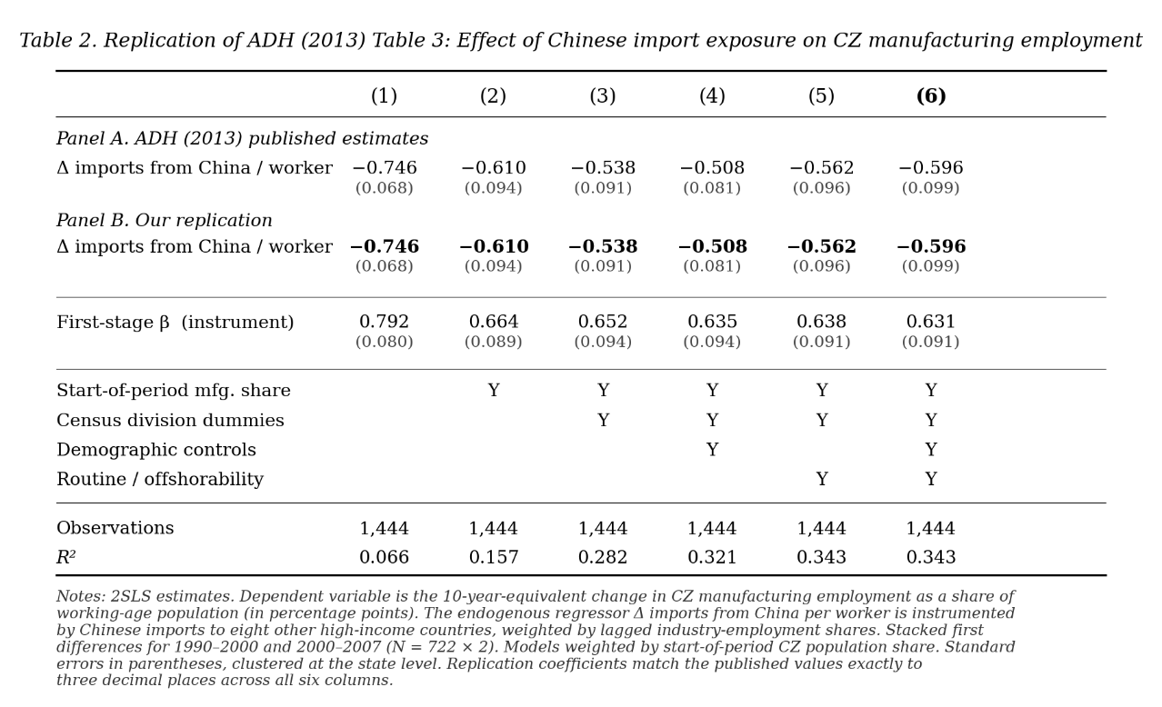
Table 2. Replication of ADH (2013) Table 3 — Effect of Chinese import exposure on CZ manufacturing employment share.
Economically, −0.596 implies that a $1,000 per-worker increase in decadal Chinese exposure lowers a CZ's manufacturing share by 0.6 percentage points. ADH attribute 44% of the 1990–2007 manufacturing decline to this channel. Because we use the original data and code, this is a computational reproduction—the exact match confirms our codebase functions correctly. The next section applies the same strategy to a CZ-level Republican vote share built from county-level returns 2000–2024.

