Week 2 Task Submission: Database & API Development
Name: Rishav Dev Tiwari
Program: Fusemachines AI Fellowship 2026

1. Project Overview
This project implements a fully functional REST API for the ClassicModels database utilizing a 4-layer clean architecture (Connection, Data Format, Logic, and API Layer). The application adheres to the Twelve-Factor App methodology, specifically focusing on Dependency Management, Config Management, Backing Services, and Concurrency.

2. Environment & Database Setup (Factor II, III, & IV)
The application utilizes Docker to ensure a consistent environment and to manage PostgreSQL as an isolated backing service. Database credentials and variables are isolated in a .env file.
The database is containerized using docker-compose.yml. Upon the initial startup, the container automatically executes seed.sql via the /docker-entrypoint-initdb.d/ volume bind, successfully building all 8 tables and seeding them with data.

3. API Testing & Documentation
The API leverages FastAPI automatic interactive documentation (Swagger UI). Each of the 8 tables features its own tagged section containing GET and COUNT endpoints.
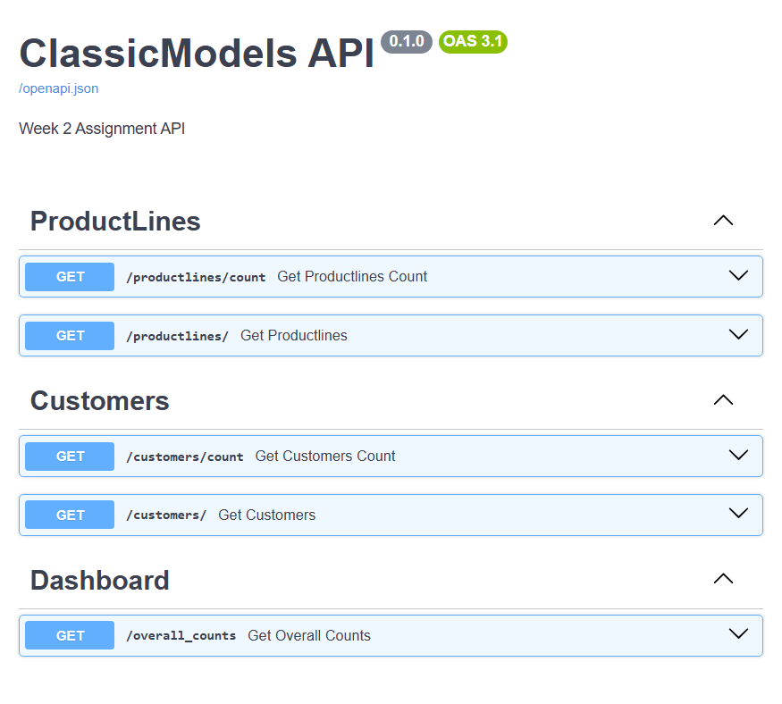
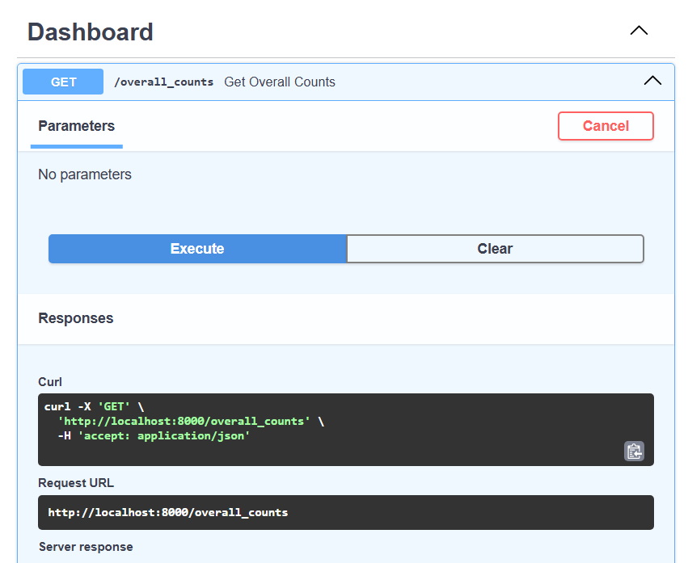
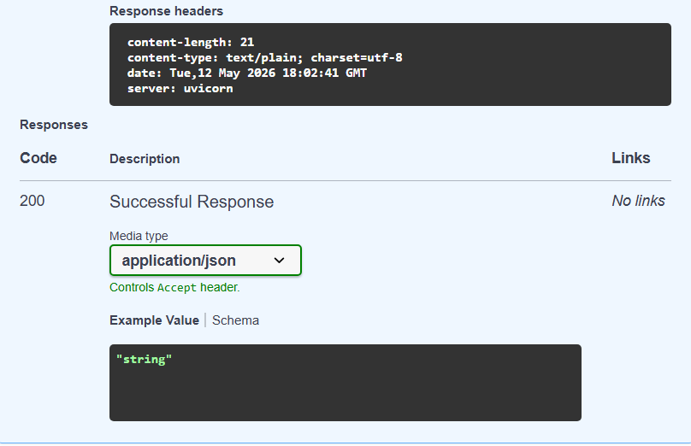

4. Concurrency Implementation (Factor VIII)
To achieve high performance under load, the application utilizes asynchronous concurrent processing for the master dashboard endpoint (/overall_counts).
Instead of querying the 8 database tables sequentially (which creates blocking delays), the API uses asyncio.gather() combined with asyncio.to_thread(). This allows the FastAPI server to dispatch all 8 SELECT COUNT(*) queries to the PostgreSQL database simultaneously, drastically reducing the total response time.
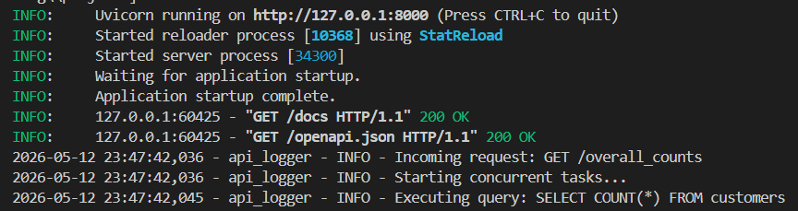

Github Repository: https://github.com/rishavdevtiwari/fusemachines-fellowship.git

