Implementation of Nonlinear Controllers for Robotic Manipulators with Real-Time and Bi-Directional Digital Twin Integration
1. Introduction
Robotic manipulators exhibit strongly nonlinear, configuration-dependent dynamics: inertial coupling between joints, Coriolis and centripetal effects, and gravity loading that varies with pose. Linear controllers such as fixed-gain PD are adequate only near a single operating point and degrade elsewhere — most visibly as steady-state error under gravity. Nonlinear control techniques such as feedback linearization (computed-torque control) instead use a model of the manipulator's own dynamics to cancel these effects, restoring a simple, uniformly tunable linear response across the workspace. Realizing such controllers on physical hardware benefits from a digital twin: a virtual replica kept synchronized with the real robot in real time and, critically, bi-directionally — reporting the robot's true state upward while carrying commands and model-based compensation terms back down. This project implements and validates a family of nonlinear controllers for a multi-joint manipulator alongside such a bi-directional digital twin.
2. Problem Statement
Fixed-gain PD control, applied independently per joint with no gravity or coupling compensation, cannot hold accuracy across the workspace: on real hardware it settles short of the target under gravity unless gains are pushed high enough to risk instability elsewhere. A full nonlinear, model-based controller avoids this, but the manipulator's onboard controller can only run a fast local loop — it cannot execute the heavier mass-matrix and Coriolis computation in real time, so compensation terms must be computed off-board and delivered over a link fast enough to stay consistent with the current pose, without leaving a stale command applied if that link degrades. Existing digital twins for manipulators also typically emphasize one direction only — visualization from telemetry, or open-loop command issuance — rather than a validated loop where both directions run concurrently. This project addresses both problems together.
3. Project Objectives
The objectives are to implement and compare three controller tiers on the same manipulator: a decoupled per-joint PD baseline; a gravity- and coupling-compensated nonlinear controller using feedback linearization, with the mass matrix, Coriolis terms, and gravity vector derived numerically from the manipulator's own kinematics; and a trajectory- and path-tracking extension of that same controller, following a continuously moving reference rather than a fixed target. A further objective is to build a real-time digital twin that renders the manipulator's actual and commanded poses simultaneously, synchronized bi-directionally over a telemetry/command link, and to validate each controller tier in simulation and on physical hardware with full logged telemetry.
4. Proposed Methodology
Forward kinematics is expressed as a chain of homogeneous transforms through the manipulator's joints; inverse kinematics solves for joint angles reaching a target end-effector position by damped least squares on a numerically differentiated Jacobian, which degrades gracefully — reporting a residual — rather than failing outright near the workspace boundary. The baseline controller treats each joint as an independent second-order system under a PD law. The nonlinear controller instead derives the manipulator's mass matrix M(q), Coriolis matrix C(q,q̇), and gravity vector G(q) numerically from the same kinematic chain, and applies the computed-torque control law τ = M(q)a_ref + Kp·e + Kd·ė + C(q,q̇)q̇ + G(q), which cancels the arm's own coupling and gravity terms so the closed-loop response is linear and uniformly tunable. On physical hardware this is split across two rates: the onboard controller runs a 100 Hz current-mode PD loop, while the host computes the full gravity/coupling compensation and streams it down as a feed-forward term that decays to zero if not refreshed, so a lost link cannot leave a stale torque applied. A critically damped second-order reference filter smooths a step target into a continuously evolving one; the same filter, driven by a continuously moving goal instead of a fixed one, extends the controller to track a Cartesian path. The digital twin is a thread-safe shared state read by a live 3D renderer and written independently by a telemetry-reading thread (real pose, upstream) and the controller (commanded pose and compensation terms, downstream), each at its own rate, as shown in Figure 1.
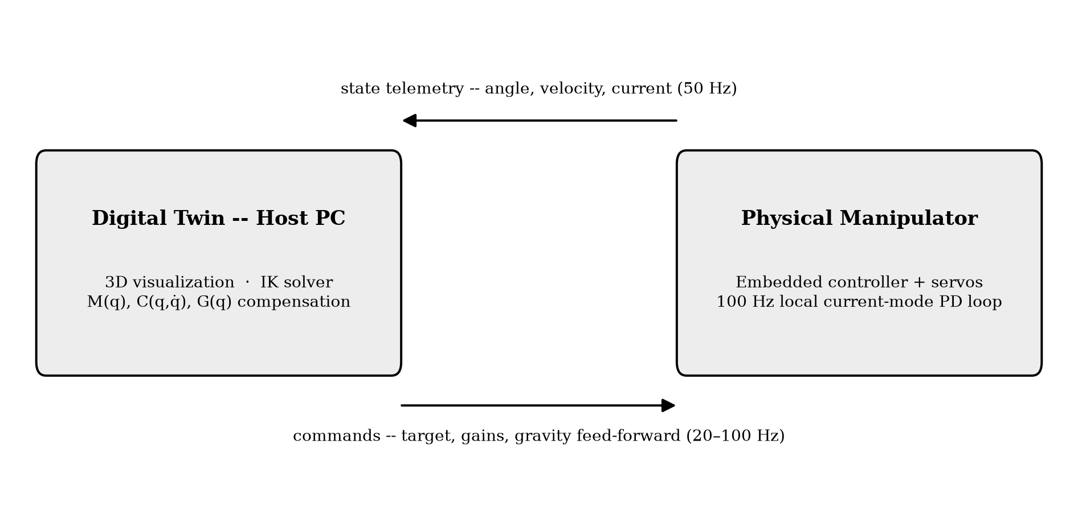
Figure 1: Bi-directional real-time link between the digital twin and the physical manipulator. The physical robot streams state telemetry upstream at 50 Hz; the host streams commands, gains, and model-based gravity/coupling compensation back downstream at 20–100 Hz, while the manipulator's own embedded controller runs a fast 100 Hz local PD loop.
5. Expected Outcomes
The PD baseline and the gravity/coupling-compensated nonlinear controller were both implemented and exercised on physical hardware as well as in simulation; the baseline's steady-state droop under gravity, and its removal once nonlinear compensation is added, were both directly observed. The trajectory-tracking extension was likewise validated on hardware and in simulation, reducing peak jerk by more than an order of magnitude relative to a step input while holding final accuracy to a fraction of a millimeter of the inverse-kinematics solution. A further extension that tracks a continuously moving path rather than a single point reuses the same control law and was validated through simulated closed-loop runs, which also surfaced and fixed a numerical issue in the inverse-kinematics solver near joint limits; hardware trials of this extension are still pending. Across all three controllers, the digital twin's bi-directional link was confirmed to track live hardware telemetry continuously, independent of which controller is active.
6. Future Scope
Planned extensions include hardware trials of the path-tracking controller and generalizing it beyond planar circles and rectangles; replacing the current approximate, point-mass inertia model with measured or CAD-derived link parameters to sharpen gravity and coupling compensation; adaptive or robust variants of the nonlinear controller that accommodate model uncertainty without hand-tuned gains; extending the same bi-directional digital twin architecture to other robotic platforms beyond a single manipulator; and richer in-twin visualization that overlays tracking error and the individual dynamics terms — torque, gravity, and Coriolis contributions — directly on the live view rather than only in post-run plots.
7. Conclusion
This project implemented and validated, on real hardware, a family of nonlinear controllers for a robotic manipulator — from independent per-joint PD to full feedback-linearization control that cancels the arm's own mass-matrix, Coriolis, and gravity terms, to a trajectory- and path-tracking extension of that same law. Throughout, a real-time digital twin kept a virtual replica synchronized bi-directionally with the physical robot, reporting true state upward and carrying commands and model-based compensation downward, and was validated independently of whichever controller was active. The results confirm that nonlinear, model-based compensation directly addresses the tracking limitations of linear PD control, and that a correctly split, bi-directional digital twin is a practical foundation for developing such controllers safely.

