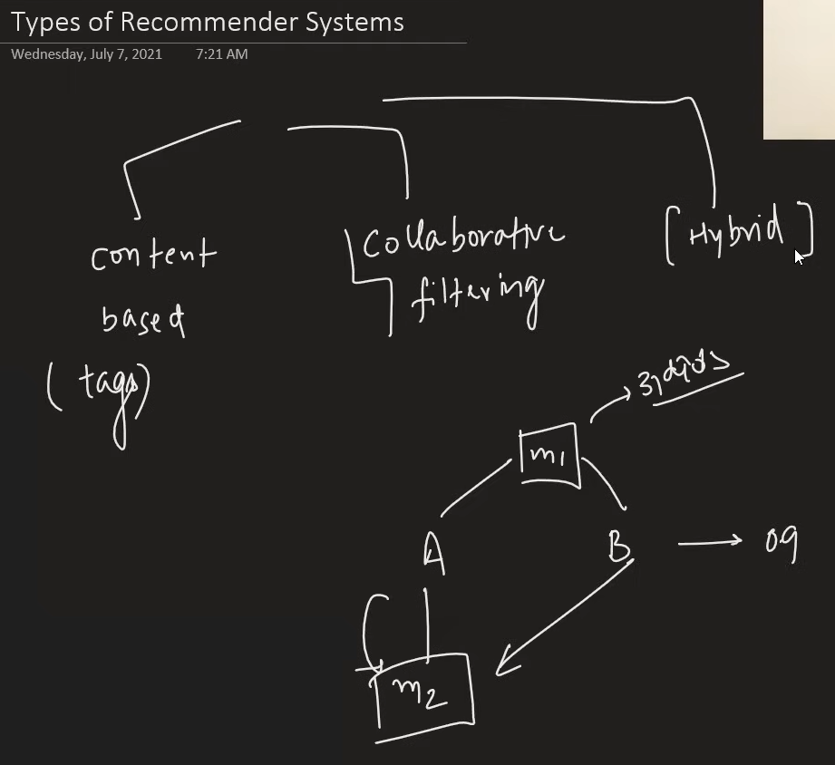

This project is content based.

Next do collborative and Hybrid based project.

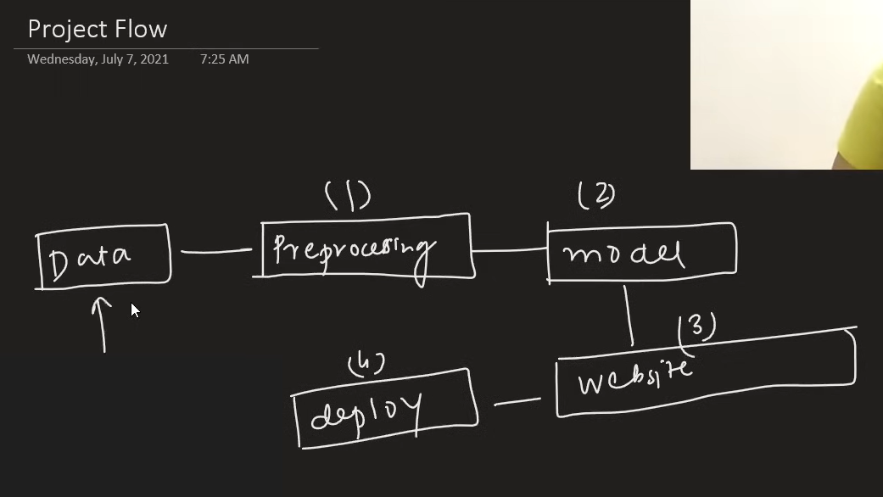

Dataset



<https://www.kaggle.com/datasets/tmdb/tmdb-movie-metadata>