https://p5js.org/
p5.js is a friendly tool for learning to code and make art. It is a free and open-source JavaScript library built by an inclusive, nurturing community. p5.js welcomes artists, designers, beginners, educators, and anyone else!
Books to get started with p5.js
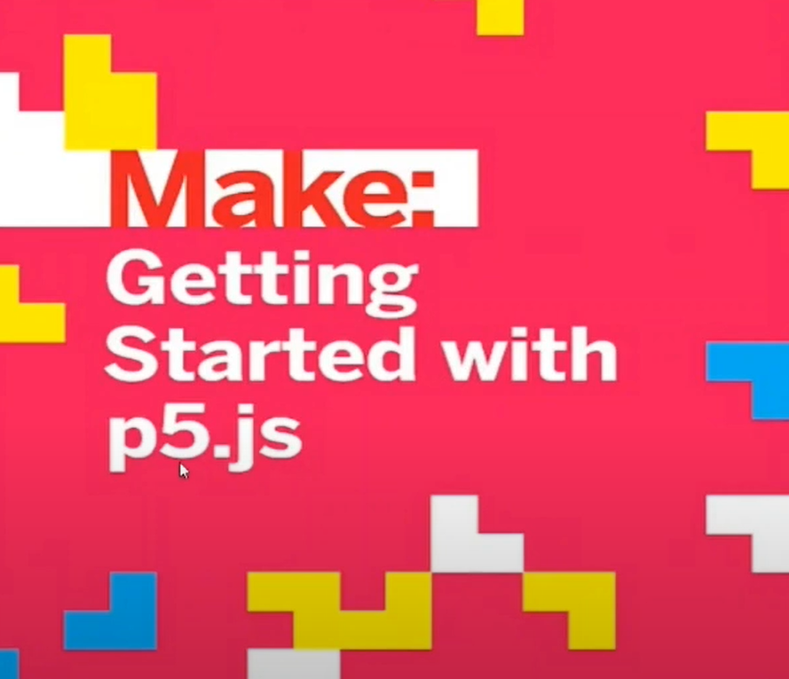

https://ml5js.org/

PoseNet: Detect 17 points of body parts.
