Create a new google colab file
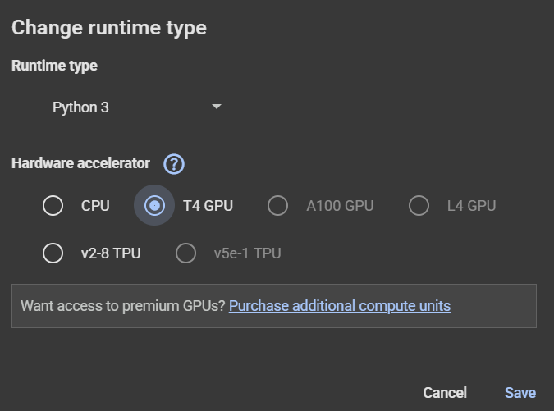
To reduce NN train time.

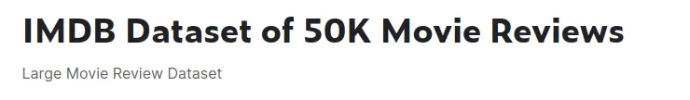
Use this dataset from Kaggle.
Create new taken in Kaggle for API.
Upload in google colab folder.

Goto https://www.kaggle.com/datasets/lakshmi25npathi/imdb-dataset-of-50k-movie-reviews
Click on three dot -> copy API command

