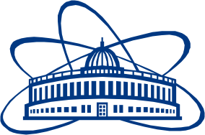

JOINT INSTITUTE FOR NUCLEAR RESEARCH

Flerov Laboratory of Nuclear Reactions

**FINAL REPORT ON THE**

**INTEREST PROGRAMME**

*Production and spectroscopic investigation of new neutron-rich isotopes near the neutron N=126 shell closure using the multi-nucleon transfer reactions.*

**Supervisor:**

Mr. Viacheslav Vedeneev

**Student:**

Rishav Pandey, India

Jabalpur Engineering College

**Participation period:**

February 14 – March 25, 2022

Wave 6

Dubna, Russia.