V2B Synthetic Data — Users, Cars, Sessions Generation
How three CSVs encode user behavior, fleet physics, and per-day arrivals.
1. The three CSVs
users.csv, cars.csv, and sessions.csv form a causal chain — generated in this order: users first, then cars, then sessions. Each users.csv row maps 1:1 to a cars.csv row (same car_id); each car_id produces 0..N sessions across the sim window.
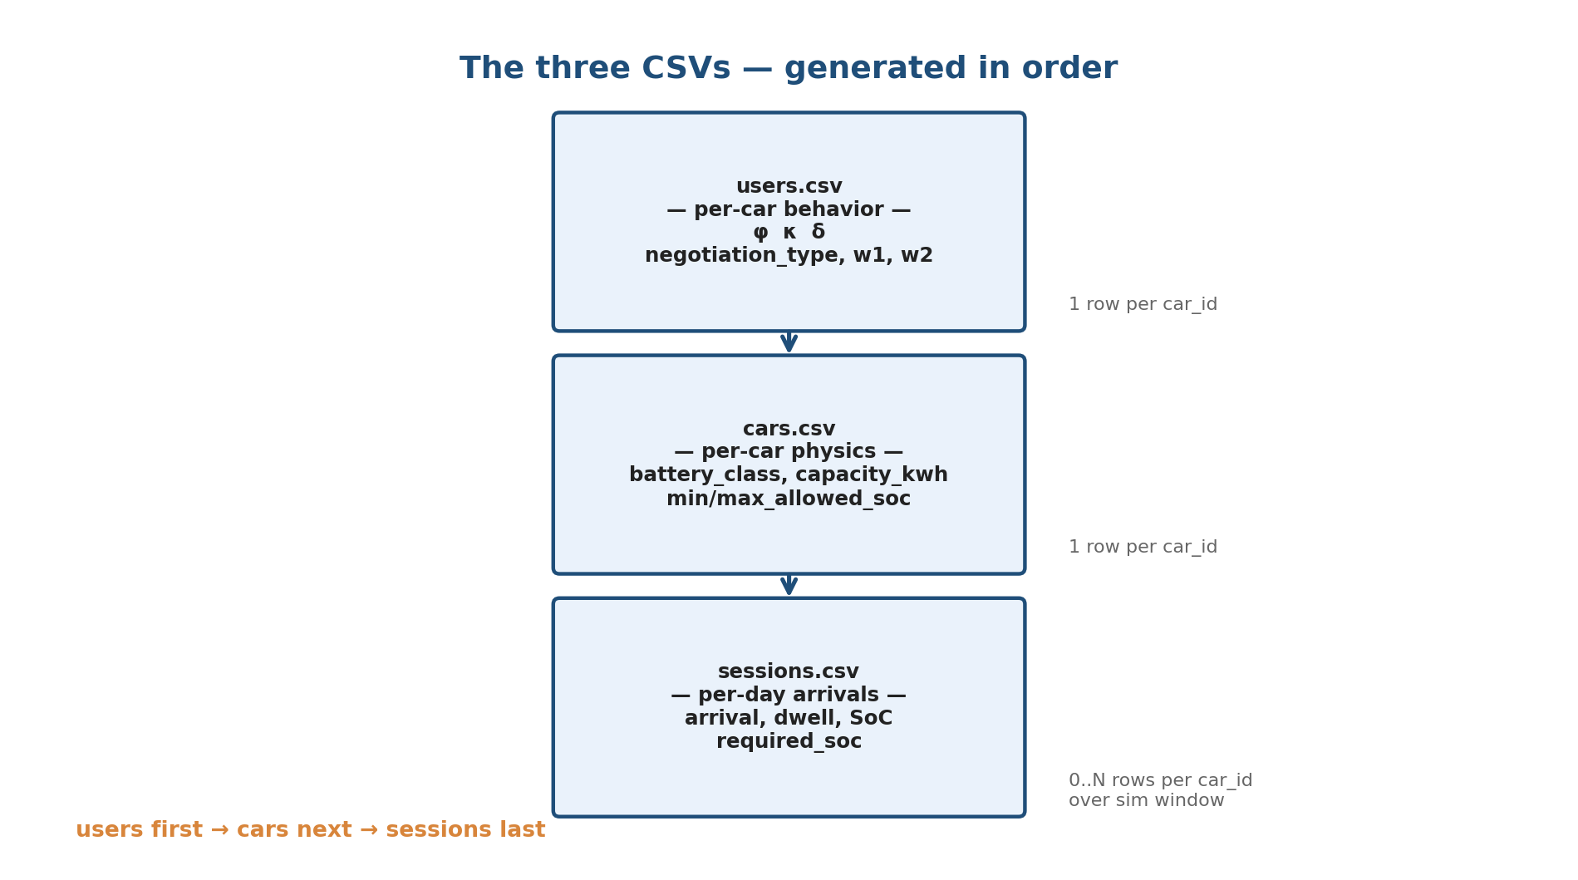
2. Three behavioral axes (per car)
Axis | Meaning | Range | Where it bites
φ (phi) — frequency | P(show up on any given day) | [0.0, 1.0] | Bernoulli gate, sessions step 2
κ (kappa) — consistency | How regular arrival timing is | [0.0, 1.0] | σ_eff = σ · (1 − κ · 0.5), step 3
δ (delta_km) — commute | One-way commute proxy | [3, 100] km | shift_eff = shift − 0.003·δ, step 5
3. Default region grid (5 regions)
Region | φ | κ | δ (km) | Wt | Mental model
stable_commuter | [0.85, 1.00] | [0.75, 1.00] | [40, 80] | 0.35 | Long-distance office, daily
flexible_local | [0.70, 0.95] | [0.50, 0.80] | [5, 15] | 0.25 | Local, frequent + flexible
irregular_distant | [0.40, 0.70] | [0.20, 0.50] | [40, 100] | 0.20 | Long commute, ~3 days/wk
occasional_visitor | [0.05, 0.20] | [0.10, 0.40] | [3, 50] | 0.10 | Rare drop-in
erratic | [0.30, 0.70] | [0.05, 0.30] | [5, 80] | 0.10 | Unpredictable schedule

4. users.csv generation
1. Optional Dirichlet perturb — if axes_distribution_dirichlet_alpha < 1e6, realized_weights ~ Dirichlet(weights · α); else verbatim. Logged to manifest.
2. Assign region — region ~ Categorical(realized_weights)
3. Sample axes (independent in 3D box) — φ ~ U(freq_lo, hi), κ ~ U(consist_lo, hi), δ ~ U(dist_km_lo, hi)
4. Assign negotiation type — negotiation_type ~ Categorical(negotiation_mix) — 4 CONSENT clusters (I/II/III/IV)
5. Sample CONSENT weights — (w1, w2) ~ N(cluster_μ, cluster_σ), clipped ≥ 0, × w_multiplier
Schema: car_id, region, phi, kappa, delta_km, negotiation_type, w1, w2
5. cars.csv generation
1. Branch by battery_heterogeneity — homog → all argmax(battery_mix); mixed α ≥ 1e6 → per car Categorical(battery_mix); mixed α < 1e6 → once-per-sample realized_mix ~ Dirichlet(battery_mix · α), then per car Categorical.
2. Lookup BATTERY_SPECS — capacity_kwh ∈ {24, 40, 75, 100}; SoC bounds per class (typ. [10, 100]).
Schema: car_id, capacity_kwh, min_allowed_soc, max_allowed_soc, battery_class
6. sessions.csv generation (10 steps)
For each car_id × each weekday in sim_window — rejection sampling, max 8 retries.
1. Resolve region — from users.csv
2. Attendance gate — draw ~ U(0,1); skip day if draw > φ
3. Bivariate Gaussian copula sample — on (arrival_hour, dwell_hours); marginals TruncNorm(μ_r, σ_eff; [lo, hi]) × Weibull(k_r, λ_r). (u_arr, u_dwell) ~ N₂(0, [[1, ρ], [ρ, 1]]); σ_eff = σ_r · (1 − κ · 0.5); ρ = region.copula.rho_gaussian — typ. negative ⇒ early arrivers stay longer. Departure = arrival + dwell.
4. Snap arrival — to 15-min grid
5. Arrival SoC — shift_eff = shift_r − 0.003 · δ; arrival_soc ~ Beta(α_r, β_r) + shift_eff
6. Required SoC at departure — required_soc ~ TruncNorm(85, 5), clamped to [max(min_depart_soc, arrival_soc+ε), max_allowed_soc]
7. D5 reachability — energy_needed = (required − arrival)/100 · capacity; max_charge = rate · dwell · 0.96; retry from step 3 if energy_needed > max_charge (≤ 8x).
8. Floor duration — to 15-min multiples
9. Non-overlap (C7) — drop if overlaps prior session for same car_id today
10. Track external SoC — previous_day_external_use_soc = SoC delta since last building session
Schema: session_id, car_id, building_id, arrival, departure, duration_sec, arrival_soc, required_soc_at_depart, previous_day_external_use_soc
7. Worked example
car_id = 42, day = 2024-04-08 (Mon)
users.csv: region=flexible_local φ=0.84 κ=0.62 δ=12.4 km negotiation_type=II w1=0.71 w2=0.48
cars.csv: battery_class=bolt_40 capacity_kwh=40 min/max_soc=10/100
region: f_arr=N(9.5, σ=1.5) f_dwell=Weibull(1.8, 6.5) f_soc=Beta(5,5) shift=0 ρ=−0.2
Attendance: draw=0.31 < 0.84 → continue.
Copula: σ_eff = 1.5·(1−0.62·0.5) = 1.035; (u_arr, u_dwell) = (−0.42, 0.18)
arrival_hour = 9.18 dwell = 7.6 h → snap arrival = 09:15
Arrival SoC: shift_eff = −0.003·12.4 = −0.037; Beta(5,5)=0.512 + shift = 0.475 → 47.5%
Required: floor=max(0.80, 0.475+ε)=0.80; TruncNorm(85,5) → 84.3%
D5: need = (84.3−47.5)/100·40 = 14.7 kWh; max = 20·7.6·0.96 = 146 kWh ✓
Duration: 7.6 h → 7.5 h = 27000 sec
→ sessions.csv: session_id=412, arrival=2024-04-08 09:15, departure=16:45, duration_sec=27000,
arrival_soc=47.5, required_soc_at_depart=84.3, prev_day_ext_use_soc=0.0
8. Knob cheat sheet
Bucket | Knob | Effect
ev_fleet | ev_count | # car_ids in users.csv and cars.csv
ev_fleet | battery_mix | Simplex over leaf_24/bolt_40/m3_75/rivian_100
ev_fleet | battery_heterogeneity | homog vs mixed branch in cars.py
ev_fleet | battery_mix_dirichlet_alpha | Per-sample mix perturbation (1e6 = off)
user_behavior | axes_distribution | 5-region grid: defines (φ,κ,δ) bounds + weight
user_behavior | negotiation_mix | CONSENT cluster distribution
user_behavior | w_multiplier | Scales (w1, w2)
user_behavior | min_depart_soc | Floor on required_soc_at_depart
user_behavior | axes_distribution_dirichlet_alpha | Per-sample region-weight perturbation
user_behavior | region_distributions.<r>.<dist>.<param> | Deep override of region distributions
charging_infra | charger_count, *_rate_kw, directionality_frac | Gate D5 reachability
sim_window | mode, weekdays_only, start, custom_end | Day loop in sessions.py
noise | arrival_time_jitter_min, soc_arrival_jitter_pct, profile | Post-render jitter; tmyx_stochastic = ±5min, ±3%

