API Security Risk Analysis Report

Name: Rishav Soni
Internship: Future Interns.
Task: Task 3
Date: 21/04/2026

2. OBJECTIVE:
The objective of this task is to analyze the security of a public API, identify potential vulnerabilities, and provide recommendations to improve security.

3.TOOLS USED:
- Postman (API testing)
- Browser Developer Tools
- JSONPlaceholder API (test API)

4. API DETAILS
API Name: JSONPlaceholder
Base URL: https://jsonplaceholder.typicode.com
Endpoints Tested:
- /users
- /users/1
- /comments

5. METHODOLOGY
- Sent API requests using Postman
- Analyzed responses and headers
- Checked authentication and authorization
- Tested multiple endpoints
- Evaluated rate limiting and data exposure

6. FINDINGS :

1. No Authentication
Description:
The API allows access without any authentication.
Impact:
Anyone can access sensitive data.
Severity: High
Recommendation:
Implement authentication such as API keys or JWT.
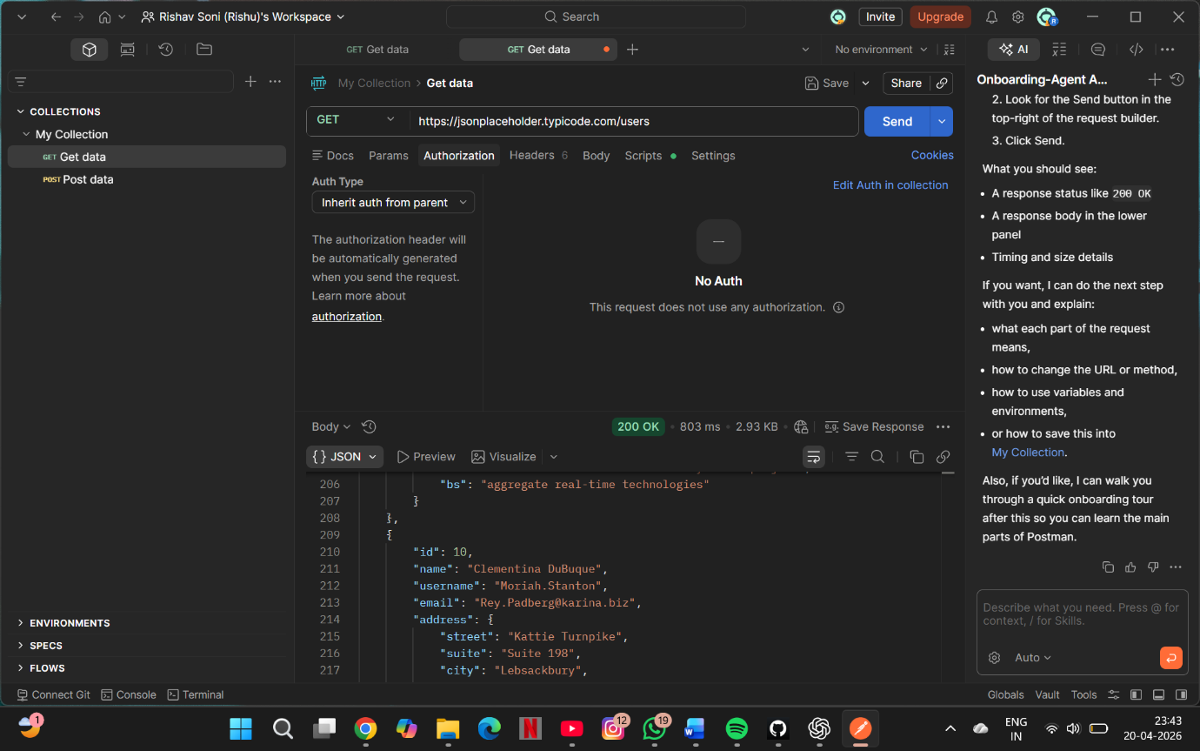

2. Data Exposure:
Description:
The API exposes user details such as email, phone, and address.
Impact:
Sensitive information can be misused.
Severity:
Medium
Recommendation:
Limit the amount of data returned.

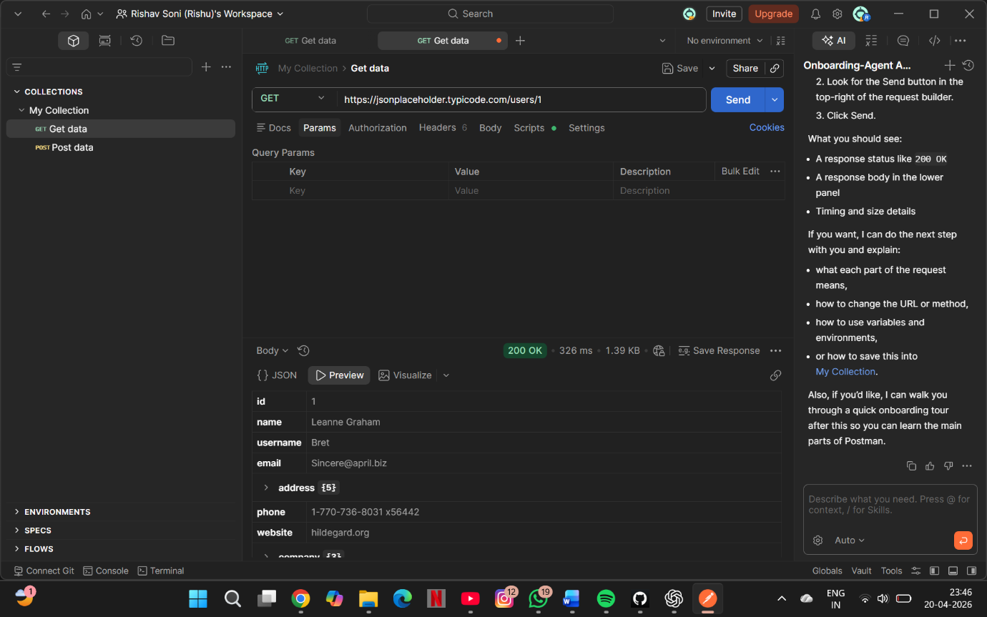

3. Broken Access Control:
Description:
The API allows access to specific user data using endpoints like /users/1 without any authorization.
Impact:
Unauthorized users can access other users’ data.
Severity: High
Recommendation:
Implement proper authorization and access control mechanisms.

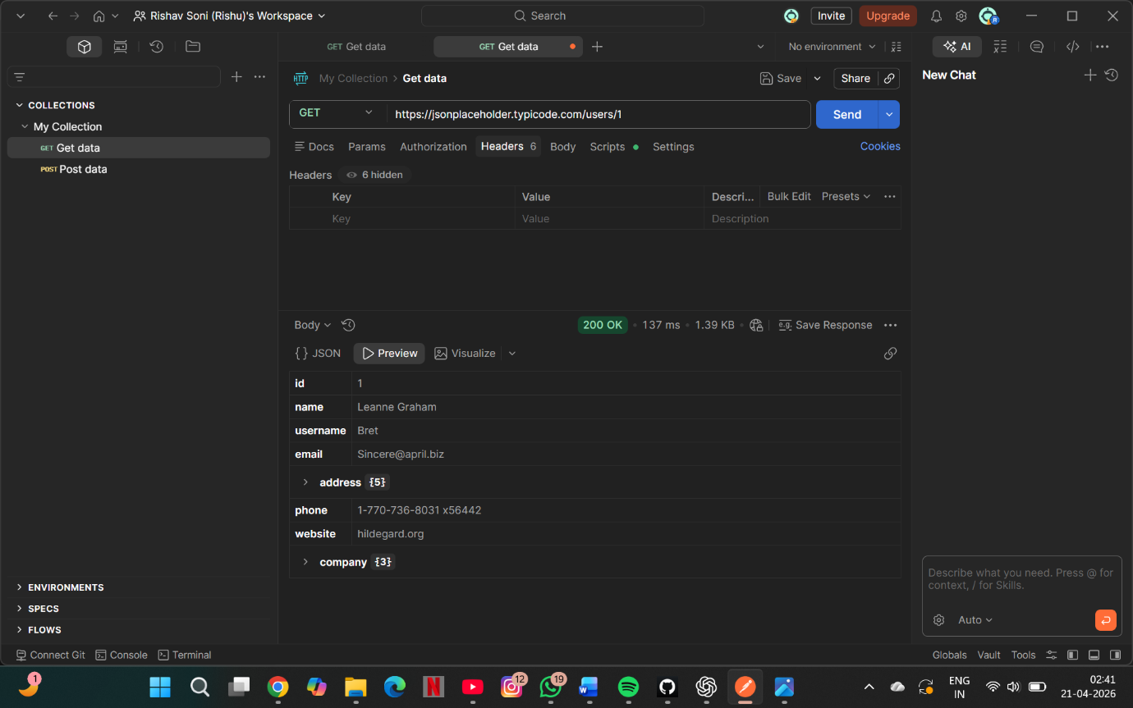

4. Weak Rate Limiting:
Description:
The API allows a high number of requests (1000), which is not strict.
Impact:
Attackers can perform large-scale requests.
Severity:
Low
Recommendation:
Reduce rate limits and apply stricter controls.

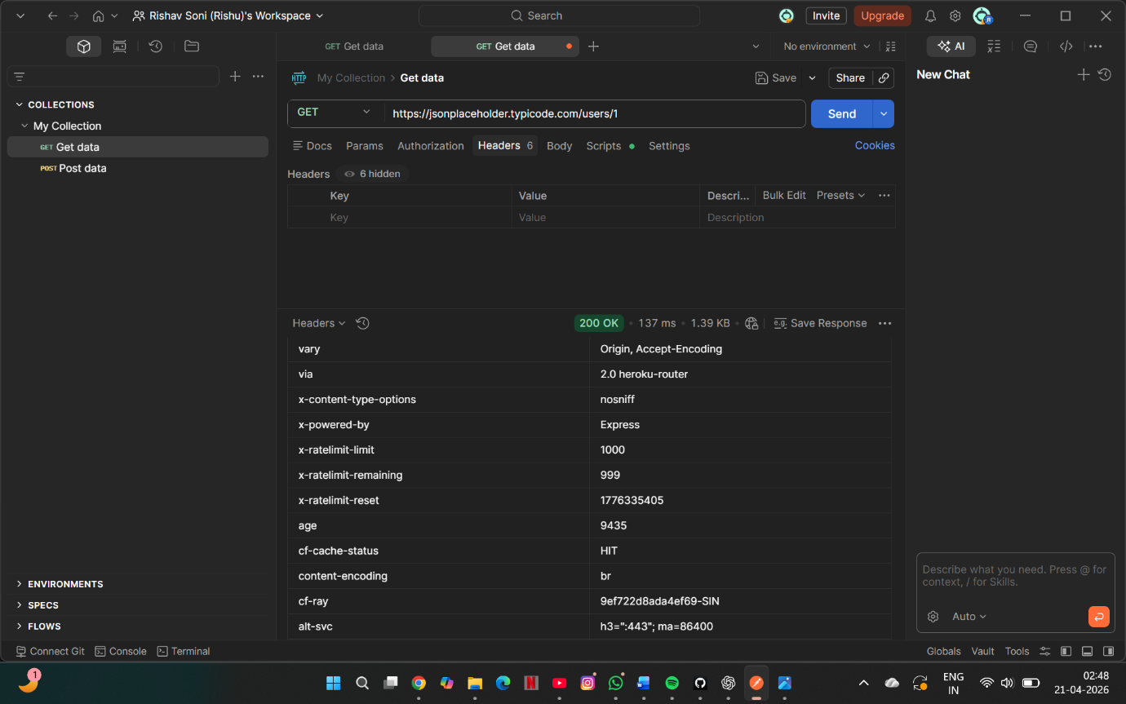

5. Missing Security Headers:
Description:
Important headers like Content-Security-Policy and X-Frame-Options are missing.
Impact:
Increases risk of attacks like XSS.
Severity:
Low
Recommendation:
Add proper security headers.

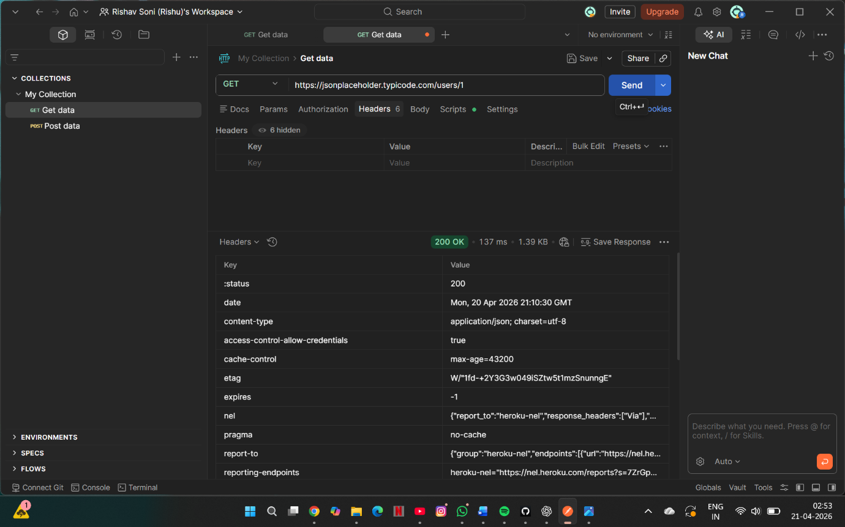
Figure: Response headers showing absence of important security headers

8. CONCLUSION:
The API contains several security weaknesses including lack of authentication, data exposure, and weak access control. These issues should be addressed to improve overall API security.

9. REFERENCES:
- https://jsonplaceholder.typicode.com
- Postman documentation

