RISHABH CHOUDHARI [mr.faith2411@gmail.com](mailto:mr.faith2411@gmail.com)



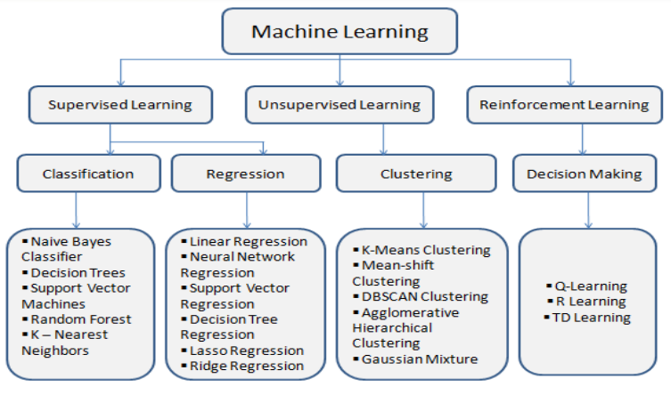



Bernoulli Naive Bayes To understand Bernoulli Naive Bayes algorithm, it is essential to understand Naive Bayes. Naive Bayes is a supervised machine learning algorithm to predict the probability of different classes based on numerous attributes. It indicates the likelihood of occurrence of an event. Naive Bayes is also known as conditional probability. Naive Bayes is based on the Bayes Theorem

The Naive Bayes classifier is based on two essential assumptions:-

(i) Conditional Independence - All features are independent of each other. This implies that one feature does not affect the performance of the other. This is the sole reason behind the ‘Naive’ in ‘Naive Bayes.’ (ii) Feature Importance - All features are equally important. It is essential to know all the features to make good predictions and get the most accurate results.

