**Stark Server Writeup**

**Wireshark Screenshot of one sample transaction**

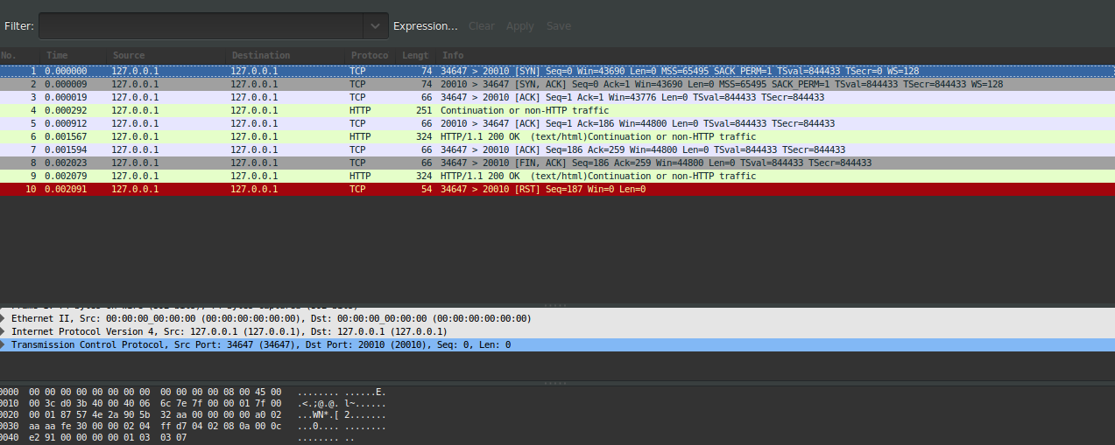

**Time Analysis:**

All time mentioned below are in Microseconds

Test Parameters

Machine : silo.soic.indiana.edu

**Test 1:** One 1MB file

**Persistent**

./web_client.bin localhost 20010 p test.txt

Time Elapsed: 15308

**Non-Persistent**

./web_client.bin localhost 20010 np test.txt

Elapsed: 17880

**Test 2:** 10 IMB files

**Persistent**

./web_client.bin localhost 20010 p FileList.txt

Time Elapsed: 6697392

**Non-Persistent**

./web_client.bin localhost 20010 np FileList.txt

Elapsed: 7352442

**Test 3 :** 9 - 1 MB files

**Persistent**

./web_client.bin localhost 20010 p FileList.txt

Time Elapsed: 7412647

**Non-Persistent**

./web_client.bin localhost 20010 np FileList.txt

Elapsed: 3293324

**Test 4:** 8 - 1 MB files

**Persistent**

./web_client.bin localhost 20010 p FileList.txt

Time Elapsed: 3368107

**Non-Persistent**

./web_client.bin localhost 20010 np FileList.txt

Elapsed: 8200537

**Test 5:** 7 - 1 MB files

**Persistent**

/web_client.bin localhost 20010 p FileList.txt

Time Elapsed: 2580060

**Non-Persistent**

/web_client.bin localhost 20010 np FileList.txt

Elapsed: 2854597

**Test 6:** 6 - 1 MB files

**Persistent**

Time Elapsed: 2793567

**Non-Persistent**

Elapsed: 2561356

**Test 7:** 5 - 1 MB files

**Persistent**

Time Elapsed: 2088104

**Non-Persistent**

Elapsed: 2312464

**Test 8:** 4 - 1 MB files

**Persistent**

Time Elapsed: 1800012

**Non-Persistent**

Elapsed: 2365830

**Test 9:** 3 - 1 MB files

**Persistent**

Time Elapsed: 1304033

**Non- Persistent**

Elapsed: 1391927

**Test 10:** 2 - 1 MB files

**Persistent**

Time Elapsed: 678311

**Non-Persistent**

Elapsed: 1251184

**Test 11:** 1 - 1 MB files

**Persistent**

Elapsed: 16329

**Non-Persistent**

Time Elapsed: 15495

**UDP Test Cases**

Test Parameters

Machine : silo.soic.indiana.edu

**Test 1:-**

*File Size:*

$ ls -l ../udp_server.c

-rw------- 1 sirdas students **9168** Sep 20 20:55 ../udp_server.c

*Time Elapsed*

**./udp_client.bin localhost 20010 udp_server.c**

Time Elapsed: 1315

**Test 2:**

*File Size:*

$ ls -l ../test.txt

-rw------- 1 sirdas students 1009368 Sep 20 18:51 test.txt

*Time Elapsed:*

**./udp_client.bin localhost 20010 test.txt**

Packet Loss

Segment no: 1008 Max Segment No: 1010

**Answers to Questions**

*Test your client and server applications on the CS machines. Compare and contrast the time that it takes to request and receive one to ten 1 MB text files using non-persistent and persistent connections. Explain the trends that you observe. What is the expected RTT in this environment? Does the time taken to service multiple requests grow linearly? Why or Why not?*

The comparison of the 2 scenarios is present above. The results did have some anomalies

**Test 3 :** 9 - 1 MB files

**Persistent**

./web_client.bin localhost 20010 p FileList.txt

Time Elapsed: 7412647

**Non-Persistent**

./web_client.bin localhost 20010 np FileList.txt

Elapsed: 3293324

**Test 6:** 6 - 1 MB files

**Persistent**

Time Elapsed: 2793567

**Non-Persistent**

Elapsed: 2561356

The other tests showed consistent trends of Persistent connections taking less time than Non -Persistent ones.

The time taken to do the tests don't grow necessarily linearly at the granularity of increasing the file size by one as can be seen in test 9 and 10 were Non- persistent connections seem to take less time with 3 files than 2 files but this could be due external factors not accounted for.

**Test 9:** 3 - 1 MB files

**Persistent**

Time Elapsed: 1304033

**Non- Persistent**

Elapsed: 1391927

**Test 10:** 2 - 1 MB files

**Persistent**

Time Elapsed: 678311

**Non-Persistent**

Elapsed: 1251184

But yes over a granularity of 10 files the time taken to finish the request does increase linearly:-

**Test 2:** 10 IMB files

**Persistent**

./web_client.bin localhost 20010 p FileList.txt

Time Elapsed: 6697392

**Non-Persistent**

./web_client.bin localhost 20010 np FileList.txt

Elapsed: 7352442

Yes it increases linearly as multiple request require more RTTs.

*Using your connection client and server, how long does it take to request and receive a 1 MB file? How does this time compare to the times for persistent and non-persistent connections?*

**Results:**

**Test 1:** One 1MB file

**Persistent**

./web_client.bin localhost 20010 p test.txt

Time Elapsed: 15308

**Non-Persistent**

./web_client.bin localhost 20010 np test.txt

Elapsed: 17880

Non-persistent is more than Persistent as expected but I don't see a significant difference.

*Complete the same analysis for the multi-threaded server. In addition, your analysis should discuss the performance received using the UDP client and server applications. Do you experience packet loss when using your UDP client and server applications? If so, when does loss occur?*

Test Parameters

Machine : silo.soic.indiana.edu

**Test 1:-**

*File Size:*

$ ls -l ../udp_server.c

-rw------- 1 sirdas students **9168** Sep 20 20:55 ../udp_server.c

*Time Elapsed*

**./udp_client.bin localhost 20010 udp_server.c**

Time Elapsed: 1315

**Test 2:**

*File Size:*

$ ls -l ../test.txt

-rw------- 1 sirdas students 1009368 Sep 20 18:51 test.txt

*Time Elapsed:*

**./udp_client.bin localhost 20010 test.txt**

Packet Loss

Segment no: 1008 Max Segment No: 1010

Yes I do experience packet loss in case of large files like 1 MB for files like 8 KB there is no packet loss. As you can see above I received 1008 parts of the 1 MB file and lost 2 segments.