**Assignment 1**

**Aim:**

1. Assume $Ɵ=π/3, t=0 to 2π and l=2m$.

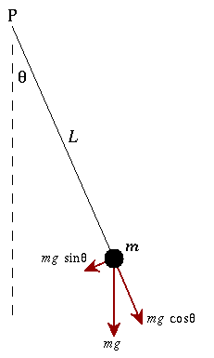

1. To model the given physical system to a 2nd order ODE.
2. Solve the 2nd Order Differential Equation.
3. Plot $‘i’ vs ‘t’$ for t: 0-200

**Code:**

1. Balancing forces on the free body diagram we get: $mL^{2}\frac{d^{2}θ}{dt^{2}}+mgsin\left(θ\right)L=0$ and assuming the values of $m, L, g be 1kg,1m,10m/s^{2}$ respectively and

$θ^{'}\left(0\right)=0 and θ\left(0\right)= π/6$, we get: $θ''\left(t\right)+10\sin\left(θ(t)\right)=0$. Also assuming $θ$ tends to small value.

1. **Using Mupad:**

eq:= ode({q''(t) = -4.8*q(t),q(0) = PI/6,q'(0) = 0},q(t))

x(t) :=solve(eq)

1. **Using Editor:**

Clc;

clear all;

close all;

syms t;

theta(t) = 0.5235987756*cos(2.19089023*t);

t = 0:0.01:2*pi;

plot(t,theta(t));

title('Analysis of Physical System');

xlabel('time(s)'),ylabel('theta(t)');

**Output:**







**Conclusions:** 2nd order derivative equation were derived for given System, solved using mupad editor and graph was plot for the same.