**Experiment 1(B)**

**Aim:**

1. To solve the ode equation: $y\left(x\right)=x^{2}+x+4$.
2. To model the physical system using 2nd order ODE.

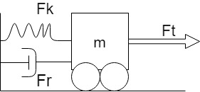

1. Assume: $k=0, m=750 kg , B=30 Ns/m ,Fr= 300N$ form a 1st order ODE.
2. Using Mupad solve the 1st order ODE with initial condition $v(0) = 0.$
3. Plot ‘v’ vs ‘t’ in MATLAB for $t: 1 to 200s$
4. Plot using @ode45 Function.

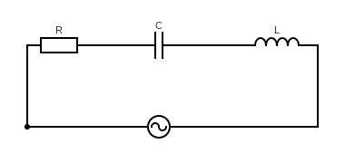

Vmcos (wt)

$V_{m}= 10V , w=50 rad/sec , L=2H , C=1F, R=1Ω , i(0)=0, i’(0)=0$.

1. To model the given RLC circuit in series model in Matlab to a 2nd order ODE.
2. Solve using Mupad for given values.
3. Plot $‘i’ vs ‘t’$ for t: 0 to 200 sec.

**Software Used:** Matlab 2018

**Theory:**

1. **Mupad**: Mupad is a GUI driven MATLAB package that helps you do algebra, calculus, as well as to graph and visualize functions. As you know, MATLAB is good for writing simple programs and working with numbers, but is cumbersome for doing symbolic calculations. Mupad is useful here.
2. **ode@45:** Syntax » $\left[t,y\right]= ode45(odefun,tspan,y_{0})$

Where tspan = [t0 tf], integrates the system of differential equations *y*′=*f* (*t*,*y*) from $t_{0} to t_{f}$  with initial conditions y0. Each row in the solution array y corresponds to a value returned in column vector t.

$[t,y,te,ye,ie] = ode45(odefun,tspan,y_{0},options)$ additionally finds where functions of $(t,y)$ , called event functions, are zero. In the output, $t_{e}$  is the time of the event, $y_{e}$ is the solution at the time of the event, and $i_{e}$  is the index of the triggered event.

**Code 1:**

eq:= ode({y(x) = x^2 + x + 4},y(x))

solve(eq)

**Output:**

$$\{x^{2}+x+4\}$$

**Code 2:**

1. Balancing forces on the free body diagram we get: $F-kx-B\frac{dx}{dt}=m\frac{d^{2}x}{dt^{2}}$ and Substituting the given $k,B, m$ and $v\left(t\right)= \frac{dx}{dt}$, we get: $25v^{'}\left(t\right)+v\left(t\right)=10$.
2. **Using Mupad:**

eq:= ode({25*v'(t) + v(t) = 10,v(0)=0},v(t))

solve(eq)

1. **Using Editor:**

clc;

close all;

clear all;

syms t;

v(t) = 10 - 10*exp(-t/25);

t = 0:200;

plot(t,v(t));

title('Analysis of Physical System');

xlabel('time(s)'),ylabel('v(t)');

d) **Using @ode45:**

function dv = asdf(t,v)

dv = (10-v)/25;

end

clc;

close all;

clear all;

[t,v] = ode45(@asdf,0:200,0);

plot(t,v);

title('Analysis of Physical System using @ode45');

xlabel('time(s)'),ylabel('v(t)');

**Output:**



$$ode\left(25v^{'}\left(x\right)+v\left(x\right)-10,v\left(t\right)\right)$$

$$\{10-10e^{\frac{-x}{15}}\}$$

**Conclusions:** 2nd order derivative equation were derived for given Physical System, 1st ODE solved using mupad editor and graphs were plot for the same using ode45 function and matlab text editor.

**Code 3:**

1. Adding the voltages to $V_{m}\sin\left(wt\right)$ with same current $i$ we get:

$V_{m}\cos\left(wt\right) =Ri\left(t\right)+L\frac{di(t)}{dt}+C\int{i(t)dt}$

$$or$$

$V_{m}\operatorname{wsin}\left(wt\right)+ R\frac{di(t)}{dt}+L\frac{d^{2}i(t)}{dt^{2}}+Ci\left(t\right)=0$

Using initial conditions we get: $500\cos\left(50t\right)=i^{'}\left(t\right)+2i^{''}\left(t\right)+i\left(t\right).$

1. **Using Mupad:**

eq:= ode({500*sin(50*t) + i’(t) + 2*i’’(t) + i(t) = 0,i(0)=0,i’(0) = 0},i(t))

solve(eq)

1. **Using Editor:**

clc

clear all

close all

syms t;

i(t) = cos((7^(1/2)*t)/4)*((12500*cos(50*t - (7^(1/2)*t)/4))/24992501 … - (499925000*7^(1/2)*exp(-t/4)*sin((7^(1/2)*t)/4))/174947507;

t = 0:1:200;

plot(t,i(t));

title('Analysis of Electrical System');

xlabel('time(s)'),ylabel('i(t)');

**Output:**



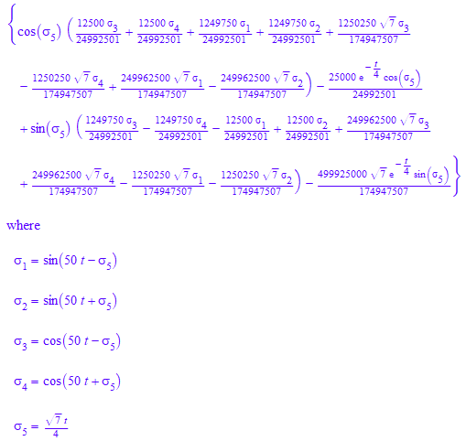



**Conclusions:** 2nd order derivative equation were derived for given System, solved using mupad editor and graph was plot for the same.

**Assignment 1**

**Aim:**

1. Assume $Ɵ=π/3, t=0 to 2π and l=2m$.

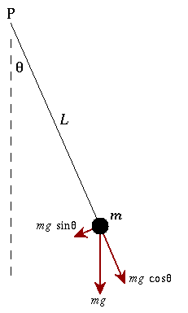

1. To model the given physical system to a 2nd order ODE.
2. Solve the 2nd Order Differential Equation.
3. Plot $‘i’ vs ‘t’$ for t: 0-200

**Code:**

1. Balancing forces on the free body diagram we get: $mL^{2}\frac{d^{2}θ}{dt^{2}}+mgsin\left(θ\right)L=0$ and assuming the values of $m, L, g be 1kg,1m,10m/s^{2}$ respectively and

$θ^{'}\left(0\right)=0 and θ\left(0\right)= π/6$, we get: $θ''\left(t\right)+10\sin\left(θ(t)\right)=0$. Also assuming $θ$ tends to small value.

1. **Using Mupad:**

eq:= ode({q''(t) = -4.8*q(t),q(0) = PI/6,q'(0) = 0},q(t))

x(t) :=solve(eq)

1. **Using Editor:**

Clc;

clear all;

close all;

syms t;

theta(t) = 0.5235987756*cos(2.19089023*t);

t = 0:0.01:2*pi;

plot(t,theta(t));

title('Analysis of Physical System');

xlabel('time(s)'),ylabel('theta(t)');

**Output:**







**Conclusions:** 2nd order derivative equation were derived for given System, solved using mupad editor and graph was plot for the same.