**Experiment 3(A)**

**Title of the Experiment:**

To study the given block of series, parallel and feedback systems of given transfer functions G(s) and H(s)

$$G_{1}\left(s\right)=\frac{s^{2}+1}{s^{2}+s+4} G_{2}\left(s\right)=\frac{s^{2}+s+2}{s^{3}+s^{2}+s+4} H\left(s\right)=\frac{1}{500s^{2}}$$

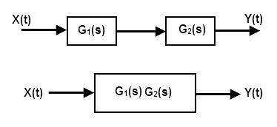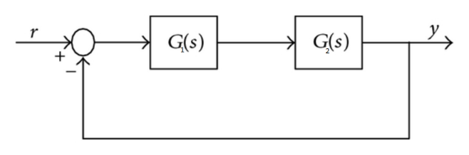

Fig-1: Series connection Fig-2: Unity feedback connection

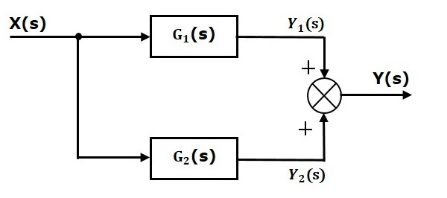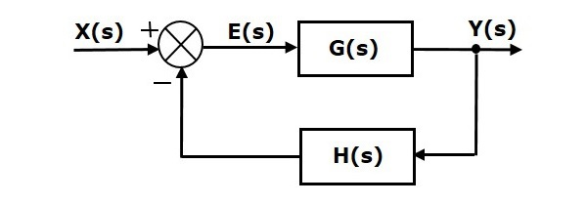 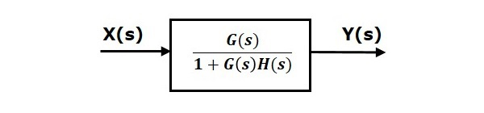

Fig-3: Parallel connection Fig-4: Feedback connection

**Objective of the Experiment:** To study various system transformation using Control System Toolbox

**Software:** MATLAB 2018

**Formula:** If two transfer functions G1 & G2 are given then series, parallel and feedback transformation are as follow:

* Series: $C= G1*G2$
* Parallel: $C= G1+G2$
* Feeback: $C= \frac{G1}{1+G1*G2}$

**Theory:** Matlab 2018 have three inter connections of transfer functions i.e. series, parallel and feedback.

* **Series:** Series connects two model objects in series. This function accepts any type of model. The two systems must be either both continuous or both discrete with indentical sample time.

Syntax**: series(G1,G2)**

This command is equivalent to the direct multiplication **G1 * G2**

* **Parallel:** Series connects two model objects in parallel. This function accepts any type of model. The two systems must be either both continuous or both discrete with indentical sample time.

Syntax**: parallel(G1,G2)**

This command is equivalent to the direct addition **G1 + G2**

* **Feedback:** Series connects two model objects in **Feedback**. This function accepts any type of model. The two systems must be either both continuous or both discrete with indentical sample time.

Syntax**: feedback (G1,G2)**

This command is equivalent to the direct division **G1 / G2**

**MATLAB Code:**

clc;

clear all;

close all;

%transfer Functions

G1 = tf([1 0 1],[1 1 4]);

G2 = tf([0 1 1 2],[1 1 1 4]);

H = tf([0 0 1],[500 0 0]);

%series connection

Y1 = series(G1,G2)

%unity feedback connection

Y2 = feedback(Y1,1)

%parallel connection

Y3 = parallel(G1,G2)

%feedback connection

Y4 = feedback(G1,H)

**MATLAB Results:**

Y1 =

s^4 + s^3 + 3 s^2 + s + 2

--------------------------------------

s^5 + 2 s^4 + 6 s^3 + 9 s^2 + 8 s + 16

Continuous-time transfer function for series connection

Y2 =

s^4 + s^3 + 3 s^2 + s + 2

---------------------------------------

s^5 + 3 s^4 + 7 s^3 + 12 s^2 + 9 s + 18

Continuous-time transfer function for unity feedback

Y3 =

s^5 + 2 s^4 + 4 s^3 + 12 s^2 + 7 s + 12

---------------------------------------

s^5 + 2 s^4 + 6 s^3 + 9 s^2 + 8 s + 16

Continuous-time transfer function for parallel connection

Y4 =

500 s^4 + 500 s^2

--------------------------------

500 s^4 + 500 s^3 + 2001 s^2 + 1

Continuous-time transfer function for feedback connection

**Conclusion:**

* The given functions were simplified the help of Matlab Control System Toolbox and verified algebraically, it can be conclude that is easier to simplify the block diagrams than to do it manually
* From above it is clear that if we are given series, parallel or feedback systems than we can use functions of Matlab to reduce it into its equivalent form.
* Also we can use Mathematical operators for the same.

**Experiment 3(B)**

**Aim:**

* To study about potentiometer as measurement instruments of angular displacement.
* Their application in error detection and in measurement of the relative angle of two entities.

**Apparatus:** Potentiometer based angular displacement measurement kit, Patch Chords and Power Supply.

**Circuit Diagram:**

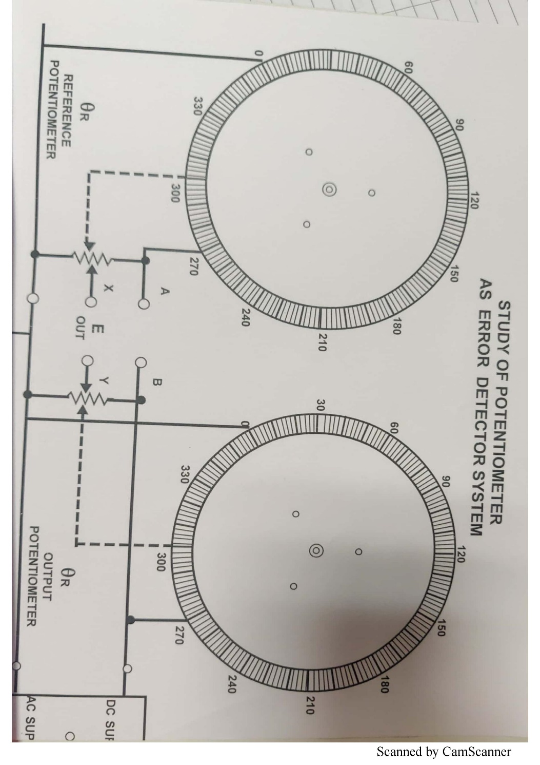

Fig-1

Reference from Controls lab book

**Theory:-**

**Angular displacement:** The angular displacement is defined as the angle through which an object moves on a circular path. It is the angle, in radians, between the initial and final positions.

**Potentiometer Characteristics:**

A potentiometer gives a change in resistance that is linearly related with shaft position. R1 is the total resistance, over a range of 0 to 345 degrees, then value of resistance R at any shaft position is given by

$$R= \frac{R_{1}}{θ_{t}}θ_{i}$$

**Application:** Angle measurement in Servo Motors**:**

* A servo contains a normal DC motor. This motor is connected to a potentiometer (or a variable resistance) through gears. As the motor rotates, the potentiometer's resistance changes. So the circuit can measure exactly what direction the motor's shaft is pointing.
* The desired position is sent in through the signal wire. As long as the signal wire has a position, the servo will ensure that the motor's shaft remains at the correct position.
* Also, the speed with which the motor turns is proportional to the difference between its actual position and desired position. So if the motor is near the desired position, it will turn slow. Otherwise it will turn fast. This is called proportional control.

**Procedure:**

Potentiometer as measurement instruments of angular displacement:

* Connect supply to reference potentiometer by shorting points A&B
* Connect ground point and variable point of reference potentiometer to Digital Panel Meter for voltage measurement
* Resistance can be measured directly using digital multi-meter.
* Slowly change the potentiometer from 0° to 300 in steps of 60 and measure output voltage and resistance.
* Tabulate the results.

Error detection in measurement of the relative angle of two potentiometer:

* Connect supply to reference potentiometer by shorting points A&B
* Connect ground point and variable point of reference potentiometer to Digital Panel Meter for voltage measurement
* Keep the reference potentiometer at position 120 degree.
* Slowly change the potentiometer from 0° to 270 in steps of 30 and measure output voltage.
* Connect error output Vxy of potentiometer to the input of error amplifier. Set gain of error amplifier to minimum.
* Repeat above steps for different gains and measure the output voltage.
* Tabulate the results.

**Observation Table**:

Table 1: Measurement of Resistance and Output voltage for angular displacement

|  |  |  |
| --- | --- | --- |
| Angular Displacement $θ_{i}$ (Degrees) | Measured Resistance $R_{i}$ (ohm) | Output Voltage $V_{0}$ (volts) |
| 60 | 0.17 | 0.2 |
| 120 | 0.349 | 0.42 |
| 180 | 0.528 | 0.63 |
| 240 | 0.704 | 0.85 |
| 300 | 0.864 | 1.05 |

Table 2: Measurement of Error voltage and amplified voltage for error measurement

$$θ_{i}=120°$$

|  |  |  |  |  |  |  |
| --- | --- | --- | --- | --- | --- | --- |
| Error ${(θ}_{f - }θ_{i})(°)$ | Error  Voltage(volts) | Amplified output Voltage(volts) | | | | |
| Gain = -0.5 | Gain = -1 | Gain = -1.4 | Gain = -1.9 | Gain = -2.5 |
| 0 | 0.48 | -0.23 | -0.48 | -0.70 | -0.91 | -1.20 |
| -30 | 0.421 | -0.204 | -0.41 | -0.60 | -0.78 | -1.03 |
| -60 | 0.33 | -0.16 | -0.32 | -0.47 | -0.62 | -0.82 |
| +30 | 0.54 | -0.26 | -0.54 | -0.79 | -1.02 | -1.35 |
| +60 | 0.606 | -0.29 | -0.59 | -0.87 | -1.13 | -1.49 |

**Calculations: $Gain=\frac{V_{A}}{V_{e}}$**  where, $V_{A}$ = Amplified Voltage and $V_{e}$ = Error Voltage

**Result:** It was observed that the error voltage was proportional to the difference between the angles of the two potentiometers.

$$∆θ∝V_{e}$$

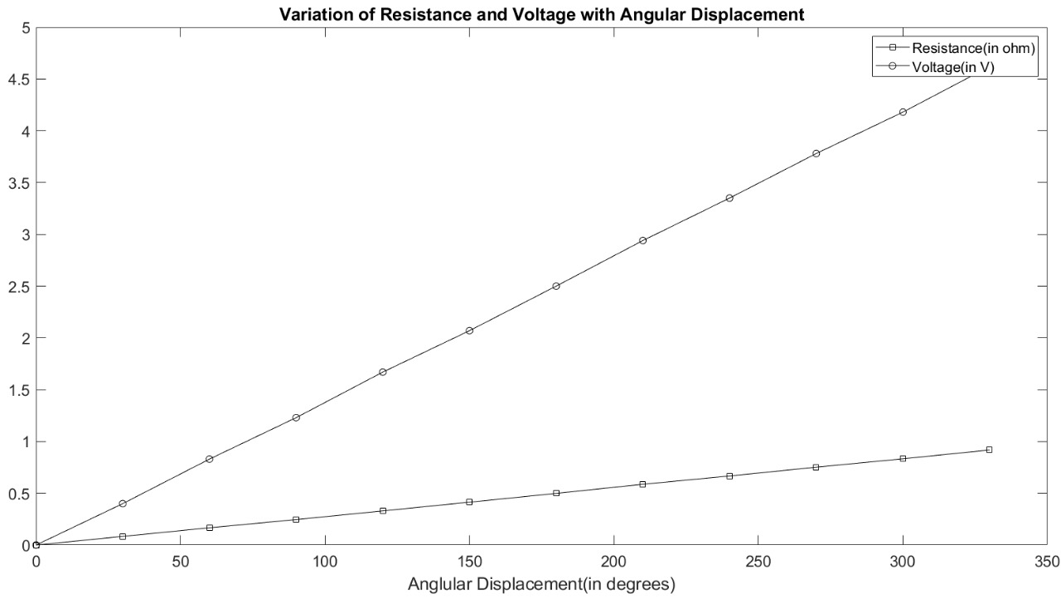

**Conclusion:** Potentiometers with error amplifiers were found to be a good basis for instrumentation of measurement of both in angular displacement and error in it. When the error is too low to be detected by the instrument, it is amplified to get the error in the detectable region.

**Experiment 3(C)**

**Title of the Experiment:**

* Use block diagram reduction techniques to replace the system with one block diagram.

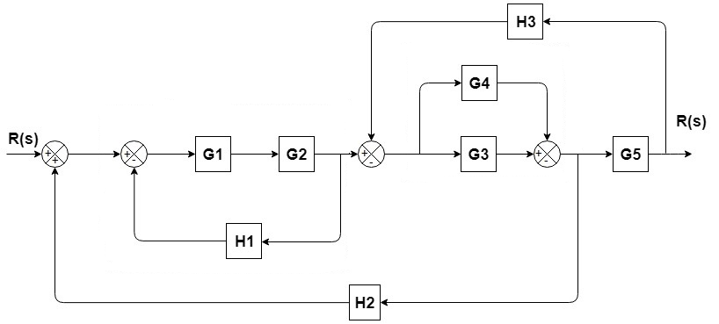

Fig-1: System Block Diagram

**Objective of the Experiment:** To study various system reduction techniques using Control System Toolbox

**Software:** MATLAB 2018

**Theory:**

**Reduction procedure for block diagrams:**

* Find the blocks connected in series and simplify.
* Find the blocks connected in parallel and simplify.
* Find the blocks connected in feedback loop and simplify.
* If we face difficulty with take-off point while simplifying, shift it towards right.
* If we face difficulty with summing point while simplifying, shift it towards the left.
* Keep repeating the above steps until you get the most simplified form, i.e., single block.

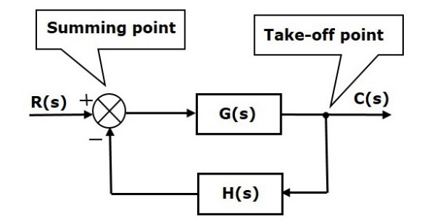

Fig:2 – General System Block Diagram

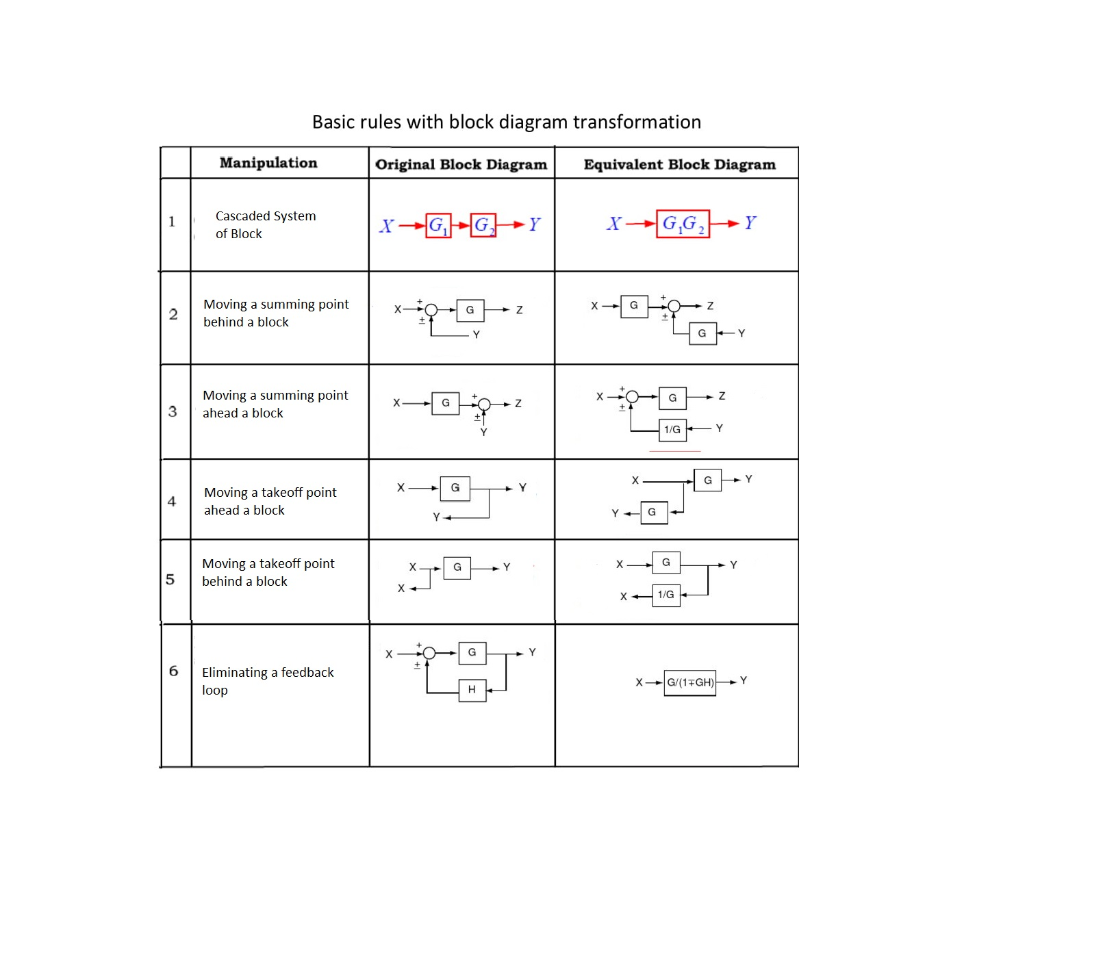

Table:1 – System Reduction Methods

(Reference from book Control Systems Engineering. By I.J. Nagrath)

**Procedure:**

For Fig1:

* Use Rule 1 for blocks G1 and G2 to get G1G2, use Rule 6 for blocks G1G2 and H1 and use Rule 6 for blocks G3 and G4.

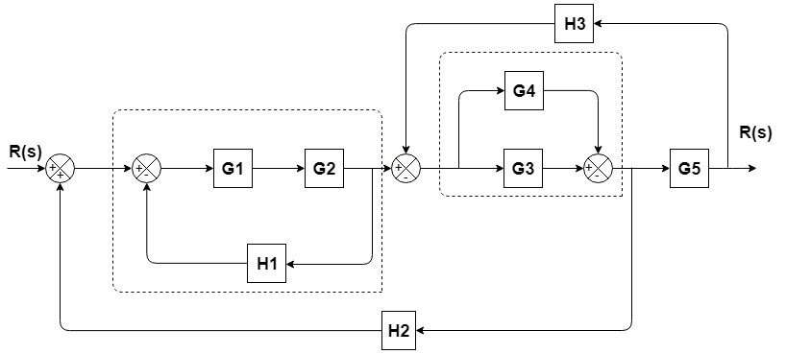

Fig-3

* Use shifting take-off point after the block G5.

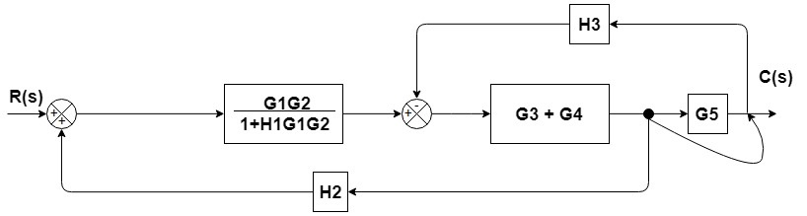

Fig-4

* Use Rule 1 for blocks (G3+G4) and G5, use Rule 6 for resultant and H3.

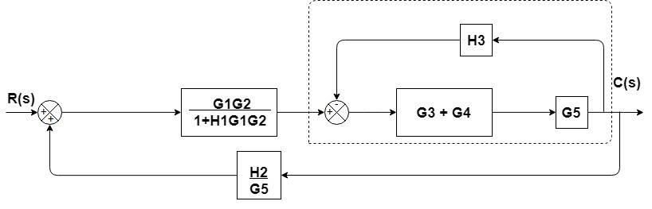

Fig-5

* Use Rule 1 for blocks for the two block in series and then use Rule 6 for feedback connection\

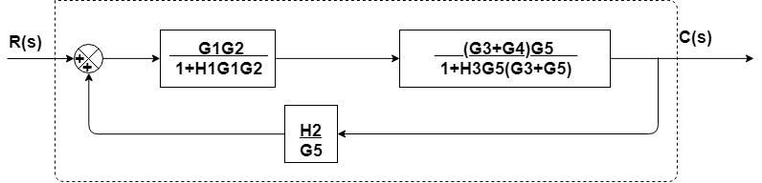

Fig-6

* Use Rule 1 for blocks connected in series.

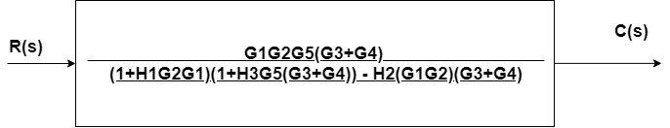

Fig-7

**Matlab Code:**

clc;

clear all;

close all;

G1 = tf([0 0 1],[1 14 40]);

G2 = tf([1 0 1],[1 6 5]);

G3 = tf([0 1 1],[1 4 4]);

G4 = tf([1 0 4],[1 2 2]);

G5 = tf([0 1 1],[1 2 1]);

G5INV = tf([1 2 1],[0 1 1]);

H1 = tf(1);

H2 = tf([0 0 1],[100 0 0]);

H3 = tf([0 2 4],[1 1 4]);

G34 = parallel(G3,G4);

G12 = series(G1,G2);

GH121 = feedback(G12,H1);

G345 = series(G34,G5);

GH3453 = feedback(G345,H3);

Gtop = series(GH3453,GH121);

HG25 = series(H2,1/G5);

Y = feedback(Gtop,HG25);

s=tf('s');

%Manully calculated

Y2 = (100 *s^12 + 800 *s^11 + 3400 *s^10 + 10500 *s^9 + 23700 *s^8 + 41000 *s^7 + 55400 *s^6 + 55500 *s^5 + 42200 *s^4 + 24200 *s^3 + 7200 *s^2)/(100 *s^15 + 3000 *s^14 + 38000 *s^13 + 277600 *s^12 + 1.351e06 *s^11 + 4.763e06 *s^10 + 1.271e07 *s^9 + 2.617e07 *s^8 + 4.187e07 *s^7 + 5.158e07 *s^6 + 4.74e07 *s^5 + 3.03e07 *s^4 + 1.183e07 *s^3 + 2.091e06 *s^2 + 314*s + 72);

**Matlab Results:**

>>Y =

100 s^12 + 800 s^11 + 3400 s^10 + 10500 s^9 + 23700 s^8 + 41000 s^7 + 55400 s^6 + 55500 s^5 + 42200 s^4 + 24200 s^3 + 7200 s^2

--------------------------------------------------------------------

100 s^15 + 3000 s^14 + 38000 s^13 + 277600 s^12 + 1.351e06 s^11 + 4.763e06 s^10 + 1.271e07 s^9 + 2.617e07 s^8 + 4.187e07 s^7 + 5.158e07 s^6 + 4.74e07 s^5 + 3.03e07 s^4 + 1.183e07 s^3 + 2.091e06 s^2 + 314 s + 72

Continuous-time transfer function.

>> Y2 =

100 s^12 + 800 s^11 + 3400 s^10 + 10500 s^9 + 23700 s^8 + 41000 s^7 + 55400 s^6 + 55500 s^5 + 42200 s^4 + 24200 s^3 + 7200 s^2

--------------------------------------------------------------------

100 s^15 + 3000 s^14 + 38000 s^13 + 277600 s^12 + 1.351e06 s^11 + 4.763e06 s^10 + 1.271e07 s^9 + 2.617e07 s^8 + 4.187e07 s^7 + 5.158e07 s^6 + 4.74e07 s^5 + 3.03e07 s^4 + 1.183e07 s^3 + 2.091e06 s^2 + 314 s + 72

Continuous-time transfer function(Manually Calculated).

>> isequal(Y,Y2)

ans =

logical

1

**Conclusion:**

As we reduce the block diagram using system reduction method, the system starts getting reduced by changing series of systems results in a system whose transfer function is the product of the transfer functions of systems present in series. While systems in parallel lead to a system whose transfer function is the sum of the transfer functions of systems present in parallel. Using feedback, the actual output can be compared to the desired output and gain of the system is changed accordingly.

**Assignment 3(A)**

**Title of the Experiment:**

* For a given two tank system do the following:
  + Obtain system Equations.
  + Design the block diagram from the obtained equations.
  + Reduce the block diagram using system reducing techniques.

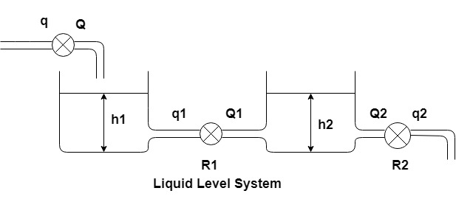

Fig-1

**Objective of the Experiment:** To derive system equations and reduce its block diagram for given system.

**Software:** MATLAB 2018

**Theory:**

**Reduction procedure for block diagrams:**

* Find the blocks connected in series and simplify.
* Find the blocks connected in parallel and simplify.
* Find the blocks connected in feedback loop and simplify.
* If we face difficulty with take-off point while simplifying, shift it towards right.
* If we face difficulty with summing point while simplifying, shift it towards the left.
* Keep repeating the above steps until you get the most simplified form, i.e., single block.

After analyzing the given system the following equations were obtained:

$$C_{1}\frac{dh_{1}}{dt}=q-q_{1},$$

$$C_{2}\frac{dh_{2}}{dt}=q_{1}-q_{2},$$

$$q_{1}= \frac{h_{1}-h_{2}}{R_{1}} and q_{2}= \frac{h_{2}}{R_{2}}$$

Applying Laplace Transformation both sides, we get

$${sC}_{1}H_{1}\left(S\right)= Q\left(S\right)- Q_{1}\left(S\right),$$

$$sC_{2}H_{2}\left(S\right)= Q_{1}\left(S\right)- Q_{2}\left(S\right),$$

$$Q_{1}(S)= \frac{H_{1}\left(S\right)-H_{2}\left(S\right)}{R_{1}} and Q_{2}(S)= \frac{H_{2}}{R_{2}}$$

The block diagram from these system equations is

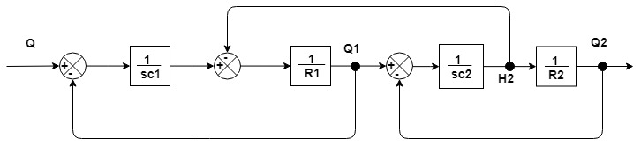

Fig-2

* Shift the take off point H2 to Q2 as shown in Fig-3

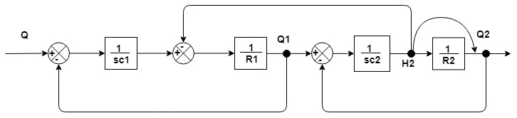

Fig-3

* Use Rule 1 for block shown in Fig-4

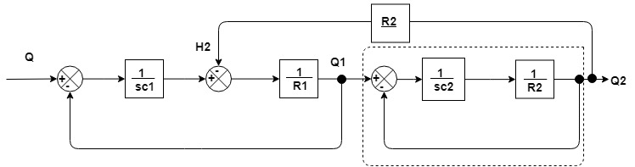

Fig-4

* Use Rule 6 for the block shown in Fig-5

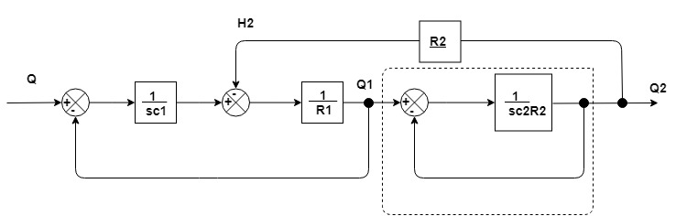

Fig-5

* Shift the point Q1 to Q2 as shown in Fig-6

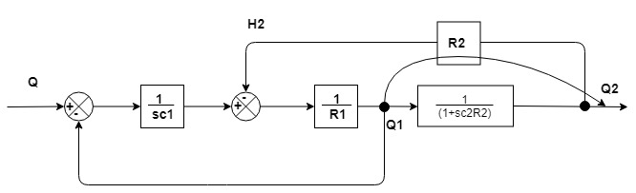

Fig-6

* Use Rule 1 for two blocks in series and with its resultant and R2 use Rule 6 as shown in Fig-7

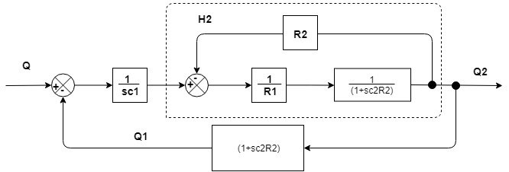

Fig-7

* Use Rule 1 for two blocks in series and with its resultant and (1+s $C_{2}R_{2}$) use Rule 6 as shown in Fig-8

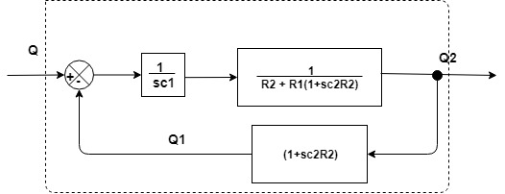

Fig-8

* Final Transfer Function:

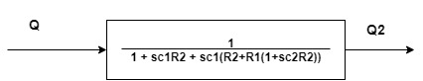

Fig-9

**Matlab Code:** Assuming $C_{1}{=1 ,R}_{1}=1, C_{2}=2, R_{2}=2$

clc;

close all;

clear all;

c1 = 1; c2 = 2; r1 = 1; r2 = 2;

g1 = tf([0 1],[c1 0]);

g2 = tf(1/r1);

g3 = tf([0 1],[c2 0]);

g4 = tf(1/r2);

g34 = series(g3,g4);

gh34 = feedback(g34,1);

g2t = series(gh34,g2);

gh2t = feedback(g2t,r2);

gt = series(gh2t,g1);

gf = feedback(gt,1/gh34)

cal_gf = tf([0 0 1],[4 7 1])

gf-cal_gf

**Matlab Result:**

gf =

0.25

-------------------

s^2 + 1.75 s + 0.25

Continuous-time transfer function.

cal_gf =

1

---------------

4 s^2 + 7 s + 1

Continuous-time transfer function.

gf-cal_gf

ans = 0

Static gain.

**Conclusion:**

Also we can use Mathematical operators for the same. As we reduce the block diagram using system reduction method, the system starts getting reduced by changing series of systems results in a system whose transfer function is the product of the transfer functions of systems present in series. While systems in parallel lead to a system whose transfer function is the sum of the transfer functions of systems present in parallel. Using feedback, the actual output can be compared to the desired output and gain of the system is changed accordingly.

**Assignment 3(B)**

**Title of the Experiment:**

* Satellite single-axis altitude control system

K, a, b are controller parameters where $K=10.8*{10}^{8}$, a = 1, b = 8.

J is spacecraft moment of inertia where

* + Obtain $T\left(s\right)=\frac{θ\left(s\right)}{θ_{d}\left(s\right)}$
  + Plot step response to a 10 $°$ step input.
  + Compare the step response of spacecraft when J is reduced by 20% and 50% and discuss the results.

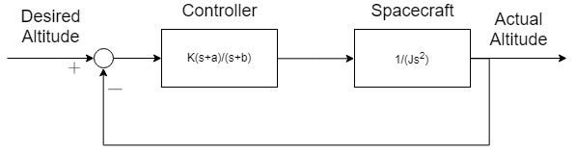

Fig-1: Block diagram of the system

**Objective of the Experiment:** To obtain the transfer function of the given system and plot its step response.

**Software:** MATLAB 2018

**Theory:** Let us assume the following transfer functions for given system in Fig-1

$$G\left(s\right)= \frac{k(s+a)}{s+b}, F\left(s\right)= \frac{1}{{Js}^{2 }} and H\left(s\right)=1$$

Then the original can be simplified as G(s) and F(s) are in series and its resultant is in feedback relationship with H(s). Therefore the resulted transfer Function is

$$C\left(s\right)= \frac{G(s)F(s)}{1+G\left(s\right)H\left(s\right)F(s)}$$

Putting the functions in above equations we get,

$$C\left(s\right)=\frac{θ\left(s\right)}{θ_{d}\left(s\right)}=\frac{\frac{K\left(s+a\right)}{s+b}}{1+1*\frac{1}{Js^{2}}*\frac{K\left(s+a\right)}{s+b}}$$

$$C\left(s\right)=\frac{Js^{2} *K\left(s+a\right)}{Js^{2}\left(s+b\right)+K\left(s+b\right)}$$

Here $K=10.8*{10}^{8}$, a = 1, b = 8, $J=10.8*{10}^{8}$

**Matlab Code:**

**Response to a 10 $°$ step input:**

clc;

clear all;

close all;

K = 10.8E8;

num1 = K*[1 1];

den1 = [1 8];

num2 = [1];

den2 = K*[2 0 0];

c1 = tf(num1,den1);

sc1 = tf(num2,den2);

g = series(c1,sc1);

transfer = feedback(g,1);

step(transfer);

xlabel('time(sec)'),ylabel('Amplitude');

title('Step Response for 10degree step input');

**when J is reduced by 20% and 50%**

clc;

clear all;

close all;

K = 10.8E8;

num1 = K*[1 1];

den1 = [1 8];

num2 = [1];

den2 = K*[2 0 0];

c1 = tf(num1,den1);

sc1 = tf(num2,den2);

g = series(c1,sc1);

transfer = feedback(g,1);

step(transfer);

xlabel('time(sec)'),ylabel('Amplitude');

title('Step Response for 10degree step input');

clc;

clear all;

close all;

K = 10.8E8;

num1 = K*[1 1];

den1 = [1 8];

num2 = [1];

den2 = K*[2 0 0];

c1 = tf(num1,den1);

sc1 = tf(num2,den2);

g = series(c1,sc1);

transfer = feedback(g,1);

step(transfer);

xlabel('time(sec)'),ylabel('Amplitude');

title('Step Response for 10degree step input');

**Matlab Results:**



Fig-2



Fig-3 Fig-4

The step response plots for the single axis satellite altitude control system were plotted for different values of J and the graphs were analysed.

**Conclusion:**

From the above step responses, we can infer that as the moment of inertia decreases the time required to reach the steady state condition also decreases