**Experiment 4**

**Aim:** To study about systems of second order and analyse their time response.

* Effect of damping ratio $ζ$ on performance measure and plot the step response for the given block diagram for $ζ=0.1, 0.3, 0.5, 1, 2$.

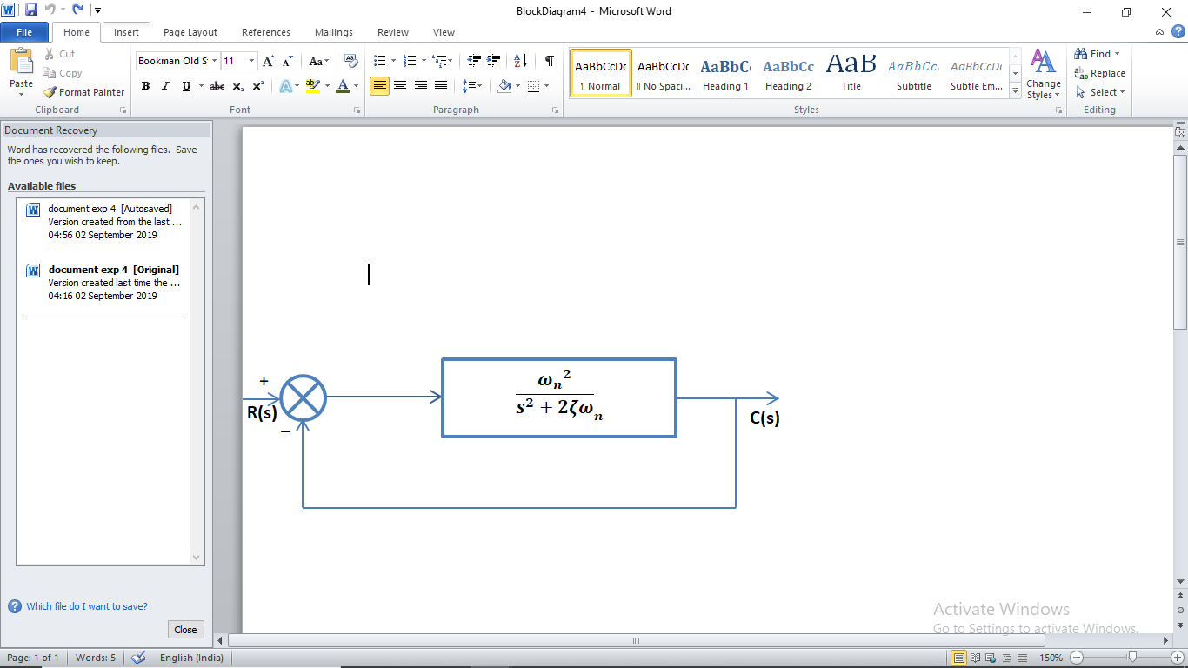

* Calculate $t_{r}, t_{p}, t_{d}, M_{p}$ with change in $ζ$
* To analyse the effect of addition of the following poles together and zeros subsequently to transfer function such that the transfer function becomes

$$\frac{{ω_{n}}^{2}}{{(s}^{2}+2ζω_{n}+{ω_{n}}^{2} )} \frac{\prod{(1+sԎ_{z})}}{\prod{(1+sԎ_{p})}}$$

**Software:** Matlab 2018a

**Equations/Formula**:



$t_{r}= \frac{π- ϕ}{w_{n}\sqrt{1-{ζ }^{2}}}$

$t_{s} = \frac{4}{ζw_{n} }$

$M_{p}=1- \frac{e^{-ζw_{n}t}}{\sqrt{1-ζ^{2}}}sin⁡\{\left(w_{n}\sqrt{1-ζ^{2}}\right)t+ ∅\}$

**Theory:** The order of a control system is determined by the power of s in the denominator of its transfer function. If the power of s in the denominator of transfer function of a control system is 2, then the system is said to be second-order control system. The general expression of transfer function of a second order control system is given as

$$\frac{c(s)}{e(s)}= \frac{{ω_{n}}^{2}}{{(s}^{2}+2ζω_{n} )}$$

# Here $ζ$ and $w_{n}$ are damping ratio and natural frequency if the system respectively. After giving unity feedback to the system the transfer equation becomes

$$\frac{c(s)}{e(s)}= \frac{{ω_{n}}^{2}}{{(s}^{2}+2ζω_{n} + {ω_{n}}^{2})}$$

There are number of common terms in transient response characteristics and which are

1. **Delay time** (td) is the time required to reach at 50% of its final value by a time response signal during its first cycle of oscillation.
2. **Rise time** (tr) is the time required to reach at final value by a under damped time response signal during its first cycle of oscillation. If the signal is over damped, then rise time is counted as the time required by the response to rise from 10% to 90% of its final value.
3. **Peak time** (tp) is simply the time required by response to reach its first peak i.e. the peak of first cycle of oscillation, or first overshoot.
4. **Maximum overshoot** (Mp) is straight way difference between the magnitude of the highest peak of time response and magnitude of its steady state. Maximum overshoot is expressed in term of percentage of steady-state value of the response. As the first peak of response is normally maximum in magnitude, maximum overshoot is simply normalized difference between first peak and steady-state value of a response.

# MATLAB Code:

clc;

close all;

clear all;

wn = 1;

z = [0.1 0.3 0.5 0.7 1 2];

G1 = tf([0 0 wn],[1 2*z(1) 0]);

G2 = tf([0 0 wn],[1 2*z(2) 0]);

G3 = tf([0 0 wn],[1 2*z(3) 0]);

G4 = tf([0 0 wn],[1 2*z(4) 0]);

G5 = tf([0 0 wn],[1 2*z(5) 0]);

G6 = tf([0 0 wn],[1 2*z(6) 0]);

Y1 = feedback(G1,1);

Y2 = feedback(G2,1);

Y3 = feedback(G3,1);

Y4 = feedback(G4,1);

Y5 = feedback(G5,1);

Y6 = feedback(G6,1);

S = stepinfo(Y1)

subplot(2,3,1),

step(Y1);title('z = 0.1');

subplot(2,3,2),step(Y2);title('z = 0.3');

subplot(2,3,3),step(Y3);title('z = 0.5');

subplot(2,3,4),step(Y4);title('z = 0.7');

subplot(2,3,5),step(Y5);title('z = 1');

subplot(2,3,6),step(Y6);title('z = 3');

**Re**

**Fig – 1 : After changing value of zeta of the system**

**Calculations**

|  |  |  |  |  |
| --- | --- | --- | --- | --- |
| $$ζ$$ | Rise Time(tr)  (secs) | Settling Time ${(t}_{s})$ (secs) | %Mp | Peak Time ${(t}_{p})$ (secs) |
| 0.1 | 1.66 | 40 | 72.92% | 3.157 |
| 0.3 | 1.81 | 13.33 | 37.23% | 3.3 |
| 0.7 | 1.93 | 8 | 16.3% | 3.62 |
| 1 | 3.75 | - | - | - |
| 3 | 3.74 | - | - | - |

**Matlab Code:**

clc;

close all;

clear all;

p = [0.5, 1, 2, 4, 5, 7];

ze = [0.1 ,1, 3, 5, 7, 8];

wn = 1;

z = 0.2;

G = tf([0 0 wn],[1 2*z 0]);

Y = feedback(G,1);

for i=1:6

k = tf([0 1],[1 p(i)]);

h(i) = series(Y,k);

Y = h(i);

end

for i=1:6

k = tf([1 ze(i)],[0 1]);

h(i) = series(Y,k);

Y = h(i);

subplot(2,3,i),step(h(i))

str = sprintf('Adding zero at %f',ze(i));

title(str);

hold on;

end

hold off;

**Result:**

Y =

1

-----------------------------------------------------------------------------------

s^8 + 19.9 s^7 + 151.3 s^6 + 564 s^5 + 1134 s^4 + 1379 s^3 + 1166 s^2 + 629 s + 140

Continuous-time transfer function after adding poles



**Fig – 2 : After Adding poles to the system**

Y =

s^6 + 24.1 s^5 + 216.4 s^4 + 885.4 s^3 + 1599 s^2 + 991.3 s + 84

-----------------------------------------------------------------------------------

s^8 + 19.9 s^7 + 151.3 s^6 + 564 s^5 + 1134 s^4 + 1379 s^3 + 1166 s^2 + 629 s + 140

Continuous-time transfer function after adding zeros.



**Fig – 3 : After Adding zeros to the system**

**Conclusion :**

* It was observed that the increasing value of zeta, the damping ratio of the system, the oscillations of the system for a step response dies when zeta is increased such amount that there s
* The addition of poles to a closed loop transfer function decreased the no of oscillations and also the overshoot was rectified.
* The addition of zeros to a closed loop transfer function makes its response time faster, also it changes all the transient state properties.