**Experiment 7**

**Aim:** To study the stability of a system in the presence of disturbance in MATLAB.

1. Unit step input without presence of disturbance
2. Unit step disturbance in the absence of input
3. Unit step input and unit step disturbance

Also Calculate % $M_{P}, t_{s} and t_{P}$.

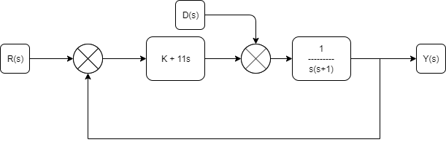

Fig 1: Given System

**Software:** Matlab 2018a

**Theory:** To study the response of a system in the presence of a disturbance, we apply superposition theorem to the system. The superposition theorem for [electrical circuits](https://en.wikipedia.org/wiki/Electrical_network) states that for a linear system the response ([voltage](https://en.wikipedia.org/wiki/Voltage) or [current](https://en.wikipedia.org/wiki/Electric_current)) in any branch of a bilateral [linear circuit](https://en.wikipedia.org/wiki/Linear_circuit) having more than one independent source equals the algebraic sum of the responses caused by each independent source acting alone, where all the other independent sources are replaced by their internal [impedances](https://en.wikipedia.org/wiki/Electrical_impedance).

**Matlab Code:**

clc;

close all;

clear all;

k = [10 20 50 100];

s = tf('s');

G = 1/(s*(s+1));

G1 = 11*s;

for i=1:4

t = parallel(G1,k(i));

Y = feedback(series(t,G),1);

subplot(3,4,i),step(Y);

str = sprintf('K = %d',k(i));

result(i) = stepinfo(Y);

title(str);

end

for i=1:4

t = parallel(G1,k(i));

YY = feedback(G,t);

subplot(3,4,4 + i),step(YY);

str = sprintf('K = %d',k(i));

title(str);

result2(i) = stepinfo(YY);

end

for i=1:4

YYY = parallel(Y(i),YY(i));

subplot(2,2,i),step(YYY);

str = sprintf('K = %d',k(i));

title(str);

stepinfo(YYY)

end

**Calculations:**

|  |  |  |  |  |  |  |  |  |  |
| --- | --- | --- | --- | --- | --- | --- | --- | --- | --- |
|  | Response without disturbance | | | Response with only disturbance | | | Response with disturbance | | |
|  | Tr | Ts | Overshoot | Tr | Ts | Overshoot | Tr | Ts | Overshoot |
| K = 10 | 0.204 | 0.38 | 0 | 2.45 | 4.436 | 0.09 | 0.328 | 1.869 | 0 |
| K = 20 | 0.169 | 0.913 | 3.86 | 1.136 | 2.06 | 0.1 | 0.192 | 0.30 | 1.55 |
| K = 50 | 0.126 | 0.718 | 12.89 | 0.376 | 0.59 | 0.648 | 0.129 | 0.715 | 12.113 |
| K = 100 | 0.097 | 0.665 | 22.016 | 0.185 | 0.594 | 9.473 | 0.098 | 0.661 | 21.72 |

Table 1: Values obtained from plot

**Result:**



Fig 2: Response without disturbance Fig 3:Response with only disturbance



Fig 1: Response with disturbance

**Conclusion:**

* On increasing the value of k, system response system shows more ideal properties (in presence of noise). This however increases overshoot, which can be overcome by tuning the $K_{d}$ of the PID controller.
* Best possible value of k if found to be 100 for this case.