**Experiment 8**

**Aim:**

* Calculate the Bode Plot of
$G\left(s\right)= \frac{100}{S+30}$

$G\left(s\right)= \frac{100(s+1)}{(s+5)(s+75)}$

* Explore the sisotool and observe the effect of adding poles and zeros.
* Design an opamp based integrator and obtain its bode plot using Simulink/.

**Software:** Matlab 2018a and Simulink

**Theory:**

**Rules for Constructing Bode Diagrams:**

* 1. Rewrite the transfer function in proper form. A transfer function is normally of the form rewrite this so the lowest

$$H\left(s\right)= k\frac{\sum_{i=0}^{m}{b_{m}s^{m}}}{\sum_{j=0}^{n}{a_{n}s^{n}}}$$

order term in the numerator and denominator are both unity.

* 1. Separate the transfer function into its constituent parts.
  2. Draw the Bode diagram for each part.
  3. Draw the overall Bode diagram by adding up the results from step 3**.**

**Bode**: Bode plot of frequency response, or magnitude and phase data. It creates a Bode plot of the frequency response of a dynamic system model sys. The plot displays the magnitude (in dB) and phase (in degrees) of the system response as a function of frequency. bode automatically determines frequencies to plot based on system dynamics.

**Syntax**: bode(sys)

**Sisotool**: sisotool opens the SISO Design Tool. This Graphical User Interface lets you design single-input/single-output (SISO) compensators by graphically interacting with the root locus, Bode, and Nichols plots of the open-loop system. To import the plant data into the SISO Tool, select the Import item from the File menu. By default, the control system configuration is

r -->[ F ]-->O--->[ C ]--->[ G ]----+---> y

- | |

+-------[ H ]----------+

where C and F are tunable compensators.

**Syntax**: sisotool(G) specifies the plant model G to be used in the SISO Tool. Here G is any linear model created with TF, ZPK, or SS.

**Matlab Code:**

clc;

close all;

clear all;

s = tf('s');

G = 100/(s+30);

Y = 100*(s+1)/((s+5)*(s+75));

subplot(2,1,1),bode(G);

grid on;

subplot(2,1,2),bode(Y) ;

grid on;

sisotool(G);

sisotool(Y);

**Result:**

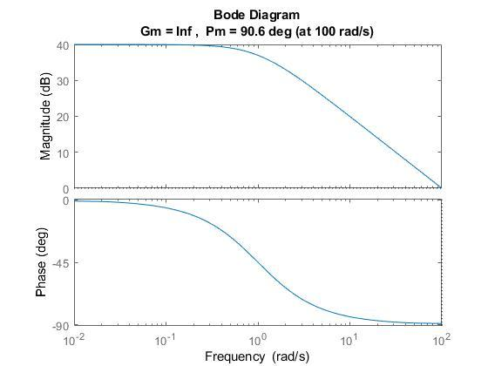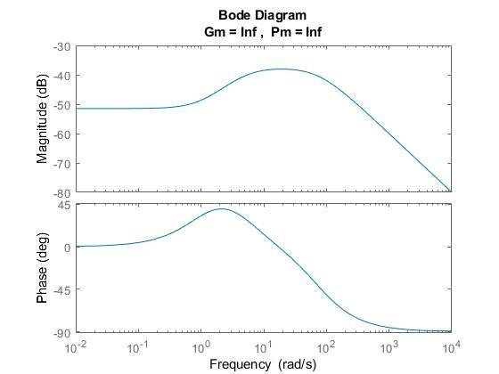

Fig. 1 Bode Plot for $G_{1}(s)$ Fig. 2 Bode Plot for $G_{2}(s)$

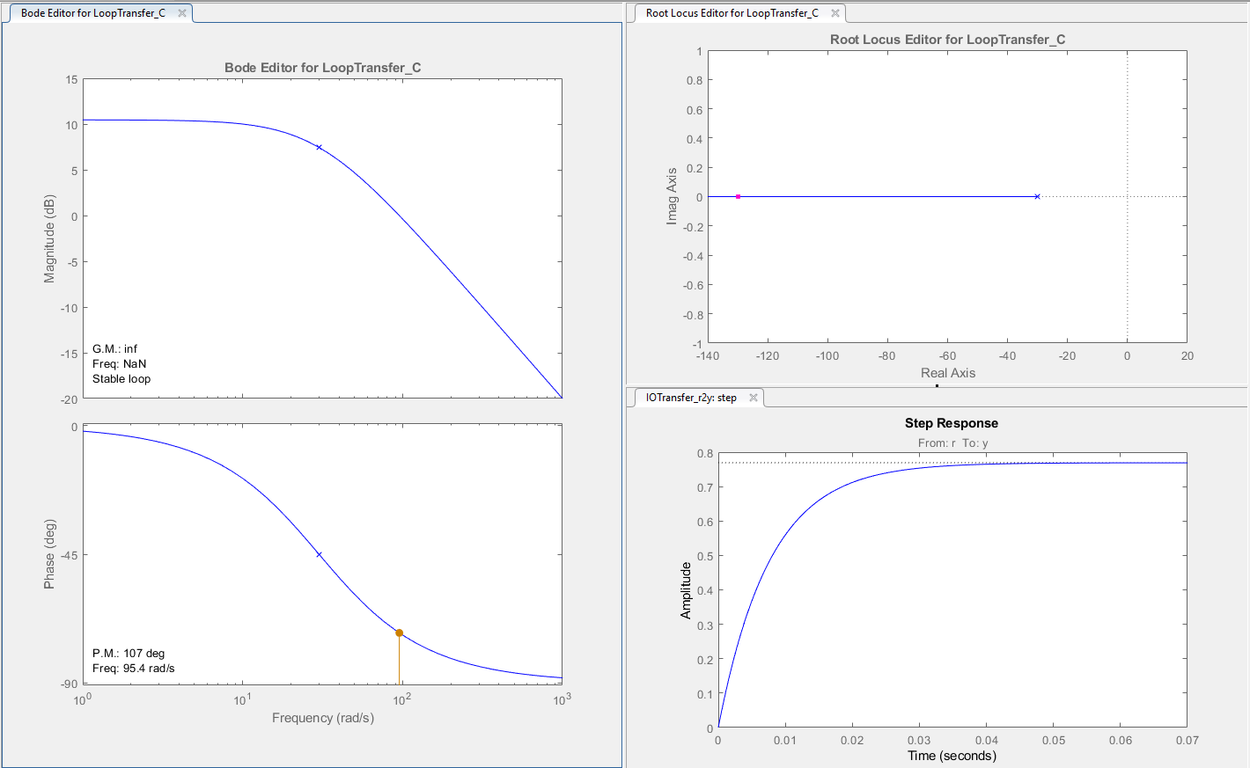

Fig. 3 SISOTOOL Plot for $G_{1}(s)$

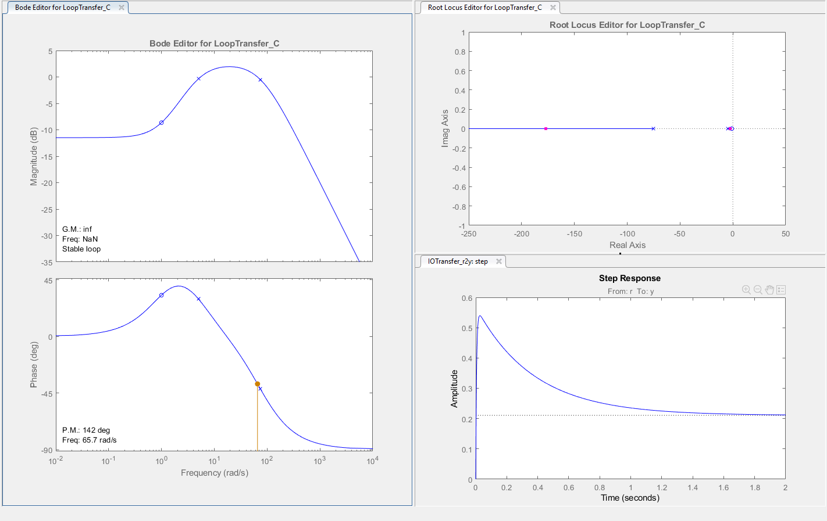

Fig. 3 SISOTOOL Plot for $G_{2}(s)$

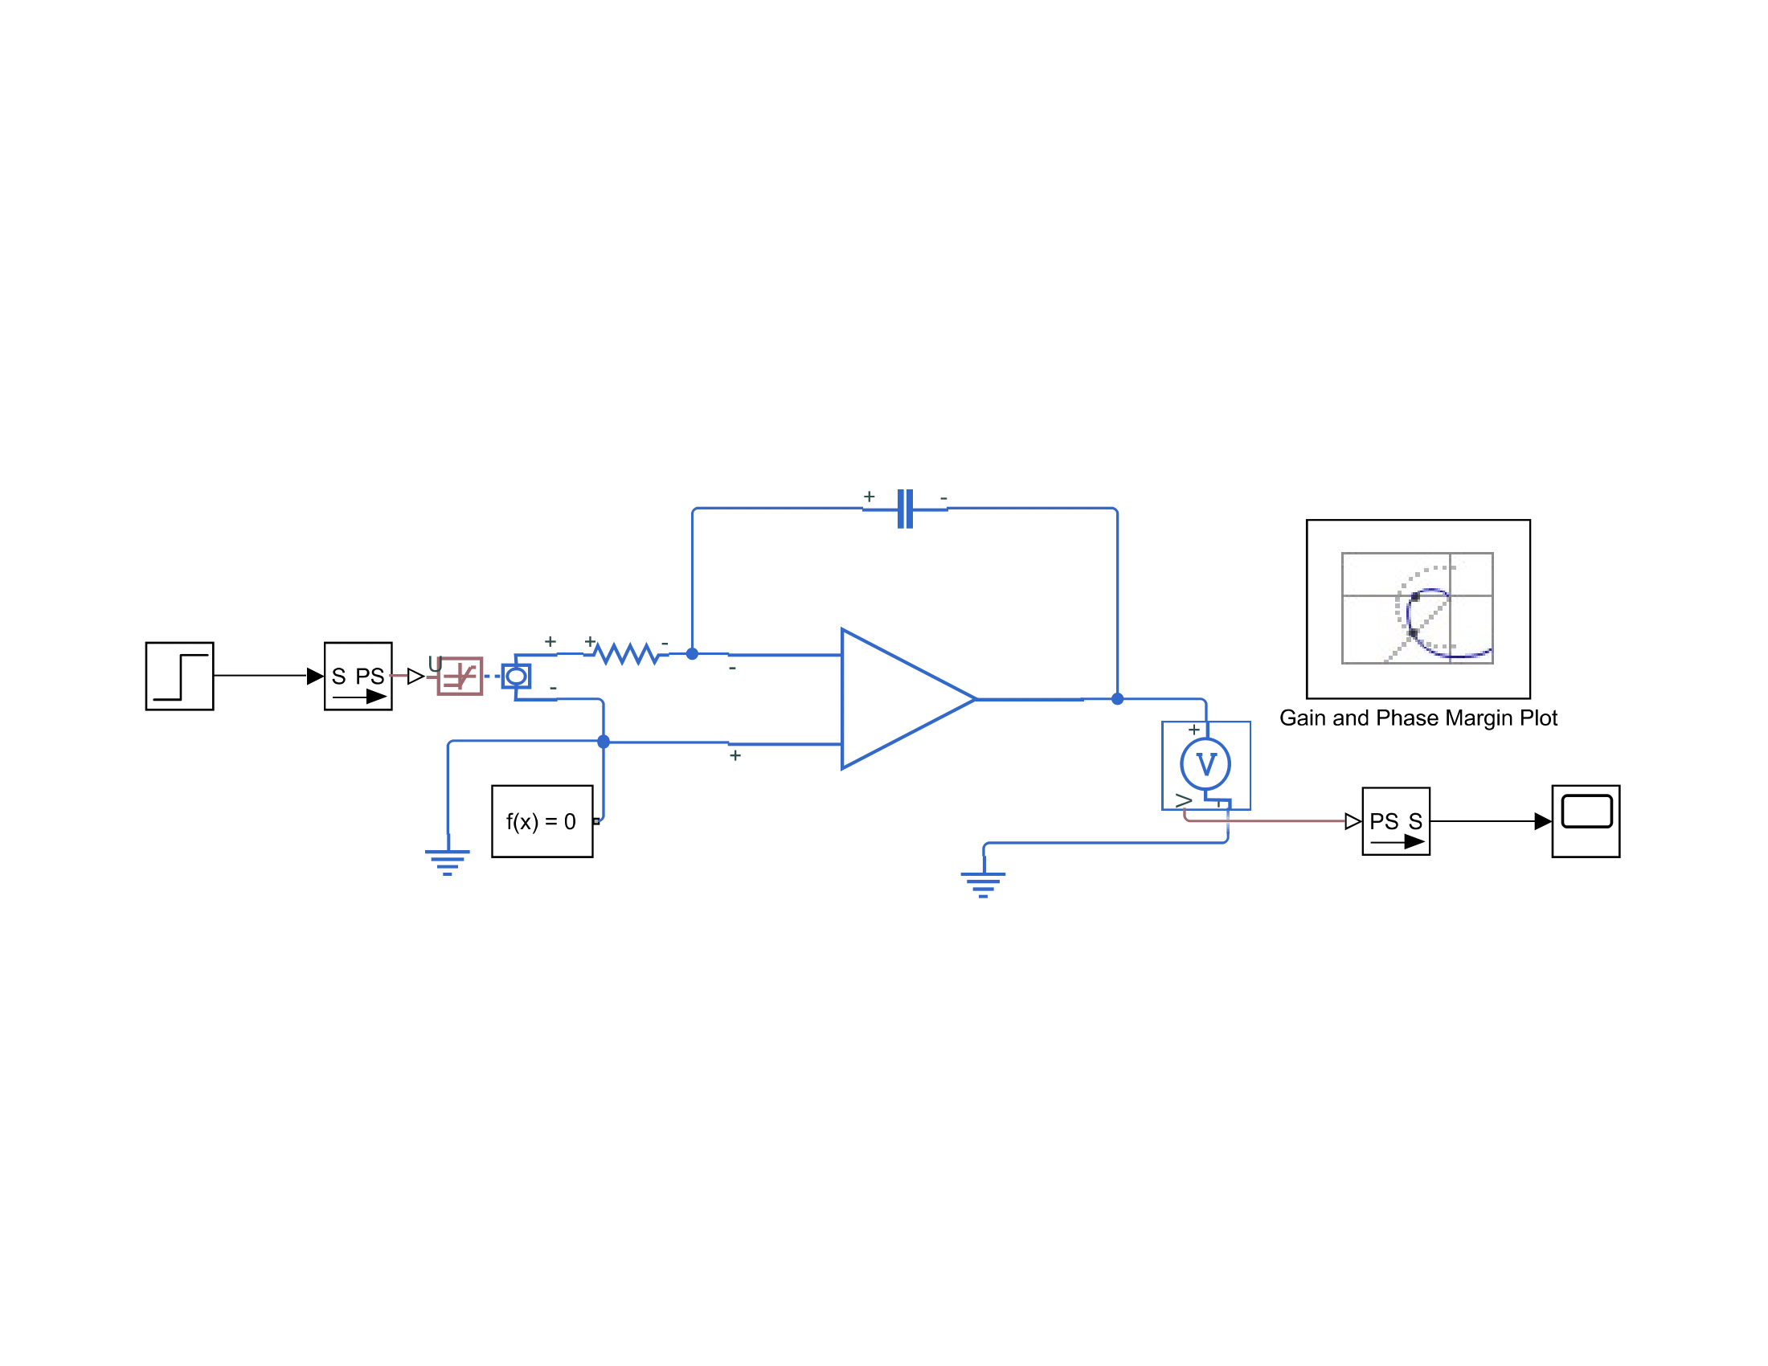

Fig. 4 SIMULINK Model for Integrator using Op-Amp

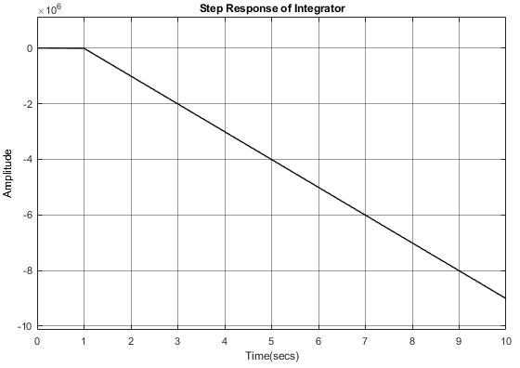

Fig. 5 Step Response for the Integrator in Time domain.

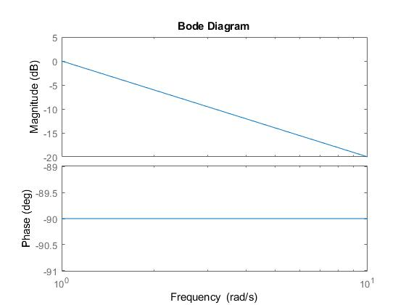

Fig. 6 Bode Plot for the Integrator.

**Conclusion:**

* Bode plots were studied for the given systems.
* On adding zeros, root locus is pulled towards the left half, which makes the system relatively more stable.
* On adding poles, root locus is pulled towards the right half, which makes the system relatively less stable.