**Experiment-2**

**Aim:**

1. To write and simulate the VHDL codes for the following basic combinational logic using dataflow modelling.

1. 3:8 Decoder
2. 4 bit comparator
3. 4 bit ALU with 8 possible operators (bits)
4. 4 bit ALU with 8 possible operators (integers)

**Software required:**

1.Quartus II

**VHDL code:**

**Code A:**

library ieee;

use ieee.std_logic_1164.all;

Entity decoder_3_8 is

port (I: in std_logic_vector(2 downto 0);

En: in std_logic;

y: out std_logic_vector(7 downto 0));

end decoder_3_8;

Architecture behave of decoder_3_8 is

begin

y<="00000001" when I = "000" else

"00000010" when I = "001" else

"00000100" when I = "010" else

"00001000" when I = "011" else

"00010000" when I = "100" else

"00100000" when I = "101" else

"01000000" when I = "110" else

"10000000" when I = "111" else

"00000000";

end behave ;

**Code B:**

library ieee;

use ieee.std_logic_1164.all;

Entity comparator_4_bit is

port (A,B: in std_logic_vector(3 downto 0);

y: out std_logic_vector(2 downto 0));

end comparator_4_bit;

Architecture behave of comparator_4_bit is

begin

y <= "100" when A=B else

"010" when A>B else

"001" when A<B else

"000";

end behave ;

**Code C:**

library ieee;

use ieee.std_logic_unsigned.all;

use ieee.std_logic_arith.all;

use ieee.numeric_std.all;

use ieee.std_logic_1164.all;

Entity alu_4_bit is

port (A,B: in std_logic_vector(3 downto 0);

s: in std_logic_vector(2 downto 0);

y: out std_logic_vector(3 downto 0));

end alu_4_bit;

Architecture dataflow of alu_4_bit is

begin

with s select

y <= A + B when "000",

A - B when "001",

A and B when "010",

A or B when "011",

A xor B when "100",

A nand B when "101",

A nor B when "110",

A xnor B when "111",

"0000" when others;

end dataflow ;

**Code D:**

library ieee;

use ieee.std_logic_unsigned.all;

use ieee.std_logic_arith.all;

use ieee.numeric_std.all;

use ieee.std_logic_1164.all;

Entity alu_4_bit_int is

port (A,B: in integer range 0 to 3;

s: in std_logic_vector(2 downto 0);

y: out integer range 0 to 3);

end alu_4_bit_int;

Architecture dataflow of alu_4_bit_int is

begin

with s select

y <= A + B when "000",

A - B when "001",

abs (A - B) when "010",

A * B when "011",

A / B when "100",

A mod B when "101",

A ** 2 when "110",

2 ** B when "111",

0 when others;

end dataflow ;

**RTL schematic:**

**RTL a:**

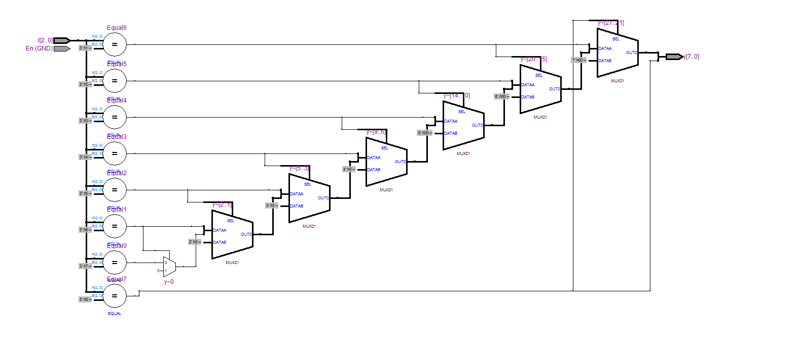

**RTL b:**

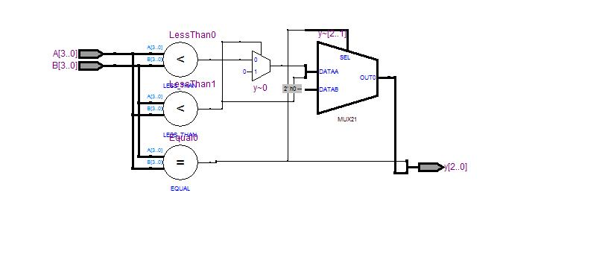

**RTL c:**

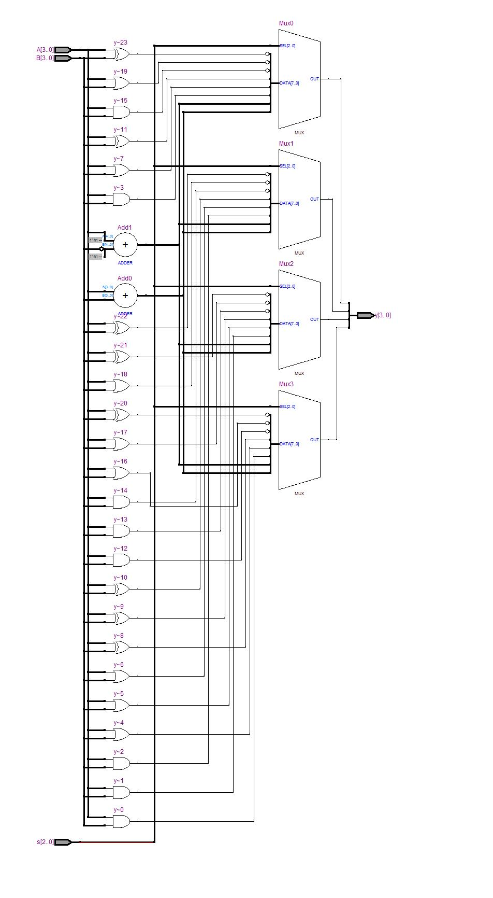

**RTL d:**

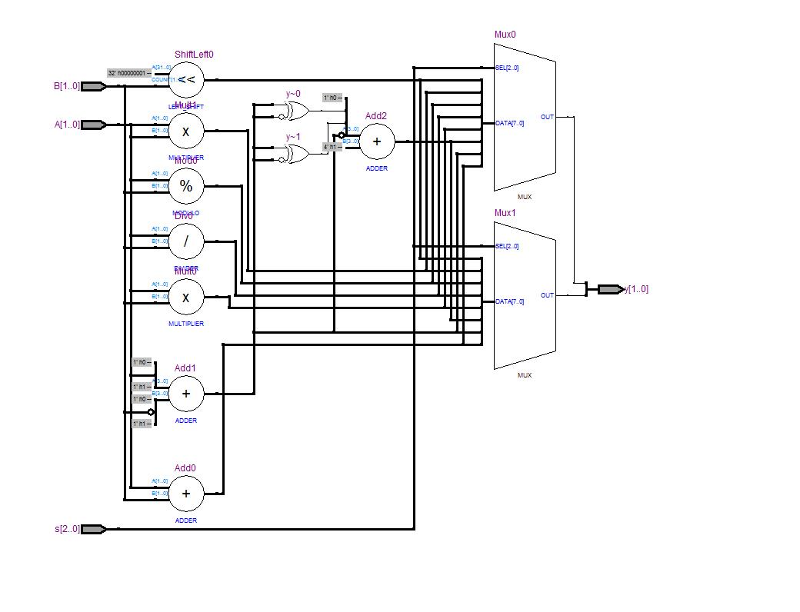

**Waveforms:**

**Waveform A:**

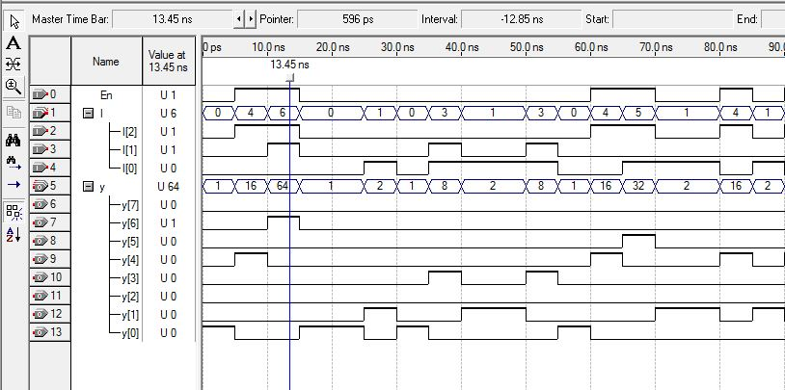

**Waveform B:**

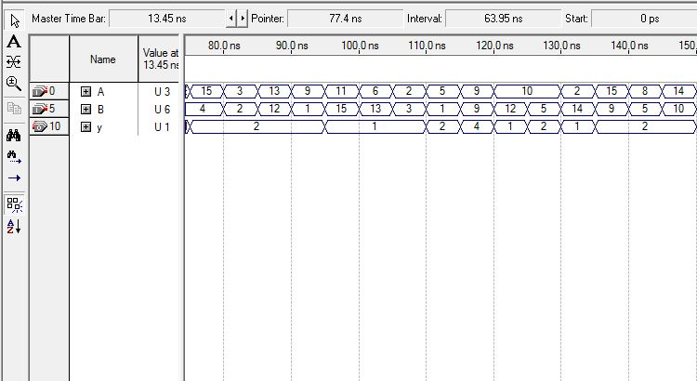

**Waveform C:**

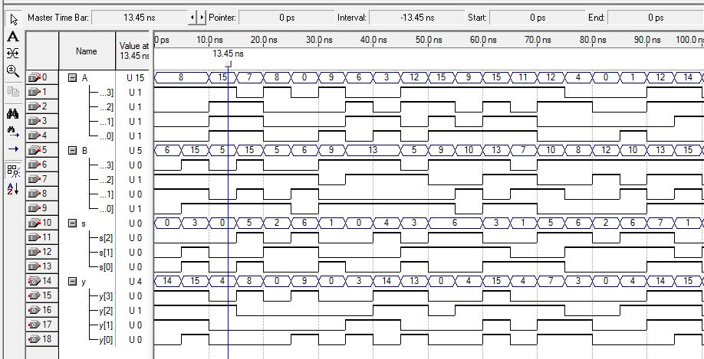

**Waveform D:**

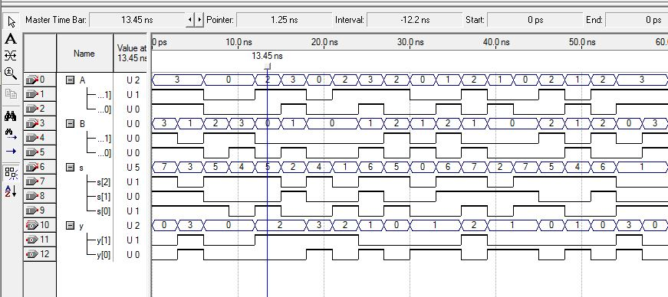

**Result:**

Hence the VHDL codes were written and the simulation was successful for the given basic combinational logic. Waveforms and RTL schematic were recorded and verified.