**Experiment-6**

**Aim:**

1.To write and simulate the VHDL codes for the following structural modelling.

a. Full adder using two half adder and or gate

b. 8:1 MUX using 2:1 MUX

c. 4 bit shift register using D-flip flop

**Software required:**

1.Quartus II

**VHDL code:**

**Code a:**

library ieee;

use ieee.std_logic_1164.all;

entity HA is

port(a,b : in bit;

s,c : out bit);

end HA;

architecture dataflow of HA is

begin

s<= A xor B;

c <= A and B;

end dataflow;

library ieee;

use ieee.std_logic_1164.all;

entity or1 is

port(x,y : in bit;

z : out bit);

end or1;

architecture dataflow of or1 is

begin

z<=x or y;

end dataflow;

**Code b:**

library ieee;

use ieee.std_logic_1164.all;

Entity half_adder is

Port(A,B: in bit;

S,C: out bit);

end half_adder;

Architecture dataflow of half_adder is

begin

s <= ((not a) and b) or (a and (not b));

c <= a and b;

end dataflow;

**Code c:**

library ieee;

use ieee.std_logic_1164.all;

Entity mux is

Port(I: in std_logic_vector(3 downto 0);

S: in std_logic_vector(1 downto 0);

Y: out std_logic);

end mux;

architecture dataflow of mux is

begin

y <= ((not s(0)) and (not s(1)) and i(0)) or (s(0) and (not s(1)) and i(1)) or ((not s(0)) and s(1) and i(2)) or (s(0) and s(1) and i(3));

end dataflow;

**Code d:**

library ieee;

use ieee.std_logic_1164.all;

Entity full_adder is

Port(A,B,Ci: in bit;

S,Co: out bit);

end full_adder;

architecture dataflow of full_adder is

begin

s <= ((not a) and (not b) and ci) or ((not a) and b and (not ci)) or (a and b and ci) or (a and (not b) and (not ci));

co <= (b and ci) or (a and ci) or (a and b);

end dataflow;

**RTL schematic:**

**RTL a:**

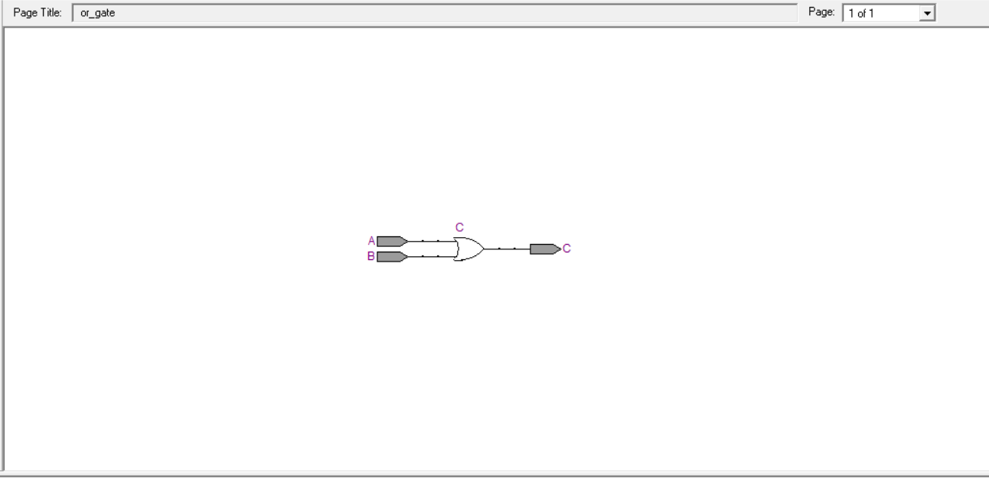

**RTL b:**

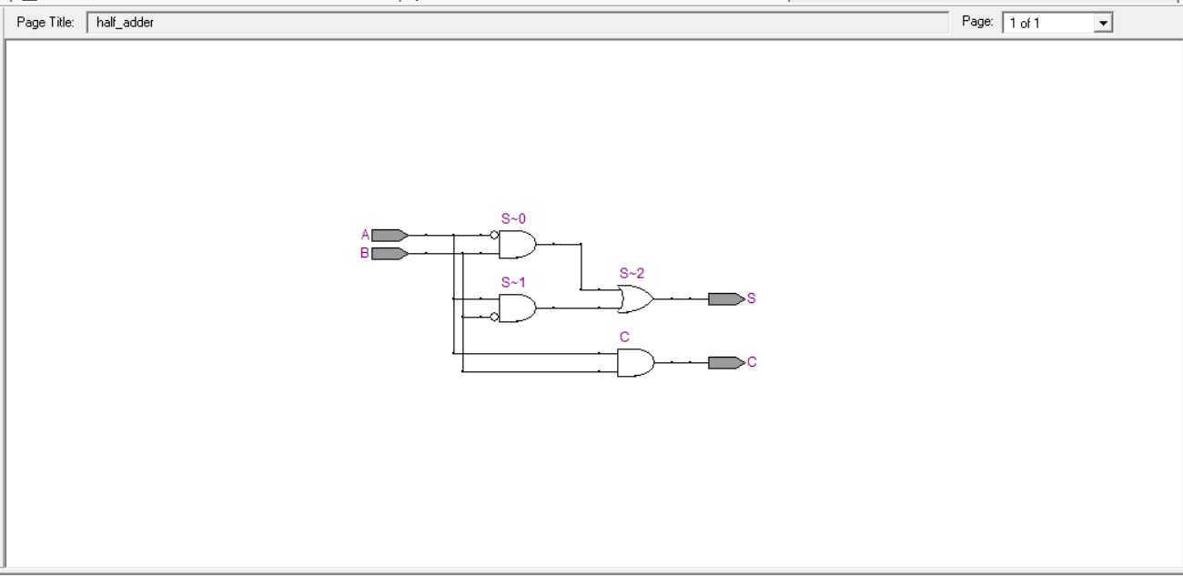

**RTL c:**

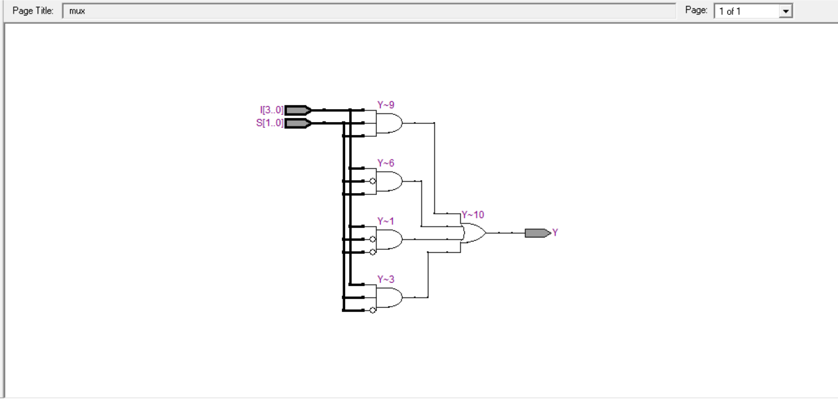

**RTL d:**

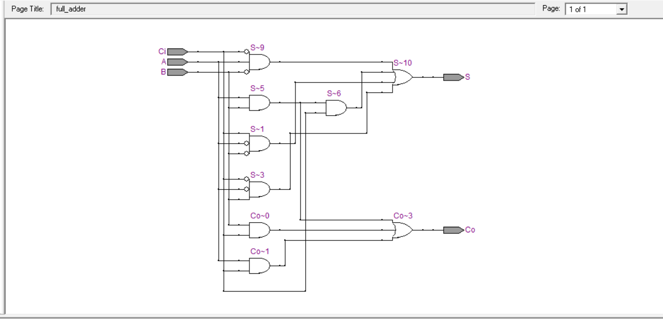

**Waveforms:**

**Waveform a:**

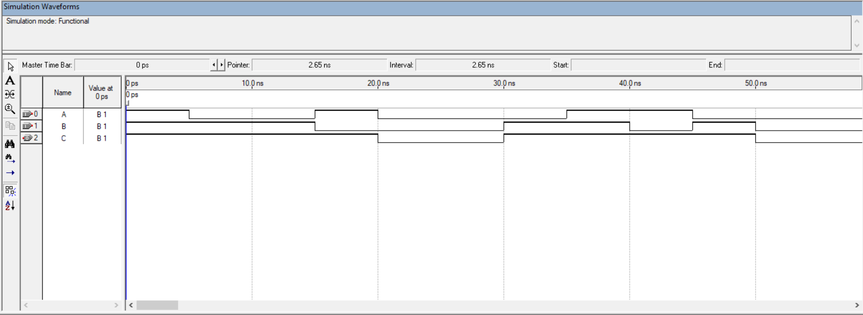

**Waveform b:**

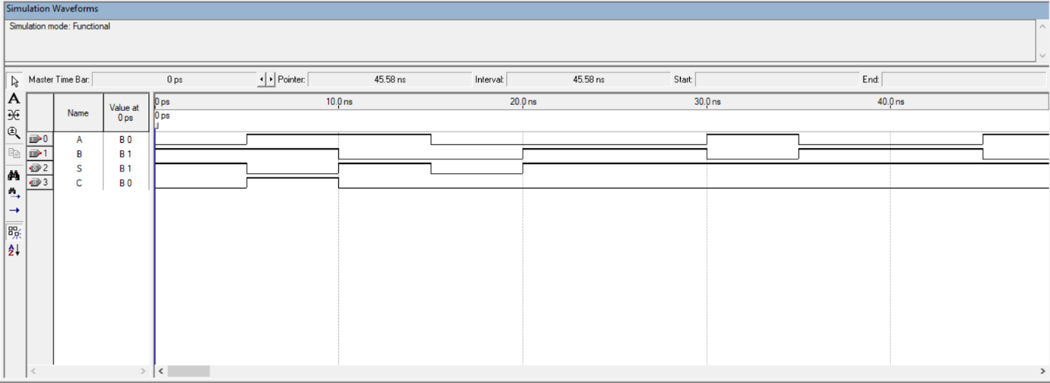

**Waveformc:**

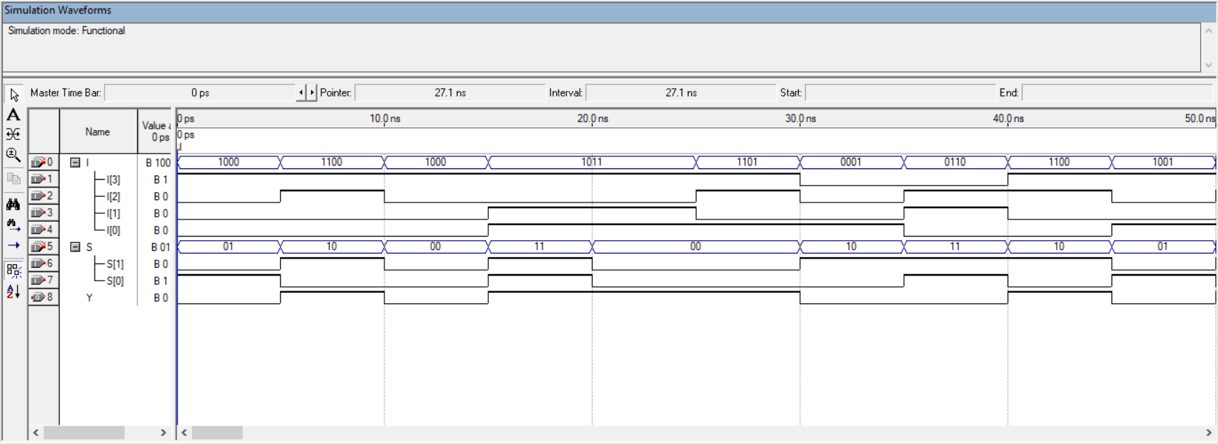

**Waveform d:**

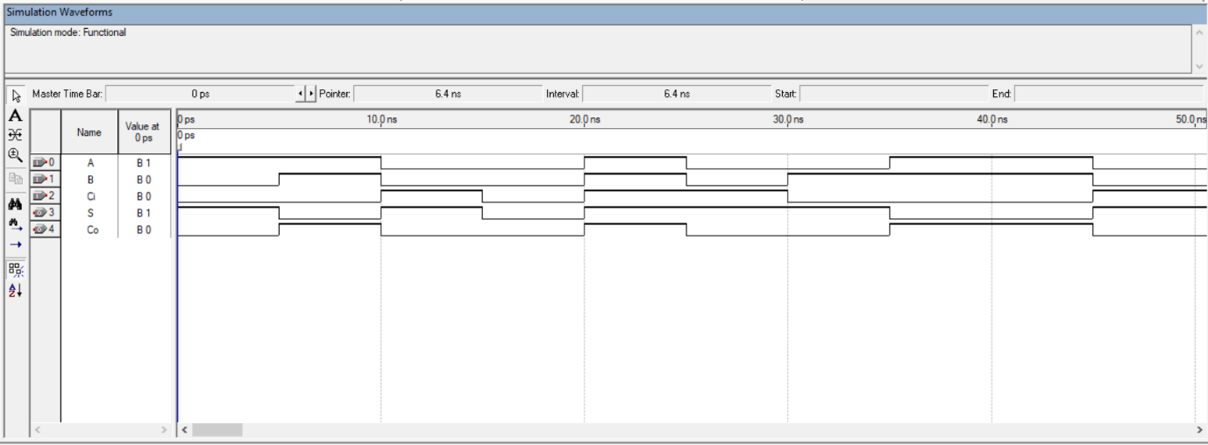

**Result:**

Hence the VHDL codes were written and the simulation was successful for the given bsic combinational logic.

Waveforms and RTL schematic were recorded and verified.