**Experiment-8**

**Aim:**

1.To write and simulate the Verilog codes for the following.

* full adder using dataflow
* 3:8 decoder using **case**

**Software required:**

1.Quartus II

**VHDL code:**

**Code a:**

module full_adder(i1,i2,cin,cout,s);

input i1,i2,cin;

output cout,s;

assign s = i1^i2^cin;

assign cout = (i1&i2)|(cin&(i1^i2));

endmodule

**Code b:**

module decoder_3_8(I,Y);

input [2:0] I;

output [7:0] Y;

reg [7:0] Y;

always@(I)

begin

case(I)

3'b000 : Y = 8'b00000001;

3'b001 : Y = 8'b00000010;

3'b010 : Y = 8'b00000100;

3'b011 : Y = 8'b00001000;

3'b100 : Y = 8'b00010000;

3'b101 : Y = 8'b00100000;

3'b110 : Y = 8'b01000000;

3'b111 : Y = 8'b10000000;

endcase

end

endmodule

**RTL schematic:**

**RTL a:**

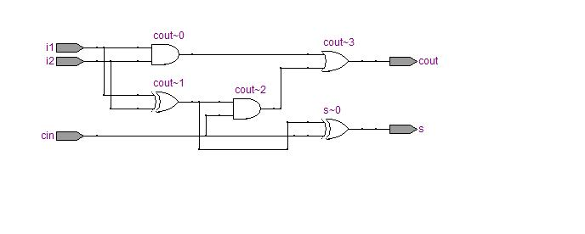

**RTL b:**

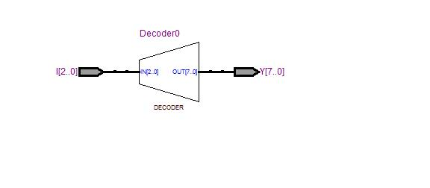

**Waveforms:**

**Waveform a:**

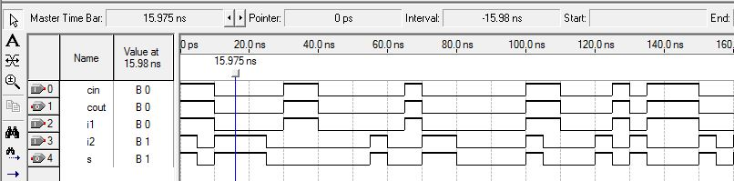

**Waveform b:**

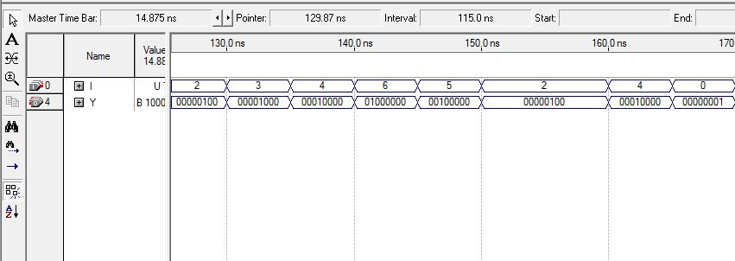

**Result:**

Hence the Verilog codes were written and the simulation was successful for the given basic combinational logic.

Waveforms and RTL schematic were recorded and verified.