**Experiment-9**

**Aim:**

1.To write and simulate the Verilog codes for the following structural modelling.

* Full adder using two half adder and or gate
* 4 bit full adder using 1 bit full adder

**Software required:**

1.Quartus II

**VHDL code:**

**Code a:**

module full_adder(a,b,cin,cout,sum);

input a,b,cin;

output sum, cout;

wire s0,c0,c1;

HA H1 (a,b,s0,c0);

HA H2 (s0,cin,sum,c1);

Orr O1 (cout,c0,c1);

endmodule

module HA(x,y,s,c);

input x,y;

output s,c;

assign s = x^y;

assign c = x&y;

endmodule

module Orr(z,x,y);

input x,y;

output z;

assign z = x|y;

endmodule

**Code b:**

module FA_using_1bitFA(a, b, cin,sum, cout);

input [3:0] a,b;

input cin;

output [3:0] sum;

output cout;

wire c1,c2,c3;

FA f1 (a[0],b[0],cin,c1,sum[0]);

FA f2 (a[1],b[1],c1,c2,sum[1]);

FA f3 (a[2],b[2],c2,c3,sum[2]);

FA f4 (a[3],b[3],c3,cout,sum[3]);

endmodule

module FA(x,y,c,co,s);

input x,y,c;

output co,s;

assign s = x^y^c;

assign co = (x&y) | (c&(x^y));

endmodule

**RTL schematic:**

**RTL a:**

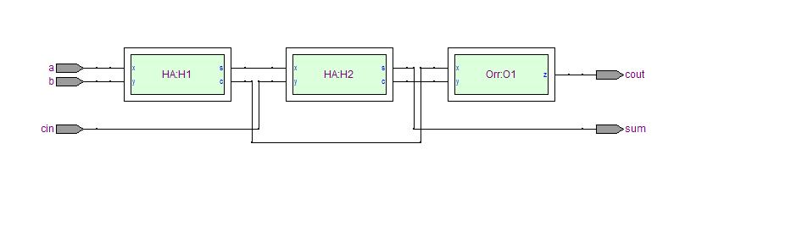

**RTL b:**

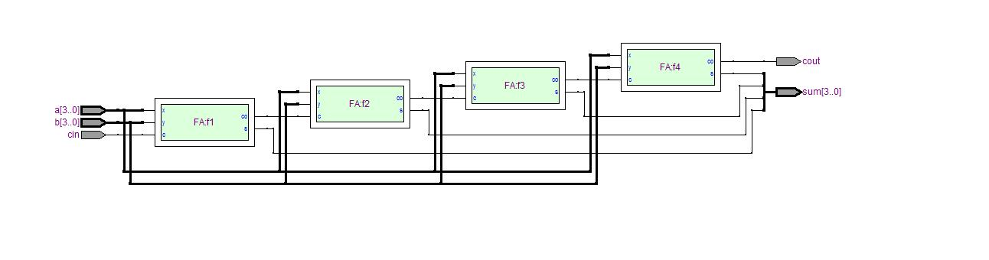

**Waveforms:**

**Waveform a:**

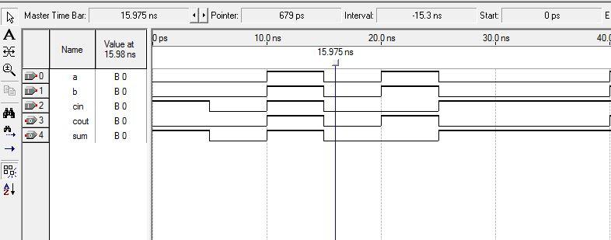

**Waveform b:**

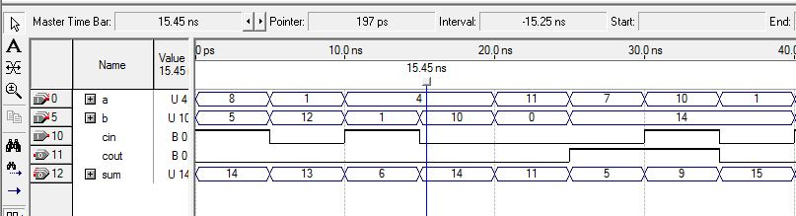

**Result:**

Hence the Verilog codes were written and the simulation was successful for the given basic combinational logic.

Waveforms and RTL schematic were recorded and verified.