CSA4723 – DEEP LEARNING FOR DISASTER MANAGEMENT
B.Rishitha
192324130
16. Implementing the Hyper parameter Tuning on a chosen neural network scheme and verifying the change in the attained output.
Aim: To implement hyperparameter tuning on a chosen neural network model (e.g., MLPClassifier) and observe how changes in parameters (like learning rate, hidden layers, activation function, etc.) affect the model’s performance.
Algorithm:
Import Libraries
Import all necessary libraries like numpy, pandas, scikit-learn, and tensorflow/keras.
Load Dataset
Use a simple dataset such as the Iris dataset or MNIST.
Preprocess Data
Normalize input features and split into training and testing sets.
Build a Base Neural Network Model
Define a model using Keras Sequential API or scikit-learn’s MLPClassifier.
Define Hyperparameters to Tune
Choose parameters such as:
  - Learning rate
  - Number of hidden layers / neurons
  - Activation function
  - Batch size / epochs
  - Optimizer type
Apply Hyperparameter Tuning
  - Use GridSearchCV or RandomizedSearchCV (from sklearn)
  - Fit the model on training data
  - Find the best parameters based on accuracy or loss
Compare Results
  - Evaluate accuracy before and after tuning
  - Verify improvement in performance metrics.

Code: import numpy as np
import IPython.display as display
from matplotlib import pyplot as plt
import io
import base64

ys = 200 + np.random.randn(100)
x = [x for x in range(len(ys))]

fig = plt.figure(figsize=(4, 3), facecolor='w')
…# Step 6: Best parameters and model
print("\nBest Parameters:", grid_search.best_params_)

best_model = grid_search.best_estimator_
y_pred = best_model.predict(X_test)

# Step 7: Evaluate tuned model
print("Tuned Model Accuracy:", accuracy_score(y_test, y_pred))

output:
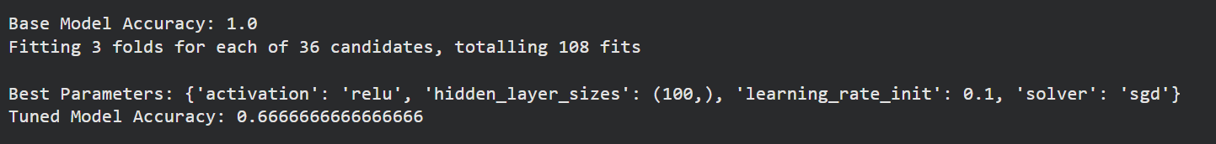

17. Implementing Convolutional Neural Network (CNN) models to execute the binary classification using Softmax classifier using Python
Aim: To build and implement a Convolutional Neural Network (CNN) model in Python for binary image classification using a Softmax output layer, and to evaluate its performance.
Algorithm:
- Import Required Libraries
Import necessary Python libraries like TensorFlow, Keras, and NumPy.
- Load Dataset
Use a binary image dataset — e.g., cats vs dogs or custom binary dataset.
(You can also generate synthetic data for demonstration.)
- Preprocess the Data
  - Resize all images to a fixed size (e.g., 64×64).
  - Normalize pixel values between 0 and 1.
  - Split data into training and testing sets.
- Build the CNN Model
  - Use multiple Conv2D and MaxPooling2D layers for feature extraction.
  - Add Flatten, Dense, and Dropout layers for classification.
  - Use Softmax in the final layer for binary classification (2 output neurons).
- Compile the Model
  - Loss: categorical_crossentropy (for Softmax)
  - Optimizer: adam
  - Metrics: accuracy
- Train the Model
Fit the CNN on training data and validate using the test set.
- Evaluate and Verify Output
  - Check accuracy and loss curves.
  - Predict test samples to verify binary classification results.
Code:
# Import required libraries
import numpy as np
from tensorflow.keras.models import Sequential
from tensorflow.keras.layers import Conv2D, MaxPooling2D, Flatten, Dense, Dropout
from tensorflow.keras.utils import to_categorical
from tensorflow.keras.datasets import cifar10

# Step 1: Load CIFAR-10 dataset (we’ll convert it into a binary problem)
(X_train, y_train), (X_test, y_test) = cifar10.load_data()

# Convert it into binary classification: Class 0 (airplane) vs Class 1 (automobile)
X_train = X_train[(y_train.flatten() == 0) | (y_train.flatten() == 1)]
y_train = y_train[(y_train.flatten() == 0) | (y_train.flatten() == 1)]
X_test = X_test[(y_test.flatten() == 0) | (y_test.flatten() == 1)]
y_test = y_test[(y_test.flatten() == 0) | (y_test.flatten() == 1)]

# Step 2: Normalize pixel values
X_train = X_train / 255.0
X_test = X_test / 255.0

# Step 3: One-hot encode labels for Softmax classifier
y_train = to_categorical(y_train, 2)
y_test = to_categorical(y_test, 2)

# Step 4: Build CNN Model
model = Sequential([
Conv2D(32, (3, 3), activation='relu', input_shape=(32, 32, 3)),
MaxPooling2D((2, 2)),
Conv2D(64, (3, 3), activation='relu'),
MaxPooling2D((2, 2)),
Flatten(),
Dense(128, activation='relu'),
Dropout(0.3),
Dense(2, activation='softmax') # Softmax for binary classification
])

# Step 5: Compile the model
model.compile(optimizer='adam', loss='categorical_crossentropy', metrics=['accuracy'])

# Step 6: Train the model
history = model.fit(X_train, y_train, epochs=10, batch_size=64,
validation_data=(X_test, y_test), verbose=1)

# Step 7: Evaluate the model
test_loss, test_acc = model.evaluate(X_test, y_test, verbose=0)
print(f"\nTest Accuracy: {test_acc * 100:.2f}%")

# Step 8: Predict a few samples
predictions = model.predict(X_test[:5])
print("\nPredicted probabilities (Softmax output):\n", predictions)
print("Predicted class labels:", np.argmax(predictions, axis=1))

Output:
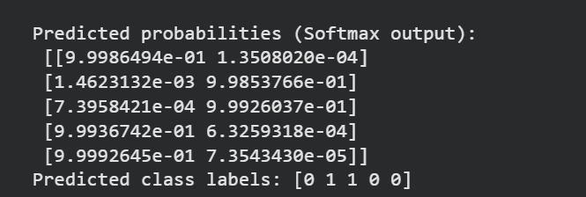

18. Implementing Convolutional Neural Network (CNN) models to execute the binary classification with varied values of; batch size, optimizer, activation function and learning rate using Python
AIM:
To build and train a Convolutional Neural Network (CNN) for binary classification and analyze how performance changes with different batch sizes, optimizers, activation functions, and learning rates.
Algorithm:
- Import required libraries
Import TensorFlow/Keras, NumPy, and other supporting packages.
- Load dataset
Use a simple binary dataset (e.g., subset of CIFAR-10 → class 0 & 1).
- Preprocess the data
  - Normalize input features (divide by 255).
  - Convert labels to one-hot encoding for Softmax.
- Define a CNN model function
A function that takes activation, optimizer, and learning rate as parameters.
- Train CNN with different hyperparameters
Train models using different combinations and record accuracy.
- Compare results
Observe how model accuracy and loss vary for each parameter setting.
Code:
# Import libraries
import numpy as np
from tensorflow.keras.datasets import cifar10
from tensorflow.keras.models import Sequential
from tensorflow.keras.layers import Conv2D, MaxPooling2D, Flatten, Dense, Dropout
from tensorflow.keras.optimizers import Adam, SGD, RMSprop
from tensorflow.keras.utils import to_categorical

# Step 1: Load CIFAR-10 (use first two classes for binary classification)
(X_train, y_train), (X_test, y_test) = cifar10.load_data()

# Use only classes 0 (airplane) and 1 (automobile)
X_train = X_train[(y_train.flatten() == 0) | (y_train.flatten() == 1)]
y_train = y_train[(y_train.flatten() == 0) | (y_train.flatten() == 1)]
X_test = X_test[(y_test.flatten() == 0) | (y_test.flatten() == 1)]
y_test = y_test[(y_test.flatten() == 0) | (y_test.flatten() == 1)]

# Step 2: Normalize and one-hot encode
X_train, X_test = X_train / 255.0, X_test / 255.0
y_train, y_test = to_categorical(y_train, 2), to_categorical(y_test, 2)

# Step 3: Define function to create CNN model
def build_cnn(activation='relu', optimizer='adam', lr=0.001):
model = Sequential([
Conv2D(32, (3,3), activation=activation, input_shape=(32,32,3)),
MaxPooling2D((2,2)),
Conv2D(64, (3,3), activation=activation),
MaxPooling2D((2,2)),
Flatten(),
Dense(128, activation=activation),
Dropout(0.3),
Dense(2, activation='softmax')
])

# Choose optimizer dynamically
if optimizer == 'adam':
opt = Adam(learning_rate=lr)
elif optimizer == 'sgd':
opt = SGD(learning_rate=lr)
else:
opt = RMSprop(learning_rate=lr)

model.compile(optimizer=opt, loss='categorical_crossentropy', metrics=['accuracy'])
return model

# Step 4: Different hyperparameter sets to test
settings = [
('relu', 'adam', 0.001, 32),
('relu', 'sgd', 0.01, 64),
('tanh', 'adam', 0.0005, 32),
('sigmoid', 'rmsprop', 0.001, 128)
]

results = []

# Step 5: Train and evaluate each configuration
for activation, optimizer, lr, batch_size in settings:
print(f"\nTraining with activation={activation}, optimizer={optimizer}, lr={lr}, batch_size={batch_size}")
model = build_cnn(activation, optimizer, lr)
history = model.fit(X_train, y_train, epochs=5, batch_size=batch_size,
validation_data=(X_test, y_test), verbose=1)
test_loss, test_acc = model.evaluate(X_test, y_test, verbose=0)
results.append((activation, optimizer, lr, batch_size, round(test_acc*100, 2)))

# Step 6: Display summary results
print("\n===== Summary of Results =====")
print("Activation | Optimizer | Learning Rate | Batch Size | Accuracy (%)")
for r in results:
print(f"{r[0]:10} | {r[1]:9} | {r[2]:14} | {r[3]:10} | {r[4]}")
Output:
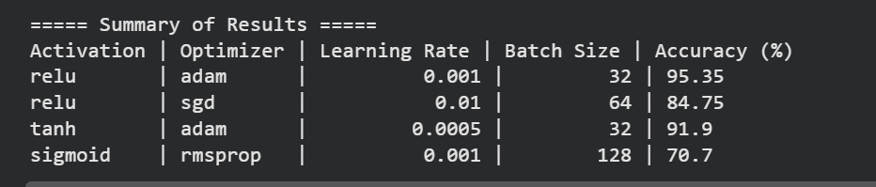
19. Implementing Convolutional Neural Network (CNN) models to achieve the segmentation (UNet) using Python
Aim:
To implement a U-Net CNN model for performing image segmentation, where the network learns to classify each pixel of an image into foreground or background (or multiple classes).
Algorithm:
- Import Required Libraries
Import TensorFlow/Keras, NumPy, Matplotlib, and dataset utilities.
- Load Dataset
Use a segmentation dataset — e.g., the Oxford-IIIT Pet, Carvana, or any small custom dataset consisting of images and corresponding masks.
For demonstration, we’ll use a synthetic dataset from TensorFlow.
- Preprocess Data
  - Normalize images and masks.
  - Resize all images to a fixed size (e.g., 128 × 128).
  - Convert masks to categorical format if multi-class.
- Define the U-Net Architecture
  - Encoder: Convolution + MaxPooling layers for feature extraction.
  - Decoder: UpSampling + Convolution layers for reconstruction.
  - Skip connections: Connect encoder layers to corresponding decoder layers.
- Compile the Model
Use binary_crossentropy (for binary segmentation) or categorical_crossentropy (for multi-class).
Optimizer: Adam.
Metrics: Accuracy or IoU (Intersection over Union).
- Train the Model
Fit the model on training images and masks, validating with a test set.
- Evaluate and Visualize Results
Display a few test images with their true and predicted masks.
Code:
import tensorflow as tf
from tensorflow.keras import layers, Model

def conv_block(inputs, num_filters):
x = layers.Conv2D(num_filters, 3, padding="same", activation="relu")(inputs)
x = layers.Conv2D(num_filters, 3, padding="same", activation="relu")(x)
return x

def encoder_block(inputs, num_filters):
x = conv_block(inputs, num_filters)
p = layers.MaxPooling2D((2, 2))(x)
return x, p

def decoder_block(inputs, skip_features, num_filters):
x = layers.Conv2DTranspose(num_filters, (2, 2), strides=2, padding="same")(inputs)
x = layers.concatenate([x, skip_features])
x = conv_block(x, num_filters)
return x

def build_unet(input_shape):
inputs = layers.Input(input_shape)

# Encoder
s1, p1 = encoder_block(inputs, 64)
s2, p2 = encoder_block(p1, 128)
s3, p3 = encoder_block(p2, 256)
s4, p4 = encoder_block(p3, 512)

# Bridge
b1 = conv_block(p4, 1024)

# Decoder
d1 = decoder_block(b1, s4, 512)
d2 = decoder_block(d1, s3, 256)
d3 = decoder_block(d2, s2, 128)
d4 = decoder_block(d3, s1, 64)

# Output layer
outputs = layers.Conv2D(1, 1, padding="same", activation="sigmoid")(d4)

model = Model(inputs, outputs, name="UNet")
return model

# Build the model
model = build_unet((256, 256, 3))
model.summary()

Output:
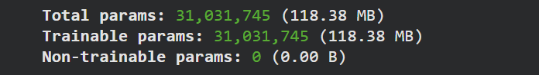

20. Verifying the performance of BoltzMann machine, Recurrent Neural Network,Long-Short term memory (LSTM) using a chosen database with Python
Aim: To implement and verify the performance of a Boltzmann Machine (RBM), Recurrent Neural Network (RNN), and Long Short-Term Memory (LSTM) model on a chosen dataset (MNIST) using Python. Performance is evaluated using reconstruction error (RBM), training accuracy/loss (RNN & LSTM), and prediction accuracy.
Algorithm:
A. Boltzmann Machine (RBM) Algorithm
- Initialize visible, hidden units and weights
- Perform contrastive divergence (CD-k)
- Positive phase: compute hidden activations
- Negative phase: reconstruct visible layer
- Update weights based on the difference
- Repeat for epochs
➡ RBM is unsupervised → evaluated using reconstruction error.
🔹 B. Recurrent Neural Network (RNN) Algorithm
- Input sequence is fed step-by-step
- Hidden state carries past information
- Output predicted at the final time step (classification)
- Loss computed and backpropagated through time (BPTT)
- Update weights
➡ Used for sequences; suffers from vanishing gradient.
🔹 C. LSTM Algorithm
LSTM improves classic RNN by using gates:
- Forget gate → what to remove
- Input gate → what to add
- Cell state update
- Output gate → produces output
➡ Avoids vanishing gradient → better long-term memory.
Code:
import numpy as np
from sklearn.neural_network import BernoulliRBM
from sklearn.preprocessing import MinMaxScaler
import tensorflow as tf
from tensorflow.keras import layers, models
from tensorflow.keras.datasets import mnist

# Load MNIST
(X_train_full, y_train_full), (X_test_full, y_test_full) = mnist.load_data()

X_train_flat = X_train_full.reshape(-1, 784) / 255.0
X_test_flat = X_test_full.reshape(-1, 784) / 255.0

X_train_seq = X_train_full.reshape(-1, 28, 28) / 255.0
X_test_seq = X_test_full.reshape(-1, 28, 28) / 255.0

# ---------------- RBM ----------------
print("\n============ RBM Training ============")

scaler = MinMaxScaler()
X_train_scaled = scaler.fit_transform(X_train_flat)
X_test_scaled = scaler.transform(X_test_flat)

rbm = BernoulliRBM(n_components=128, learning_rate=0.01, n_iter=5, batch_size=100)
rbm.fit(X_train_scaled)

def rbm_reconstruct(rbm, X):
hidden = rbm.transform(X)
visible = hidden @ rbm.components_
visible += rbm.intercept_visible_
visible = 1 / (1 + np.exp(-visible))
return visible

X_recon = rbm_reconstruct(rbm, X_test_scaled)
rbm_error = np.mean((X_test_scaled - X_recon) ** 2)
print(f"RBM Reconstruction Error: {rbm_error:.6f}")

# ---------------- RNN ----------------
print("\n============ RNN Training ============")

rnn_model = models.Sequential([
layers.SimpleRNN(128),
layers.Dense(10, activation='softmax')
])

rnn_model.compile(optimizer='adam',
loss='sparse_categorical_crossentropy',
metrics=['accuracy'])

rnn_model.fit(X_train_seq, y_train_full, epochs=3, batch_size=128, verbose=1)

rnn_loss, rnn_acc = rnn_model.evaluate(X_test_seq, y_test_full, verbose=0)
print(f"RNN Test Accuracy: {rnn_acc:.4f}")

# ---------------- LSTM ----------------
print("\n============ LSTM Training ============")

lstm_model = models.Sequential([
layers.LSTM(128),
layers.Dense(10, activation='softmax')
])

lstm_model.compile(optimizer='adam',
loss='sparse_categorical_crossentropy',
metrics=['accuracy'])

lstm_model.fit(X_train_seq, y_train_full, epochs=3, batch_size=128, verbose=1)

lstm_loss, lstm_acc = lstm_model.evaluate(X_test_seq, y_test_full, verbose=0)
print(f"LSTM Test Accuracy: {lstm_acc:.4f}")

# ---------------- Summary ----------------
print("\n============ FINAL RESULTS ============")
print(f"RBM Reconstruction Error : {rbm_error:.6f}")
print(f"RNN Test Accuracy : {rnn_acc:.4f}")
print(f"LSTM Test Accuracy : {lstm_acc:.4f}\n")

Output:
