IAAS Picoscope Architecture
The IAAS (Impulse Acquisition & Analysis Software) is a modular Python desktop application for capturing and analyzing lightning/switching impulses using PicoScope hardware.

High-Level Data Flow
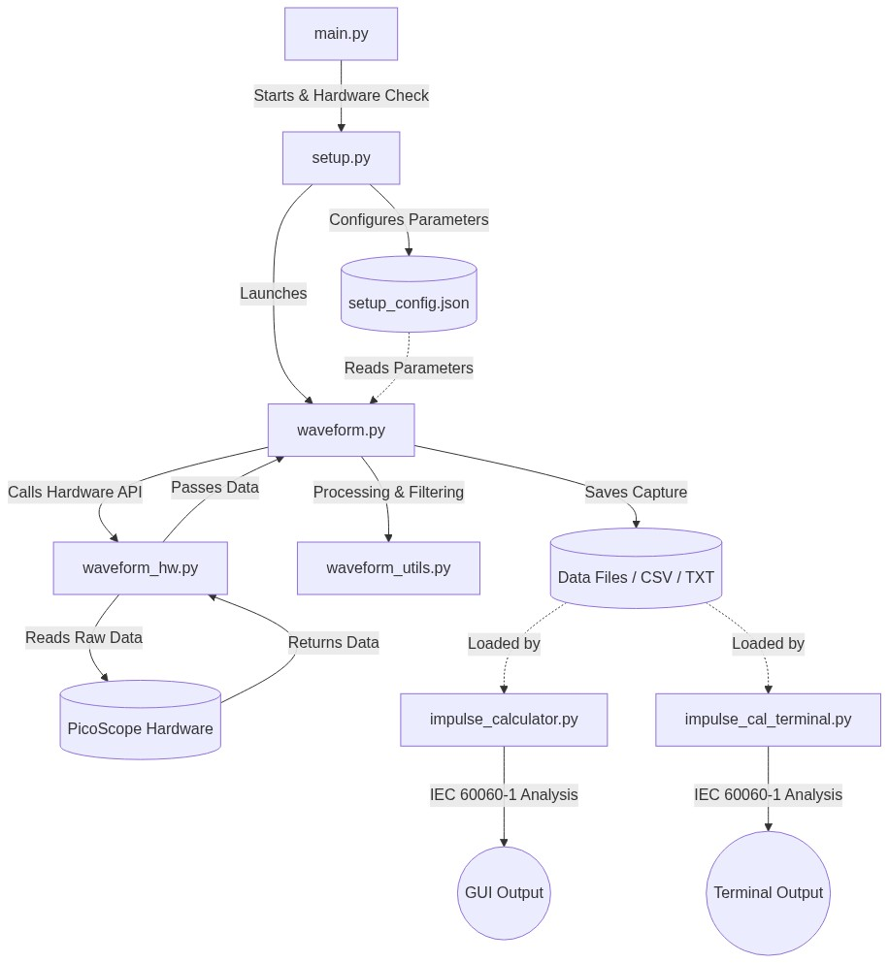
1. main.py starts the application, shows a splash screen, checks for hardware, and launches setup.py.
2. setup.py configures parameters and saves them to setup_config.json, then launches waveform.py.
3. waveform.py reads parameters, provides the live dashboard, and communicates with waveform_hw.py to read raw data from the physical hardware.
4. waveform_utils.py assists with signal processing and filtering before the data is saved to a file.
5. Saved files can be loaded by impulse_calculator.py (for GUI analysis) or impulse_cal_terminal.py (for CLI analysis) to extract precise IEC 60060-1 parameters.

Component Breakdown

1. main.py (Application Entry Point)
- Role: Orchestrates the application startup sequence.
- Functionality: Displays a graphical video splash screen, scans for physical PicoScope hardware via the SDK. If hardware is missing, it falls back to a "Demo Mode". Transfers control to setup.py after initialization.

2. setup.py (Configuration GUI)
- Role: The pre-test configuration screen.
- Functionality: Allows the user to configure impulse types (Lightning/Switching), expected voltages/currents, and attenuation ratios. Saves the configuration state to setup_config.json for persistence. Provides the main "Start" button to launch the live acquisition screen (waveform.py).

3. waveform.py (Live Acquisition GUI)
- Role: The primary oscilloscope dashboard.
- Functionality: Provides a real-time plotting interface (using Matplotlib inside Tkinter). Handles the "Arm Trigger" / "Stop" buttons. Communicates directly with the PicoScopeHW class. Saves captured waveform traces to disk for later analysis.

4. waveform_hw.py (Hardware Layer)
- Role: Abstraction layer for the PicoSDK.
- Functionality: Contains the PicoScopeHW class. Handles low-level C-bindings to open the scope, set voltage ranges, arm block triggers, and retrieve data buffers.

5. waveform_utils.py (Utilities Layer)
- Role: Helper functions.
- Functionality: Provides signal processing utilities, data smoothing, or file I/O operations used during live plotting.

6. impulse_calculator.py (Analysis GUI)
- Role: Standalone post-processing analysis tool.
- Functionality: Loads saved waveform files (txt/csv). Calculates highly precise IEC 60060-1 parameters (Front Time T1, Tail Time T2, Overshoot Beta, Oscillation Frequency). Auto-detects chopped waveforms. Displays an annotated plot with interactive pan tools.

7. impulse_cal_terminal.py (Analysis CLI)
- Role: Command-line equivalent of the calculator.
- Functionality: Allows bulk or headless processing of waveforms. Outputs a detailed text report of IEC 60060-1 parameters directly to the console. Generates and saves an annotated PNG plot to the file directory.

Configuration & Assets
- setup_config.json: Persists hardware configurations between sessions.
- images/: Contains all static assets including the IAAS/Carona Power logos and navigation toolbar icons.

