CURRICULUM VITAE

ASHISH SHARMA
Mobile No: +91-8630484746 Email:ashusharma08@gmail.com
Flat 301, Sahaar Delhi (Dreams) Kuldeep Vihar ashiishsharma08@yahoo.com
Aligarh (U.P.) 202001

Career Objective

A seasoned IT professional with over 14+ years in the industry with a strong background in Virtualization and Windows. Currently designated as Lead Associate and primarily focusing on solution architect and solution engineering.

Managing hybrid cloud environment VMware cloud Foundation (On-Prem VxRail Infrastructure) and Azure cloud. Managing Azure cloud around 2000 VMs and On-Prem 1000 ESXi servers with 10000 virtual machines in 7 Plus vCenters. |  | Key Product Expertise  - VMware Cloud Foundation.  - HCI (VxRail & vSAN)  - Aria Suite  - NSX-T  - vSphere ESXI 7 & 8  - Azure  - JIRA (Agile)
Core Competencies
- Plan, design, and implement VCF environments including Mgmt. and VI workload domain.
- Deploy and configure NST-T.
- Setup and manage vSAN clusters, including stretched cluster, fault domains, and VM storage policies.
- Deploy and configure the VMware Aria Suite components (Aria Automation, Aria Operations and Aria lifecycle).
- Capacity Planning & Performance Optimization
- Technical Documentation and HLD/LLD Design
- Security and Compliance in Virtual Environments
- IT operations Management

Migration Projects

- Lead and execute workload migrations to VCF environments, including from legacy 3 –tier infrastructure and non-VMware platforms.
- Use tools such as VMware HCX for vMotion and migration.
- Conduct pre-migration assessments, dependency mapping, and develop migration runbooks and rollback plans.

Key Skills & Roles and Responsibility

- VMware Cloud Foundation Environment Deployment & Management.
- VCF deployment and upgradation and manage.
- Solution Design and Implementation of VCF and VxRail.
- Capacity Planning & Performance Optimization of vSphere and HCI environments.
- HLD and LLD documents creation and update.
- New Workload domain deployment.
- NSX-T deployment and lifecycle management.
- Managing and troubleshooting of NSX-T (4.X) environment.
- Tier 0 & 1 gateway, Segments, and firewall rules creation.
- Segment Distributed firewall rule creation.
- Aria automation deployment and manage.
- Aria Automation VM deployment template creation.
- Approval template creation for VM deployment in Aria Automation.
- Deployment and upgradation of vRealize Aria Operations.
- Dashboard creation for troubleshooting and performance monitoring in Aria Operations.

- VMware vSphere 7.x & 8.x Environment Deployment & Management.
- vCenter server installation and upgradation from 7.0 to 8.0.
- Analysis of vSphere environment and perform right sizing, deletion of orphan resources deletion.
- Performing health check and troubleshooting if any alerts find.
- Planning and performing VxRail code upgrade.
- Planning, Deployment, and managing of VxRail vSAN clusters.
- Creating and managing vSAN standard and Stretched cluster.
- Managing multiple VxRail (8.0.330) environment.
- Managing VxRail clusters expansion and decommission
- VxRail cluster capacity forecasting.
- Cluster creation of vSAN normal and stretched cluster.
- Create and manage VM, Content library, Clone and templates.
- Create and manage Distributed switch and standard switch including migration.
- Vendor mgmt., Firmware and BIOS upgradation in Dell servers (P 570F).

WORK EXPERIENCE

Coforge Limited Greater Noida, 24 April 2023 - Till Now.
Position: VMware Architect
Client: Caesars Entertainment
Notice Period: Immediate joiner

HCL Technology Sector 126 Noida, 5 Dec-2019– 21 April 2023
Position: Associate Consultant.
Client: - H&M

Genpact Headstrong Capital Market Sector 59 Noida, 30 March-2016 – 5 Nov-2019
Position: Lead Associate
Client: - Arise Management

VCARE Call Center Sector 63 Noida, 21 Sept. 2015 – 25 March-2016
Position: Sr. VMware Administrator

Adecco India, 22 Jan 2015 4 Sept. 2015
Position: VMware Administrator
Client: - HCL Tech. Sector 126 Noida,
Project: - Astra Zeneca (Project Team)

Sequel Mynd Solutions Pvt Ltd, Jan 2011 - 4 Sept. 2015
Position: VMware Administrator
Client: - Dimension Data, Faridabad Haryana

EDUCATIONAL QUALIFICATION & PROFESSIONAL CERTIFICATION

- B. A. from B.R.AMBEDKAR University Agra.
- VCP 5 Training from Mercury Solution.
- Certification in VCP5-DCV on version sphere 5.1 and 5.5 (Candidate Id – VMW-01194624U-00367963)
- Azure AZ-103 Training from Koining Solution Delhi and Certification AZ-103
- Certification in MCTS 070-620,640 (CANDIDATE ID: sr7031156)
- MCSE & CCNA Training from HCL Career Development Center.
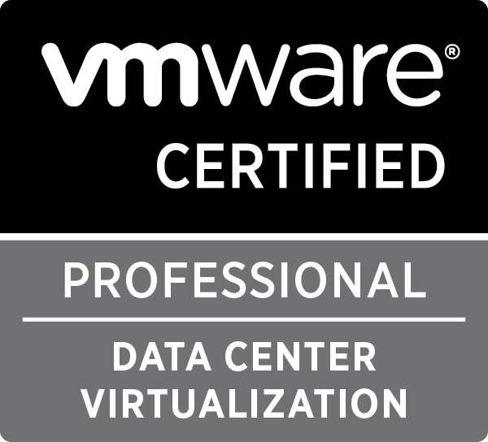
Strengths
- Fast learning capabilities and teamwork.
- Ability to prioritize workload and meet deadlines.
- Hardworking and Optimistic.
Hobbies
- Reading motivational books
- Watching movies
Personal Information

Full Name : Ashish Sharma
Father’s Name : Devdutt Sharma
Marital Status : Married

Declaration

I do hereby declare that the above information furnished by me is fair and true to the best of my knowledge and belief.

Place: Aligarh
Date: (Ashish Sharma)

