Create a dockerfile, docker-compose file which when executed must display your basic details in the website.

**------------------------------------------------------------------------------------------**

**Dockerfile:**

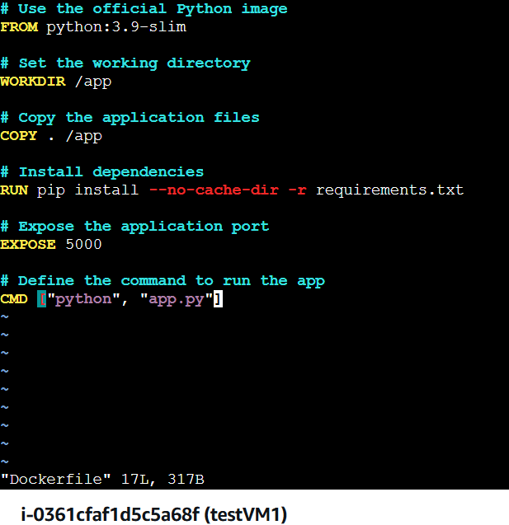

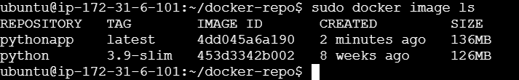



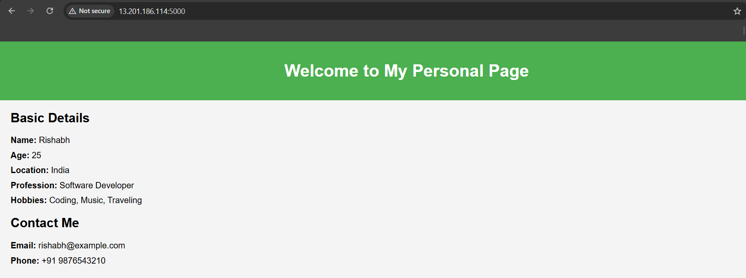

--------------------------------------------------------------------------------------------------------------------------------------

**Docker Compose**

Creating container via docker compose from the same image which was build using “Dockerfile”.

