Create a custom docker image for nginx and deploy it using docker compose, where the volume bind mount should be at /var/opt/nginx location. Push the created custom docker image to your docker-hub.

**Dockerfile**

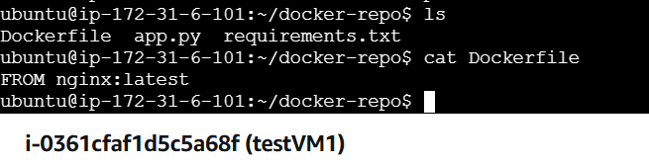

**docker-compose**

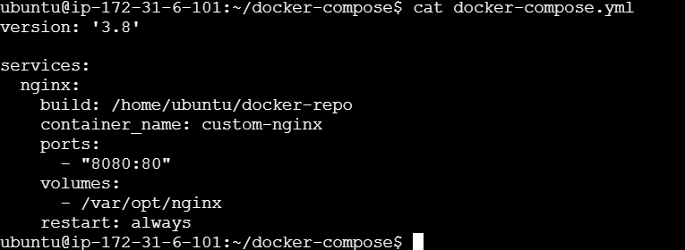

**Container**

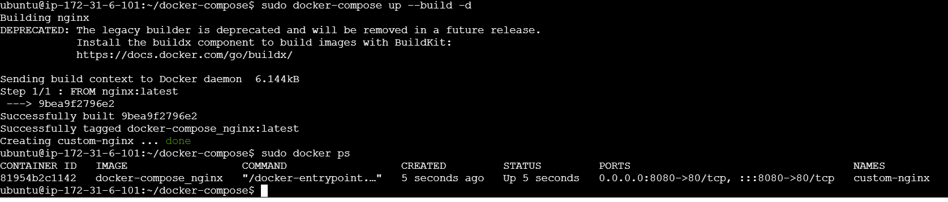

**Image**

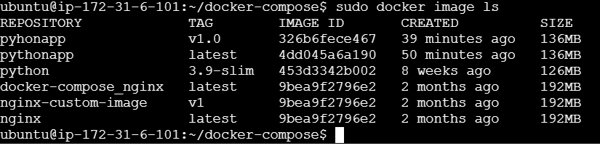

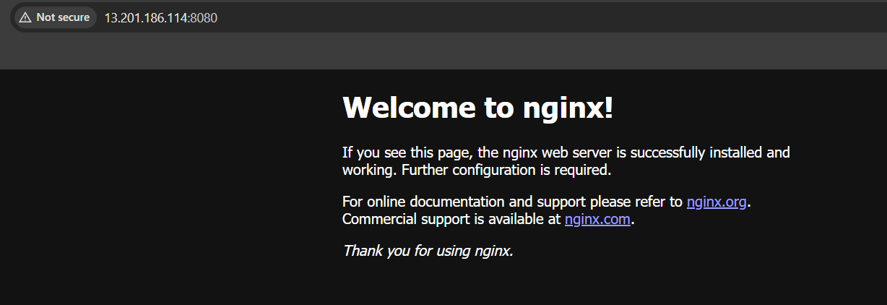

**Docker Hub**

