React Application

https://github.com/rishi-cmyk/guvi-final-project.git

http://65.2.83.79/

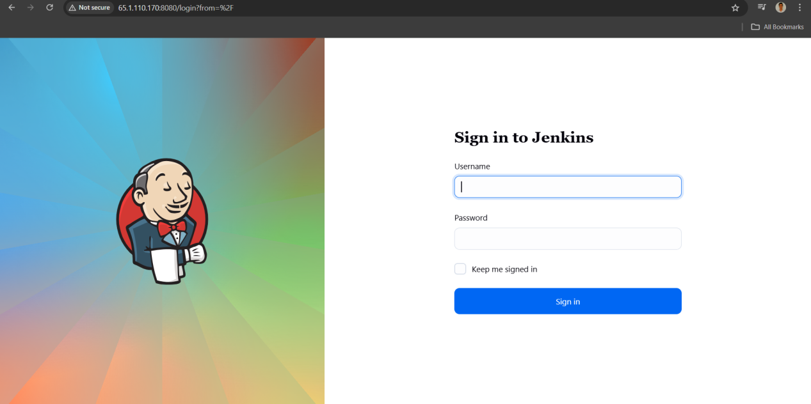

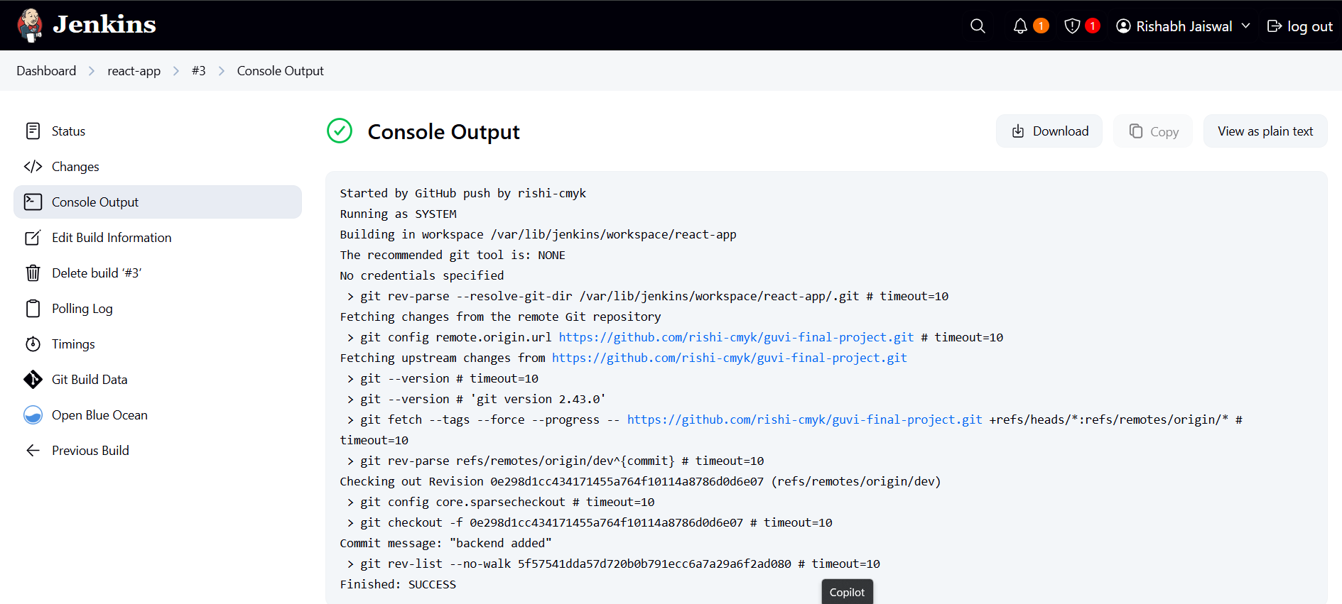
Jenkinsfile

pipeline {
agent any

environment {
DOCKERHUB_CREDENTIALS = credentials('dockerhub-creds')
IMAGE_NAME_DEV = "rjaiswal127/react-app-dev"
IMAGE_NAME_PROD = "rjaiswal127/react-app-prod"
}

stages {
stage('Checkout') {
steps {
git branch: "${env.BRANCH_NAME}", url: '200~https://github.com/rishi-cmyk/guvi-final-project.git'
}
}

stage('Build Docker Image') {
steps {
script {
sh 'chmod +x build/build.sh'
sh './build/build.sh'
}
}
}

stage('Deploy Image') {
when {
branch 'main'
}
steps {
script {
sh 'chmod +x build/deploy.sh'
sh './build/deploy.sh'
}
}
}
}

post {
success {
echo "Build & Deploy completed successfully!"
}
failure {
echo "Build failed. Check logs."
}
}
}

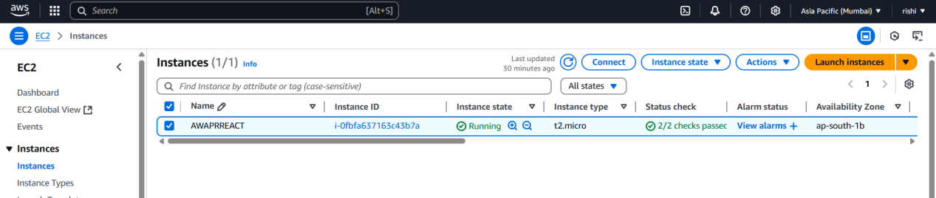

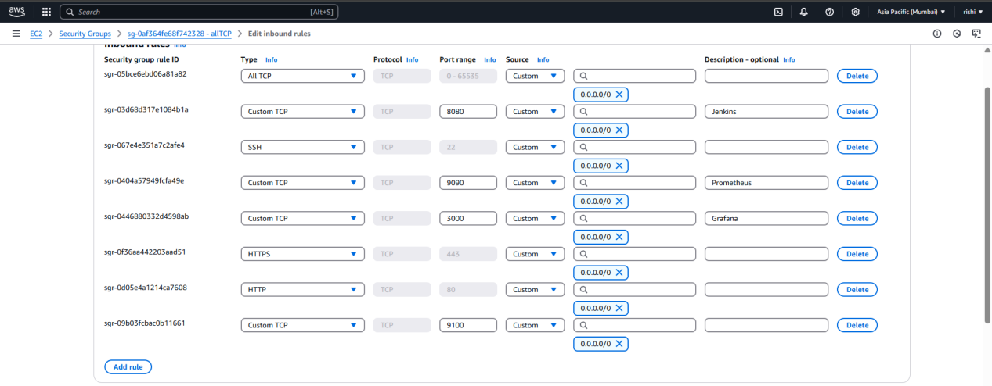

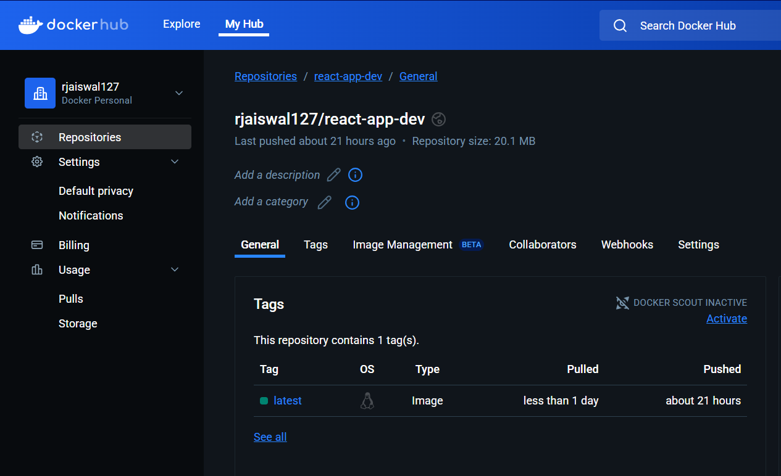

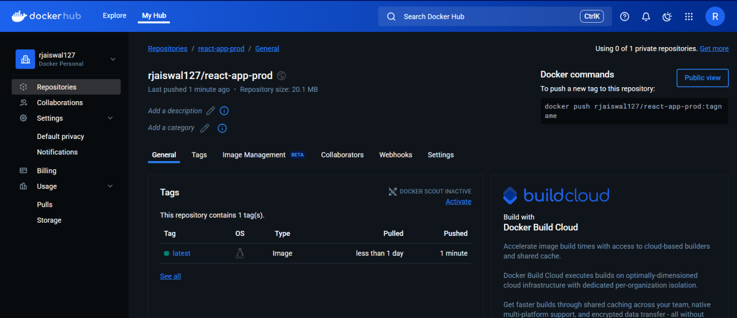

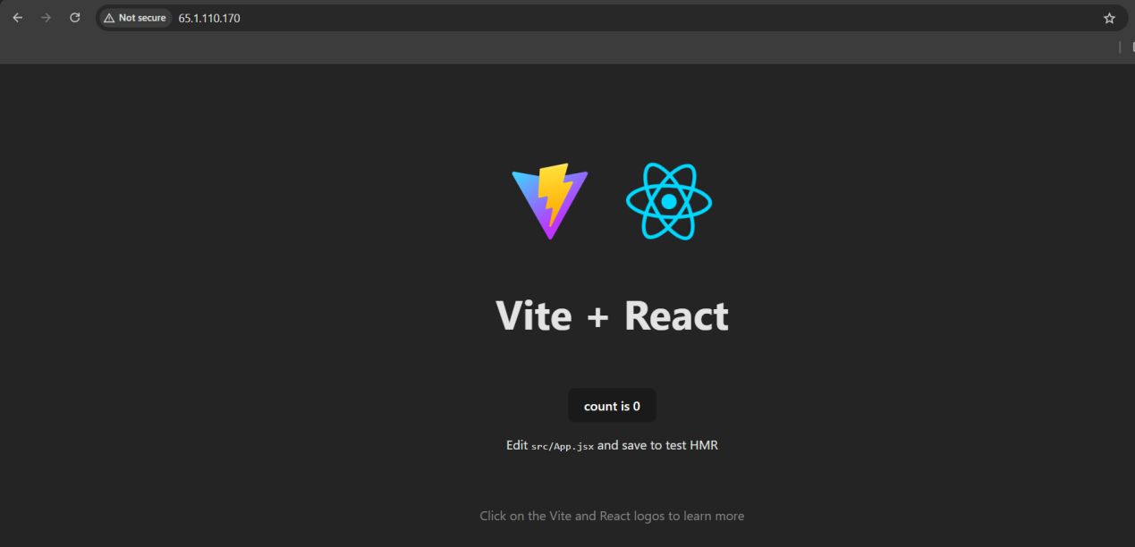
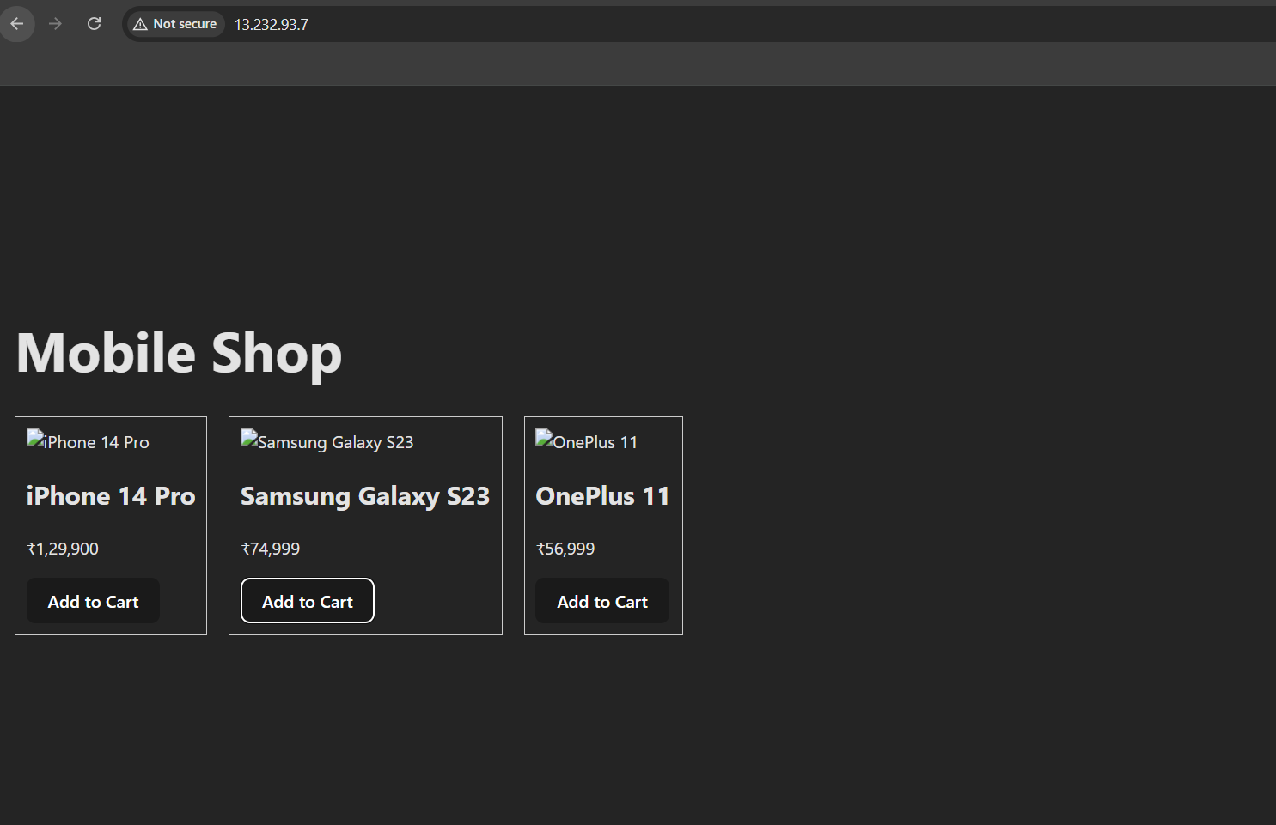

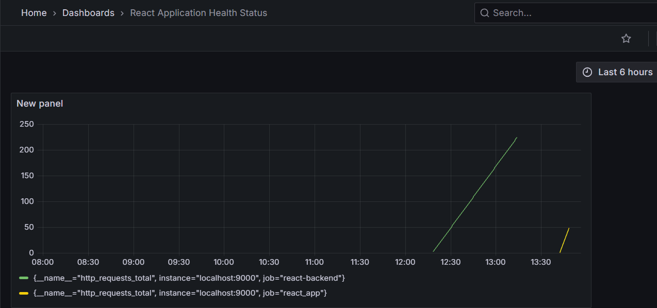

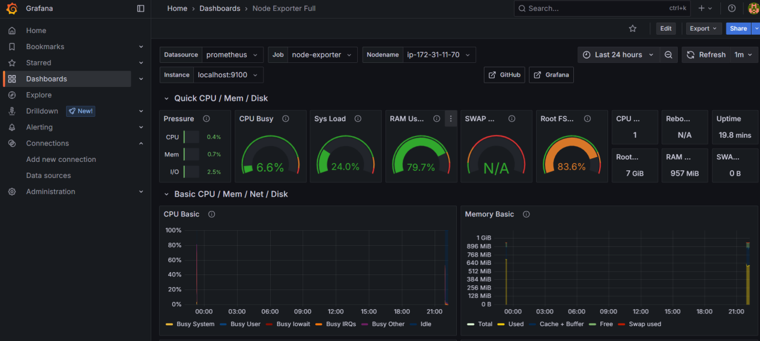

When Application is up, no alerts
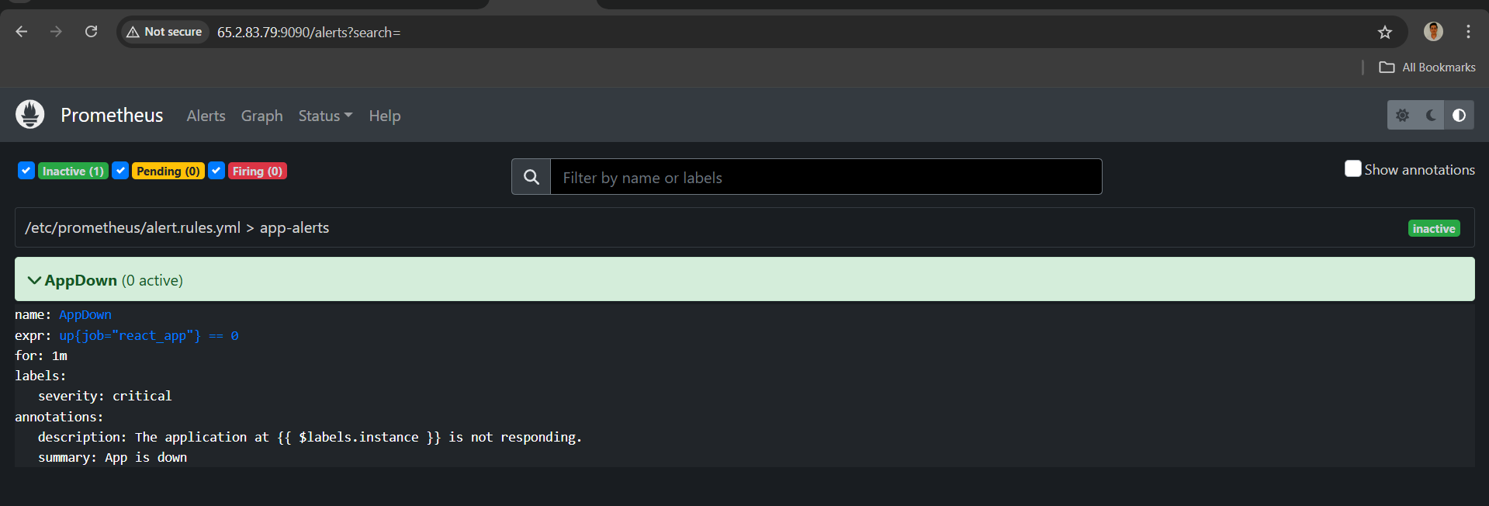

When Application is down
